

**Dear Dr. Abdallah Abu Khalil**  
  
First of all, I am interested in the beginning of this course, and in your style in general.  
  
If anyone asks me – **Who am I ?** – I will begin to say My name is **Muhammad Ibrahim Musleh**, I am from Kalandia Camp, my age is 20 (1999), I study from 1st grade to 9th grade in the Kalandia Camp School, then I continue the 10th grade to 12th grade in Al- Ummah Secondary School, Now I am in the 4th year in Birzeit University.

I am interested in animal life, especially cats, and also Computer system –I would attach some photos of our animals in our university.

**Why I Choose Doctor of Pharmacy ?**   
  
1- I love to help people very much, whether to give him advice or treat him with medicine.  
  
2- In my study, I can help animals in some situations with help from a veterinarian.   
**Note: We can use some medicine that is produced for humans, to treat animals.**3- Etc. **In summary, The Path of Faith Begins With Love (طريق الإيمان يبدأ بالحب)**

I am interested in Helping people, Animals lives, especially cats, and Computer systems –I would attach photos of our animals in our university.   
  
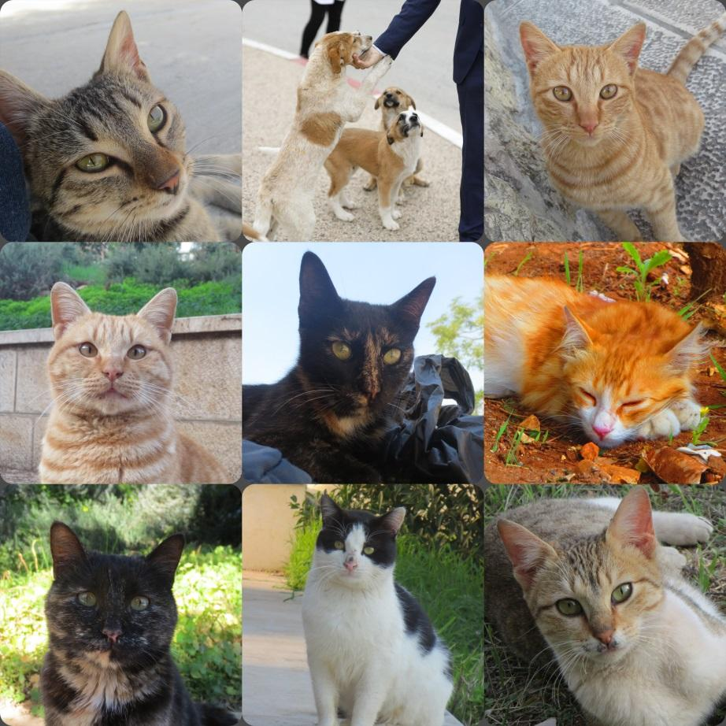

**I expect and hope from this course to increase my:-**  
  
1- Skill of communication with health care professionals and patients.  
  
2- Documentation skills for any patient.

3- The Motivation of patients.

4- Etc.