

**First Semester 2020/2021**

**Homework 1**

**Medicinal Chemistry 1**

**Instructor Amin Thawabteh**

**Student name and I.D Muhammad Musleh /1162595**

1. Cell membrane –Bilayer Phospholipid- consist of Head (Polar- Hydrophilic) and Tail (Nonpolar- Hydrophobic), so Adrenaline will not cross the cell membrane, because it has three functional group (OH) and small carbon skeleton, thin it will attach to head part (Hydrophilic) more the other. On the other hand Estrone has big carbon skeleton (Bigger than adrenaline) and less functional group, two functional group (OH , RCOR), thus it can across the cell membrane, because it is hydrophobic compound (Relatively).  
     
   In summary, We look at Functional group and Carbon skeleton and compare them.
2. **(6)** As we can see Cholesterol has one Functional group (OH)-Hydrophilic- and the remain is Carbon skeleton –Hydrophobic- so the compound will be oriented as, OH close to Head group, and carbon skeleton to tail group. (Like photo below)  
   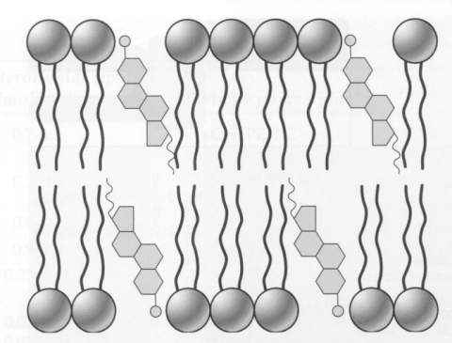







1. **(8)** First of all, Electron density is a measurement of electron’s probability at a specific location. Fact : If electron density (For carbonyl oxygen =O ) increase, it will increase its hydrogen bond acceptor (HBA).   
     
   Carboxylate (COOR-) is the strongest HBA, because it has a negative charge shared between two oxygen atoms (Resonance), but the second compound has Nitrogen atom, carbonyl oxygen is strong HBA, because nitrogen has lone pair of electrons, can increase electron density, the last two compounds Ketone (RCOR) and Ester (ROCOR) are polar compound, because they have Oxygen atoms and have slightly negative charge, so HBA are founded but less stronger than other.