

**First Semester 2020/2021**

**Homework 2**

**Medicinal Chemistry 1**

**Instructor Amin Thawabteh**

**Student name and I.D Muhammad Musleh /1162595**

1. The base is Like Dissolve Like, and most of the organic compounds are non-polar, so are less soluble in water, that’s why we compare the solubility of Aliphatic and Aromatic compounds, Aliphatic compounds are less soluble in water than Aromatic compounds, because Aromatic compounds have SP2 carbons with Pi-electron. However, Aliphatic compounds are somewhat polar (apolar) due to the presence of SP3 carbons.
2. Compound X is Tyrosine, the three groups are Alcohol, Amine, Carboxylic Acid. Its insoluble in water because it has Aromatic ring opposite to OH, and the pH play a critical role in this situation.
3. Analytical Water Solubility of :-  
     
   **a- Paracetamol**  
     
   1 Phenyl = 2.15  
   1 OH = **-** 0.67  
   1 Amide = **-** 0.97  
   logP = 0.51  
   H2O Soluble  
     
   **b- Atenolol**   
     
   1 Phenyl = 2.15  
   1 O=C-N = **-** 0.7  
   7 Carbons = 3.5  
   1 OH = **-** 1.12  
   1 Secondary Amine = **-** 0.68  
   1OR = **-** 0.02  
   logP = 3.13  
   H2O Insoluble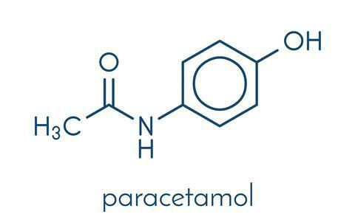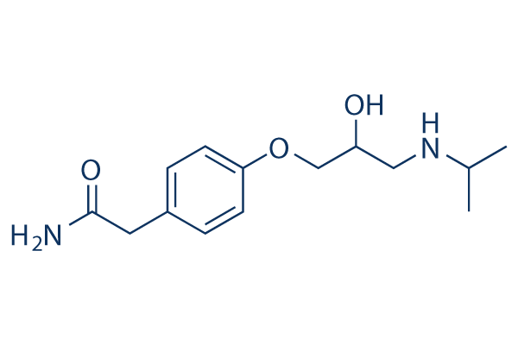
4. Reduce biological activity because of inability of the 2nd enantiomer to achieve number of interactions with the receptor surface. The Easson-Stedman Theory state that the more potent enantiomer must be involved in a minimum of three intermolecular interactions with the surface of the biologic target and that less potent enantiomers only interacts with two sites. Enantiomers frequently have substantially different biological activity because they bind to receptors in the body that are also chiral, so if 1 enantiomer binds to chiral binding site, the mirror image of the orginal molecule will not bind as well.