

**Homework 3**

**PROTEINS**

**Medicinal Chemistry 1**

**Instructor Amin Thawabteh**

**Student name and I.D Muhammad Musleh /1162595**

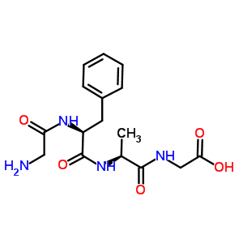

1. L- Alanyl – L – Phenylalanyl - Gylcine
2. The unique thing about glycine is that it contain Hydrogen atom (H) rather than Carbon skeleton-Not has Side chain- (R group). See the attached figure.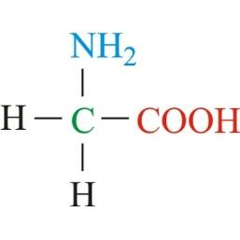





1. Possible interactions for the side chains of:-

| Amin Acid | Interacitions |
| --- | --- |
| Serine | **Covalent Bond** (Between Alpha Amino group to alpha Carboxyl group), and **Polar OH** (H bonding) |
| Phenylalanine | **Covalent Bond, VDW** (Van Der Waals) |
| Glycine | **Covalent Bond; No side chain** |
| Lysine | **Covalent Bond**, and NH group is a good **HBD** (Hydrogen Bond Donor), **Basic**; NH2 to NH3+ |
| Aspartic acid | **Covalent Bond**, **Acidic**; COOH to COO- |
| Aspartate | **Covalent Bond**, **Acidic**; COOH to COO- (Same like Aspartic Acid) |

