

**Homework 5**

**RECEPTORS**

**Medicinal Chemistry 1**

**Instructor Amin Thawabteh**

**Student name and I.D Muhammad Musleh /1162595**

1. **(2)**

The possible binding interactions for the functional groups in each molecule are shown as HBD (hydrogen bond donor), HBA (hydrogen bond acceptor), ionic and vdw (van der Waals interactions). It should also be noted that van der Waals interactions involving alkyl groups or alkyl chains are possible.

The following amino acids have side chains which could interact by hydrogen bonding: Ser, Thr, Tyr, Asn, Gln.

The following amino acids have side chains which could interact by ionic interactions: Asp, Glu, His, Lys, Arg.

The following amino acids have aromatic or heteroaromatic groups in their side chains which could interact by van der Waals interactions; Phe, Tyr, Try.

The following amino acids contain alkyl side chains which could interact by van der Waals interactions; Val, Leu. Ile. Met, Pro.

In addition, the peptide links between amino acids in the binding site can interact with ligands by hydrogen bonding.

Acetylcholine

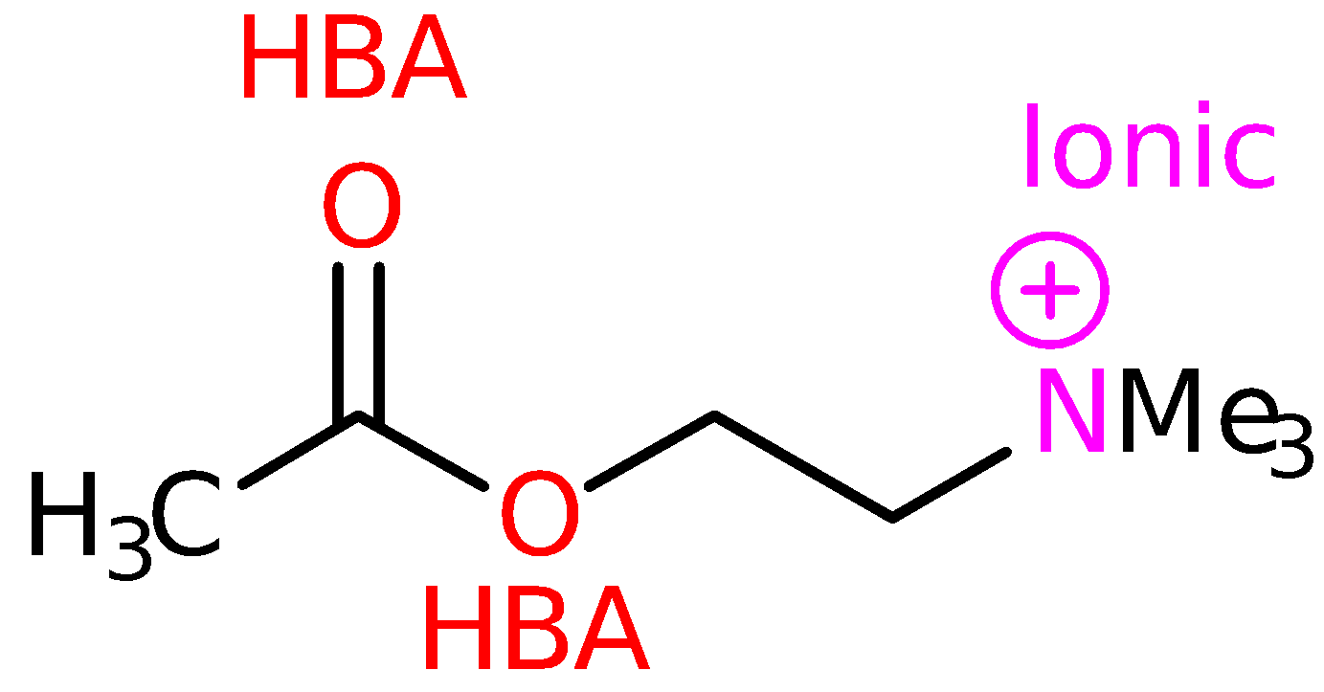

It is also known that three of the four methyl groups fit into hydrophobic pockets and participate in van der Waals interactions (see sections 19.7 and 15.14.1).

Noradrenaline and adrenaline

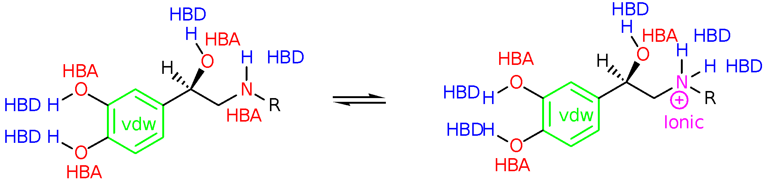

The amino group of both nordrenaline and adrenaline can exist as the free base or as the protonated, ionised form. Note that the nitrogen can act as a HBA in the free base but not when it is ionised. Further details on the binding interactions of noradrenaline and adrenaline can be found in sections 15.14.1, 20.8 and 20.9

Dopamine

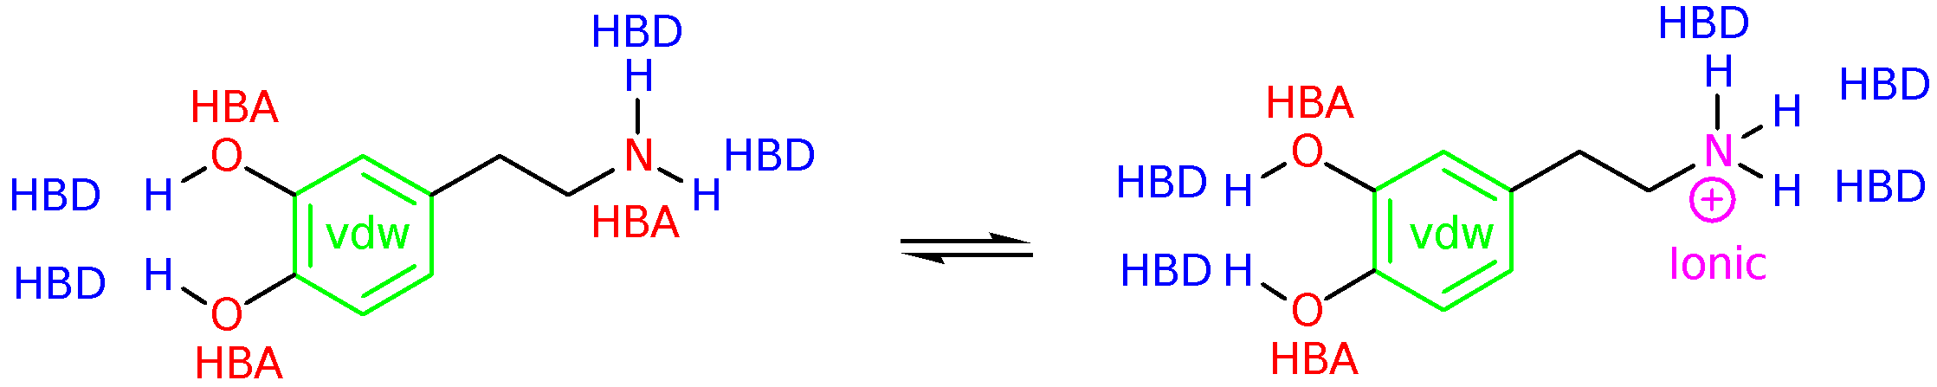

The amino group of dopamine can exist as the free base or as the protonated, ionised form. Note that the nitrogen can act as a HBA in the free base but not when it is ionised. Further details on the binding interactions of dopamine can be found in section 15.14.1.

Glycine

Glycine is an amino acid which is more likely to exist as the zwitterion with both the amino and carboxylic acid groups being ionised.

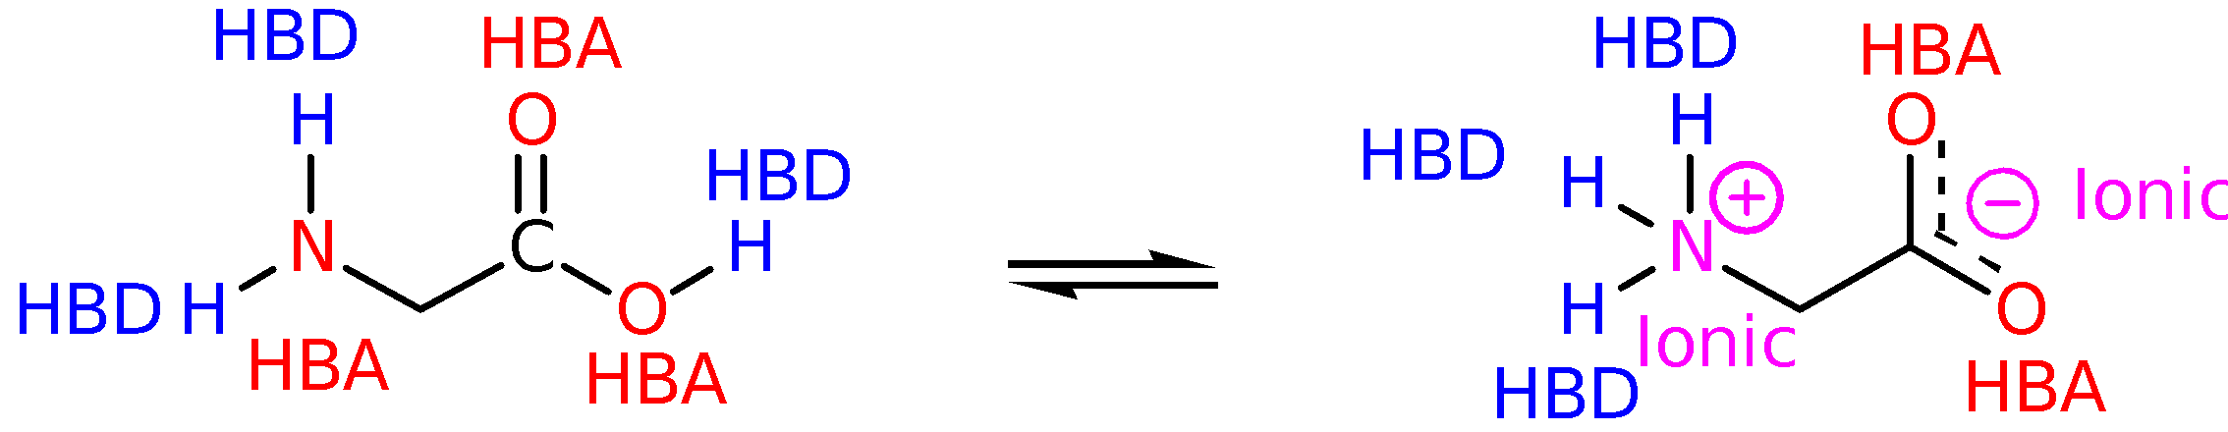

Serotonin

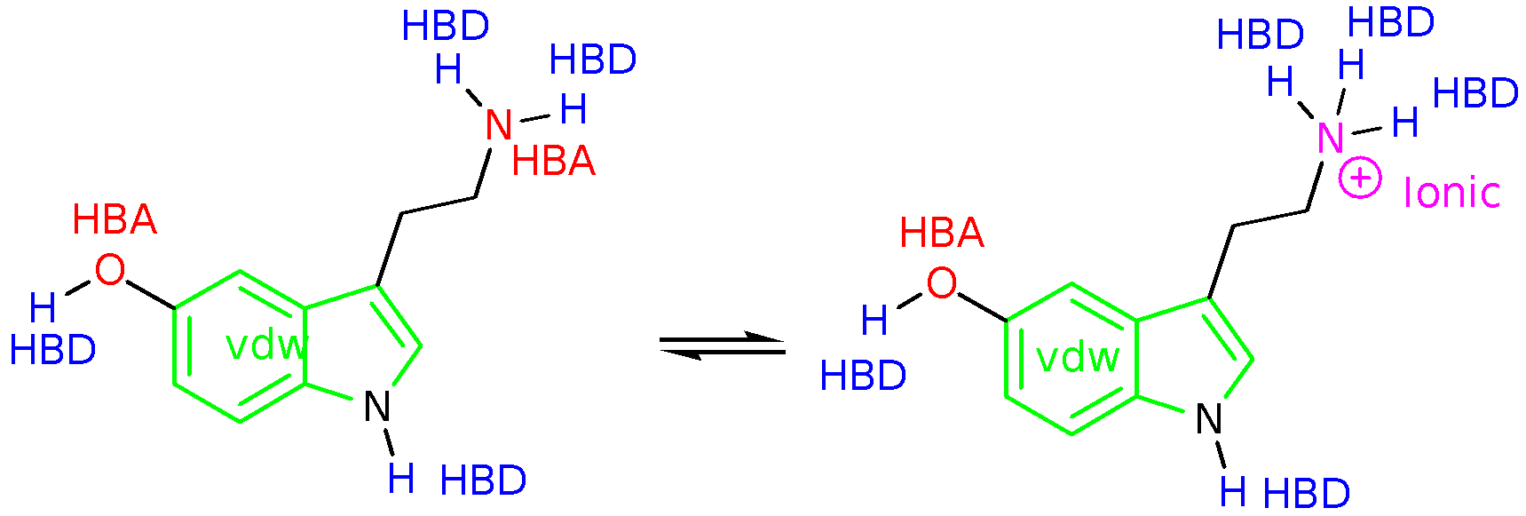

The amino group of serotonin can exist as the free base or as the protonated, ionised form. Note that the nitrogen can act as a HBA in the free base but not when it is ionised. Note also that the heterocyclic nitrogen is unlikely to be a good HBA since its lone pair interacts with the ring's π system. Further details on the binding interactions of serotonin can be found in section 15.14.1.

γ-Aminobutyric acid

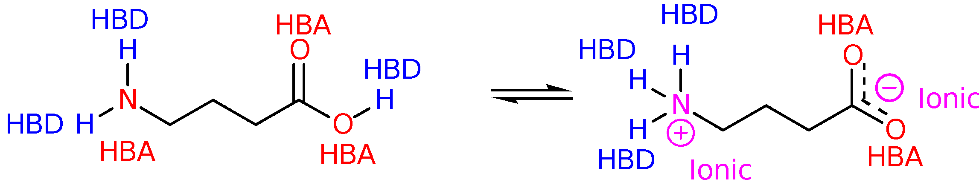

Glutamic acid

