

**Homework 9**

**Medicinal Chemistry 1**

**Cholinergics, Anticholinergics and Anticholinesterases**

**Instructor Amin Thawabteh**

**Student name and I.D Muhammad Musleh /1162595**

1. 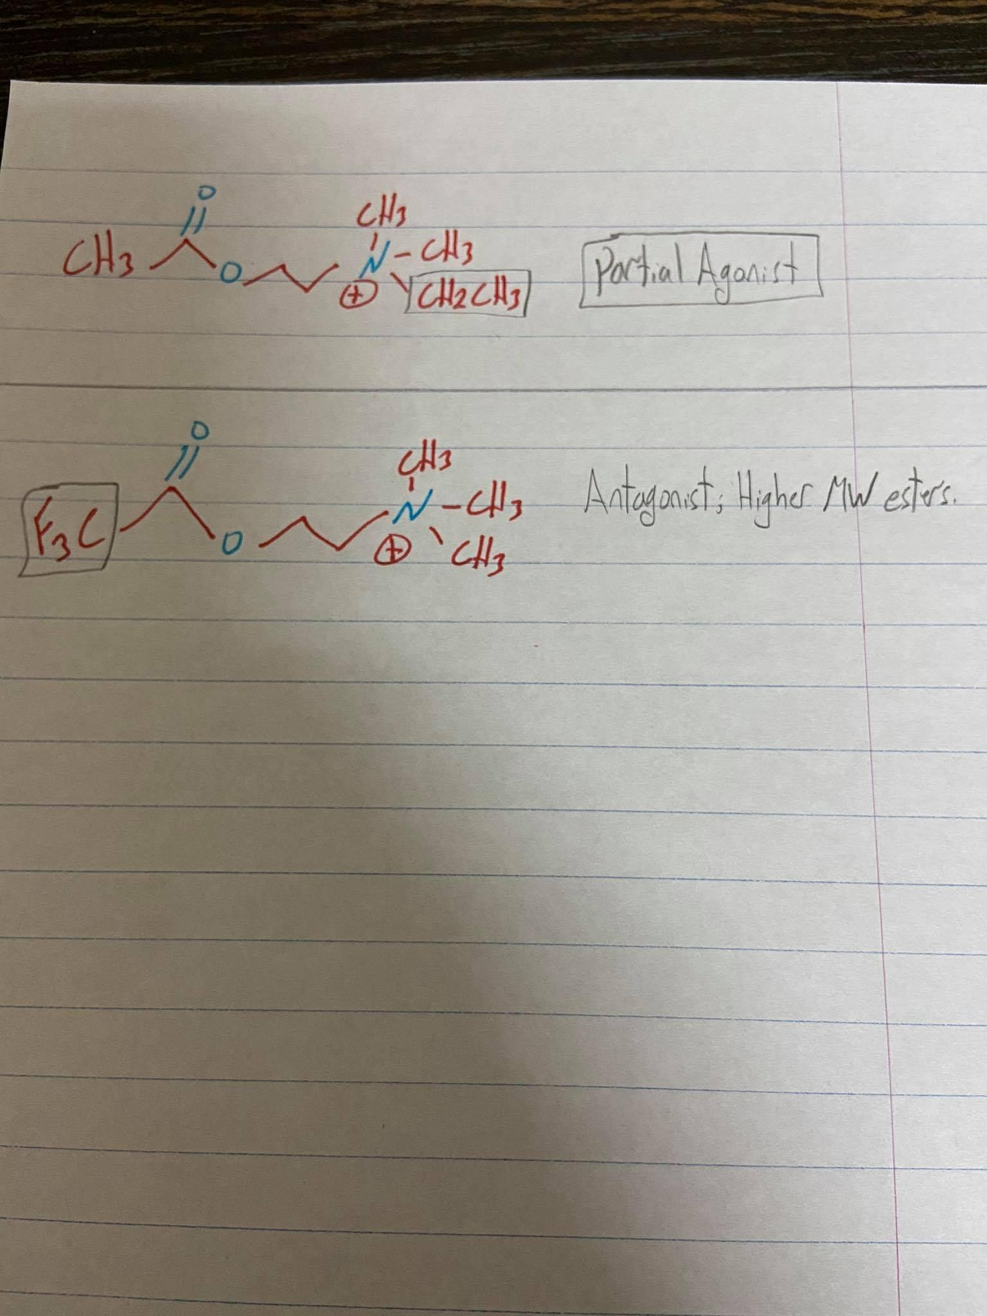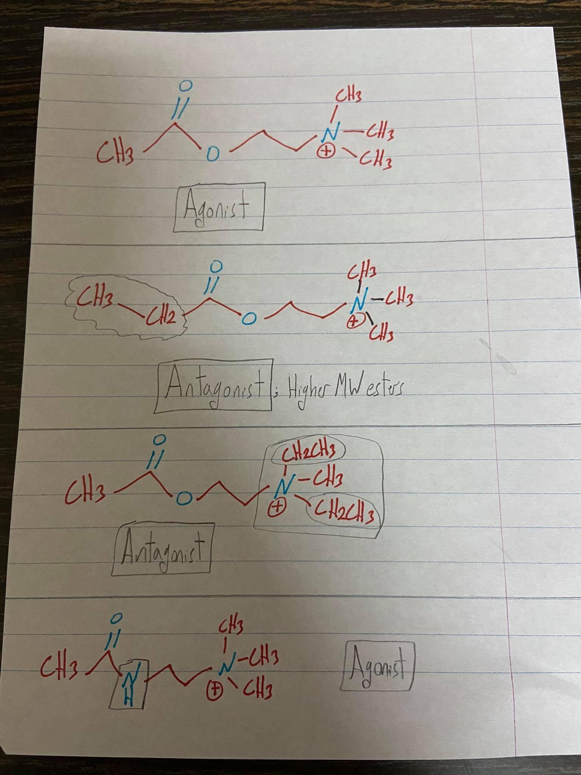
2. **(4)** There are many of binding interaction that holding Ach in binding site of AChE. Tryptophan residue forms π- cation interaction(N on the Ach has a positive charge and active site of AChE has a negative charge so do ionic interaction with N-cationic Quternery Amine , Histidine acts as Acid-Base catalyst, Serine acts as nucleophile, Aspartate residue interacts with Histidine residue to orientate and active the ring  
     
   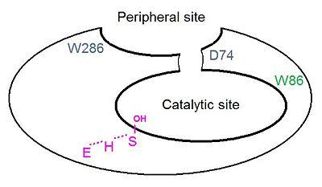
3. **(6)** Selective to M2 receptor, no effect of ionic strength because of the distance between N and O. However, Pilocarpine does not have quaternary ammonium group. (!)