**Answers**

1)

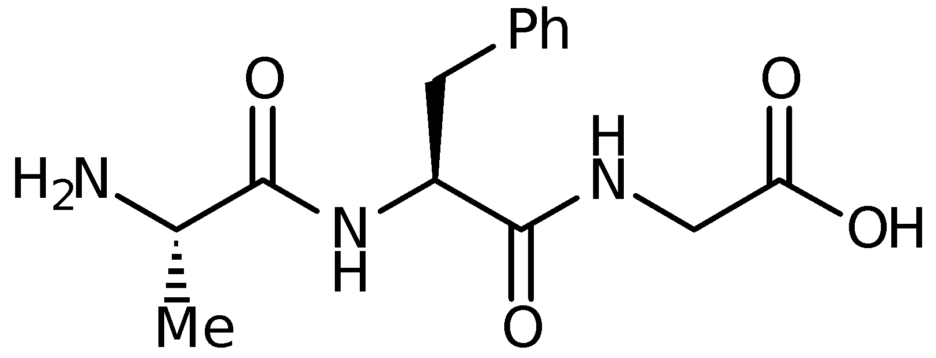

2) Glycine is the only amino acid with no side chain and is the only naturally occurring amino acid that is not asymmetric.

3) Possible interactions are shown below for the side chains of serine, phenylalanine, glycine, lysine and aspartic acid (HBA= hydrogen bond acceptor; HBD = hydrogen bond donor; vdw = van der Waals interactions).

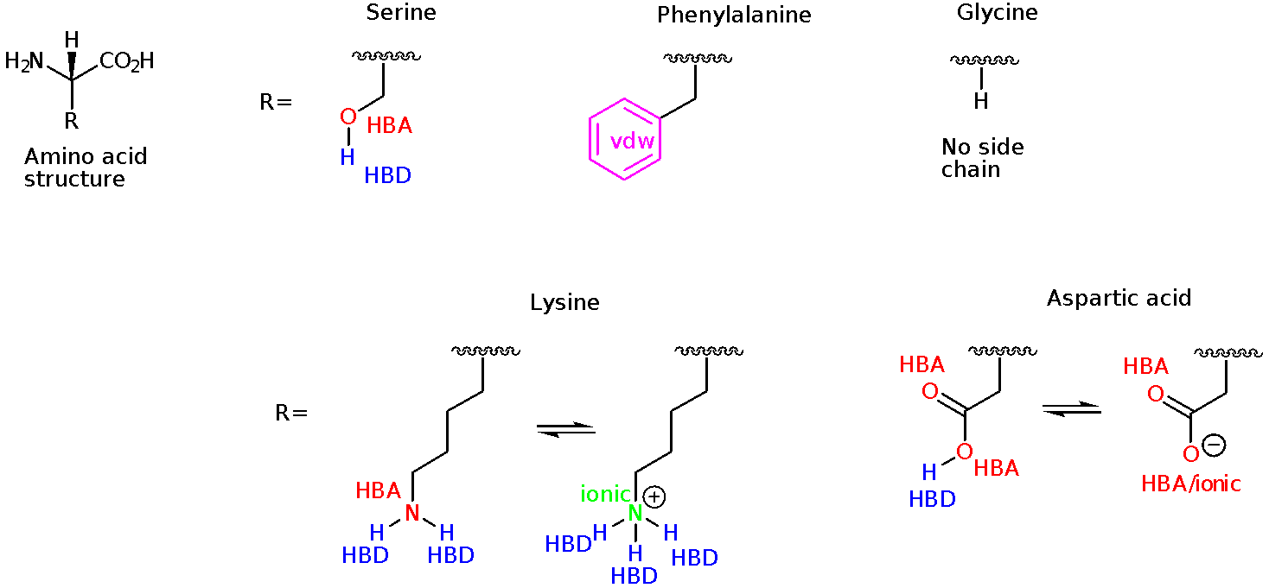

3) The peptide bond is planar since it is possible for the nitrogen lone pair to interact with the carbonyl group as follows.

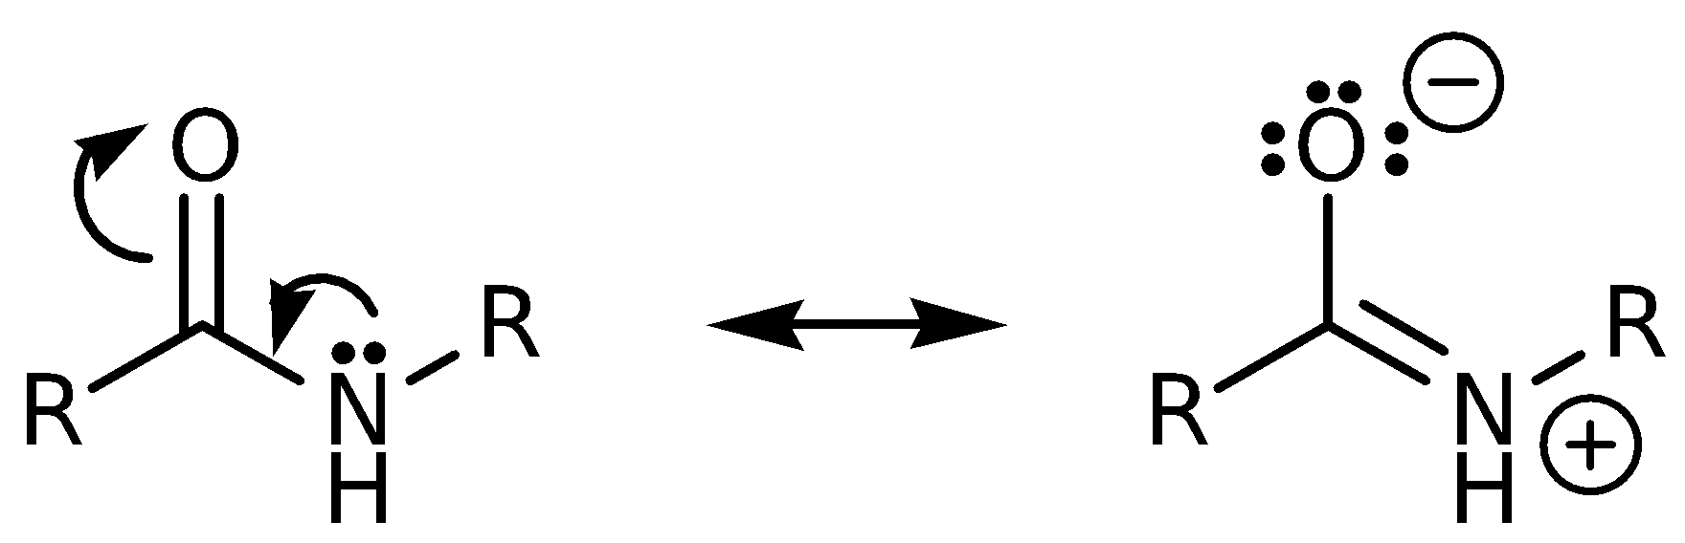

4) If a sequence of amino acids with hydrophobic side chains can be identified in the primary structure, it is possible that this is a transmembrane (TM) region of the protein (i.e it is located within the cell membrane as shown below) This is because hydrophobic side chains would interact more favourably with the fatty cell membane than with the aqueous environments on either side of the cell membane. Regions of the protein that are made up predominantly of polar side chains are almost certainly located intracellularly or extracellularly.

However, it would be wrong to conclude that all amino acids with hydrophobic side chains are located in transmembrane regions and all amino acids with polar side chains are located intracellularly or extracellularly.

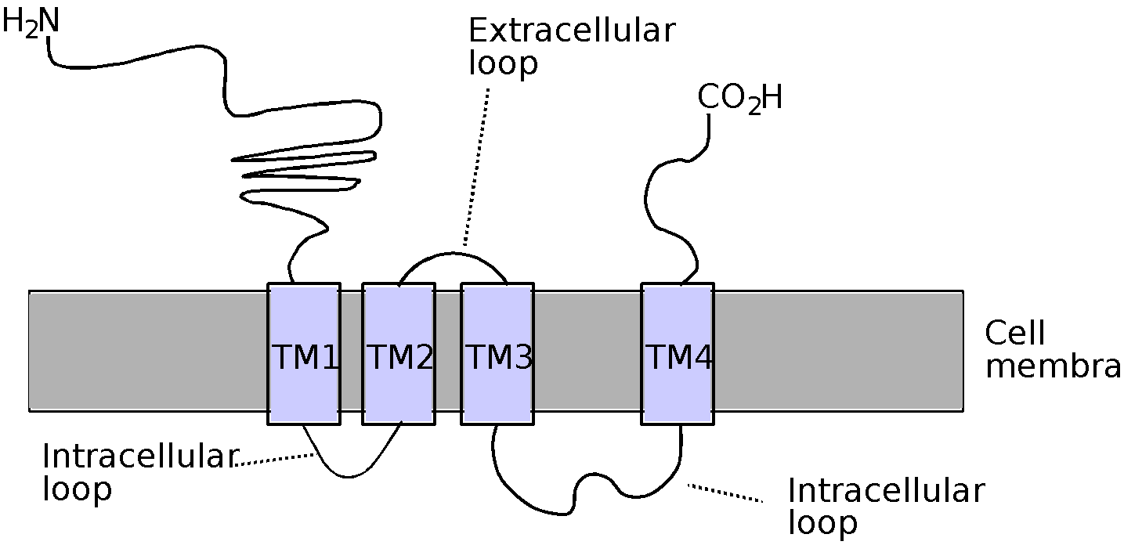

5) The structure of L-alanyl-L-valine is shown below.

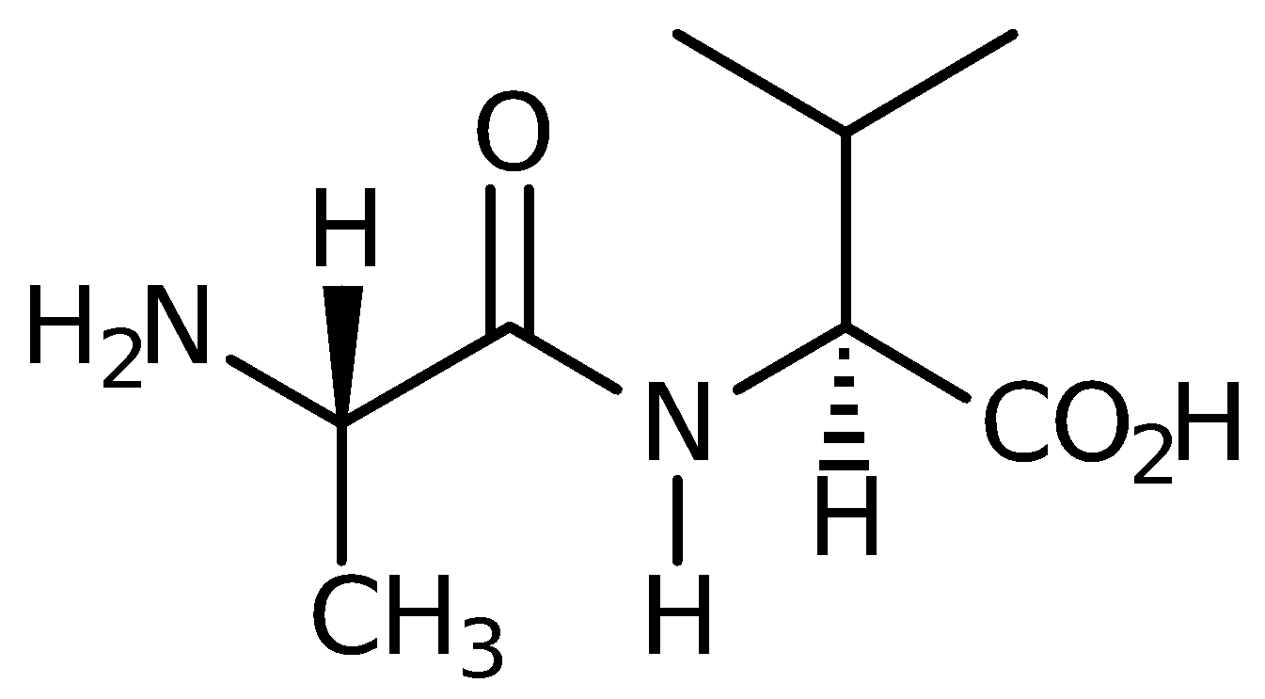

An attempt to couple alanine directly to valine may well produce the desired products but a whole range of other structures will also be formed.

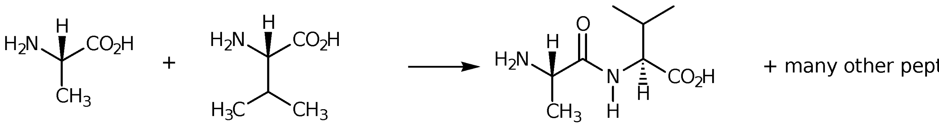

For example, there is nothing to stop alanine coupling with itself, or valine coupling with itself to form L-alanyl-L-alanine and L-valyl-L-valine respectively.

There is also no reason why any of the above dipetides that are formed could not undergo a further coupling reaction to form tripeptides, tetrapeptides etc.

The reaction is also likely to need forcing conditions since one is attempting to form an amide between an amine and a carboxylic acid. This is likely to result in racemisation of asymmetric centres.

Due to these problems, it is necessary to protect the amino group of one amino acid and the carboxylic acid of the other before a coupling reaction is attempted. It is also important to have coupling reagents (e.g. dicyclohexylcarbodiimide) in order to achieve milder, non-racemising conditions.

6) The functional groups involved are alcohols and phenols. Both f these functional groups can form hydrogen bonds. When the groups are phosphorylated, the phosphate groups are ionised and will interact with ionic groups rather than hydrogen bonding groups.

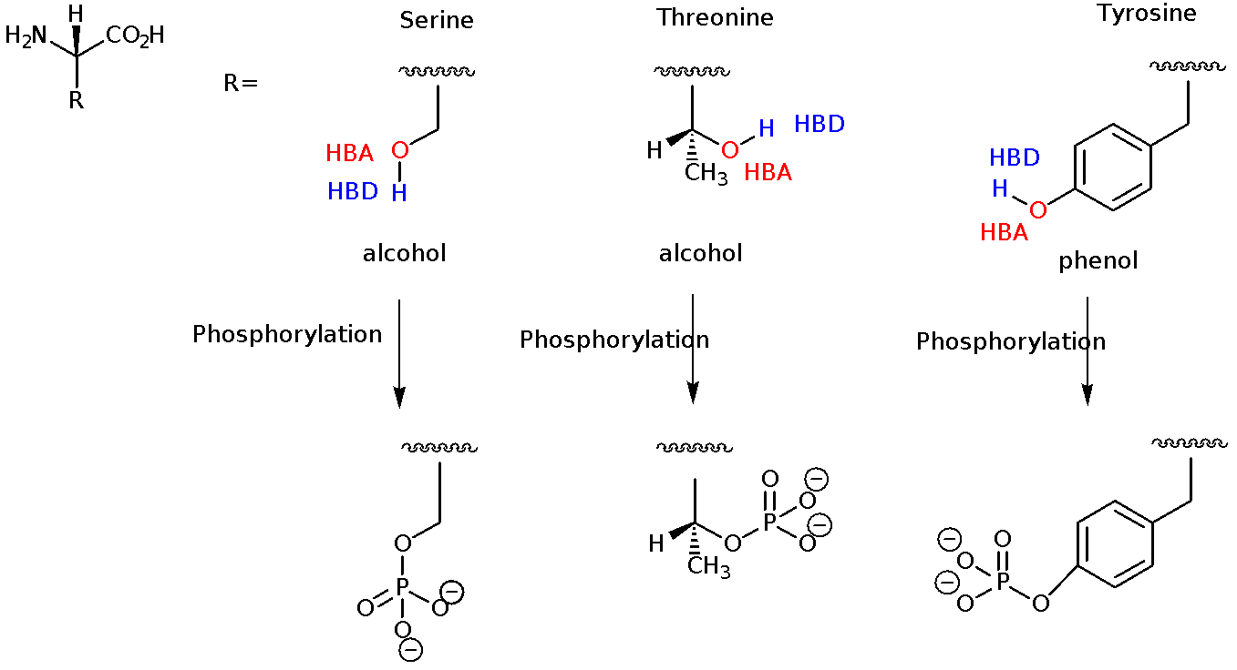The tertiary structure will alter as a result (see section 6.5.6).

7) Glu-Leu-Pro-Asp-Val-Val-Ala-Phe-Lys-Ser-Gly-Gly-Thr

The question already shows the three letter coding for this polypeptide. The one letter coding is ELPDVVAFKSGGT.