

**Homework 2**

**Over the Counter Medication and Supplies/PHAR437**

**Instructor Abdullah Rabba**

**Student name and I.D Muhammad Musleh /1162595**

**Please read the attached file with 2 cases. for each case write below**

**1: your recommendation and why do you recommend that?**

**2: the most possible cause of the patients presentation**

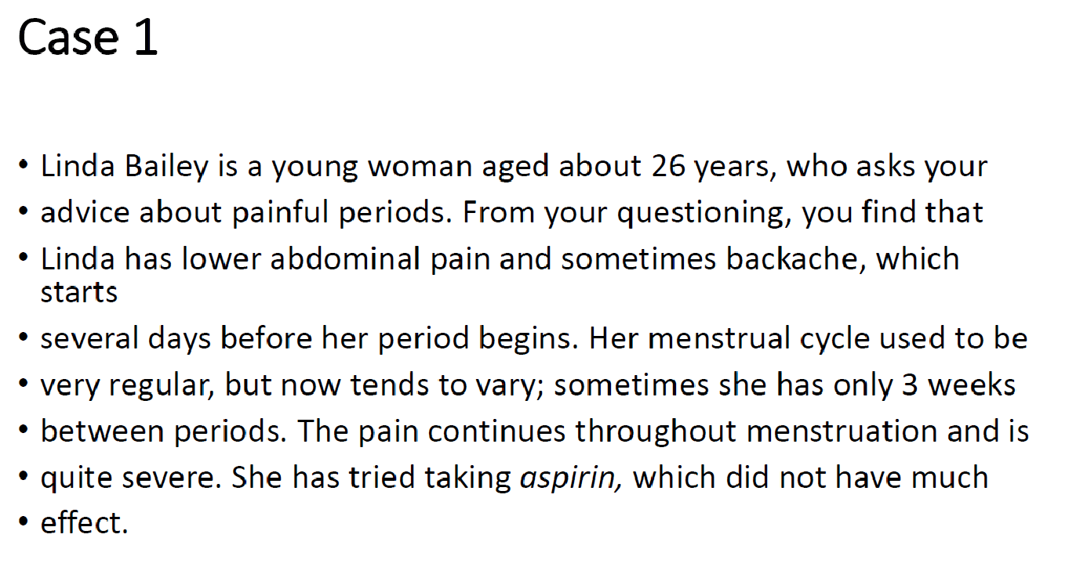

1. **My Recommendation for the patient  
     
   First of all, I hope you are Ok, and will be fine.  
     
   From your Information I suggest you to visit a gynecologist (Doctor of women) to understand what causes of this pain and about the Irregular Period, you can take Ibuprofen until you visit Doctor.  
     
   Because the period change from Regular to Irregular, and the degree and onset of Pain.**
2. **The Most Possible Causes:-  
     
   It is a secondary Dysmenorrhea, may be have an infection in the pelvic or the style of life.**

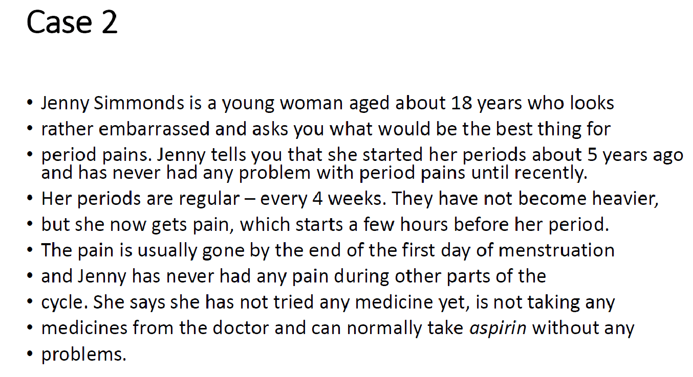

1. **My Recommendation for the patient  
     
   First of all, I hope you are Ok, and will be fine.  
     
   From your Information I suggest to take NSAID, like Ibuprofen or Declofenacm. However if the pain not relief by the medicine, we can change it to another medicine.  
     
   Because the onset of pain, and she does not use any medicine in the past.**
2. **The Most Possible Causes:-  
     
   From the information it is certain a Primary Dysmenorrhea.**