Machine / Instruments

1. Digital Caliper for Thickness measurement 150 mm

A digital caliper is used to determine the thickness of a tablet by placing it inbetween its clamps and closing them tightly against it. This will give areading of what the thickness in millimeters the tablet is. No parameters needto be inserted.

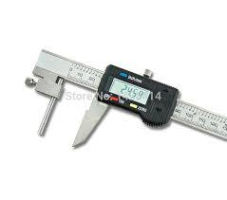

2. Hardness Tester - Pharmatest PTB111

Type: PTB111E500

Serial number: 20329

Company: Pharmatest

It is used to determine how much force it takes to break a tablet(measured in kPa). This is important in determining how muchmechanical pressure it can withstand and if it will break during futureprocesses and handling.

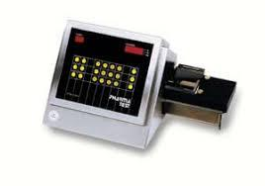

3. Friability tester -Pharmatest PTF

Type: PT F30ERA

Serial number: 19084

Company: Pharmatest

Friability tests whether the handling of the tablets by themanufacturers and later by the consumer will affect the integrity of thetablet. This is done by elevating the tablets and then letting them fallfrom a 6 inch distance, a number of 100 times. If the 10 tablets initially inserted into the machine lose more than 1% of their weight, or if any of thembreak, then they are not durable enough.

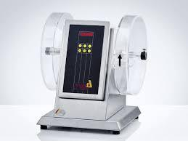

4. Analytical Balance

Model: AS 220/C/2

Company: Radwag

Min weight 10mg

Required to measure the weights of the tablets before different tests and for weight

variations tests.

5. Compression machine - IMA Active Kilian

Type: Pressima

Version: EU- B/D

This is a multi punch machine used for the compression of a large number of tablets at a

speed higher than a single punch machine. Manay parameters must be inserted such as

the pre-compression force, compression force, depth of die cavity, and the speed of the

machine.

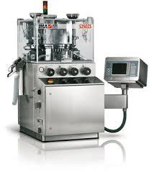

**Data and calculations :**

**For weight variation :**

| **Tablet** | **Weight of tablet** | **Accepted or not** |
| --- | --- | --- |
| **1** | 0.82 | Accepted |
| **2** | 0.81 | Accepted |
| **3** | 0.85 | Not accepted |
| **4** | 0.80 | Accepted |
| **5** | 0.80 | Accepted |
| **6** | 0.82 | Accepted |
| **7** | 0.73 | Not accepted |
| **8** | 0.82 | Accepted |
| **9** | 0.72 | Not accepted |
| **10** | 0.84 | Accepted |

Average weight = sum of weights \ 10 = 0.801 g

Upper limit = average weight + (average weight * error%) = 0.841

Lower limit = average weight - (average weight * error%) = 0.76

**For hardness test** :

| **Tablet** | **1** | **2** | **3** | **4** | **5** | **6** | **7** | **8** | **9** | **10** | **Average** |
| --- | --- | --- | --- | --- | --- | --- | --- | --- | --- | --- | --- |
| **Hardness** | 15.3 | 9.8 | 14.9 | 14.5 | 13.9 | 16.5 | 6.9 | 16.7 | 10.4 | 13.9 | 13.28 |
| **Thickness** | 0.3 | 0.3 | 0.3 | 0.3 | 0.3 | 0.3 | 0.3 | 0.3 | 0.3 | 0.3 | 0.3 |
| **Height** | 1.6 | 1.7 | 1.65 | 1.7 | 1.7 | 1.7 | 1.7 | 1.65 | 1.65 | 1.65 | 1.67 |

Average hardness = 13.28 Kp .

Average thickness = 0.3 cm.

Average height = 1.67 cm .

**For friability test :**

| **Weight of tablets before processing** | 8.0064 |
| --- | --- |
| **Weight of tablets after processing** | 7.9768 |
| **Friability (%loss)** | 0.0036% |

**%loss =** (Weight of tablets before processing - Weight of tablets after processing)\ Weight of tablets before processing * 100% **=** 0.0036%

Discussion :

In weight variation test the average weight was 0.801 g with upper limit 0.841 and lower limit 0.76 , and three of the tablets were not accepted ,it is may due to changing the speed during compression and the flowability of the granules itself and the force of pressure of the machine and particle size distribution play a role on this .

In hardness and thickness test , the average of hardness was 13.28 Kp and the thickness was 0.3cm and the height 1.67 . in monograph the accepted value of the hardness is 4 Kp , so our value was very good which is due to supply sufficient amount of binder , so all the tablets were accepted .

In friability test the loss was 0.0036% which is less than 1% , and the tablets that we collect after the friability test were not crashed , so our batch is accepted .

It may affect the elegance , appearance , consumer acceptance of the tablets.

The friability test is closely related to the hardness test and is designed to evaluate the ability of the tablet to withstand abrasion in packaging , handling and shipping .

Conclusion :

In this experiment , we have done many official and non official test(weight variation ,hardness , friability) , to make sure that our tablets are in specific properties that can use in proper shape without any mistakes in process . and this lead to the desired therapeutic effect for the patient.