

**Faculty of Pharmacy, Nursing and Health Professions**  
  
**Program of Doctor of Pharmacy**  
  
**Industrial Pharmacy PHAR 411**  
  
**Lab Report  
  
Compression**  
**Experiment No.** :8  
  
**Lab Coordinator**   
Moammal Qurt  
  
  
**Student Name and I.D** Muhammad Musleh

1162595  
ـــــــــــــــــــــــــــــــــــــــــــــــــ  
 Saleh Aqel

1160596

**Experiment Date :** 2019/10/23

**Submission Date** : 2019/11/6

**Students Signature**

**Supervisor Signature**

**Objectives:-**

1. To produce tablet by compression machine, also to reach the point of weight (0.8 g).
2. To measure the parameters of my tablets, Hardness, Length, Thickness, and Friability.

**Abstract:-**

In this experiment, I make tablets from the compression machine, and do two tests Hardness and Friability. From this tests I can understand the function of the inactive material added.

**Introduction:-**

Tablets and capsules represent unit dosage forms whereas liquid oral dosage forms such as syrups, suspensions, emulsions, solutions and elixirs usually contain one dose of medication in 5 to 30 mL. Such doses are erratic by a factor ranging from 20 to 50% when the drug is self-administered by the patient. The oral route of drug administration is the most important method for systemic effects. The standard quality control tests such as diameter, size and shape, uniformity of weight, thickness, hardness, friability, percentage of medicament (Assay), rate of disintegration, dissolution and solubility can be carried out on compressed tablets for their evaluation.

This is important to facilitate packaging and decide tablet compressing machine to use. The weight uniformity and content uniformity to make sure the correct dosage and content of drug. Next, its concerned with sampling, testing and documentation during manufacturing and also completion of manufacturing.

**Experimental:-  
  
1- Procedure:-**

**Compression:**

Transfer the granules to the compression area, Make sure that the compression machine is clean and ready to be used, Fill the hoper of the machine with the granules, Adjust the weight of the tablet, Adjust the hardness of the tablets, Start compression with the supervision of the responsible person, Collect the tablets in plastic bags and transfer them to the storage area.

**Hardness:**

A tablet is placed between two anvils, force is applied to the anvils, & the crushing, strength that just causes the tablet to break is recorded (in kp). Minimum of 6 tablet samples should be tested then take the average hardness. Limit: Tablet hardness must be above 4 kp minimum. In general, if the tablet hardness is too high, we first check its disintegration before rejecting the patch. And if the disintegration is within limit, we accept the patch.

**Friability:**

Weigh tablets together = W1, For tablets with an average weight of 0.65 g or less take a sample of whole tablets, corresponding to about 6.5 g and for tablets with an average weight of more than 0.65g take a sample of 10 whole tablets. Dedust the tablets carefully and weigh accurately the required number of tablets. Place the tablets in the drum and rotate them 100 times. Take the tablets out, and clean them with a brush and weigh them again = W2 (any broken or smashed tablets are not picked up. Normally, when capping occurs, friability values are not calculated. the sample fails the test. )

**2- Ingredients: Paracetamol and Inactive Ingredients.**

**2- Machine/ Instrument**

1. **Compression Machine-Tablet Press:-**

IMA Active Kilian

Type: Pressima

Version: EU- B/D

This is a multi-punch machine used for the compression of a large number of tablets at a

speed higher than a single punch machine. Many parameters must be inserted such as

the pre-compression force, compression force, depth of die cavity, and the speed of the

machine.

Figure 1 : Tablet Press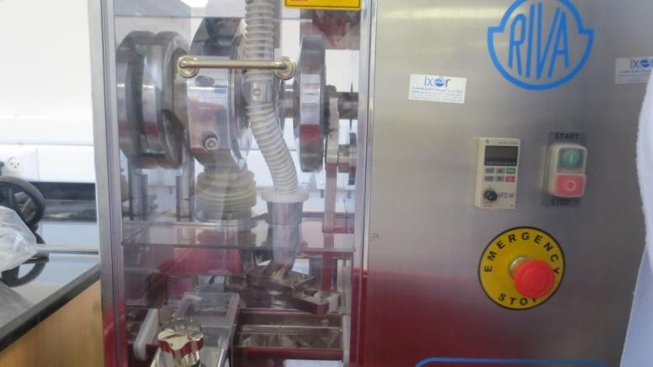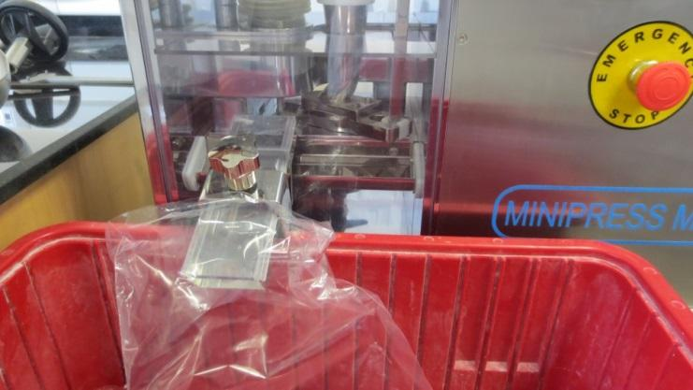

1. **Hardness:-** Pharmatest PTB111

Type: PTB111E500

Serial number: 20329

Company: Pharmatest

It is used to determine how much force it takes to break a tablet(measured in kPa). This is important in determining how muchmechanical pressure it can withstand and if it will break during futureprocesses and handling.

Figure 2 : Tablet Hardness Tester

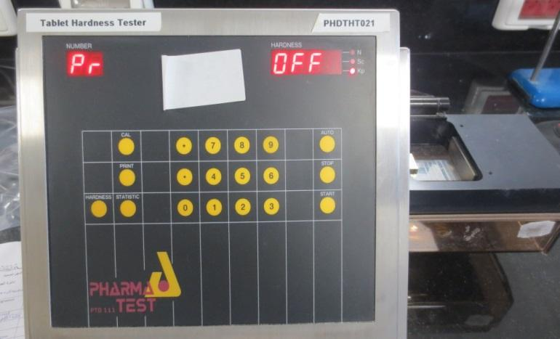

1. **Friability:-**Pharmatest PTF

Type: PT F30ERA

Serial number: 19084

Company: Pharmatest

Friability tests whether the handling of the tablets by themanufacturers and later by the consumer will affect the integrity of thetablet. This is done by elevating the tablets and then letting them fallfrom a 6 inch distance, a number of 100 times. If the 10 tablets initially inserted into the machine lose more than 1% of their weight, or if any of thembreak, then they are not durable enough.

Figure 3 : Friability Tester

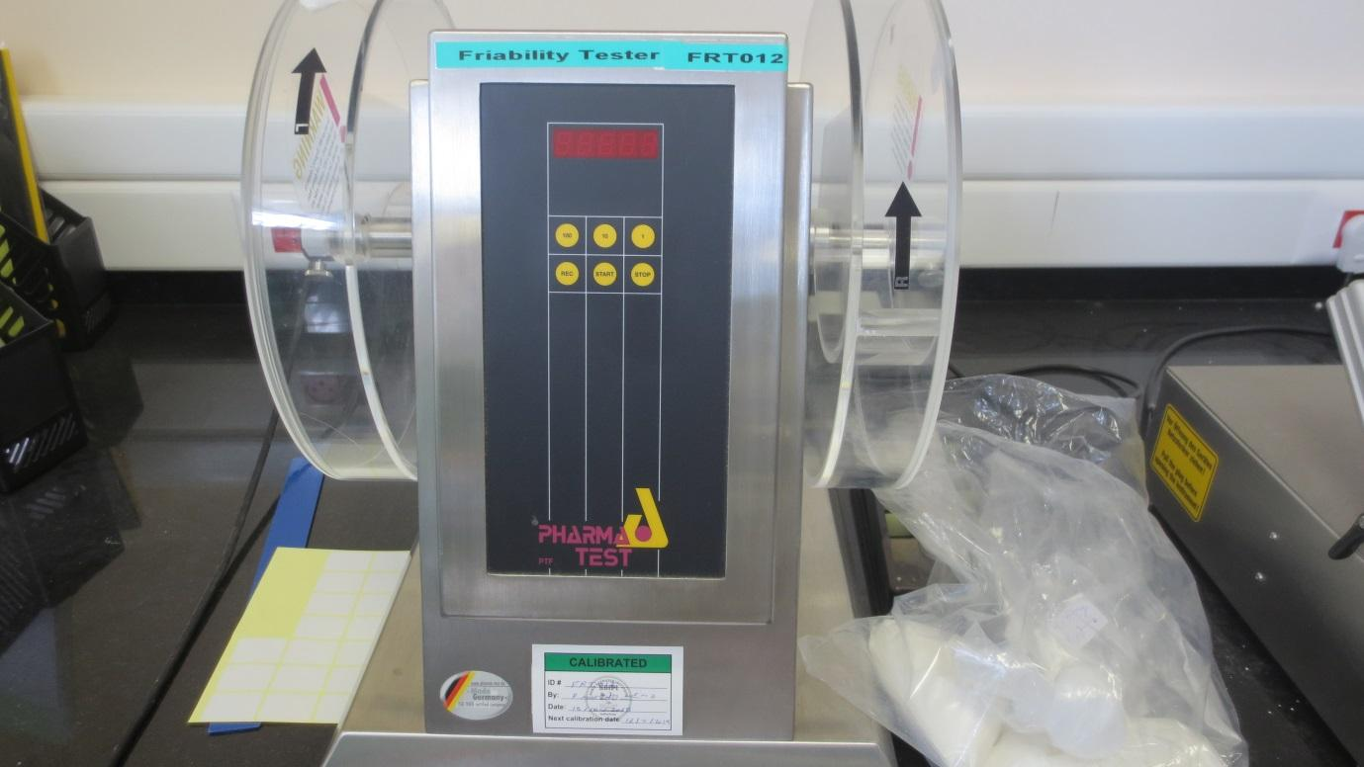

4. Digital Calliper for Thickness measurement 150 mm

A digital calliper is used to determine the thickness of a tablet by placing it in between its clamps and closing them tightly against it. This will give reading of what the thickness in millimetres the tablet is. No parameters need to be inserted.

Figure 4 : Calliper

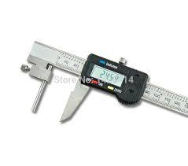

5. Analytical Balance

Model: AS 220/C/2

Company: Radwag

Min weight 10mg

Required to measure the weights of the tablets before different tests and for weight

variations tests.

Figure 5 : A.Balance

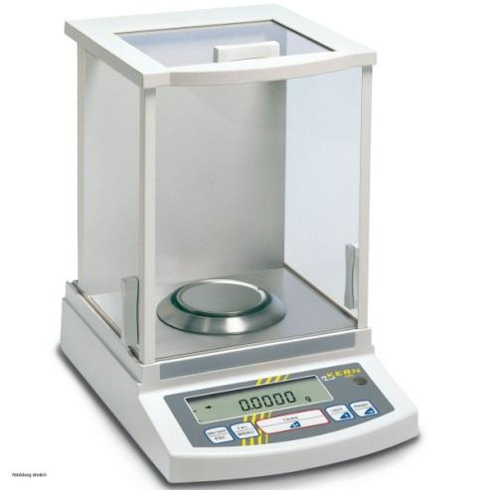

**Data and calculations :**

**For weight variation :**

| **Tablet** | **Weight of tablet** | **Accepted or not** |
| --- | --- | --- |
| **1** | 0.82 | Accepted |
| **2** | 0.81 | Accepted |
| **3** | 0.85 | Not accepted |
| **4** | 0.80 | Accepted |
| **5** | 0.80 | Accepted |
| **6** | 0.82 | Accepted |
| **7** | 0.73 | Not accepted |
| **8** | 0.82 | Accepted |
| **9** | 0.72 | Not accepted |
| **10** | 0.84 | Accepted |

Average weight = sum of weights \ 10 = 0.801 g

Upper limit = average weight + (average weight * error%) = 0.841

Lower limit = average weight - (average weight * error%) = 0.76

**For hardness test** :

| **Tablet** | **1** | **2** | **3** | **4** | **5** | **6** | **7** | **8** | **9** | **10** | **Average** |
| --- | --- | --- | --- | --- | --- | --- | --- | --- | --- | --- | --- |
| **Hardness** | 15.3 | 9.8 | 14.9 | 14.5 | 13.9 | 16.5 | 6.9 | 16.7 | 10.4 | 13.9 | 13.28 |
| **Thickness** | 0.3 | 0.3 | 0.3 | 0.3 | 0.3 | 0.3 | 0.3 | 0.3 | 0.3 | 0.3 | 0.3 |
| **Height** | 1.6 | 1.7 | 1.65 | 1.7 | 1.7 | 1.7 | 1.7 | 1.65 | 1.65 | 1.65 | 1.67 |

Average hardness = 13.28 Kp .

Average thickness = 0.3 cm.

Average height = 1.67 cm .

**For friability test :**

| **Weight of tablets before processing** | 8.0064 |
| --- | --- |
| **Weight of tablets after processing** | 7.9768 |
| **Friability (%loss)** | 0.0036% |

**%loss =** (Weight of tablets before processing - Weight of tablets after processing)\ Weight of tablets before processing * 100% **=** 0.0036%

**Discussion :-**

In weight variation test the average weight was 0.801 g with upper limit 0.841 and lower limit 0.76 , and three of the tablets were not accepted ,it is may due to changing the speed during compression and the flowability of the granules itself and the force of pressure of the machine and particle size distribution play a role on this .

In hardness and thickness test , the average of hardness was 13.28 Kp and the thickness was 0.3cm and the height 1.67 . in monograph the accepted value of the hardness is 4 Kp , so our value was very good which is due to supply sufficient amount of binder , so all the tablets were accepted .

In friability test the loss was 0.0036% which is less than 1% , and the tablets that we collect after the friability test were not crashed , so our batch is accepted .

It may affect the elegance , appearance , consumer acceptance of the tablets.

The friability test is closely related to the hardness test and is designed to evaluate the ability of the tablet to withstand abrasion in packaging , handling and shipping .

**Conclusion :-**

In this experiment , we have done many official and non-official test(weight variation ,hardness , friability) , to make sure that our tablets are in specific properties that can use in proper shape without any mistakes in process . and this lead to the desired therapeutic effect for the patient.

**References:-**

1. <http://labteknologifarmaseutikal2013.blogspot.com/2013/12/assessment-of-quality-of-tablets-and.html>