

**Faculty of Pharmacy, Nursing and Health Professions**  
  
**Program of Doctor of Pharmacy**  
  
**Industrial Pharmacy PHAR 411**  
  
**Lab Report  
  
Sieve Analysis, Bulk Density, Angle of Repose**  
**Experiment No.** :3-5  
  
**Lab Coordinator**   
Moammal Qurt  
  
  
**Student Name and I.D** Muhammad Musleh

1162595  
ـــــــــــــــــــــــــــــــــــــــــــــــــ  
 Saleh Aqel

1160596

**Experiment Date :** 2019/10/9

**Submission Date** : 2019/10/23

**Students Signature**

**Supervisor Signature**

**Objectives:-**The purpose of this lab is to determine the powder and granules properties such as densities, porosities flow and particle size distribution.

**Abstract:-**Quality control tests on the sample of 100g of acetaminophen are done ,to determine the characteristics of granules that prepared ,and to control any predicted problem. Including flowability which determined by angle of repose , and particle size distribution by sieve analysis , and bulk density to calculate carr's index . the angle of repose was 26.36.

**Introduction:-**

New drug development involves many complicated steps for incorporating an active pharmaceutical ingredient into a suitable dosage form; these processes must be optimized and tested. Among the factors that need to be tested, particle size is considered the most important physical characteristic. [1][2]

Particle size affects drugs in many ways. A mixture lacking a uniform particle size distribution segregates according to the different particle sizes. Flowability decreases with decreasing particles size since the friction and adhesion forces between particles increase. Also a uniform distribution ensures uniform dissolution when the particles dissolve. [1][2] Many methods of size analysis are used to determine size of particles and size distribution. The goal of all particle-sizing techniques is to provide a single number that is indicative of the particle size. However, particles are threedimensional objects for which at least three parameters (length, breadth and height) are required in order to provide a complete description.

Most particle sizing techniques therefore assume that the material being measured is spherical and report the particle size as the diameter of the sphere. [1][2] 1 As most particles are not actually spheres, the value obtained by different techniques will vary and therefore the result obtained must be accompanied with details of the applied technique and method.

Many methods of particle size analysis are available including laser diffraction, optical microscopy, SEM, BET, surface area measurement. [1][2]

Sieve analysis is a practice or procedure used to assess the particle size distribution of a granular material by allowing the material to pass through a series of sieves of progressively smaller mesh size and weighing the amount of material that is stopped by each sieve as a fraction of the whole mass. The process may be automated or manual. The automated process uses a device called the sieve shaker, which vibrates for a certain amount of time to allow all the particles to pass through the sieves. The method used in this experiment is dry sieving, which is suitable for non-sticky powder.

Another method called wet sieving is available for powders with higher moisture contents. Dry sieve analysis should be carried out in conditions that won’t affect the moisture content of the sample, seeing how that may affect the results by causing the particles to stick or clog the openings of the sieves’ used. [1][2]

The size distribution is often of critical importance to the way the material performs in use. A sieve analysis can be performed on any type of non-organic or organic granular materials including sands, crushed rock, clays, granite, feldspars, coal, and soil, a wide range of manufactured powders, grain and seeds, down to a minimum size depending on the exact method. Being such a simple technique of particle sizing, it is probably the most common. [1][2]

Another two important factors to be tested prior to tablet production are the flowability and compressability of a powder mixture.

Flowability is important to assure that the mixture would move freely through the tableting machine, and not stick to the different components of the machine.

Compressability is the ability of the mixture to be compressed into tablets. Two ways to estimate the flowability and compressability of the mixture are measuring the density of the mixture, and measuring the angle of repose. Three types of density (measured by g/mL) are of importance when working with powders and granules.

The first type, the bulk density, is calculated by dividing the mass of the powder by the bulk volume. The bulk volume of a powder includes the volume occupied by the particles as well as the volume 2 occupied by the intraparticular and interparticular voids. It can be determined easily using a graduated cylinder and a balance. The tapped density of a powder can be calculated by dividing the mass to the tapped volume. The tapped volume is the volume the powder occupies after being tapping the container it is in as to reduce the interparticular spaces as much as possible by arranging the particles so. This tapping is done using a device called a tapped density tester, which taps a graduated cylinder a number of times, until the volume of the powder decreases no longer, meaning the spaces between particles were reduced as much as possible. Using the bulk density and tapped density of a powder, one can determine the compressability index, or Carr’s index, which gives an idea about the flowability and compressability of the powder or granules. Carr’s index can be calculated using the equation ((tapped density-bulk density)/tapped density)*100%. A large decrease in volume after tapping, which is a large increase in density, indicates high interparticulate forces between particles which prevents them from compacting well.

This is what Carr’s index indicates, the interparticulate forces between particles, and thus their compressability and flowability. The third type of density is the true density, which only takes into account the true volume, which the volume occupied by the powder without any spaces between particles. True density can either be determined experimentally by placing the powder in a fluid (gas or liquid) which doesn’t interact with any of its components, and noting the change in the volume of the fluid. This change is the true volume of the powder. Using the true density, along with the bulk and tapped density, the bulk and tapped porosity, which is the volume occupied by the particles’ voids, can be determined by the equation:- Porosity = (true density - bulk or tapped density) / true density The angle of repose is used to indicate the flow properties of powders. It’s the descent angle formed by a pile of the powder formed by pouring it on a flat surface through a conical funnel. It’s affected by the friction between particles, and their resistance to movement. Despite many problems with the techniques of its measurement, the angle of repose is still widely used to indicate flowability. Difficulties in measuring it may arise due to segregation or consolidation of particles, as well as dusting of the powder material during 3 the operation. By measuring the height of the heap formed, and its diameter, the angle of repose can be calculated by (tan (angle) = height / 0.5diameter) The angle falls in the range 0-90 degrees, and through known ranges and their flowability, one can estimate how well is the powder at hand flowable.

**Experimental:-  
  
1- Procedure:-**

For sieve analysis : first we have recorded the weight of each empty sieve ,and we have arranged as the smallest mesh number at the top and the largest mesh at the bottom , and then we have weighted 100 g of the powder and added to the top of the sieve and covered with the rubber cap , and then the nest of the sieve is agitated ,and the sieves are reweighed and the weight of the material are determined .

For bulk and tab density : the quantity of the powder is weighed , then we have determined the weight of a 100ml graduated cylinder . without tapping , use a powder funnel to fill the cylinder to 100ml of powder , then using an automated tap density apparatus , we have tapped 100 tap , and then we have recorded the volume occupied by the sample .

For angle of repose : a piece of paper is put under the funnel , and then we have positioned the bottom of a funnel about 5 cm above the center of the piece of paper , and then slowly we have poured the granules sample into the funnel , and then we have marked the base of the formed circle , the height of the pile using a ruler is determined , and the powder is removed , and the diameter of the circle is measured .

**2- Machine/ Instrument**

**1.Precision Balance KERN kb2000-2N**

Serial number W1206981

A precision balance is needed to obtain an accurate mass of each ingredient being used. The balance had a minimum increment weight of 1 mg, and a maximum weight of 2010 grams. This was suitable for our measurements as the weight of the mixture as a whole was well under this amount and we had no ingredients weighing under 10 mgs. No parameters have to be inserted.

Figure 1 : Balance

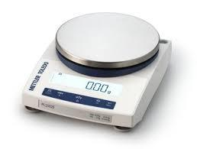

**2. Cubic Mixer**

Serial number 10.00499

Company: Pharma test

This machine was used to mix the superdisintegrant and direct compression binder at a slow and controlled rate to ensure uniform distribution between the granules. In addition to the slow and short mixing of the lubricant. Parameters added were the RPM and time of mixing.

Figure 2 : Wet Granulator  
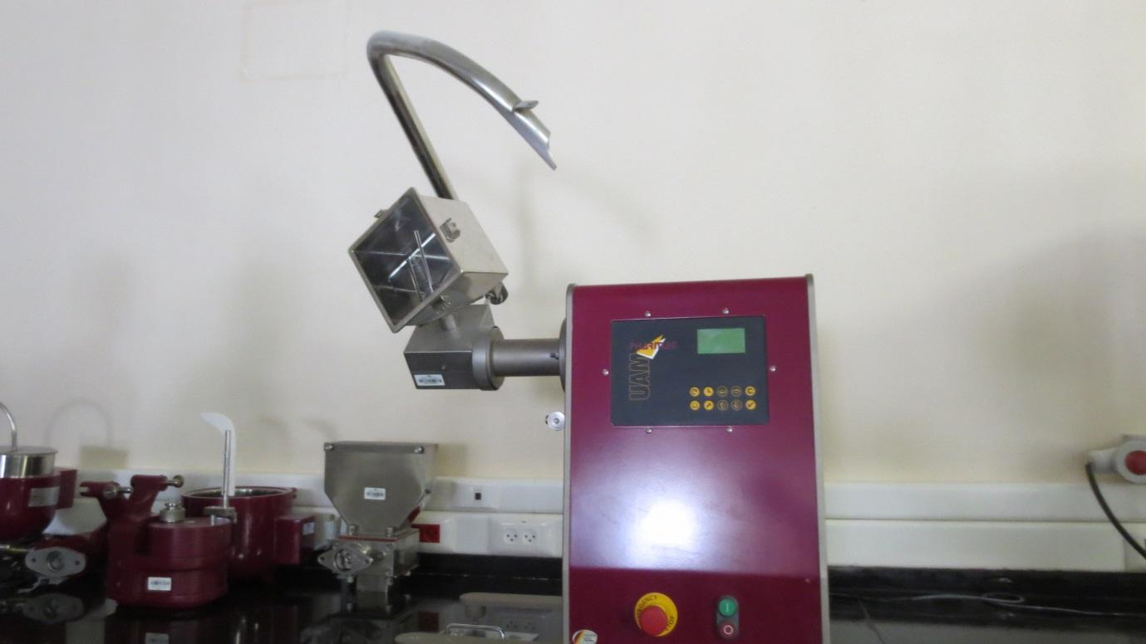

**3. Sieve Shaker**

Company: Retsch

The shaker used for determine of particle size and separation, divide it to eight sieves from 1.7 mile meter to 25 micro meter, and turn on for 10 minutes, weight the eight sieves before and after shaker.

Figure 3 : Shaker

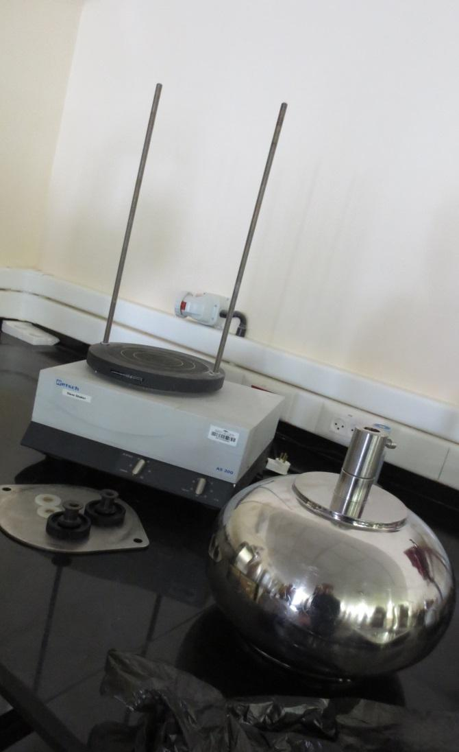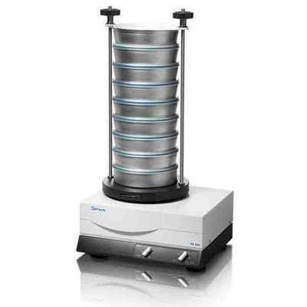

**4. Tab Density Tester**

Company: Atlas

Model: AT2000

Used to determine tap density of bulk powder, parameters are time, trials, number of shake.  
Figure 4 : Tab Density Tester

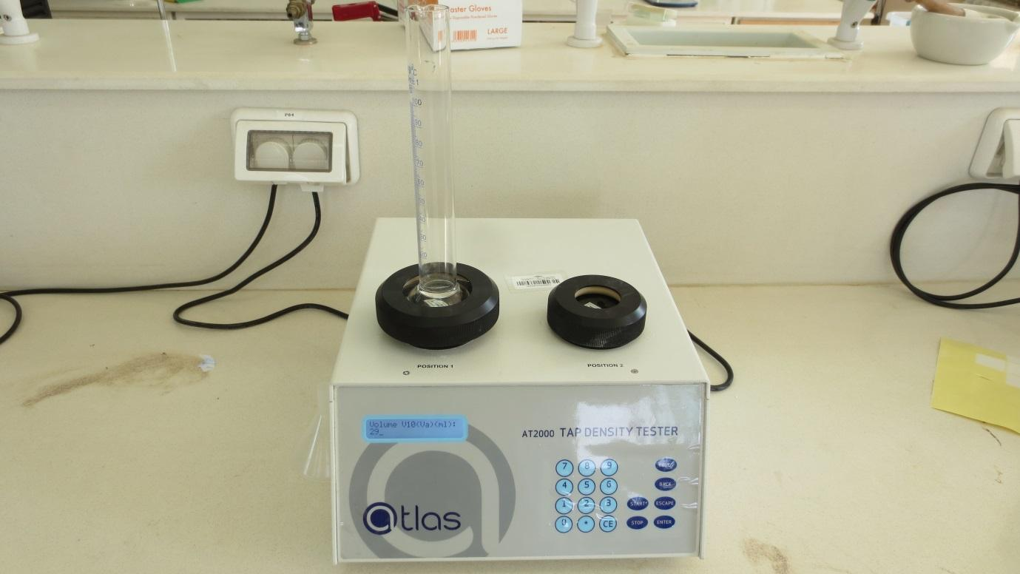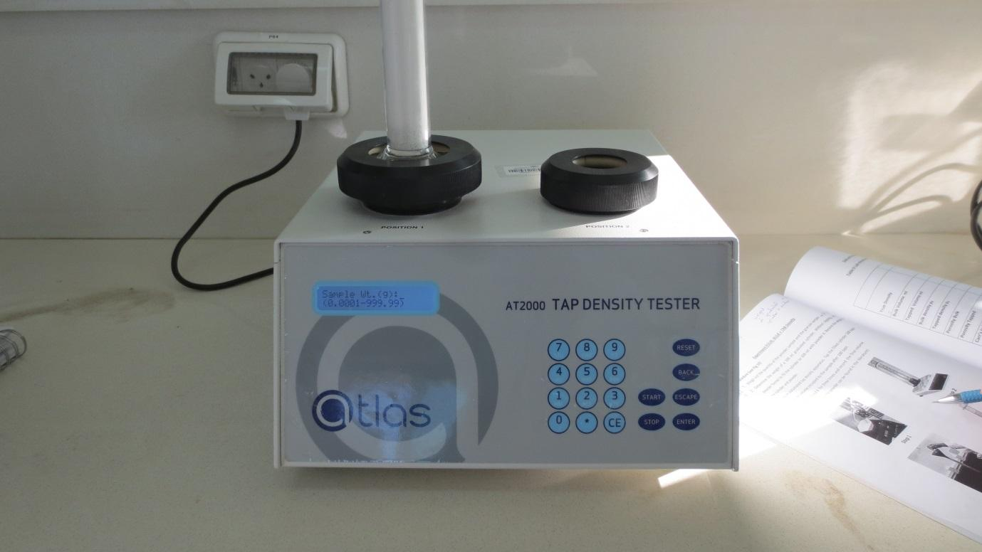

**Results and discussion :-**

**Sieve Results:-**

**Table 1: Sieve results.**

| **Opening Size (μm)** | **Sieve Weight(g) –Empty-** | **Material + Sieve Weight (g)** | **Weight Retained on each Sieve Wn (g)** | **% Weight of Sample Retained on each Sieve** | **Cumulative % of Sample Retained on each Sieve** |
| --- | --- | --- | --- | --- | --- |
| **1.7 mm** | **379.38 g** | **380.4 g** | **1.02 g** | **1.02 %** | **31.92 %** |
| **850 μm** | **340.2 g** | **371.1 g** | **30.9 g** | **30.9 %** | **46.8 %** |
| **600 μm** | **290.0 g** | **305.9 g** | **15.9 g** | **15.9 %** | **37 %** |
| **300 μm** | **269.1 g** | **290.2 g** | **21.1 g** | **21.1 %** | **24.6 %** |
| **250 μm** | **249.8 g** | **253.3 g** | **3.5 g** | **3.5 %** | **7.9 %** |
| **150 μm** | **244.9 g** | **249.3 g** | **4.4 g** | **4.4 %** | **8.1 %** |
| **90 μm** | **238.8 g** | **242.5 g** | **3.7 g** | **3.7 %** | **21.6 %** |
| **25 μm** | **277.8 g** | **295.7 g** | **17.9 g** | **17.9 %** | **20.6 %** |
| **Pan** | **348.8 g** | **351.5 g** | **2.7 g** | **2.7 %** | **2.7 %** |
| **Total** |  |  | **101.12 g** | **101.12 %** |  |

**Figure 5 : Weight Vs. Opening Size.**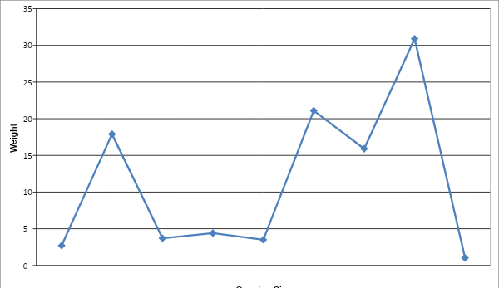

**Figure 6 : Cumulative Vs. Opening Size.**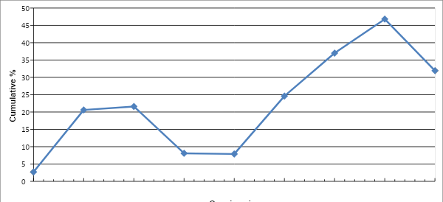

Sieving used to distinguish between particle size, to separate granules, and to see the size distribution. I used eight sieves in the experiment the largest one is 1.7 mm and the smallest one is 25 micro meter. (Top biggest mesh –smallest holes-). According to Figure 5 and 6 I can conclude that my granules have variation in granules.

**Bulk and Tab density:-**

Bulk density measured by tab density tester, it depends on size and shape of particles. Voids get filled with particles and thus the density increases, coarse aggregate increase bulk density a lot, because have few voids which fill by fine aggregate. I can define bulk density by mass of bulk solid that occupies volume, three types of bulk density: Aerated, Poured, Tap.

The measurement of my paracetamol sample equal 1.35 g/ml, the weight equal 85.27 and the volume equal 63 ml, voids is the spaces between granules. The true density equal 1.4, so as I observed the difference between true and bulk density is 0.05 g/ml. True Density, in this procedure we used a solvent doesn’t dissolve of interact with API.

**Table2 : Measurements for Bulk Density**

| **Trails** | **Weight** | **Volume** | **Density** |
| --- | --- | --- | --- |
| **1** | **145 g** | **79 ml** | **1.35 g/ml** |
| **2** | **59.73 g** | **63 ml** |
| **Difference** | **85.27 g** | **63 ml (Only the last reading)** |

**True Density:-**

Weight = 49.44 g

Volume of oil = 55 ml

Volume of oil + granules = 90 ml

Displaced volume = 35 ml

True Density = 1.4 g/ml

**Angle of Repose:-**

**Table3 : Measurements for Angle of Repose**

| **Trials** | **Height (H)** | **Diameter (D) -2R-** | $θ$ |
| --- | --- | --- | --- |
| **1** | **2.5 cm** | **10 cm** | 26.36 |
| **2** | **2.4 cm** | **9.8 cm** |
| **3** | **2.5 cm** | **10 cm** |
| **Mean** | **2.46 cm** | **9.93 cm** |

$θ= H/0.5D$

The $θ$ equal 26.36, this measurement classified as Excellent flow. Angle of Repose used to measure the flow ability of granules, it’s important for know if I need to add more lubricant or not before compression.

**Conclusion :-**

In the last lab we apply Sieving Analysis, Bulk Density, Angle of Repose, for Sieving we use it to determine the uniformity of granules and particle size, if the distribution of granules were wide this would cause segregation and cause differences in tablets. Bulk density affecting flow ability, if the density increase the hardness would increase because volume would be decreased from the shaker. Angle of repose determines the flow ability, better flow ability prevent failed in machine and sticking at it.

**Questions :-**

1. **Describe as many limitations as you can think of for particle size determination by sieving. What types of particles could not be sized by sieving.**

Sieve analysis is a method best used for powders or granules with a size above 75μm. Smaller sizes may not be separated accurately. Sticky or oily particles will stick to the sieves and will clog the openings, so any moist powders can not be used. Sieving may also lead to the destruction and breaking of granules if high amplitude and test times are used.

1. **If a large percentage of powder were deposited on the top sieve or the bottom pan, is the particle size you determined representative of the powder sample ? Justify your answer**

No, normal distribution includes a peak in the middle, with distribution of particles to the left and right of it. This would mean that most the particles are uniform with a slight deviation. However, if they all piled up at the top of the bottom, then no actual separation occurred. To represent the sample, different sieve sizes must be chosen to allow better distribution of the powder among them.

1. **Would you expect to get the same mean sieved diameter if you performed the experiment described above, but made the following changes ? Justify your answer.**
2. **Increased the sieving time to 10 minutes.**

Increasing the sieving time may break up granules or cause particles that were stuck in larger mesh size sieves to end up in different sieves. However, for the test to be correct and the results collected, the test must be reproducible with less than 5% difference in weight of mass weight between consecutive sievings of the sample. So increasing the time should not affect of the results unless in other cases.

1. **Increased the sample quantity.**

Increasing the sample quantity will slow the sieving process and cause more large particles to close the openings and allow less particles to pass.

1. **What are the other methods that can be used to identify the size of particle rather than sieving process ?**

1. Microscopy

2. Sedimentation Technique

3. Electrical Sensing Zone Method

4. Laser Diffraction Method

5. Surface Area Measurement Technique

1. **What are the importance of size particles analysis in formulation ?**

Particle size analysis helps determine the degree and range of particle size distribution. The less variation in particle size, the less segregation will occur during tableting and uniformly dosed tablets will be formed.

1. **A granulation has been prepared with a bulk density of 0.73 g /ml. If the granulation**

**is tableted with 10 mm diameter, flat faced tooling (circular), and the lower punch**

**drops to a depth of 8 mm in the die cavity, what will be the theoretical weight of**

**the resulting tablet?**

Diameter = 10 mm = 1 cm

Height = 8 mm = 0.8 cm

Volume of the tablet = πr2 h = 0.7854 cm3 = 0.7854 ml

Theoretical weight = Volume of the Tablet * Density = 0.7854 * 0.73 = 0.5733 g

1. **Give reasons why the actual tablets weight might deviate from the theoretical weight.**

Due to different particle sizes of the granules in the mixture, bad flowability of the powders or sticking to the punches, and tableting defects.

1. **What factors will influence angle of repose for the materials?**

Factors which affect the angle of repose include

1. The friction between the particles or the particles and the device used for measurement 2. Particle size, as finer granules have smaller angles of repose.

3. Moisture. Because the higher the moisture content of the powder, the larger the angle of repose.

1. **What other method can be used to calculate the angle of repose for the materials?**

Tilting box method and the revolving cylinder method. The tilting box method is mostly used for fine, non-cohesive materials, whose size is less than 10 mm. The powder material is put in a box and the box is then slowly tilted until the powder begins to slide in bulk and then the angle is measured. The revolving cylinder method is similar except the powder is inserted into a cylinder which slowly tumbles.

**References:-**

1. Etzler, F. M., and Nasir Uddin, M. (2013). Powder Technology and Pharmaceutical Development: Particle Size and Particle Adhesion. KONA Powder and Particle Journal, 30. Retrieved October 17, 2018, from https://www.jstage.jst.go.jp/article/kona/30/0/30 2013014/ pdf/-char/en.

2. Particle Size Determination. (n.d.). Retrieved October 17, 2018, from <http://particle.dk/our-services-analytical-laboratory/particle-size-determination2/>

3. Fassihi, A. R., & Kanfer, I. (1986). Effect of Compressibility and Powder Flow Properties on Tablet Weight Variation. Drug Development and Industrial Pharmacy,12(11-13), 1947-1966. doi:10.3109/03639048609042619

4. Arambulo, A., Fu, H. and Deardorff, D. (2017). Compressed Tablets—Weight Variation. Journal of Pharmaceutical Sciences.

5. Breslin, A. (2017, April 24). Methods of Determining the Angle of Repose. Retrieved October 9, 2018, from https://sciencing.com/methods-determining-angle-repose8380160.html

6.<https://apps.itd.idaho.gov/apps/manuals/QA/Archive/files/2013Jan/2013FILES/files/2013Jan/FOP/t30-short-wpr.pdf>

7. <http://www.virginiadot.org/VDOT/Business/asset_upload_file678_3529.pdf>

8. <http://www.d.umn.edu/~pfarrell/Soils/Soil%20Lab%20Files/BULK%20DENSITY%20LAB.htm>