**Objectives :**

To coat the tablets made in previous experiments and perform quality control tests on them, as well as test the tablets’ dissolution. This all ensures that the tablets are functional, safe, and follow the USP regulations.

**Abstract :**

After forming tablets in the previous labs, a coating material needed to be placed on them to protect the tablet’s integrity and enhance its features. Therefore a coating solution was prepared, the coat was applied, and then the tablets were tested for a number of quality control tests and their dissolution profile was determined. The average weight of the tablets was found to be mg, their average thickness was 6.187 mm, and their average hardness was Kp. Disintegration was successful with a time of . The dissolution however, resulted in an average dissolution percentage of .

**Introduction:**

Coating is a process in which the tablet or pharmaceutical dosage form is covered by an edible paint that carries out a couple of functions like: masking a disagreeable odor, color or taste, offers a physical or chemical protection of the drug, to control or sustain the release of the drug or to protect the drug form the gastric acid or increasing the mechanical strength of the drug. [1]

It is best to have the coat be uniform and not crack under stress. Usually the coating solution is sprayed on the uncoated tablets as they are flipped in a pan, and as the coat is being applied a film coat forms on the surface of the tablet, and the liquid part of the coat is then evaporated by the applied hot air inside the pan. The coat may applied be by single application of the coating solution or by multiple applications throughout the rotation of the pan.

Film coating is used in this experiment:

There are two types of film coats: functional and non functional. Non functional films do not play a role in the release of the drug, while functional films were designed to control the drug’s release. Non functional films contain a number of materials in them and in our experiment we used Opadry®, which is according to the manufacturing company “a high productivity, water soluble, pH independent complete dry powder film coating system containing polymer, plasticizer and pigment which allows for immediate disintegration for fast, active release” [3]

Multiple factors play a role in the coating process:

1. Solid content in the coating solution(roughness of the tablets ).

2. Viscosity of the coating solution(spreading of the coat liquid on the surface of the tablet). 3. Surface tension(wetting and spreading of the liquid and the merging of droplets into single drops).

4. Drying rate(structure of dried coat).

5. Heat(adhesion and cohesion) [2]

The coated tablets are tested for the same QC tests that were used for the uncoated tablets, including tablet thickness, hardness, friability, disintegration and weight variation, and they are also tested for dissolution. Dissolution is a test designed to check the final product for the concentration of active ingredient. Basicly the test is done by dissolving the drug in a beaker specially designed for that purpose by the pharmacopoeia laws for 30 mins, and then comparing a diluted volume of the dissolved drug with a standard solution. The absorbance of light of both is tested to see the percentage of the drug in it, the test is passed if the drug is (75-125%) of the standard concentration.

**Experimental:**

Procedure :

The procedure was taken from the (Shtaya, H., & Samaro, A. Industrial Pharmacy Lab. Manual. Birzeit: Faculty of Pharmacy, Nursing and Health Professions .)

lab manual, pages 54-65

**Machine / Instruments:**

1. Digital Caliper for Thickness measurement 150 mm A digital caliper is used to determine the thickness of a tablet by placing it in between its clamps and closing them tightly against it. This will give a reading of what the thickness in millimeters the tablet is. No parameters need to be inserted.

2. Hardness Tester - Pharmatest PTB111 Type: PTB111E500 Serial number: 20329 Company: Pharmatest It is used to determine how much force it takes to break a tablet (measured in kPa). This is important in determining how much mechanical pressure it can withstand and if it will break during future processes and handling.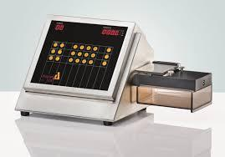

3. Friability tester -Pharmatest PTF Type: PT F30ERA Serial number: 19084 Company: Pharmatest Friability tests whether the handling of the tablets by the manufacturers and later by the consumer will affect the integrity of the tablet. This is done by elevating the tablets and then letting them fall from a 6 inch distance, a number of 100 times. If the 10 tablets initially inserted into the machine lose more than 1% of their weight, or if any of them break, then they are not durable enough.

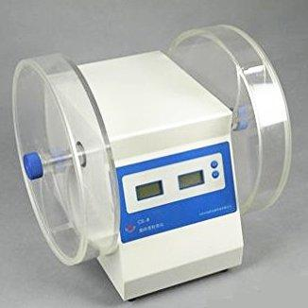

4. Analytical Balance Model: AS 220/C/2 Company: Radwag Min weight 10mg Required to measure the weights of the tablets before different tests and for weight variations tests.

5. Disintegration Tester - Pharmatest DIST 3 Type: DIST-3 Serial number: 20459 This machine includes six tubes to insert the tablets in with mesh wire beneath them so as the water from the bath beneath them can enter. The water bath should be at a temperature of 37° and the tablets should be inserted at a rate of 30 times per minute. The time it takes for all 6 tablets to disappear completely must be under 15 minutes to ensure that the drug is therapeutically effective in a normal time frame.

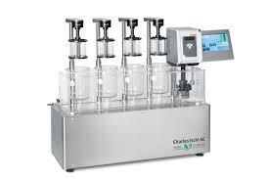

6. Pharmatest coating pan Model: CP 9 Serial number: 10-00499 Company: Pharma test A coating pan is a rotating pan which is heated and where tablets are inserted to start the coating process. A nozzle connected to the coating solution is used to target the tablets inside the pan and slowly form a layer of coating around them. Parameters inserted are simply the rotations per minute of the coat, while the pressure used when squeezing the nozzle determines the range of the spray and the speed of applying the coat are left to the operator.

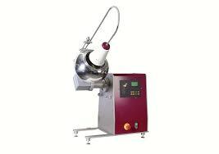

7. Low-Head Tablet Dissolution Test Apparatus Model: PT-DT70 Serial Number: 20391 Company: Pharma test Dissolution testing is an essential step of tablet quality control testing. Six tablets are inserted into the apparatus and a paddle rotates inside the medium with the tablet for an amount of time (according to the type of tablets) and sample of the medium are taken at intervals to determine the percentage of active ingredient that has dissolved.

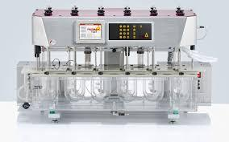

8. UV absorption spectrometer Model: Lambda 25 Serial number: 501S15071203 Company: PerkinElmer A spectrophotometer works by releasing a beam of light at different wavelengths and then reading the radiation intensity that reaches a detector on the other side of the sample. The intensity of the radiation is proportional to the concentration of the sample solution. In our experiment it was used to determine the wavelength of the maximum absorbance of paracetamol, and then compare the samples’ absorbance with the standard paracetamol absorbance.

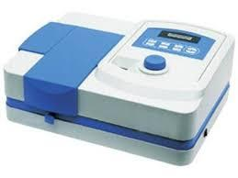

**References :**

1. Basu, A., De, A., & Dey, S. (n.d.). Techniques of Tablet Coating: Concepts and Advancements: A Comprehensive Review. Retrieved December 5, 2018, from <http://www.rroij.com/open-access/techniques-of-tablet-coating-concepts-andadvancements-a-comprehensive-review.php?aid=34923>

2. Gazzaniga, A. (n.d.). [Http://users.unimi.it/gazzalab/wordpress/wpcontent/uploads/2011/12/14-Forme-Farmaceutiche-Solide-Orali-Filmatura.pdf[Pdf](http://users.unimi.it/gazzalab/wordpress/wpcontent/uploads/2011/12/14-Forme-Farmaceutiche-Solide-Orali-Filmatura.pdf%5bPdf)].

3. Colorcon. (n.d.). Colorcon Inc. Retrieved from Colorcon.com:

https://www.colorcon.com/products-formulation/all-products/film-coatings/immediaterelease/opadry