**Biology and Biochemistry Department**

**BIOC 312**

**Biochemistry II lab**

**Experiment #7**

**Sec 1**

**Student Name: Meran Nasser**

**Student ID: 1190803**

**Instructor: Dr. Johnny Stiban**

**Teacher Assistance: Mr. Yousef Nammari**

**Partners:**

**Ali Milhem**

**Abdalrahman**

**AbdelFattah**

**Melak Ottallah**

**Date of Experiment: 21/04/2022**

**The submission: 12/05/2022**

**Title  
Metabolic Regulation II – The effects of fasting on tissue protein content**

* **Objective:**

The main objective is to use the Folin-Lowry method in this experiment, by which the protein was determined and extracted from starving rats at different hours, and the effects of starving rat on liver, heart and muscle tissues were verified.

* **Introduction**:

Proteins are large, complex molecules that serve a number of important tasks in the human body. They are essential for the structure and formation, function, and control of the body's tissues and organs, and they accomplish most of their work in cells.1

Proteins are made up of hundreds or thousands of smaller components or units known as amino acids that are linked in lengthy chains. A protein is made up of 20 distinct types of amino acids that can be mixed with each other. The amino acid sequence dictates the three-dimensional structure and function of each protein.1

Starvation allows mammals to live by activating proteolysis and lipolysis in a variety of tissues. Changes in hormonal and neuronal states during fasting induce these reactions, at least in part. Proteolysis pathways that are triggered during hunger vary dramatically depending on tissue type and starvation duration. Then, if the decrease in blood glucose is not treated and compensated for immediately, neurological disorders can occur, which can lead to death, because glucose oxidation is one of the main sources of energy in animal tissues, and the only source of energy in the brain, so glucose levels must be taken into account. The body requires appropriate glucose levels in the blood, but when blood glucose levels are low, the initial compensation comes from the breakdown of glycogen in the liver. The oxidation of fatty acids in adipose and other tissues represents a second compensatory process. Thirdly, proteins are broken down to provide energy and to manufacture glucose 6-phosphate from non-carbohydrate sources through gluconeogenesis once all other sources have been exhausted.2 3 4

* **Materials:**

1. 4 Rats of the same age, sex and weight
2. 200 ml of 100 % trichloroacetic acid
3. Water bath (45°C)
4. Homogenization buffer: 280 mM sucrose, 10 mM Tris-HCI pH 7.2
5. 100 ml methanol
6. 100 ml diethyl ether
7. 4.5 M NaOH
8. Heparinized tubes
9. 10 ml of 1 mg/ml BSA standard
10. *Alkaline solution:* Mix 250 ml of (20 g/l Na₂CO3 in 0.1 M NaOH) and 5 ml of (5 g/1 CuSO4 in 10 g/l Na, K tartrate).
11. Folin-Ciocalteu reagent

* **Methods:**

There were 4 experimental animal groups: (1) 1 rat supplied with normal diets (2) 1 rat fasted for 24 hours (3) 1 rat fasted for 48 hours (4) 1 rat fasted for 96 hours for the starved rats, water must be provided at all times.

**I-Extraction of proteins from tissues:**

1. Rats were sacrificed and approximately 5-10 ml of blood was collected in heparinized tubes.

2. About 0.5 g of the following tissue was removed: (a) liver, (b) skeletal muscle, (c) heart.

3. Tissue was homogenized in 10 ml of homogenization buffer

4. 2.5 ml of TCA was added to the homogenate.

5. Homogenized samples were left on ice for 10 minutes.

6. Centrifuge at 4 °C for 10 minutes at 13,000 g. The supernatant (amino acids and carbohydrates) was discarded and the pellet was resuspended in 2 mL TCA and spin again as before.

7. The supernatant was discarded again and the pellet was resuspended in 1 ml methanol and 1 M diethyl ether and left in a water bath at 45 °C for 15 min.

8. Centrifuge as before and discard the supernatant (methanol soluble fraction, including lipids).

9. The pellet were resuspended in 2 mL diethyl ether and swirled as before. The supernatant was discarded and the pellets were allowed to dry in a water bath for 5 minutes (these pellet are the insoluble TCA and methanol fraction, which consists mainly of proteins).

**II-Protein estimation:**

10. The protein pellet were dissolved in 1 ml 4.5 M NaOH + 0.5 ml water. vortex well until pellet dissolve.

11. Different solutions of BSA standards for standard solution were prepared (serial dilutions of 1 mg/mL BSA solution to a solution containing 1 part 4.5 M NaOH and 0.5 parts water). 1 ml of each standard is made. One tube without BSA (1 mL NaOH + 0.5 mL water) as a blank.

12. For each protein standard (and proteins extracted) 5 ml of alkaline solution was added. Vortex well and leave it for 5 min at room temperature.

13. 0.3 ml of Folin reagent was added to each tube and vortex well. Incubate at 37 °C for 10 min. The absorbance was read against the blank at 700 nm.

* **Result**:

Table_1: Protein content and absorption at 700 nm in the liver and muscle.

|  |  |  |  |  |
| --- | --- | --- | --- | --- |
|  | **Abs at 700 nm Liver** | **Protein concentration mg/ml of liver** | **Abs at 700 nm**  **Muscles** | **Protein concentration mg/ml of Muscles** |
| **96 h** | 2.325 | 1.950 | 3.008 | 2.533 |
| **48 h** | 1.363 | 1.126 | 1.278 | 1.054 |
| **Normal** | 2.543 | 2.135 | 3.500 | 2.954 |
| **24 h** | 2.716 | 2.283 | 3.444 | 2.906 |

Table_2: The data of standard curve.

|  |  |
| --- | --- |
| Absorbance (700nm) | Concentration |
| 0 | Blank |
| 0.841 | 1 |
| 0.335 | 0.5 |
| 0.123 | 0.25 |
| 0.063 | 0.125 |
| 0.057 | 0.0625 |
| 0.031 | 0.03125 |

Figure_1: The curve between concentration of BSA Vs. absorbance at 700 nm.

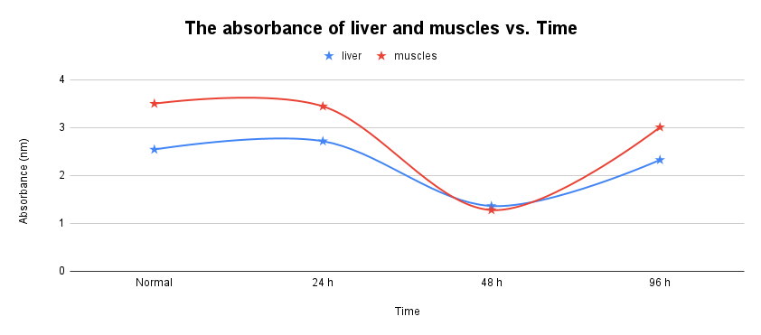

Figure_2: The absorbance (700 nm) of liver and muscles Vs. time

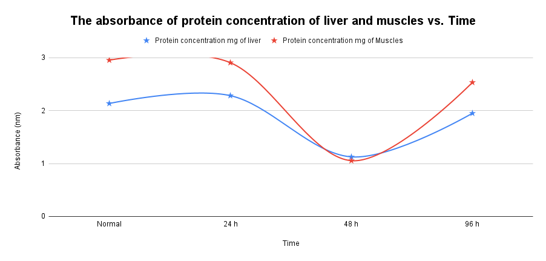

Figure_3: The absorbance 700 nm of concentration of protein (liver and muscles) Vs. time.

Table_3: The data of protein content (mg protein/ g tissue) * the calculated in appendix

|  |  |  |
| --- | --- | --- |
| Time/Tissue | Liver | Muscles |
| Normal | 4.270 mg/g tissue | 5.908 mg/g tissue |
| 24 h | 4.566 mg/g tissue | 5.812 mg/g tissue |
| 48 h | 2.252 mg/g tissue | 2.108 mg/g tissue |
| 96h | 3.9 mg/g tissue | 5.066 mg/g tissue |

* **Discussion:**

First, we dissected 4 rat so that each group got one of the rat that had been fasting for specific hours.

Then there came Figure_1, which showed BSA concentration vs. absorbance at 700 nm. The figures were reasonable, and the points were not far off from what was predicted. As a result, the straight line equation was: Y= 1.1695x+0.0455, which is the equation that allows us to compute protein concentration.

As we see the results in Figure_3 and Table_1, we had many clear errors on Figure_3 due to the correct is that the more hours of fasting, the less the absorption and protein in the liver and muscles, but the following happened:

The percentages were high in the liver and muscles at first because the rat was normal and not starved, so this ratio is expected; however, the value increased after 24 hours, which is incorrect because protein concentration should decrease over time; then it decreased after 48 hours, which is good; however, it increased again, confirming that there is a mistake in the results.

So as in Table_1, the 24 hr. of rat starved value was in liver equal to 2.716 mg/ml while in muscle it was equal to 3.444 mg/ml. The error can be interpreted that the micropipette was not good, or there was little supernatant left, which may cause an error rate.

After the rat starved for 96 hr., it is clear that there is also an error, because the value of the protein concentration of the liver is 1.950 mg/ml, which is less than the normal rat, but not less than 48 h. As a result, there is an inaccuracy since the longer we fast, the less protein we have accessible to us, and vice versa.

The ratio of protein concentration was 2.533 mg/ml in muscles, which is a significant proportion. The issue is expected to be that the supernatant was removed before the centrifuge, and this is the cause of our error. We also have a random error, which includes the spectrophotometer, which has an error rate that is constantly there. and the predicted additional faults were that the rats were not of the same sex, age, or weight, so these factors play a significant influence because hid not the same, the protein use and consumption varies from weight to weight. It is also possible not to put the tube in the water bath before centrifuging in many steps such as step 7 for example. And one of the errors expected in the experiment is that the tube of homogenize was not 100% clean, also which caused a percentage of the error. Finally, one of the possible errors is that the micropipette was not accurate or had a specific malfunction.

* **Conclusion:**

In conclusion, the concentrations of protein were extracted from the liver and muscles, and the effect of fasting the mice for various hours was observed using the Folin-lowry method, and it was discovered how critical the presence of sugar is for the vital processes that occur in the body, and that if it decreased or increased, it would result in a variety of diseases, including death.

* **Appendix:**
* In Table_1 and from standard curve the equation is:

Y = 1.1695x + 0.0455

Y = the absorbance of liver and muscles

X= concentration of protein

For example, the abs. of liver when he starved 24 h = 2.716

So: 2.716 – 0.0455 = 1.1695x

X = 2.283 mg

* In Table_3 the protein content (mg protein/ g tissue)

*For example in liver the concentration of protein (96h) = 1.950 mg/ml

And we used 1 ml in part protein estimation so:

1.950 mg/ml * 1 ml = 1.950 mg

Then the tissue = 0.5 g, so 1.950 mg/0.5 g = 3.90 mg protein/g tissue.

* **References**:

1 Genetics, H., & Work, H. (2022). What are proteins and what do they do?: MedlinePlus Genetics. Retrieved 8 May 2022, from [https://medlineplus.gov/genetics/understanding/howgeneswork/protein/](https://medlineplus.gov/genetics/understanding/howgeneswork/protein/?fbclid=IwAR3LIaaYx1Qmuyeip6m1yqWhLSxWJv6TEk39HTth5dK2kvsk3fHuVBny6VY)

2 Finn, P. F., & Dice, J. F. (2006). Proteolytic and lipolytic responses to starvation. *Nutrition*, *22*(7-8), 830-844.‏

3 Abasolo, C., Abasolo, C., & oils, T. (2022). The oxidation process in fats and oils - BTSA. Retrieved 8 May 2022, from [https://www.btsa.com/en/process-oxidation-fats/](https://www.btsa.com/en/process-oxidation-fats/?fbclid=IwAR2vD0BButkB1TTQniFqphfno7w84npJw01wwWJkXAKoZZgjwbpnez8BjLw)

4 How the Blood Sugar of Diabetes Affects the Body. (2022). Retrieved 8 May 2022, from [https://www.webmd.com/diabetes/how-sugar-affects-diabetes](https://l.facebook.com/l.php?u=https%3A%2F%2Fwww.webmd.com%2Fdiabetes%2Fhow-sugar-affects-diabetes%3Ffbclid%3DIwAR0__7UjEeNke33XrLuTMEP4ak4GbqJ0lVqB2lYhQ1qlYF50rt003ryhkeI&h=AT2tFSAqccmiC2RapUbSMNnDTU4UbO-JZOKmw2YubKdEaKwpQDTBS-YzJ3mHDNmqrUAe_bSPiLTPt6v_8yD97c9u6IE2kb8DtqYNBlPpagWRRiX4XJ2tcG61c8XRQxYWdMdizg)