**Biology and Biochemistry Department**

**BIOC 312**

**Biochemistry II lab**

**Experiment #2**

**Sec 1**

**Student Name: Meran Nasser**

**Student ID: 1190803**

**Instructor: Dr. Johnny Stiban**

**Teacher Assistance: Mr. Yousef Nammari**

**Partners:**

**Ali Milhem**

**Abdalrahman**

**AbdelFattah**

**Melak Ottallah**

**Date of Experiment: 28/3/2022**

**The submission: 04/04/2022**

**Title**

**Glycolysis – product inhibition of Hexokinase**

**Objective:**

The objectives of this experiment is to compare two types of enzymes, which are fructose and glucose, which are hexagonal compounds. One of the objectives is also to use Hexokinase to catalyze the first reaction of glucose decomposition to eventually produce glucose-6-phosphate.

**Introduction:**

Glycolysis is the first metabolic pathway demonstrated and is also called an Embden-Meyerhof-parnas pathway. This pathway refers to the splitting of one glucose molecule into two pyruvate molecules, with pyruvate being the end product of glycolysis. The bulk of the enzymes in this pathway are found in all living organisms. Glycolysis involves 10 reactions(steps) and these reactions occur in the cytosol due to which it produces without the use of molecular oxygen, produces two ATP molecules.1 2

This phosphoryl-group transfer is catalyzed by the enzyme hexokinase. When hexokinase binds to glucose, it experiences an induced-fit conformational change, which inhibits ATP hydrolysis. Physiological concentrations of its immediate product, glucose-6-phosphate, also inhibit it allosterically. This is a mechanism by which the influx of substrate into the glycolytic pathway is controlled. So Hexokinase catalyzes the phosphorylation of glucose by ATP to glucose-6-P, which is the first step in glycolysis. It is one of the glycolysis rate-limiting enzymes.2

In mammalian tissue, there are four isoforms of hexokinase. Isoforms I, II, and III of hexokinase have molecular weights of around 100,000 and are monomers in most conditions. Isoforms I–III have 70 percent similar amino acid sequences.3 Isoform IV (glucokinase) of hexokinase has a molecular weight of 50,000, which is identical to yeast hexokinase and is found mainly in the liver.2 3

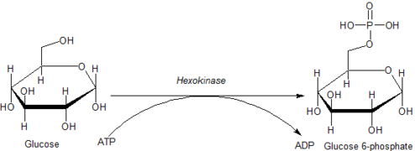 Figure_1: The Hexokinase Reaction.

* **Materials:**

1. 10 ml of 100 mM Glycylglycine Buffer, pH 8.5 (or PBS, pH 8.5)
2. 10 ml of 200 mM ATP.
3. 10 ml of 200 mM glucose
4. 10 ml of 200 mM fructose
5. 50 ml of 0.01% Cresol Red with 128 mM MgCl2 Solution (Cresol Red)*
6. 100 ml of 100 mM HCl
7. 100 ml of 1 M NaOH
8. 10 ml of 0.5% glucose solution
9. Hexokinase (HK) - *Immediately before use, prepare a solution containing 10 units/ml of hexokinase in 0.5% glucose solution*
10. 10 ml of 200 mM glucose 6-phosphate
11. Visible Spectrophotometer
12. Plastic cuvettes
13. Test Tubes

* **Methods:**

1. In a test tube, pipette 2.5 ml ATP + 3.3 ml cresol red.

2. Mixing was done by flicking the tubes and then 100 mM NaOH was slowly added (drop wise) until the solution turned from red to purple (pH ~8.2).

3. To the mixture was added 2.5 ml of glycylglycine solution. The mark of 50 ml was filled with deionized water.

4. You have been mixing well and measure the pH. The pH has been adjusted (if necessary) to 8.5 using hydrochloric acid or sodium hydroxide. This is a reaction cocktail

5. In a 3 mL cuvette, pipette 2.5 mL reaction cocktail and 0.4 mL of 200 mM glucose.

6. The inversion was mixed and the absorbance was measured at 560 nm until the reading was constant. This is the initial A560nm

7. 0.1 mL of 100 mM HCI was added to the cuvette and mixed. Immediately the final A560 nm has been recorded. Titer = ((A560nminitial – A560nmfinal) (2.9))/ ((1000) (0.1) (100))

2.9 = Volume of Titer Reaction Mix

1000 = Conversion from millimolar to micromolar

0.1 = Volume of HCI

100 = Concentration of HCI

8. In a set of cuvettes, prepared the following solutions:  
Table_1: Determination of the sample in the test tubes by preparing solutions as follows

|  |  |  |  |  |  |
| --- | --- | --- | --- | --- | --- |
| Material | Blank | Test | Test + I | Test +I *2 | Test 2 |
| Reaction cocktail | 2.5 ml | 2.5 ml | 2.3 ml | 2.1 ml | 2.5 ml |
| 200 mM glucose | 0.4 ml | 0.4 ml | 0.4 ml | 0.4 ml | -- |
| 200 mM G-6-p | -- | -- | 0.2 ml | 0.4 ml | -- |
| 200 mM fructose | -- | -- | -- | -- | 0.4 ml |

9. Mixed was by inversion and A560nm was measured to constant, then added:

Table_2: The add of Hexokinase and 0.5% glucose and read the absorbance at A560 nm

|  |  |  |  |  |  |
| --- | --- | --- | --- | --- | --- |
| Material | Blank | Test | Test + I | Test + I*2 | Test 2 |
| 0.5 % glucose | 0.1 ml | -- | -- | -- | -- |
| Hexokinase | -- | 0.1 ml | 0.1 ml | 0.1 ml | 0.1 ml |

10.The change in absorbance as a function of time was immediately mixed and measured every 20 seconds for 4 minutes.

* **Results:**

Table_3: Different Reaction Mixtures' Absorbance Values for 4 minutes, in read every 20 seconds.

|  |  |  |  |  |  |
| --- | --- | --- | --- | --- | --- |
| Time (s) | Blank | Glucose | Inhibitor x1 | Inhibitor x2 | Fructose |
| 0 | **1.513** | **0.971** | **1.795** | **1.535** | **0.687** |
| 20 | **1.506** | **0.632** | **1.764** | **1.466** | **0.458** |
| 40 | **1.504** | **0.473** | **1.722** | **1.424** | **0.333** |
| 60 | **1.503** | **0.362** | **1.670** | **1.370** | **0.271** |
| 80 | **1.501** | **0.293** | **1.573** | **1.277** | **0.229** |
| 100 | **1.502** | **0.252** | **1.398** | **1.137** | **0.199** |
| 120 | **1.500** | **0.216** | **1.173** | **0.995** | **0.174** |
| 140 | **1.499** | **0.193** | **0.981** | **0.826** | **0.155** |
| 160 | **1.499** | **0.172** | **0.701** | **0.711** | **0.142** |
| 180 | **1.498** | **0.155** | **0.579** | **0.622** | **0.129** |
| 200 | **1.498** | **0.141** | **0.480** | **0.538** | **0.118** |
| 220 | **1.498** | **0.130** | **0.410** | **0.473** | **0.109** |
| 240 | **1.498** | **0.120** | **0.364** | **0.427** | **0.102** |

*Figure_2: Absorbance at 560 nm of different reaction mixtures vs. time (S)*

**Discussion:**

As shown in figure_2, at first the Blank values ​​were very close to each other and therefore the line was linear, and the main substrate here was glucose

The results of glucose and fructose were close to each other and their results were rather good, which indicates that they are probably substrates for isozymes hexokinase that was inhibited by glucose-6-phosphate, from the results that we have we can note the type of enzyme that wasn't used so that it is Glucokinase, the reason is because glucose 6 phosphate doesn't inhibit Hexokinase isozyme IV so the kind we have is one of the three enzymes (1,2, or 3)

Bearing in mind that the fourth type (isozymes hexokinase IV) is specific for glucose only.

And as figure_2 shows, there is a specific error in the Inhibitors. This may be due to the inaccuracy of placing the solutions and preparing them exactly as the table, or it may be that the measurement was taken in the wrong way, and one of the random errors that we have is the spectrophotometer, and one of the possible errors is also not shaking the solution properly. well before measuring its absorption.

The enzyme has been placed on ice during the laboratory to keep it from spoiling.

Just as the slope increases, so our activity increases, and it is the faster rate.

As figure_3 shows, these colors that we produced during the reaction, glucose were purple in color, while the inhibitors 1, 2 and blank were yellow color, which indicates that they have little absorption, and the reason is because in the inhibitors 1,2 and blank there is a reaction in the enzyme Which caused this in the percentage of H + in the solution is increased, So the more the enzyme reaction increases, the more the percentage of H + we have, and therefore less absorption.

Reaction cocktail = ATP + Cresol red + buffer

*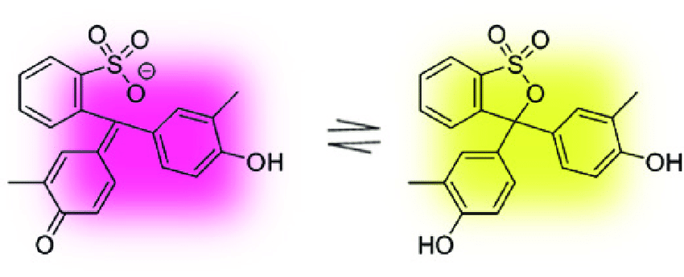  
Figure_3: Cresol Red Colorimetric Reaction in Relation to Solution pH*

**Conclusion:**

To summarize, glycolysis is an excellent process to research and utilize since it is a core metabolic pathway found in all living species, yet its individual enzymes are well described in terms of structural features and enzymatic activities. So the Hexokinase is an enzyme that catalyzes the phosphorylation process, which results in the conversion of glucose to Glucous-6-phosphate.

**References:**

1Chandel, N. S. (2021). Glycolysis. *Cold Spring Harbor Perspectives in Biology*, *13*(5), a040535.‏

2Aleshin, A., Zeng, C., Bartunik, H., Fromm, H., and Honzatko, R. 1998. Regulation of hexokinase1: crystal structure of Recombinant human brain hexokinase complexed with glucose and phosphate. Journal of Molecular Biology. 282: 345-357.

3Wilson, J. E. (1995). Hexokinases. *Reviews of Physiology, Biochemistry and Pharmacology, Volume 126*, 65-198.‏

**Appendix:**

* **Titer Determination:**
* 2.9 = Volume of Titer Reaction Mix
* 1000 = Conversion from millimolar to micromolar
* 0.1 = Volume of HCI
* 100 = Concentration of HCI
* Initial A560 nm = 1.638
* Final A560 nm = 0.037
* Titer =

$$\frac{(A560nm Initial – A560nm Final)(2.9)}{(1000)(0.1)(100)}\frac{(1.638-0.037)(2.9)}{1000*0.1*100}$$

= 4.6429 x 10-4 µM-1

One unit of enzyme activity will phosphorylate 1.0 µmole of glucose per minute at pH of 8.5 at 25oC

* To calculate the enzyme activity units:

Units/mg enzyme = $\frac{ΔA560test -ΔA560 blank}{(titer)( \frac{mg enzyme}{ml reaction mix})}$

Enzyme Activity Units/mg Enzyme **with Glucose** = 0.7177 units/mg

Enzyme Activity Units/mg Enzyme **with 1x Glcouse-6-ph** = 0.7167 units/mg

Enzyme Activity Units/mg Enzyme **with 2x Glcouse-6-ph** = 0.7161 units/mg

Enzyme Activity Units/mg Enzyme **with Fructose =** 0.7177 units/mg

* **The slope of Reaction mixture:**
* Slope of Blank = 3*10-5
* Slope of Inhibitors (x1) = 0.0051
* Slope of Inhibitors (x2) = 0.0075
* Slope of Fructose = 0.0009
* Slope of glucose = 0.0007