**Biology and Biochemistry Department**

**BIOC 312**

**Biochemistry II lab**

**Experiment #8**

**Sec 1**

**Student Name: Meran Nasser**

**Student ID: 1190803**

**Instructor: Dr. Johnny Stiban**

**Teacher Assistance: Mr. Yousef Nammari**

**Partners:**

**Ali Milhem**

**Abdalrahman**

**AbdelFattah**

**Melak Ottallah**

**Date of Experiment: 9/05/2022**

**The submission: 21/05/2022**

**Title  
The Citric Acid Cycle**

* **Objective:**

The major objective of this experiment is to investigate different enzyme activities and find irregularities and abnormalities in citric acid cycle enzyme activity ratios, as well as to measure protein quantities.

* **Introduction:**

The citric acid cycle (CAC) is a sequence of chemical events that release stored energy by oxidizing Acetyl-CoA obtained from carbs, lipids, and proteins. Organisms that respire (as opposed to ferment) employ the Krebs cycle to create energy, whether through anaerobic or aerobic respiration. Its central importance to many biochemical pathways suggests that it was one of the earliest components of metabolism and may have originated abiogenically. Despite the fact that it is called a 'cycle,' metabolites do not have to follow a single or specific route. The citric acid cycle occurs in the matrix of the mitochondrion in eukaryotic cells (in this experiment). The citric acid cycle totally oxidized to form pyruvate, the final product of glycolysis, in the mitochondrial matrix when oxygen is present. The citric acid cycle doesn't use pyruvate as a substrate. It is initially absorbed into the mitochondria, where it is converted to Acetyl-CoA and CO2 via an oxidative decarboxylation process by the pyruvate dehydrogenase complex (PDC). The Acetyl-CoA is then completely oxidized to CO2 in a sequence of 8 enzyme-catalyzed processes, releasing energy in the form of GTP, FADH and NADH.3 2

Anyway, evidence that deficiencies in these enzymes cause a variety of human diseases has reignited interest in assaying tricarboxylic acid cycle (TCAC) enzyme activity, contradicting the long-held view that any TCAC enzyme deficiency is lethal. Because in the last ten years, deficiencies in tricarboxylic acid cycle (TCAC) enzymes have been shown to cause a wide spectrum of human diseases, including malignancies and neurological and cardiac diseases. A prerequisite to the identification of disease-causing TCAC enzyme deficiencies is the availability of effective enzyme assays. so Therefore, these tests and techniques were developed. And the magnitude of organic acid buildup may be determined by residual activities associated with TCAC deficits in people. Organic acid accumulation has been proven instrumental in initiating tumor formation related to SDH or fumarase deficiency.2 1

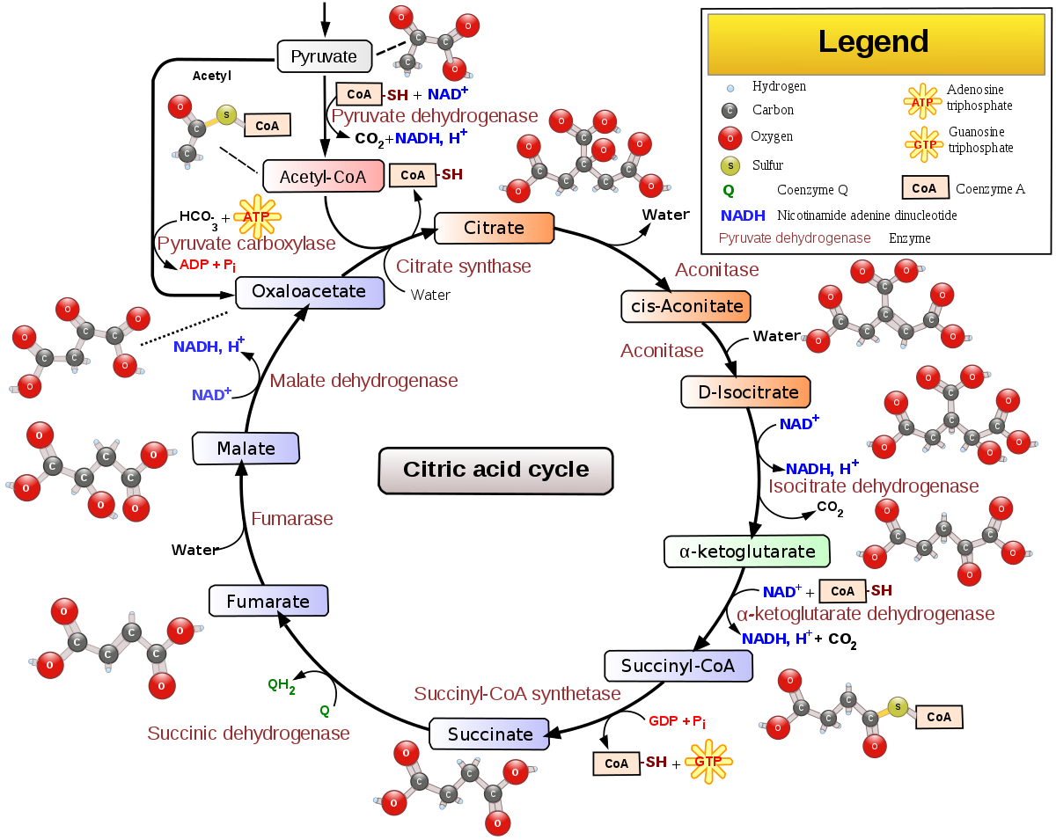

Figure_1: The citric acid cycle

* **Materials:**
* Snap-frozen rat heart (obtain heart and snap freeze it at -80°C until use) Homogenization buffer: 20 mM Tris, pH 7.2, 0.8 M sucrose, 40 mM KCl, 2 mM EGTA
* Buffer I: 50 mM KH2PO4, pH 7.2, 1 mg/ml BSA
* Buffer II: 10 mM KH2PO4, pH 7.2
* Buffer III: 10 mM KH2PO4, pH 7.8, 2 mM EDTA
* 1 mM DCPIP (dichlorophenol indophenol)
* 1 mM DCQ (decylubiquinone)
* 8 mM PMS (phenazine methosulfate)
* 80 μM Rotenone
* 1 mM succinyl CoA
* 2 mM KCN
* 100 mM succinate
* 100 mM malonate
* 100 mM glutamate
* 8 mM NAD+
* 10 IU AAT (aspartate aminotransferase)
* 150 mM fumarate
* 1 mM malate
* 20 mM DTT
* 1 mM EDTA
* 20 mM CaCl2
* 50 mM MgCl2
* 20 mM a-ketoglutarate
* 1 mM TPP (thiamine pyrophosphate)
* 1% triton X-100
* 5 mM CoASH
* 8 mM NADP+
* 5 mM cis-aconitate
* 150 mM isocitrate
* 20 mM DTNB
* 1 mM acetyl CoA
* 50 mM oxaloacetate
* Kinetic spectrophotometers
* **Methods:**

Each group of students took a different test. This process was done by TA before the laboratory. Homogenize the frozen muscle on ice in an excess of 10-20 volume of homogenization buffer. Large cell debris was removed by low speed centrifugation (1500 g for 5 min). The supernatant is your biological sample. We've always kept it on ice!!

The protein concentration in the sample was determined using the Biuret assay and the sample was diluted in homogenization buffer to 1.5 mg/mL.

1- The first assay (SCS, SDH, FUM, GDH, MDH)

1. In a 3 ml cuvette, 460 μl of buffer I was added and zero the spectrophotometer at 600 nm.

2. The following were added to the cuvette (140 μL of 1 mM DCPIP, 100 μL of 1 mM DCQ, 100 μL of 80 μM rotenone and 100 μL of 1 mM Succinyl COA), and the absorbance change was measured with the passage of time.

3. When the absorbance was almost steady, we started the assay by adding the biological sample. 100 μl of muscle sample was added and we measured the change in absorbance for 30 s. The change in uptake represents the activity of SCS based on the amount of succinate formed by the enzyme as succinate is easily oxidized by SDH reducing DCPIP and decreasing uptake. This is only possible because SDH has greater activity than SCS.

4. In order to measure SDH activity, 130 μl of 100 mM succinate was added and the rate of absorbance reduction was measured for 1 min.

5. 150 μl of 100 mM Malonate was added to inhibit SDH and the absorbance was measured for another 10 seconds. The absorbance is steady indicating that SDH is competitively inhibited.

6. For the measurement of glutamate dehydrogenase (GDH), 160 μl of 100 mM glutamate, 180 μl of 8 mM NAD and 1 IU of AAT were added to the cuvette and the absorption drop was measured for 30 s.

7. In order to assay the last two enzymes, DCPIP must now be added to the cuvette. We will add 200 μL of 1 mM DCPIP followed by 220 μL of 150 mM fumarate and measure the absorbance change for 30 s.

8. Measured MDH by adding 250 μl of 1 mM maleate and obtaining the absorbance change with time for about 30 seconds. It is important that oxaloacetate is removed by the added aspartate aminotransferase because it is a potent inhibitor of MDH.

II- Second assay (KDH, ACO, IDH)

1. In a 3 ml quartz cuvette, 250 μl Buffer II, 200 μl biological sample were added and the spectrophotometer zeroed at 340 nm.

2. The following was added to the cuvette (100 μL of 8 mM NAD, 100 μL of 20 mM DTT, 100 μL of 1 mM EDTA, 100 μL of 20 mM CaCl, 50 μL of 50 mM MgCl2, 100 μL of 20 mM α-ketoglutarate, 100 μl of 1 mM TPP and 100 μl of 1% Triton X-100) and absorbances were measured over time.

3. When the absorption was constant, 120 µl of 5 mM CoASH was added and the KDH rate was measured for 30 s.

4. To measure the aconitase rate, 135 μl of 8 mM NADP+, 150 μl of 50 mM MgCl2, and 165 μl of 5 mM cis-aconitate were added and the absorbance increase was measured for 1 min.

5. Finally, for IDH measurement, 185 μl of 150 mM isocitrate was added and the absorbance change was followed for 30 s.

* **Result**:

Figure 2: Absorbance at 340 nm of different enzymes vs. time (S) in second assay (KDH, ACO, IDH)

Figure_3: Absorbance at 600 nm of different enzymes vs. time (S) in first assay (SCS, SDH, FUM, GDH, MDH)

* **Discussion**:

In this experiment we started from the second assay so that the absorbance was taken at 340nm. I've been using the muscles and seeing what effect the enzymes have on the absorption of those muscles.

After mixing the buffer II with the muscle homogenate (biological sample), we have the Blank. And we started by putting enzymes in the cuvette, for example, EDTA was placed, which holds ions, while CaCl2 and MgCl2 are cofactor that work to activate the enzyme. For example, the activities of several coenzymes of the citric acid cycle can be significantly affected by a decrease in [Ca]. This observation led to the discovery that the calcium content of mitochondria is hormonally regulated, prompting the speculation that Ca2+ can also regulate the activity of the citric acid cycle. Added NAD+ and when applied, the absorption doesn't increase significantly, but the activity will increase gradually.

Thiamine pyrophosphate (TPP) was developed, which is very important for the reaction as it is the active form of thiamine.

And the functions as a coenzyme for a number of enzymes involved in carbohydrate metabolism, thus making metabolites from this metabolism and keto analogues from amino and fatty acid metabolism available for the production of energy. Then the Triton X-100 was added that analyzes the membrane and increases the enzyme access.

The α-ketoglutarate reaction did not occur, so CoASH was added because the CoA act to catalyze the oxidation of α-ketoglutarate. and the absorption of KDH was measured, which is the first reaction we have here as shown in Figure_2 and then we have the second reaction, which is ACO, and NADP+ was added due to is a cofactor and reduces the activity. The IDH, which is the third reaction, and isocitrate was added, due to which the reaction became very fast and the absorption was also high.

Then, we started with First Assay, and the necessary materials were placed in order as in the above method, when absorbing 600 nm. For example, DCQ was added because it is important for electron transfer, while Rotenone is a strong inhibitor for electron translate, and to block complex I. We also put part of the sample that we made with Second Assay in cuvette of first assay and then we added a biological sample, put several enzymes and saw the changes which became on the Absorbance and activity, and as shown in Figure 3, the interaction at the beginning was high at the SCS activity, then it decreased at the SDH activity, it gradually decreased, and then it became inhibition and increased slightly, and then continued at the same level at the GDH activity. The malonate inhibits the SDH and is used to stop the reaction, and the GDH it removed the oxaloacetate.

DCPIP, which has a blue color, was added, and then Fumarate was added, and as shown in Figure 3, the uptake increased and eventually decreased, very slightly in MDH activity, and this is expected.

The results are generally very good.

* **Conclusion**:

In Conclusion, Because the activity of each enzyme can be easily compared with one or more other activities evaluated in the same sample, this collection of assays is quick and easy to use and can identify even partial defects right away.

* **References**:

1 Williamson, J. R., & Cooper, R. H. (1980). Regulation of the citric acid cycle in mammalian systems. *FEBS letters*, *117*, K73-K85.‏

2 Goncalves, S., Paupe, V., Dassa, E. P., Brière, J. J., Favier, J., Gimenez-Roqueplo, A. P., ... & Rustin, P. (2010). Rapid determination of tricarboxylic acid cycle enzyme activities in biological samples. *BMC biochemistry*, *11*(1), 1-8.‏

3 Lowenstein, J. M. (1969). *Methods in Enzymology, Volume 13: Citric Acid Cycle*. Boston: Academic Press. [ISBN](https://en.wikipedia.org/wiki/ISBN_(identifier)) [978-0-12-181870-8](https://en.wikipedia.org/wiki/Special:BookSources/978-0-12-181870-8).