***Birzeit University***

***Department of Biology and Biochemistry***

***Bio III***

***Cellular Activities***

***Student Name: Nadeen tokhly***

***Student ID:1211518***

***Partner Name and ID:***

1. ***Talin Shreim1211697***
2. ***Aya badwan 1210423***
3. ***Rama Hassan 1210006***
4. ***Zeina Sharkas 1212362***

***Instructor Dr :Seema Dahabrah***

***Teacher Assistant : Lena Abo Attieh***

***Experiment Date :29_11_2021***

***Submission Date:13_12_2021***

* ***Aim:*** *The effect of different factors such as light and temperature on the rate of photosynthesis.*
* *And the effect of different sugars on fermentation.*

***INTRODUCTION:***

*Metabolism is a term that refers to all chemical events that occur in living cells and organisms. There are two types of metabolism: oxidative and nonoxidative.*

*1. Catabolism, also known as fermentation, is the breakdown of particles in order to extract energy.*

*2. Anabolism: the use of chemical or light energy, such as photosynthesis, to synthesize all of the molecules required by cells.*

*Nutrition and nutrient availability are linked to metabolism. [1]*

*Within chloroplasts, photosynthesis is the process of converting sun energy into chemical energy.*

*Plants, algae, and a few other unicellular eukaryotes, as well as some prokaryotes, all include organelles called chloroplasts.*

*It converts CO2 and other inorganic chemicals into organic compounds. O2 and organic molecules are produced during photosynthesis and are utilised in cellular respiration.*

*(Figure 1: show photosynthesis equation.).*

$$6CO_{2}+6H_{2}O→C_{6}H_{12}O_{6}+6O_{2}$$

*To function, living cells require energy from outside sources. Obligate anaerobes ferment or respire anaerobically and cannot survive in the presence of oxygen. Alcohol is produced via yeast fermentation, which is used in brewing, winemaking, and baking.*

*Figure 2: show FERMANTATION equation.*

$$C_{6}H_{12}O_{6}→2co_{2}+2C_{2}H_{6}O+2ATP$$

***Materials :***

|  |  |
| --- | --- |
| *1.* | *Geranium leaves* |
| *2.* | *Sodium Bicarbonate (NaHCO3) .* |
| *3.* | *Funnels.* |
| *4.* | *Graduated test tubes* |
| *5.* | *.* *Beakers.* |
| *6.* | *Sucrose (10%)* |
| *7.* | *Galactose (10%).* |
| *8.* | *Molasses (10%)* |
| *9.* | *Glucose (10%)* |
| *10* | *Fructose (10%)* |

|  |  |
| --- | --- |
| *11.* | *Dry yeast and 6 fermentation*  *tubes.* |
| *12.* | *Ice bucket* |
| *13.* | *Lamps (60W , 100W)* |

***\*\*Method:***

***\*Effect of light on photosynthetic rate:-***

*First, 500ml of sodium bicarbonate (NaHCO3) was added to a 1000ml beaker, followed by 5 green leaves, an inverted funnel placed on top of the leaves to ensure that no air bubbles formed and were left on the leaves, then the end of the funnel was covered with a graduated test tube filled with sodium bicarbonate, and the beaker was placed under a light source, where oxygen gas was released and collected via photosynthesis.*

*The experiment was conducted under the following environmental conditions:*

*It was done in the dark and at room temperature, then at room light and at room temperature, then under a 40 watt light bulb and at room temperature, then under a 150 watt light bulb and at room temperature, then the sample was put in ice under room light, then at room light in a 50 °C water bath, and finally in the beaker with water rather than sodium bicarbonate.*

***\*Yeast fermentation:***

*- 5 different substances were placed in 5 fermentation tubes, yeast solution was added to each tube, and all 5 tubes were placed in a 37 °C water bath to measure the amount of CO2 produced; the 5 substances were sucrose, glucose, galactose, molasses, and water for control, and each sugar concentration was 2 percent.*

***Data and result :***

*• Photosynthesis :*

*\*Table 1: Volume of O2 ( in ml ) assembled in the graduated test tubes under different environmental condition for 40 minutes.*

|  |  |  |  |  |  |  |
| --- | --- | --- | --- | --- | --- | --- |
| Time  *(min)* | *Room light/*  *Room temp*  *(control)* | *Dark*  */Room*  *temp* | *40W*  *light/Room*  *temp* | *150W*  *light/Room*  *temp* | *On Ice/*  *Room*  *light* | *50°C*  *Room*  *light* |
| *0* | *0* | *0* | *0.0* | *0* | *0* | *0* |
| *5* | *0* | *0* | *0.05* | *0* | *0* | *0* |
| *10* | *0* | *0* | *0.1* | *0* | *0* | *0* |
| *15* | *0* | *0* | *0.1* | *0* | *0* | *0* |
| *20* | *0* | *0* | *0.1* | *0* | *0* | *0* |
| *25* | *0* | *0* | *0.1* | *0.1* | *0* | *0* |
| *30* | *0* | *0* | *0.11* | *0.3* | *0* | *0.06* |
| *35* | *0* | *0* | *0.12* | *0,3* | *0* | *0.08* |
| *40* | *0* | *0* | *0.13* | *0.3* | *0* | *0.1* |

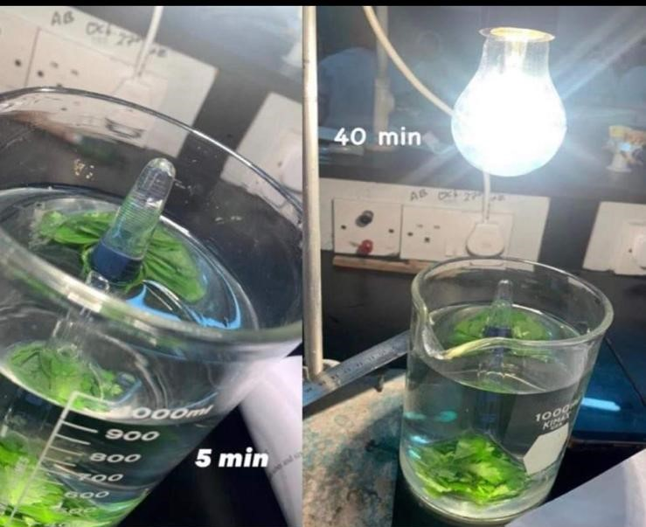

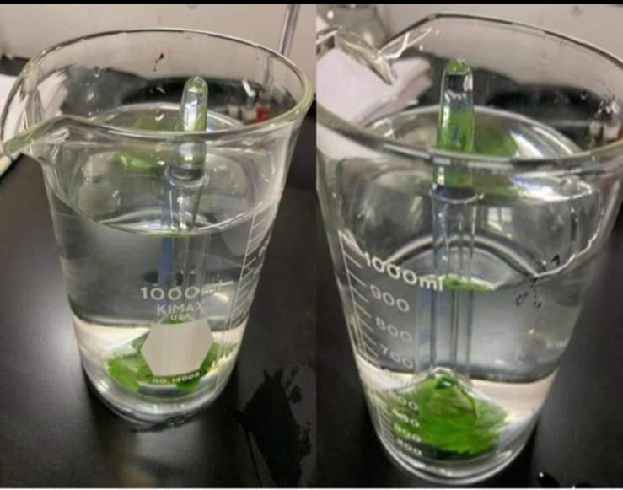 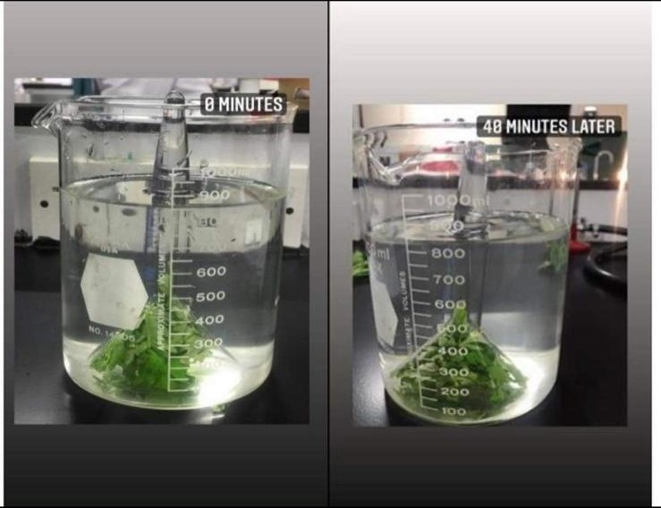

|  |  |  |  |  |  |  |
| --- | --- | --- | --- | --- | --- | --- |
| *Time*  *(min)* | *10%*  *Sucros* | *10%*  *Fructose* | *10%*  *Glucose* | *10%*  *Galactose* | *10%*  *molases* | *water* |
| *0* | *0* | *0* | *0* | *0* | *0* | *0* |
| *5* |  | *1.5* | *0.8* | *1* | *3* | *0* |
| *10* | *6.3* | *5* | *4.5* | *2.8* | *6.5* | *0* |
| *15* |  | *7.8* | *7.5* | *3.4* | *9* | *0* |
| *20* | *8.5* | *8.6* | *9* | *4* | *10* | *0* |
| *25* |  |  | *9.5* | *4.5* |  | *0* |

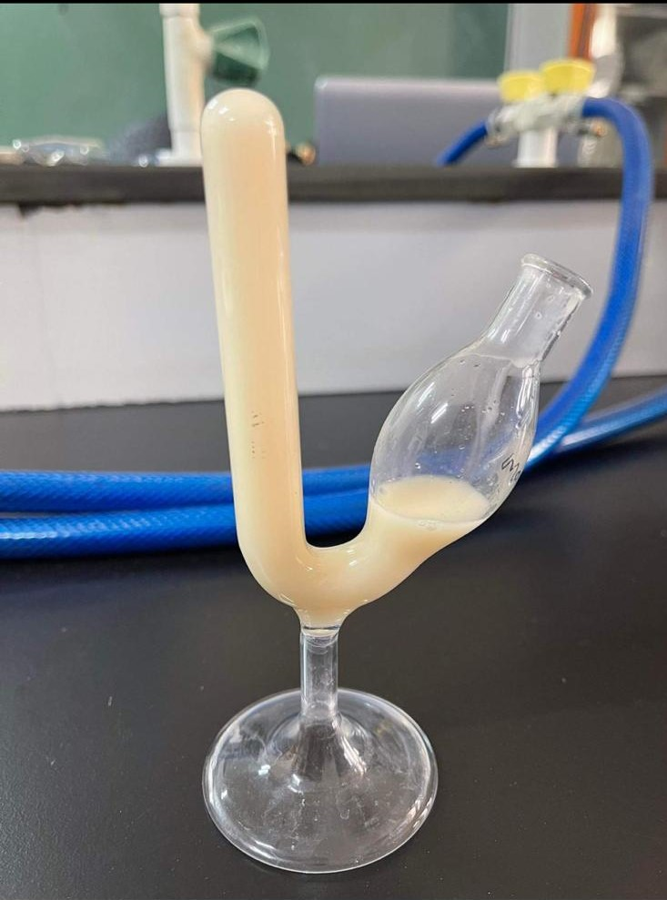

***Discussion:***

***Photosynthesis :***

*.In this experiment, we must compute the volume of oxygen collected in test tubes under various light and temperature circumstances.*

*Light is a requirement for photosynthesis. In the light-dependent stage of photosynthesis, light provides the energy needed for photolysis of the water molecule. Photosynthesis grows proportionally as more light is available (straight line relationship).* *However, this does not always imply more. When we consider photosynthesis as a process, we can see that it is constrained by at least three factors: light, water, and carbon dioxide. If we don't have enough water or carbon dioxide, more light won't help. As a result, there comes a point at which increasing the amount of light has no effect on the rate of photosynthesis [3].*

*Enzymes aid metabolism by speeding up chemical reactions. The enzyme's activity reaches a certain temperature. The temperature at which an enzyme is most active is referred to as the optimal temperature. The enzyme's activity reduces when it is not at its optimum temperature. The enzymes alter and stop working at extreme temperatures. [4]*

*Important: the experiment failed with us , and the failure of the experiment Is due to the type of plant leaves.*

***Fermentation in yeast:***

*There are six possible outcomes in this type of experiment. The distance from the tip of the tail to the level of the solution was measured, and the volume "the amount" of CO2 produced in alcoholic fermentation under different conditions was calculated.*

*. Fermentation is a chemical reaction that breaks down molecules called "sugars" to produce AT P, which is used by cells to perform work. Alcoholic fermentation is carried out by enzymes in yeast, which convert glucose to ATP and create alcohol and carbon dioxide. [5]*

*Several factors can influence the rate of fermentation, including yeast concentration, glucose concentration, and carbohydrate type.*

*Fructose, glucose, and glagtose are three distinct monosaccharides (simple sugars).*

*The position of the carbonyl group in monosaccharides is used to classify them (as aldose or ketose) The carbon skeleton's number of carbon atoms (triose, tetrose, pentose, hexose, etc.). [6]*

*When two monosaccharides are joined by a dehydration event, a disaccharide is created. This covalent bond is known as a glycosidic link (bond), and it is found in sucrose, which is made up of two simple sugars (glucose and fructose). Molasses is a dark, sweet syrup formed from sugarcane and sugar beet sugar extraction. [7]*

*In yeast, enzymes are used to break down sugar molecules (monosaccharide and disaccharide). Each sugar has its own set of enzymes, except for dialects, which have no enzymes to break down this sugar and produce ATP. As a result, all of them, save galagtose, are fermented by yeast.*

*Yeast requires (sugars) as a series of carbon that is used to build a fermented, so when we put water on yeast, no fermentation occurs since water contains sugar and can't be used as a source of carbon, so the volume of CO2 collected was zero for any period of time.*

*Because yeast needs monosaccharides to produce ATP, it must break down disaccharides into monosaccharides using particular enzymes.*

*Table 2 shows that when fermentation occurs in each of Fructose, glucose, and galagtose, which are mean monosaccharides (simple sugars), and in molasses, the volume of CO2 increases over time. However, after a long period of time, the volume of CO2 becomes fixed. This occurs because the concentration in the solution becomes low, and there is no more sugar to make fermentation.*

***Conclusion:***

*When the intensity of light, the CO2 ratio, and the temperature increase in the first experiment, the rate of photosynthesis increases until the optimal temperature is attained.*

*When the temperature drops, the rate of photosynthesis drops, and when the temperature rises above the optimum temperature, the CO2ratio rises.*

*In the second experiment, it was discovered that monosaccharides (fructose, glucose) are easier to ferment than polysaccharides (sucrose, molasses) because breaking the bonds between their components takes time. In the case of galactose, it has been discovered that not all species of yeast can ferment it; yet, these are the critical activities that the cell must carry out in order to make CO2 if it is anaerobic.*

***REFERENCES:***

*[3] http://brilliantbiologystudent.weebly.com/is-light-is-necessary-for-photosynthesis.html*

*[3] http://www.rsc.org/learn-*

*chemistry/content/filerepository/CMP/00/001/068/Rate%20of%20photosynthesis%20limiting%2*

*0factors.pdf*

*[4]http://brilliantbiologystudent.weebly.com/effect-of-temperature.html*

*[5] https://www.khanacademy.org/science/biology/cellular-respiration-and-*

*fermentation/variations-on-cellular-respiration/a/fermentation-and-anaerobic-respiration*

*[6]https://www.britannica.com/science/monosaccharide*

*[7]https://www.thespruceeats.com/what-is-molasses-1328678*