**Diffusion, Osmosis, and the Cell Membrane**

An Introduction to the function of the cell membrane and mechanisms of passive transport

Bob Birch

Fontbonne Academy

Milton, MA

Email: [rwbirch@fontbonneacademy.org](mailto:rwbirch@fontbonneacademy.org)

Ybelise Escoto

Chelsea High School

Chelsea, MA

Email: morrkia13@cs.com

Bryan Henry

Chelsea High School

Chelsea, MA

Email:rbhenry1@excite.com

# **Introduction**

This unit introduces students to the role of the cell membrane as the primary mediator for transport of material into and out of the cell. It introduces the mechanisms of diffusion and osmosis and their relationships to temperature and molecular mass. The role of polar phospholipids in the structure and function of the cell membrane is discussed. The combination of wet labs with computer simulations unit gives students an appreciation of the microscopic dynamics underlying the macroscopic observations they make in their wet labs.

# **Audience**

This unit has been designed for first year standard Biology students (9th and 10th grade). It can be readily modified for more advanced or for younger students. The unit is aligned with the Massachusetts Department of Education Science Biology frameworks.

# **Adjustments**

This unit can be easily adapted for more advanced students by incorporating additional wet labs and computer simulations related to kinetic energy and its relationship to temperature and molecular velocity. For example, in SimuLab 1 students can be asked to designed their own experiment to test the relationship between mass and the rate of diffusion.

Elimination of the second wet lab or presenting it as a demonstration will be suitable for younger students or situations with limited laboratory facilities. Presenting the computer simulations for a qualitative rather than a quantitative analysis would also be appropriate in these circumstances.

# **Placement in the Curriculum**

This unit is most appropriate for inclusion in the curriculum area involving basic cell structure and function. Specifically it should be introduced in the section introducing the function of the cell membrane and mechanisms of cross membrane transport. Students must be familiar with the use of the SMD and the Universal programs as well as Microsoft Excel. Otherwise an introduction to these programs should be included at the beginning of the unit.

This unit corresponds to the Massachusetts Department of Education frameworks for Biology section 2: Structure and Function of Cells, subsection 2.5: Explain the role of the cell membrane as a highly selective barrier (diffusion, osmosis, and active transport).

# **Time/Instructional Activities**

Lesson 1: Introduction to Cell Structure and Transport Mechanisms.

Time required: depends on length of class period (i.e. 40-60 minutes)

* Identify the cell membrane as the primary structure that regulates the movement of material into and out of the cell.
* Describe the difference between passive and active transport of material. Identify diffusion and osmosis as two passive transport mechanisms.
* Define diffusion and discuss the concept of random movement, and concentration gradients. Use examples such as perfume or other odors. Discuss biological examples such as alcohol, sodium, potassium, and oxygen diffusing across cell membranes.

Lesson 2, Lab: Diffusion Wet Lab and SimuLab.

Time required: prep time requires the time needed to cool and heat the water and assemble necessary equipment (1 hour). The actual wet lab will take approximately 20 to 25 minutes. The SimuLab will take 40 to 50 minutes if the students have received previous instruction with the software.

* Simple wet lab in which students observe the diffusion of dye in water at three different temperatures (cold, room temp, and hot). Ask students to predict the effect of temperature and compare their observations to their predictions.
* Diffusion SimuLab. Students will measure rates of diffusion at various temperatures using the diffusion SMD programs. Then correlate the results of the simulation with the wet lab.
* Students are asked to predict the relationship between molecular size and diffusion and test their predictions using the SMD programs.
* If time and student level permits, the diffusion SimuLab may be preceded with a review/discussion of the relationship between temperature and molecular velocity and kinetic energy using other SimuLabs.

Lesson 3: Osmosis and the Role of the Cell Membrane

Time required: depends on length of class period (i.e. 40-60 minutes)

* Introduce osmosis as a special form of diffusion involving water moving across a selectively permeable membrane. Discuss the similar role that concentration gradients play in osmosis compared to diffusion. Have students consider why it is important that the cell membrane be selectively permeable.
* Introduce the terms hypotonic, hypertonic, and isotonic and osmotic pressure. Discuss the role of cell proteins in establishing concentration gradients across the cell membrane.

Lesson 4, Lab: Osmosis Wet Lab and SimuLab.

Time required: prep time requires the time needed to cool and heat the water and assemble necessary equipment (1 hour). The actual wet lab will take approximately 50 to 60 minutes. The SimuLab will take 40 to 50 minutes if the students have received previous instruction with the software.

* Students perform the traditional thistle tube/sugar/starch osmosis lab in which they observe the movement of water into the dialysis tubing and the movement of sugar out of the tubing.
* Students follow this with the osmosis SimuLab series where they observe the effect of “protein” concentration inside the cell on the rate of osmosis and the increase in “cell” radius. This can involve using the “save data” options and exporting their results to Excel for graphical analysis of their results.

Lesson 5: Active Transport Mechanisms.

Time required: depends on length of class period (i.e. 40-60 minutes)

* Introduce students to the differences between passive and active transport in terms of energy requirements and the direction of movement in relationship to concentration gradients. Use examples such as the sodium/potassium pumps in nerve and muscle cells.
* Discuss other forms of active transport such as exocytosis and endocytosis and their role in phagocytosis of lymphocytes and water regulation in protozoa.

Lesson 6: The Structure of the Cell Membrane.

Time required: depends on length of class period (i.e. 40-60 minutes)

* Introduce students to the molecular components of the cell membrane including phospholipids and proteins.
* Discuss the double layer arrangement of the phospholipids and the role of their polar heads in the creation of hydrophobic and hydrophilic regions of the membrane. Point out the role these polar regions have in influencing the diffusion of charged particles across the membrane.
* Discuss the various types of proteins that are associated with the membrane and their functions including ion channels, carrier proteins, structural proteins, and antigenic protein complexes.

Lesson 7, Lab: The Formation of Micelles by Phospholipids SimuLab.

Time required: There is minimal prep time involved with this SimuLab if the computers are available. The time for the actual lab will be approximately 50 minutes.

* Students run the Micelle UMD movie to observe the creation of micelles by phospholipids. Students will study the formation of these membrane like structures as the polar regions of the phospholipids interact with water.
* Students will explore the effect of varying the concentration of the surfactant on the formation of a lipid bilayer.

# **Resources**

Standard lab equipment for the traditional diffusion and osmosis labs are required and listed with the individual lab activities.

# **Electronic Equipment**

Computers/Software

* PC or Mac computers with the SMD and Universal software installed
* Access to Microsoft Excel
* The ideal number of computers would be one for every two students. The actual number will depend on individual school resources.
* A muti-media projector would be helpful for the initial introduction to the software or presenting demonstrations of the programs.

# **Goals and Objectives**

* Master the use of virtual molecular program
* Describe the components and their arrangement in the cell membrane
* Define diffusion, osmosis, semi-permeable membrane, and equilibrium
* Predict the effects of temperature and mass on the rate of diffusion
* Distinguish between diffusion and osmosis
* Explain the role of the semi-permeable membrane in passive and active transport
* Predict and analyze the effects of concentration on osmosis
* Demonstrate the formation of micelles by phospholipid molecules

# **Assessment: Laboratory Rubric**

| Title Page  Points: * point totals were left blank for teachers to adapt to individual needs | The title page should include:   * Title of the lab * Name plus lab partners * Date |
| --- | --- |
| Introduction  Points: | The introduction should include:   * The purpose of the experiment * Brief summary of procedure and conclusions * Statement of hypothesis |
| Materials and Methods  Points: | Based upon this section, a fellow scientist should be able to repeat your experiment. This section includes:   * List all materials used * The procedure you *actually* followed in performing the experiment. The procedure may be a list but must be in complete sentences * What measurements were made and how was data collected |
| Results  Points: | All data should be clearly presented and properly recorded. All tables and figures should be numbered and titled in an informative matter. The results sections should include:   * A summary of all results in a table. Label all columns and rows and include units. Number tables as Table 1, Table 2, etc. * Include drawings if they will be helpful. Number as Fig.1 and include title * Give a short written summary of the important results. |
| Discussion  Points | This section is important because it allows you to show your understanding of the lab.   * State whether your data supports or negates the hypothesis proposed. Discuss this using specific data from the lab. * Explain the significance of this conclusion in relation to things discussed in the introduction * Include an explanation of meaningful sources of error and how they affected your data. How can the experiment be improved to reduce the errors? * Suggest further experiments that might be done * End with a clear, summarizing statement * Answer all questions list on the lab worksheet |
| References  Points: | All published work (journals, books, web sites) used as references for your paper should be listed. |
| Writing  Points: | Clarity and mechanics of writing, grammar, spelling, punctuation, etc. |
| Final Product  Points: | Sections in correct order, neatness, proof reading |
| Total Score:__________________ |  |

Adapted from Tim Reed, Weston High School, Weston, MA

# **Wet Lab 1: Diffusion and Temperature**

Purpose: To determine the effects of temperature on diffusion

Materials:

250-ml beakers food dye ice water room-temperature water

hot water thermometer watch

Procedure:

1. Pour 100 ml of ice-cold water into a beaker.

2. Using a thermometer, record the temperature of the water.

3. Carefully place 1 drop of food coloring into the water.

4. Record the amount of time required for the food color to spread evenly throughout the water.

5. Repeat using room-temperature water and hot water.

Data:

|  | **Temp. (ºC)** | **Time (seconds)** |
| --- | --- | --- |
| **Ice water** |  |  |
| **R.T. water** |  |  |
| **Hot water** |  |  |

**SimuLab 1: Diffusion**

After performing these labs, you should be able to:

* Describe the diffusion process in terms of molecules mixing
* Relate the diffusion time to the temperature of the diffusing molecules
* Relate the diffusion time to the mass of the diffusing molecules

**Determination of the Relationship between Diffusion and Temperature**

Procedure:

1. Open **SMD** and select **Diffusion** on the **Molecular-Motion** folder.

2. You will see 119 green particles and 25 blue particles. Both of these particles have a mass of 1. The blue particles represent the food dye in the water.

3. Change the **Temperature** of the blue particles to 0.3 temperature units. Change the **mass** of the particles to 0.1 mass units. Check that the graph is **concentration vs. X-axis**. Press **Show Averages**. Press **Start** and then immediately **Pause**.

4. How do the bars in the graph represent the particles in the window?

5. Repress start and allow it to run until 8 particles in total are on the right half of the screen. It may be paused and started as often as needed to determine when 8 particles are on the right half.

6. Record the diffusion time in the data table.

7. **Reset Experiment**. Set the temperature to 0.3 and mass to 0.1. Once again, determine the time needed for 8 particles in total to move to the right half. Record this in the data table. Repeat. Average all three diffusion times for Temp.=0.3,Mass=0.1

8. Reset Experiment and determine diffusion time at T=1.25, and T=4.0. **Make sure that the mass is at 0.1 for every trial.**

| **Experimental Conditions** | **Diffusion Time (trial 1)** | **Diffusion Time (trial 2)** | **Diffusion Time (trial 3)** | **Average Diffusion Time** |
| --- | --- | --- | --- | --- |
| Temp.=0.3, Mass=0.1 |  |  |  |  |
| Temp.=1.25, Mass=0.1 |  |  |  |  |
| Temp.=4, Mass=0.1 |  |  |  |  |

9. Using the data in Table 1, graph temperature versus average diffusion time.

**Determination of the Relationship between Diffusion**

**and Particle Mass**

1. Reset the experiment. Temperature should be at 4. Set Blue Particle mass to 0.5 .

2. Check that the graph is **concentration vs. X-axis**. Press **Show Averages**. Press **Start** and allow it to run as previously until 8 particles in total are on the right half of the screen.

3. Record the diffusion time into the data table below.

4. Repeat the experiment for masses of 5 and 10. Record the diffusion times in the data table below.

| **Experimental Conditions** | **Diffusion Time** |
| --- | --- |
| Mass = 0.5, temp. = 4 |  |
| Mass = 5, temp. = 4 |  |
| Mass = 10, temp. = 4 |  |

5. Using the data, graph the mass of the particle versus the diffusion time.

**Sample Data for SimuLab 1: Diffusion**

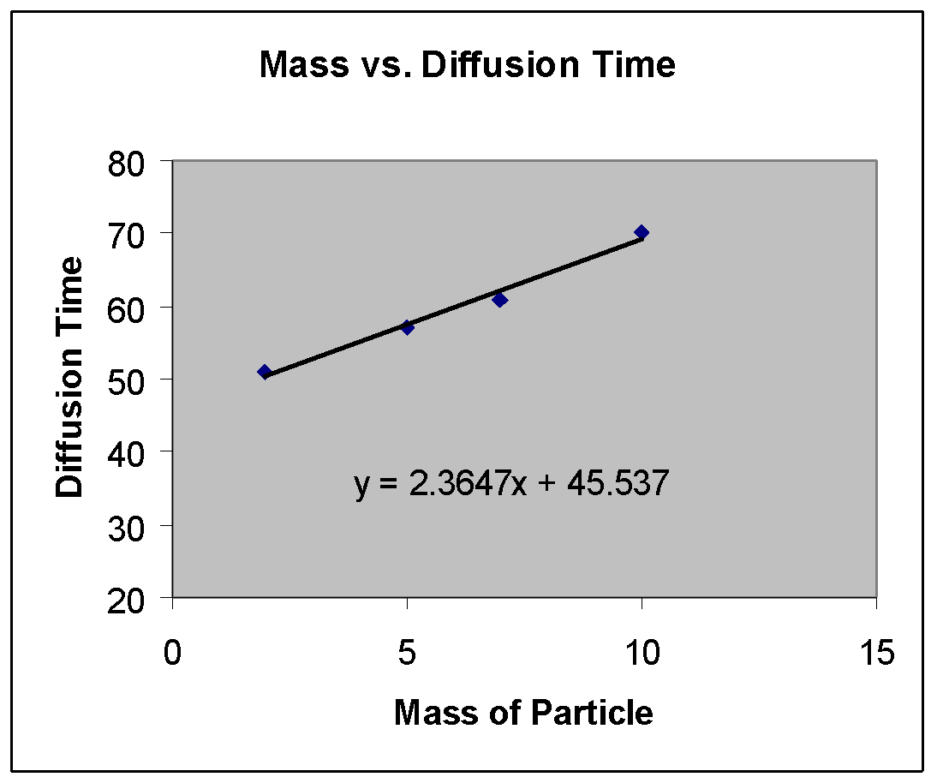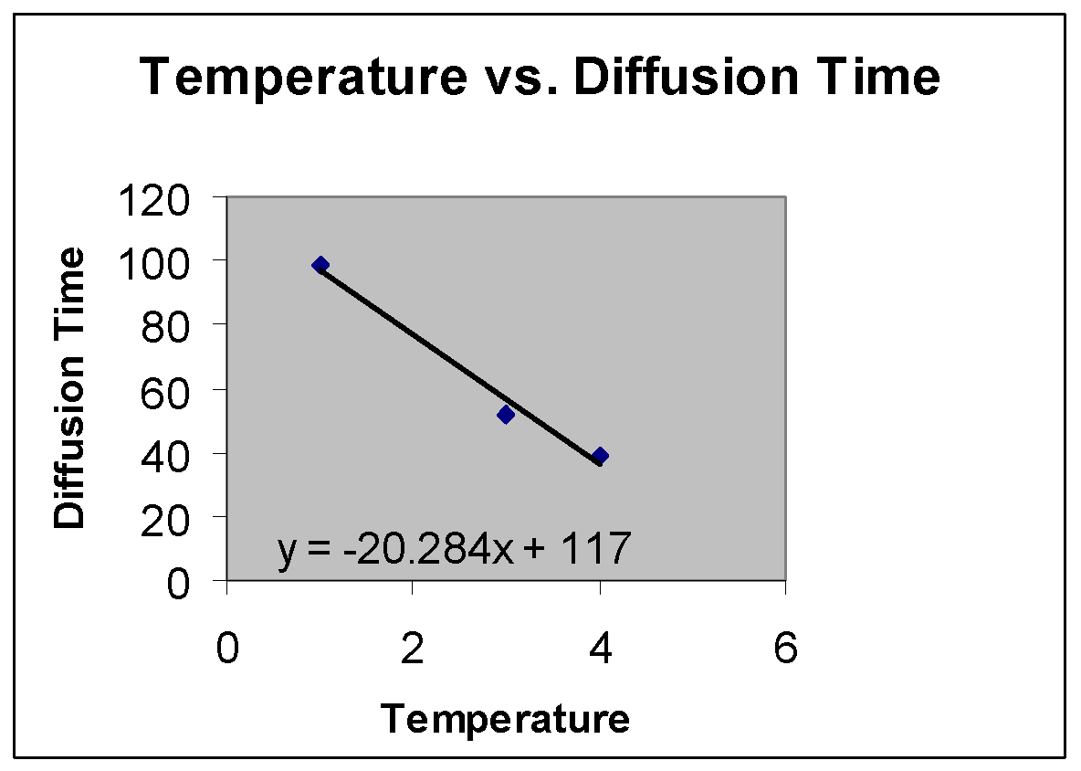

**Wet Lab 2: OSMOSIS EXPERIMENT**

**Introduction**

Osmosis occurs when different concentrations of water are separated by a differentially permeable membrane. One example of a differentially permeable membrane within a living cell is the plasma membrane. This experiment demonstrates osmosis by using dialysis membrane, a differentially permeable cellulose sheet that permits the passage of water but obstructs passage of large molecules. If you could examine the membrane with a scanning electron microscope, you would see that it is porous. Thus molecules larger than the pores cannot pass through the membrane.

# **Materials**

Per student group (4):

415 cm lengths of dialysis tubing, soaking in dH2O

810 cm pieces of string

ring stand and funnel apparatus

25 mL graduated cylinder

4 small string tags

china marker

4400 mL beakers

Per student group (table):

Dishpan half-filled with dH2O

Paper toweling

Balance

Per lab room:

Source of dH2O (at each sink)

Sucrose solutions 15% and 30%

Scissor (at each sink)

# **Procedure**

Work in groups of two or four for this experiment.

1. Obtain four sections of dialysis tubing, each 15 cm long, which have been presoaked in distilled water. Recall that the dialysis tubing is permeable to water molecules but not to sucrose.
2. Fold over one end of each tube and tie it tightly with string.
3. Attach a string tag to the tied end of each bag and number them form 1 through 4.
4. Slip the open end of the bag over the stem of a funnel. Using a graduate cylinder to measure volume, fill the bags as follows:

Bag 1. 10mL of distilled water

Bag 2. 10mL of 15% sucrose

Bag 3. 10mL of 30% sucrose

Bag 4. 10mL of distilled water

1. As each bag is filled, force out excess air by squeezing the bottom end of the tube.
2. Fold the end of the bag and tie it securely with another piece of string.
3. Rinse each filled bag in the dishpan containing distilled water (dH2O); gently blot off the excess water with paper toweling.
4. Weigh each bag to the nearest 0.5 g.
5. Record the weights in the column marked “0 min” on the table provided.
6. Number four 400mL beakers with a china marker.
7. Add 200 mL of dH2O to beakers 1 through 3.
8. Add 200 mL of 30% sucrose solution to beaker 4.
9. Place bags 1 through 3 in the correspondingly numbered beakers.
10. Place bag 4 in the beaker containing 30% sucrose.
11. After 20 minutes, remove each bag form its beaker, blot off the excess fluid, and weigh each bag.
12. Record the weight of each bag on the table provided.
13. Return the bags to their respective beakers immediately after weighing.
14. Repeat steps 15 to 17 at 40, 60, and 80 minutes from time zero.

At the end of the experiment, take the bags to the sink, cut them open, pour the contents down the drain and discard the bags in the wastebasket. Pour the contents of the beakers down the drain and wash them according to the instructions given by your teacher.

## OSMOSIS DATA TABLE AND QUESTIONS

| No. | Bag/Beaker Contents | Bag Weight (g)  0 Min | Bag Weight (g)  20 Min | Bag Weight (g)  40 Min | Bag Weight (g)  60 Min | Bag Weight (g)  80 Min | Weight change  (g) |
| --- | --- | --- | --- | --- | --- | --- | --- |
| 1 | Distilled water/  Distilled water |  |  |  |  |  |  |
| 2 | 15% Sucrose/  Distilled water |  |  |  |  |  |  |
| 3 | 30% Sucrose/Distilled water |  |  |  |  |  |  |
| 4 | Distilled water/  30% Sucrose |  |  |  |  |  |  |

Please, answer the following questions.

1. Was the direction of net movement of water in bags 2 to 4 into or out of the bags?
2. Which bag gained the most weight? Why?
3. Make a qualitative statement about what you observed.
4. Use the data above to make a graph in Excel.

# **SimuLab Lab 2: Osmosis**

Purpose: This lab will provide students with an opportunity to compare the macroscopic results of their osmosis wet lab with the molecular events underlying the process of osmosis. Specifically, this program simulates the movement of water into a cell in response to the concentration gradient established by varying amounts of protein molecules in the cell. In addition the student will collect quantitative data, export the data to Excel and analyze their results graphically.

Materials: Student will need the Universal Player, the Universal Osmosis file series, Notepad or other simple text editor, and Microsoft Excel or other suitable spreadsheet program.

Methods:

* Start the Universal Player and Excel
* Select Start Simulation and Additional Files to open the Osmosis000 file.
* Set the time delay at 10
* Before running the program select File/Save Data. Select data interval of 100, save only Average Radius, and save as a text file on a floppy disk (e.g. osm000.txt, osm025.txt, etc.).
* Run the program for 2000 time units and then close the simulation.
* Open the saved data file with Notepad and use the copy/paste commands to export the data to Excel
* Use the Excel graph wizard to create a graph of time vs. average radius. Include a trend line for the data.
* Repeat this process for the files Osmosis025, 050, 100, and 150 thereby creating a single graph with the data for all five files.

Analysis: Use the graph of the time vs. average radius for the five files students should be able to conclude that increasing the “protein” concentration in the cell increases the rate of water movement into the cell and increases the average radius (and therefore the volume) of the cell. Further discussion can relate these results to osmotic pressure and to turgor pressure in plant cells that have a fixed volume.

Sample Data and Graphs for SimuLab 2: Osmosis

| Time |  | Ave. Radius of Cell | |  |  |
| --- | --- | --- | --- | --- | --- |
|  | 0 | 25 | 50 | 100 | 150 |
| 100 | 14.4 | 15.7 | 18.9 | 22.3 | 25.3 |
| 200 | 16.3 | 17.2 | 21.3 | 25.6 | 28.0 |
| 300 | 16.6 | 18.7 | 22.6 | 27.6 | 29.5 |
| 400 | 16.5 | 20.2 | 22.9 | 27.9 | 30.2 |
| 500 | 16.4 | 22.0 | 23.2 | 28.3 | 31.1 |
| 600 | 18.0 | 22.9 | 24.8 | 29.1 | 31.8 |
| 700 | 19.2 | 24.0 | 24.9 | 30.4 | 32.2 |
| 800 | 19.0 | 25.3 | 24.9 | 30.3 | 32.8 |
| 900 | 17.3 | 25.7 | 25.9 | 29.9 | 33.2 |
| 1000 | 17.8 | 24.6 | 25.5 | 30.9 | 33.9 |
| 1100 | 19.1 | 24.6 | 25.7 | 31.9 | 34.0 |
| 1200 | 19.3 | 24.8 | 25.2 | 32.6 | 34.0 |
| 1300 | 18.2 | 25.5 | 25.6 | 32.4 | 34.0 |
| 1400 | 17.8 | 25.6 | 27.1 | 32.0 | 33.9 |
| 1500 | 18.0 | 25.0 | 27.7 | 32.2 | 33.1 |
| 1600 | 19.0 | 26.1 | 28.9 | 32.6 | 33.0 |
| 1700 | 19.4 | 26.3 | 28.4 | 33.1 | 33.9 |
| 1800 | 19.1 | 25.3 | 28.7 | 33.0 | 34.2 |
| 1900 | 18.2 | 25.7 | 29.2 | 33.4 | 34.4 |
| 2000 | 17.2 | 25.5 | 28.9 | 32.3 | 34.2 |

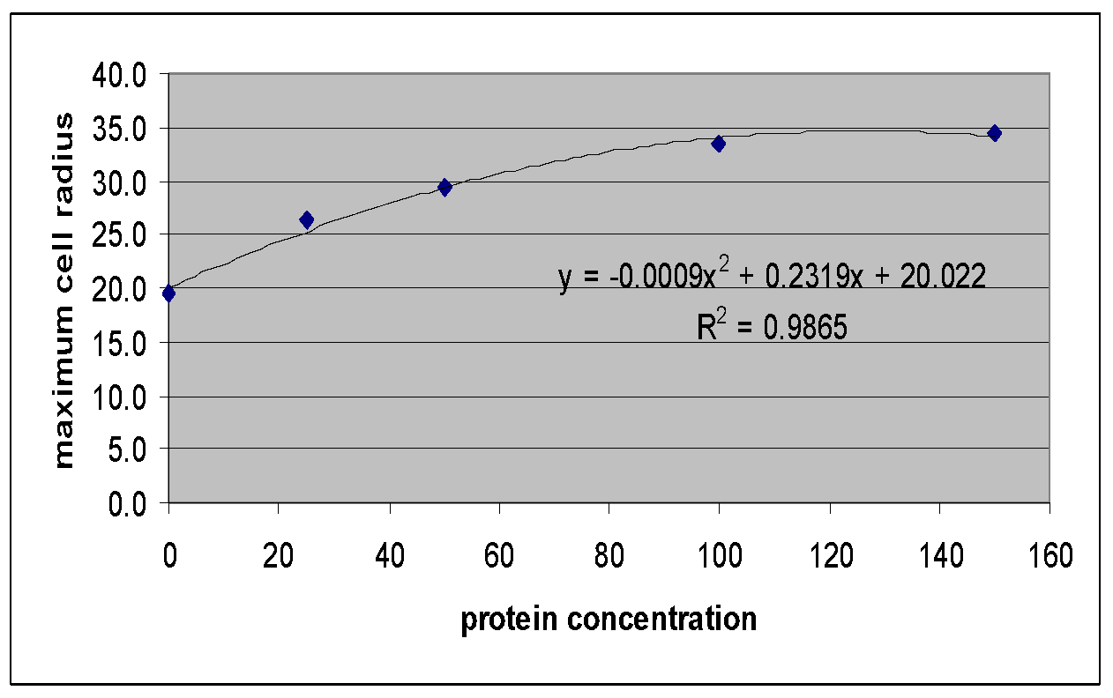

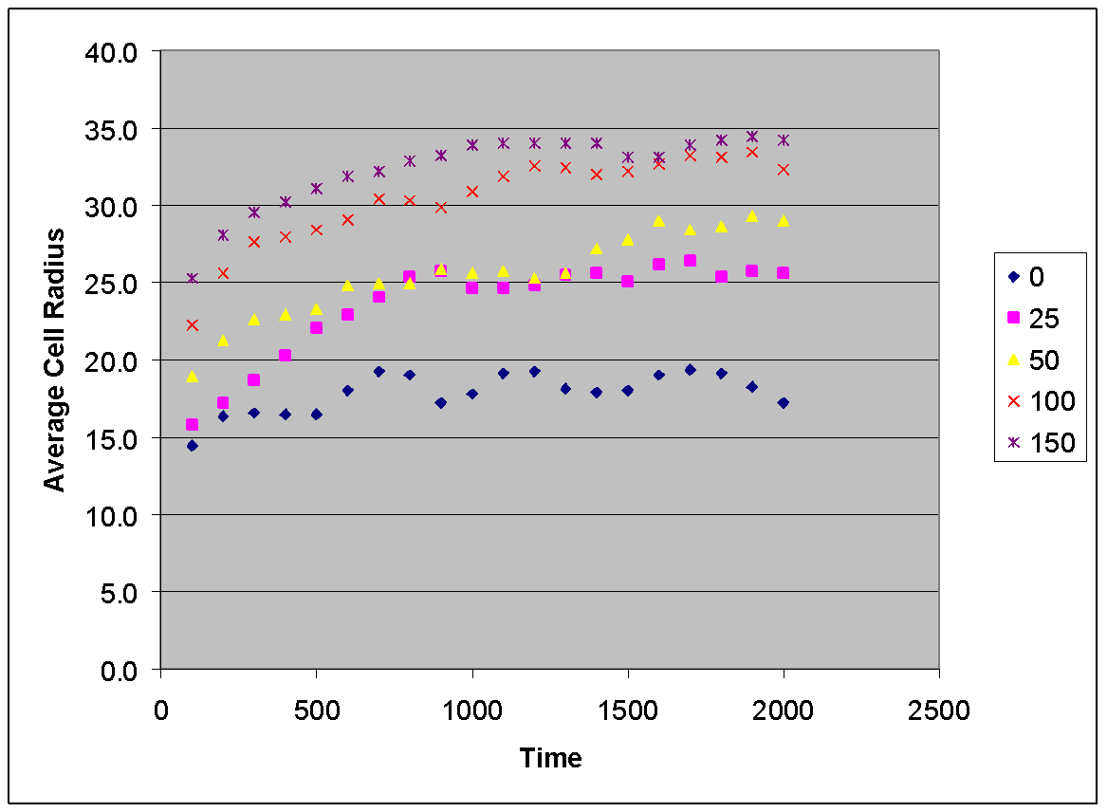**SimuLab 3: Micelle Formation**

Purpose: This is a simple simulation that will give students an opportunity to visualize the formation of membrane like micelles under different conditions and study the behavior of polar phospholipids in water.

Materials: Student will need the Universal Player, the Universal MIcelle files, Notepad or other simple text editor, and Microsoft Excel or other suitable spreadsheet program.

Methods:

* Start the Universal Player and Excel
* Select Start Simulation and Additional Files to open the Micelle file.
* Set the time delay at 1 and run the simulation for 2000 time units.
* Students should write down their qualitative observation on the distribution of the phospholipids at 100 time unit intervals.
* As the micelles form student should record the number of phospholipids in each micelle and record their data in Excel.
* Repeat these steps at varying concentrations of surfactant.

Note: This simulation takes a long time to run. The teacher may wish to make several movies of these simulations and use them in place of the actual simulations.

Analysis: The students should be able to observe the interactions of the phospholipids as the polar groups orient themselves outward toward the water. As the surfactant concentration increases, the micelles will tend to form bilayers. Students can calculate the mean and standard deviation of the number of molecules that form the micelles under different conditions.