### 

### **Science and Plants for Schools – Student Project Starter**

**Catechol Oxidase Activity in Fruits and Vegetables**

*This is a project starter, suitable for Advanced Higher biology investigations or A-level extended projects. Don’t forget to credit this resource in your bibliography by including the title, the website, the web address and the date you accessed it.*

Background information

Catechol oxidase (also called polyphenoloxidase) is an enzyme found in a wide variety of plants. It is responsible for the darkening observed when many fruits or vegetables are cut or bruised.

Catechol oxidase catalyses the reaction of catechol, which is colourless, to the yellow compound, ortho-quinone (o-quinone). o-quinone then reacts with oxygen in the air to form brown-black compounds called melanins.

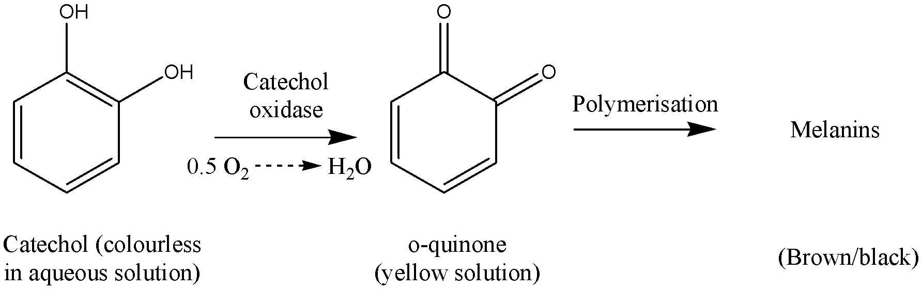

Catechol is present in small quantities in the vacuoles of cells of many plant tissues. Catechol oxidase is present in the cell cytoplasm. If the plant tissues are damaged, the catechol is released and the enzyme converts the catechol to ortho-quinone, which is a natural antiseptic. Catechol oxidase therefore has a role in plant defence mechanisms, helping to protect damaged plants against both bacterial and fungal disease.

It has been suggested that the quantity of catechol oxidase produced by a plant may be related to its susceptibility to fungal infection.

Catechol oxidase activity is also of economic importance. It has been estimated that half the world’s fruit and vegetable crop is lost due to post-harvest browning reactions due to the enzyme.

Technical information

### *A student who does a project to investigate catechol oxidase activity in plant tissues is likely to need the following equipment and materials*

* samples of fruit or vegetable (about 8 g)
* 10 cm3 distilled water
* a little sand
* mortar and pestle
* piece of muslin
* small beaker
* centrifuge (optional)
* centrifuge tubes (optional)
* marker pen
* buffer solution, pH 7
* 0.09 M (1%) catechol solution
* 1 x 10cm3 syringe
* 2 x 1cm3 syringes
* colorimeter with 440 nm filter

# **Preparation of Materials**

Catechol oxidase has a shelf life of only 2-3 days and should be stored in the dark.

Starter experiment

**Introduction**

The enzyme, catechol oxidase, can be extracted from plant tissues by simply grinding plant tissue with a little sand and distilled water, then filtering or centrifuging. Enzyme is present in the liquid extract. Catechol oxidase activity can then be estimated by measuring the rate of colour formation on adding the enzyme to its substrate, catechol in buffer. A colorimeter is used to measure absorbance at 440 nm.

Enzyme activity starts immediately on addition of the enzyme so you must be prepared to start measuring the absorbance.

# **Materials**

* samples of fruit or vegetable (about 8 g)
* 10 cm3 distilled water
* a little sand
* mortar and pestle
* piece of muslin
* small beaker
* centrifuge tubes
* marker pen
* buffer solution, pH 7
* 0.09 M (1%) catechol solution
* 1 x 10 cm3 syringe
* 2 x 1 cm3 syringes
* Stop-clock
* Colorimeter with 440 nm filter
* Cuvette

**Instructions**

1. Mash the fruit, sand and water together thoroughly using a mortar and pestle.
2. Strain the mixture through muslin into a beaker (moisten the muslin first to speed up the filtering process).

Note: the enzyme, catechol oxidase is present in the clear liquid in the beaker. With some fruits and vegetables, it may be necessary to centrifuge the strained liquid to remove the solids. In this instance, pour the strained liquid into a centrifuge tube and centrifuge for about three minutes.

1. Use a syringe to add 10 cm3 buffer solution to a boiling tube.
2. Add 1 cm3 catechol solution to the boiling tube.
3. Prepare a table to record your results showing time in seconds and absorbance at 440nm.
4. Fill a cuvette with water and place in the colorimeter. Calibrate it to zero.
5. Add 1 cm3 enzyme solution (extracted from the fruit or vegetable) to the boiling tube and start the stop-clock.
6. Immediately transfer the solution to a cuvette and record the absorbance at 440 nm every 30 s for five minutes.

Possible project titles

* Investigate the catechol oxidase content of a given fruit at different stages of ripeness.
* Investigate the catechol oxidase content of different varieties of the same fruit.
* Investigate the catechol oxidase content of different fruits.

Resource list

Further information and sample projects are available from the SAPS Biotechnology Scotland Project – 0131 558 8212

SAPS website: [www.saps.org.uk](http://www.saps.org.uk)