**Department of Biology and Biochemistry**

**BIOL111**

**Sheet Session #3: Biological membranes**

Student Name and No. Date:

1. **Diffusion In A Solid**
2. In this experiment the ____________ ion moved faster and further than _____________ and from_______________. This is because

____________________________________________________________________________________________________________________________________________________________________________________________________________.

1. **Osmosis in living cells**

a) Draw the **red blood cell** in the following solutions and briefly state the changes in the plasma membrane:

|  |  |  |
| --- | --- | --- |
| a)0.5% NaCl  Tonicity:______________  Cell status: ___________ | b)0.9% NaCl  Tonicity:______________  Cell status: ___________ | c)10% NaCl  Tonicity:______________  Cell status: ___________ |

1. Draw the **onion cell** in the following solutions and briefly state the changes in the plasma membrane:

|  |  |  |
| --- | --- | --- |
| a)0.5% NaCl  Tonicity:______________  Cell status: ___________ | b)0.9% NaCl  Tonicity:______________  Cell status: ___________ | c)10% NaCl  Tonicity:______________  Cell status: ___________ |

1. **Osmosis in artificial membranes**

Answer the questions regarding the graph below. The graph represents the results of an experiment carried out using artificial cells each filled with sugars at different concentrations and placed in a beaker filled solution.

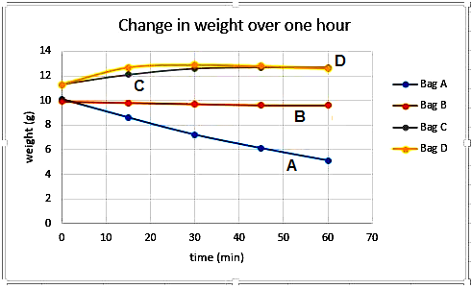

1. Which bag/s was in isotonic beaker?__________________
2. Which bag/s was in hypotonic beaker?________________