

**Department of Biology and Biochemistry**

**BIOL111**

**Expt. #7:Diffusion and Osmosis**

**Name:**  Mohammad Ibrahim Abdul Ghafour Musleh

**ID:**  1162595

**Instructor:** Sanadi Barakat

**TA:**  Haya Hamdat

**Date of Expt.:**  24th Nov., 2016

**Date** **of Submission:** 08th Dec., 2016

**Biological Membranes :Diffusion and Osmosis**

**Objectives:**

To investigate the property of Diffusion and Osmosis, and to observe the acts of passive transport: diffusion and osmosis. We will show how molecules in solution move from areas of higher concentration to areas of lower concentration.

**Introduction:**

A **biological membrane** is an enclosing or separating [membrane](https://en.wikipedia.org/wiki/Membrane) that acts as a [selectively permeable](https://en.wikipedia.org/wiki/Semipermeable_membrane) barrier within living things. Biological membranes, in the form of [cell membranes](https://en.wikipedia.org/wiki/Cell_membrane), often consist of a [phospholipid bilayer](https://en.wikipedia.org/wiki/Phospholipid_bilayer) with embedded, [integral](https://en.wikipedia.org/wiki/Integral_membrane_protein) and [peripheral proteins](https://en.wikipedia.org/wiki/Peripheral_membrane_protein) used in communication and transportation of chemicals and [ions](https://en.wikipedia.org/wiki/Ion). Bulk [lipid](https://en.wikipedia.org/wiki/Lipid) in membrane provides a fluid matrix for proteins to rotate and laterally diffuse for physiological functioning. Proteins are adapted to high [membrane fluidity](https://en.wikipedia.org/wiki/Membrane_fluidity) environment of [lipid bilayer](https://en.wikipedia.org/wiki/Lipid_bilayer) with the presence of an [annular lipid shell](https://en.wikipedia.org/wiki/Annular_lipid_shell), consisting of lipid molecules bound tightly to surface of [integral membrane proteins](https://en.wikipedia.org/wiki/Integral_membrane_proteins). The cellular membranes should not be confused with isolating tissues formed by layers of cells, such as [mucous membranes](https://en.wikipedia.org/wiki/Mucous_membrane) and [basement membranes](https://en.wikipedia.org/wiki/Basement_membrane).**(1)**

Probably the most important feature of a **biological membrane** is that it is a selectively permeable structure. This means that the size, charge, and other chemical properties of the atoms and molecules attempting to cross it will determine whether they succeed in doing so. Selective permeability is essential for effective separation of a cell or organelle from its surroundings. Biological membranes also have elastic properties that allow them to change shape and move as required .Solutes can cross the plasma membrane by simple diffusion, facilitated diffusion or active transport depending on their sizes polarity charge the presence of specialized proteins.

**Simple diffusion:** Is the process by which molecules move from the side that contains high concentration of molecules to the side that contains low concentration of molecules. Generally, small hydrophobic molecules can readily cross phospholipid bilayers by simple [diffusion](https://en.wikipedia.org/wiki/Diffusion). Particles that are required for cellular function but are unable to diffuse freely across a membrane enter through a membrane transport protein or are taken in by means of endocytosis, where the membrane allows for a vacuole to join onto it and push its contents into the cell.

**Osmosis:** Is the diffusion of water molecules across a selectively permeable membrane. Water molecules transfer from a region of higher water concentration (Lower solute concentration) to a region of lower water concentration (Higher solute concentration) through a selectively permeable membrane.

**Materials and Method:**

**In this experiment, materials were used such as:**

Methylene blue, Crystal violet, petri dish 1% agar ,1M AgNO3 , 1M KBr, 1M K3Fe(CN)6, KMnO4 due ,0.1% NaCl ,0.9% NaCl(Saline), 10% NaCl, M NaCl ,IKI, 10% Starch, 70% Ethanol, Onion, Light compound microscope, Watch glass, Beakers, Dialysis bag, Lancets, 1% Phenolphthalein, 2% agar containing NaOH and Phenolphthalein, 0.1M HCl, 0.1M NaOH, and dull knife.

**Then the methods are:**

**Diffusion in a liquid:**

A 50ml-beaker was filled with water. It was not move for 10 minutes. A drop of Crystal violet was added to the surface of water. The drop of dye was not splashed. The spreading of dye through the solution was observed. At the end of the lab session the change in colour of water in the beaker was noticed.

**Diffusion in a solid:**

A petri dish of 1.5% agar- already prepared to have 4 holes was taken. One drop of the following solutions (AgNO3, NaCl, KBr, and K3Fe(CN)6) was added to the corresponding holes with a dropper. The holes should not be over filled and they should be filled to same level. To another petri dish one drop of the following solutions (KMnO4, methylene blue, diluted KMnO4, and diluted methylene blue) was added. The two petri dishes were placed on the bench until the colour band forming with the solutions meets solution A was seen. Negative ions (Cl-, Br-, Fe(CN)6-3) from other solution were reacted with Ag+ to form precipitate. The halo formed due to diffusion of KMnO4 and methylene blue in the agar was observed. In the first petri dish the distance between each hole and the colour band was measured. The measurements were recorded. The relative rate of diffusion of (Cl-, Br- and Fe(CN)6-3) ions were ranked as slow, faster, fastest. The diameter of the halo formed due to the diffusion of the KMnO4 and methylene blue was measured. The effect of dilution on the rate of diffusion in both dyes was observed. The results were recorded.

**Diffusion in an artificial cell:**

Dialysis bag with 10% starch solution was filled. Both ends were tied up well and the bag was rinsed in water. The dialysis bag in a beaker containing a diluted iodine solution was immersed. The results were recorded after two hours.

**Osmosis in animal cell (Red blood cells):**

Four ml the following distilled water, 0.1% NaCl, Saline (0.9% NaCl), 10% NaCl were added to four test tubes. The tip of a student’s finger (Aseel) was cleaned with a piece of cotton with sterile lancet the tip of her cleaned finger was punctured. One to two drops of blood were added to each of the solution in above. Her finger was cleaned. A drop from each solution mix with blood was taken and made a wet mount. Under the compound microscope the slides were examined. Observations were drawn.

**Osmosis in plant cells (Onion cells):**

Four ml the following distilled water, 0.1% NaCl, Saline (0.9% NaCl), 10% NaCl were added to four watch glasses. Small and uniform sections of onion were cut and added to the referred salt solutions for five minutes. The epidermis of the onion section socked in the previous salt solutions was pulled and made wet mount. The prepared slides under the compound microscope were examined. Observations were drawn. While examining the wet mount of the onion epidermis in 10% NaCl, few drops of distilled water were put on the edge of the cover slip and the water was absorbed by a piece of paper from the other edge. Observations were drawn and explained.

**Data and Results:**

**Diffusion in a liquid:**

I put one drop of crystal violet in 50-ml water and I leave it for one hour then I observed that the crystal violet diffused in water (from high concentration of crystal violet to low concentration of crystal violet).

-A-

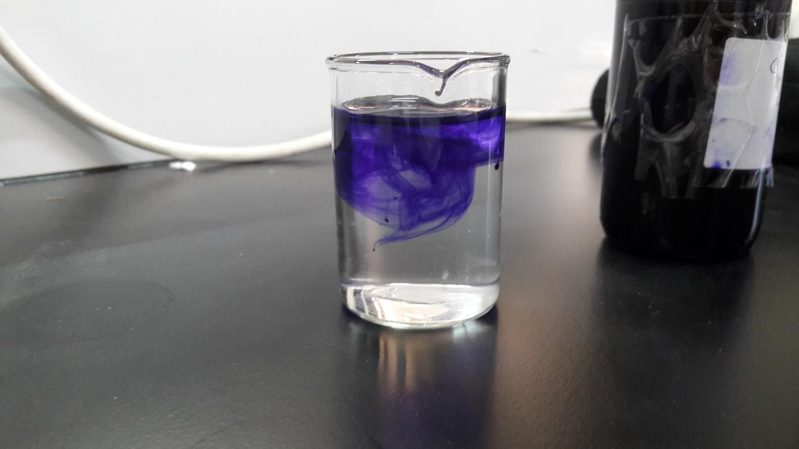

-B-

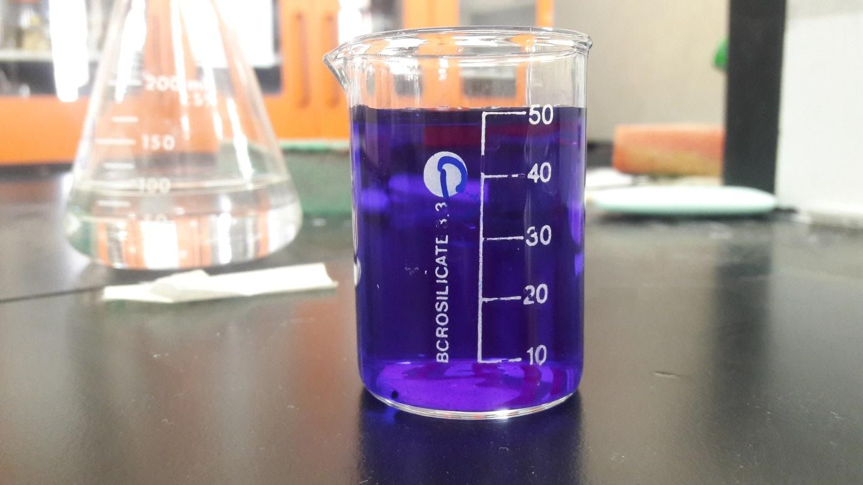

Figure 1: Diffusion in a Liquid. (A) The first second. (B) After 1 hour.

**Diffusion in a solid:**

I brought two petri dishes of 1.5% agar and placed in each one a drop of different solutions. In the first petri dish I placed 1M AgNO3, 1M K3Fe(CN)6, 1M KBr, and 1M NaCl. In the second petri dish I placed methylene blue (S3CIN18H16C), diluted methylene blue solution, potassium permanganate (KMnO4), diluted potassium permanganate solution. I observed that the rate of diffusion is affected by the molar mass or molecular weight. i.e. when the molar mass is big, the diffusion became slow and its rate became small and vice versa.

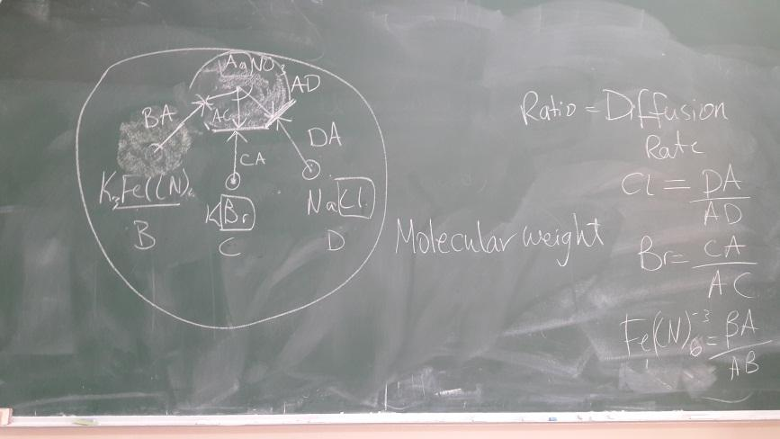

Figure 2: Diffusion in a Sold

**Diffusion in an artificial cell:**

I placed 10% starch solution in dialysis bag and tie up both ends then I put it in water after that I placed diluted iodine solution (KI) in water. I observed after 2-3 hours that diluted iodine solution is diffused in the white dialysis bag and change its colour from white to black-blue.

-A- -B-

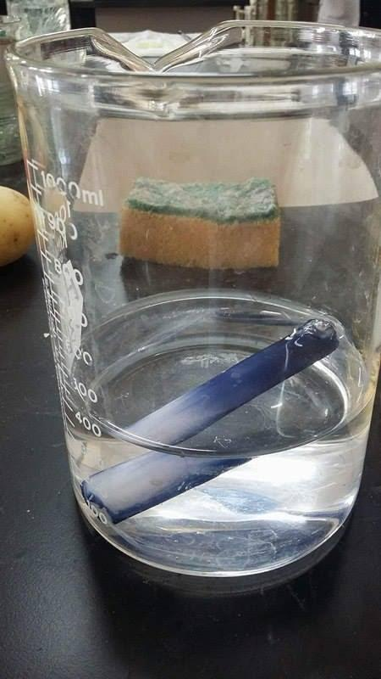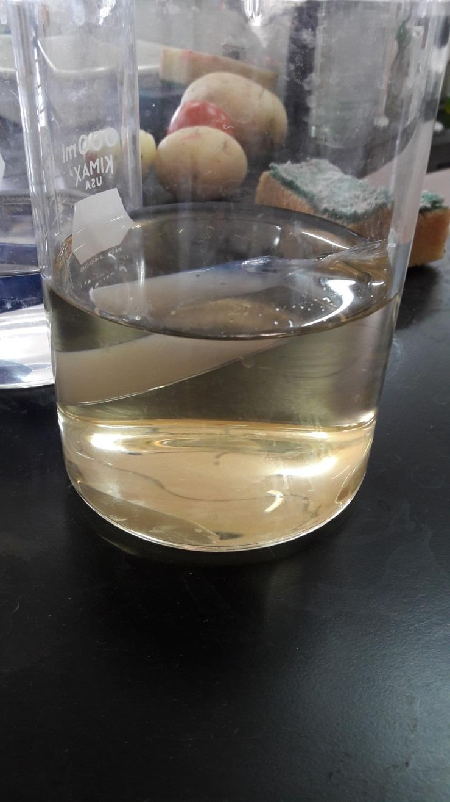

Figure 3: Diffusion in an Artificial Cell (A) The first minute. (B) After 2 hours.

**Osmosis in animal cell (Red blood cells):**

I placed blood sample (1-2 drops) in each 4ml of the following distilled water, 0.1% NaCl, Saline (0.9% NaCl), 10% NaCl. Then I examined the slides under the compound microscope. I observed that the different concentrations of solution have effects on the cell.

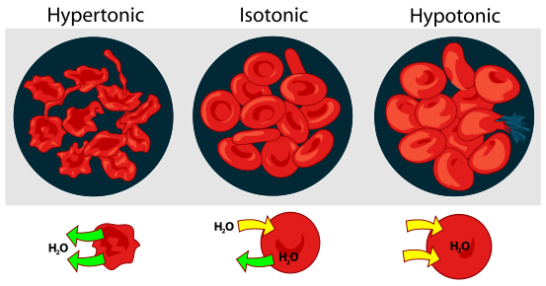

Figure 4: Osmosis in an Animal Cell (Red blood cells)- Types of osmosis.

**Osmosis in plant cells (Onion cells):**

I placed uniform sections of onion in four watch glasses which contain the following: distilled water, 0.1% NaCl, Saline (0.9% NaCl), 10% NaCl. Then I made wet mount and prepared the slides. After that I examined them under the compound microscope. I observed that the different concentrations of solution have effects on the cell on the cell, but the cell wall protected the cell from die.

**Discussion:**

When I put the crystal violet in water it is diffused from high concentration of crystal to low concentration of crystal and changed the water colour from colourless to violet.

The molar mass has effects on the speed of diffusion. The rate of diffusion is affected by the molar mass or molecular weight. i.e. when the molar mass is big, the diffusion became slow and its rate became small and vice versa.

When we put 10% Starch in artificial cell and placed it in water with few drop of IKI the colour of artificial cell change from white to blue; this means that IKI is diffused in artificial cell (High concentration of IKI to low concentration of IKI).

When I put samples of blood in different solutions, the state of blood cells will change or remains fixed. In distilled water the blood cells will be hypotonic (Lysed). This explains that the blood cell contains high number of solutions and salt in comparison with distilled water that does not contain any salt. So, the water molecule will inter to the blood cell then the cell will grow very much, the same thing in 0.1% NaCl, but in 0.9% NaCl (Saline) the blood cells will be isotonic (Normal) because the water molecules that go into and get out of the blood cell are equal and because the quantity of salt in saline and blood cell are equal. In10% NaCl, the blood cells will be hypertonic (Shrivelled) because water molecules get out of the blood cells because the concentration of 10% NaCl inside blood cells is lower than the outside of blood cells .

When I put four uniform sections of onion in four different solutions (concentration of different solutions) the state of onion cells will change or remains fixed. In distilled water the onion cells will be hypotonic (Turgid- Normal). This explains that the onion cell contains high number of solutions and salts in comparison with distilled water that does not contain any salt. So the water molecules will go into to the onion cell, the same thing in 0.1% NaCl, but in 0.9% NaCl (Saline) the onion cells will be isotonic (Flaccid) because the water molecules go into and get out from the cell are equal and because quantity of salt in saline and onion cell are equal. In 10% NaCl, the onion cells will be hypertonic (Shrivelled- plasmolyzed) water molecules get out from onion cells because the concentration of 10% NaCl inside onion cells is lower than the outside of onion cells .

**Conclusion:**

The pigments are diffused in water easily, and the temperature has an effect on the speed of diffusion. The molecular weight affects on the speed of diffusion and the rate of diffusion. The diffusion will be slow and the rate will be low if the molecular weight is big and vice versa. It is the same; if I put two gases in two tubes and the molar mass of gas (A) is bigger than the molar mass of gas (B), then I will observe that gas (B) is faster than gas (A). The artificial cell contains 10% starch it has low concentration of IKI in comparison with water that contains IKI. The blood cells with different concentration of NaCl and distilled water will be affected by osmosis diffusion of water from low concentration of salt to high concentration. The same thing in onion cells for the process osmosis but the big and main difference is that, the onion cells contain cell walls which contain cellulose that supports the cell and protects it from the dangerous thing.

**References:**

1. [**https://en.wikipedia.org/wiki/Biological_membrane**](https://en.wikipedia.org/wiki/Biological_membrane)**.**

**Appendix:**

**Q1:** What is different between diffusion of small molecule and large molecule in liquid ? (Do smaller of larger molecule diffuse faster?)

**A1:** Smaller molecules diffuse faster than larger molecules. The smaller molecules are able to move more quickly at a given temperature than larger molecules, allowing them diffuse across the membrane with greater speed.

**Q2:** What is the function of cholesterol in plasma membrane ?

**A2:**When you sleep in a cold room, you may have a couple of layers of blankets that you roll up in to keep warm. The blankets help protect your body from the cold room; this is similar to the role the cell membrane plays when it 'rolls up' around a cell. Your body is made up of trillions of these cells, which are small units working together to create organisms like you. The cells in your body have a membrane that acts like your blanket and surrounds and protects the cell. If you travel inside the cell you would find it is filled with fluid called plasma and many small parts that are vulnerable to the outside world. The cell membrane, also called plasma membrane, surrounds the cell and protects what is inside from the outside environment. This lesson will look at the cell membrane in detail and focus on cholesterol, which is one of the components found in the cell membrane.

Cholesterol is similar to phospholipids in regards to having a hydrophilic, and a hydrophobic portion. This would be referred to as being amphiphilic. The hydrophilic portion of the cholesterol bonds to the hydrophilic heads within the membrane layers. The hydrophobic regions of the cholesterol fit in between the tails of the membrane layer. The cholesterol interacts with the tails of the membrane and gives the membrane unique properties. The cholesterol assists with stability of the membrane, keeps the membrane from becoming solid at cooler temperatures, and helps anchor molecules, like protein, in the membrane. Cholesterol Helps Maintain the Fluidity of Cell Membranes. s Helps Secure Important Proteins in the Membrane, and their forth.