**Chapter One**

**Terms**

**Biology** The scientific study of life

**Emergent Properties** New properties that arise with each step upward in the hierarchy of life, owing to the arrangement and interactions of parts as complexity increases

**Systems Biology** An approach to studying biology that aims to model the dynamic behavior of whole biological systems based on a study of the interactions among the system's part

**Temperature** A measure of the intensity of heat in degrees, reflecting the average kinetic energy of molecules

**eukaryotic cell** a type of cell with a membrane-enclosed nucleus and membrane-enclosed organelles.

**Prokaryotic cell** a type of cell lacking a membrane-enclosed nucleus and membrane-enclosed organelles.

**Deoxyribonucleic Acid (DNA)** A nucleic acid molecule, usually a double-stranded helix

**Gene** a discrete unit of hereditary information consisting of a specific nucleotide sequence in DNA (or RNA in some viruses)

**Negative feedback** a form of regulation in which accumulation of an end product of a process slows the process

**Positive Feedback** a form of regulation in which an end product of a process speeds up that process

**Science** an approach to understanding the natural world

**Questions**

**Choose the best answer .**

**1. A localized group of organisms that belong to the same species is called a**

A) biosystem B) community C) population D) ecosystem E) family

**The main source of energy for producers in an ecosystem is**

A) light energy B) kinetic energy C) thermal energy

D) chemical energy E) ATP

**3. Which of the following types of cells utilize deoxyribonucleic acid (DNA) as their genetic material but do not have their DNA encased within a nuclear envelope?**

A) animal B) plant C) archaea D) fungi E) protists

**4. Prokaryotes are classified as belonging to two different domains. What are the domains?**A) Bacteria and Eukarya B) Archaea and Monera C) Eukarya and Monera

D) Bacteria and Protista E) Bacteria and Archaea

**5. A water sample from a hot thermal vent فجوة أنبوبة contained a single-celled organism that had a cell wall but lacked a nucleus. What is its most likely classification?**A) Eukarya B) Archaea C) Animalia D) Protista E) Fungi

**6. A filamentous organism has been isolated from decomposing organic matter. This organism has a cell wall but no chloroplasts. How would you classify this organism?   
A) domain Bacteria, kingdom Prokaryota** B) domain Archaea, kingdom Bacteria   
C) domain Eukarya, kingdom Plantae D) domain Eukarya, kingdom Protista   
E) domain Eukarya, kingdom Fungi

**7. Which of these provides evidence of the common ancestry of all life?**A) ubiquitous use of catalysts by living systems

B) near universality of the genetic code   
C) structure of the nucleus

D) structure of cilia

E) structure of chloroplasts

**8. Charles Darwin proposed a mechanism for descent with modification that stated that organisms of a particular species are adapted to their environment when they possess**A) non-inheritable traits that enhance their survival in the local environment.   
B) non-inheritable traits that enhance their reproductive success in the local environment.   
C) non-inheritable traits that enhance their survival and reproductive success in the local environment.   
D) inheritable traits that enhance their survival and reproductive success in the local environment.   
E) inheritable traits that decrease their survival and reproductive success in the local environment.

**9. All the organisms on your campus make up**A) an ecosystem. B) a community. C) a population. D) an experimental group.   
E) a taxonomic domain.

**10. Which of the following is a correct sequence of levels in life's hierarchy, proceeding downward from an individual animal?**A) brain, organ system, nerve cell, nervous tissue   
B) organ system, nervous tissue, brain   
C) organism, organ system, tissue, cell, organ   
D) nervous system, brain, nervous tissue, nerve cell   
E) organ system, tissue, molecule, cell

**11. Systems biology is mainly an attempt to**A) analyze genomes from different species.   
B) simplify complex problems by reducing the system into smaller, less complex units.   
C) understand the behavior of entire biological systems.   
D) build high-throughput machines for the rapid acquisition of biological data.   
E) speed up the technological application of scientific knowledge.

**12. Protists and bacteria are grouped into different domains because**A) protists eat bacteria.   
B) bacteria are not made of cells.   
C) protists have a membrane-bounded nucleus, which bacterial cells lack.   
D) bacteria decompose protists.   
E) protists are photosynthetic.

**13. Which of the following best demonstrates the unity among all organisms?**A) matching DNA nucleotide sequences B) descent with modification   
C) the structure and function of DNA D) natural selection   
E) emergent properties

**Understand well**

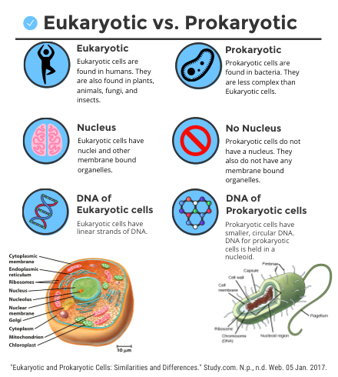A) animal B) plant C) archaea D) fungi E) protists