**1. Molecules with which functional groups may form polymers via dehydration reactions?**A) hydroxyl groups B) carbonyl groups C) carboxyl groups

**Chapter 5: Biological Molecules (Carbohydrates and Lipids)**

Name: No.:

D) either carbonyl or carboxyl groups E) either hydroxyl or carboxyl groups

**2. Which of these molecules is not formed by dehydration reactions?**A) fatty acids B) disaccharides C) DNA D) protein E) amylose

**3. Which of these classes of biological molecules consist of both small molecules and macromolecular polymers?**

A) lipids B) carbohydrates C) proteins D) nucleic acids E) lipids,

**4. Which of the following is not a polymer?**A) glucose B) starch C) cellulose D) chitin E) DNA

**5. How many molecules of water are needed to completely hydrolyze a polymer that is 11 monomers?**A) 12 B) 11 C) 10 D) 9 E) 8

**6. Which of the following polymers contain nitrogen?**A) starch B) glycogen C) cellulose D) chitin E) amylopectin

**7. The molecular formula for glucose is C₆H₁2O₆. What would be the molecular formula for a molecule made by linking three glucose molecules together by dehydration reactions?**A) C₁₈H₃₆O₁₈ B) C₁₈H₃₂O₁₆ C) C₆H₁₀O₅ D) C1₈H₁₀O₁₅ E) C₃H₆O₃

**8. On food packages, to what does the term insoluble fiber refer?**A) cellulose B) polypeptides C) starch D) amylopectin E) chitin

**9. A molecule with the chemical formula C₆H₁₂O₆ is probably a**A) carbohydrate. B) lipid. C) monosaccharide D) carbohydrate and lipid only.   
E) carbohydrate and monosaccharide only.

**10. Lactose, a sugar in milk, is composed of one glucose molecule joined by a glycosidic linkage to one galactose molecule. How is lactose classified?**A) as a pentose B) as a hexose C) as a monosaccharide D) as a disaccharide

**11. All of the following are polysaccharides except**A) lactose. B) glycogen. C) chitin. D) cellulose. E) amylopectin.

**12. A molecule with the formula C₁₈H3₆O₂ is probably a**A) carbohydrate. B) fatty acid. C) protein. D) nucleic acid. E) hydrocarbon.

**13. Which of the following is true regarding saturated fatty acids?**A) They are the predominant fatty acid in corn oil.  
B) They have double bonds between carbon atoms of the fatty acids.   
C) They are the principal molecules in butter.   
D) They are usually liquid at room temperature.   
E) They are usually produced by plants.

**14. Large organic molecules are usually assembled by polymerization of a few kinds of simple subunits. Which of the following is an exception to this statement?**A) a steroid B) cellulose C) DNA D) an enzyme E) a contractile protein

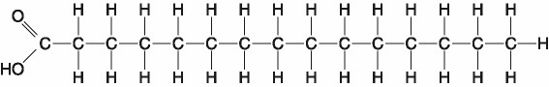

**15. Which of the following statements is true regarding the molecule illustrated in the figure above?**A) It is a saturated fatty acid.   
B) A diet rich in this molecule may contribute to atherosclerosis.   
C) Molecules of this type are usually liquid at room temperature.   
D) It is a saturated fatty acid and a diet rich in this molecule may contribute to atherosclerosis.

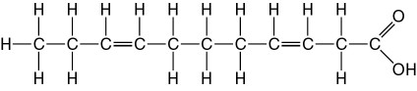

**16. The molecule shown in figure above is a**A) polysaccharide. B) polypeptide. C) saturated fatty acid. D) triacylglycerol. E) unsaturated fatty acid.

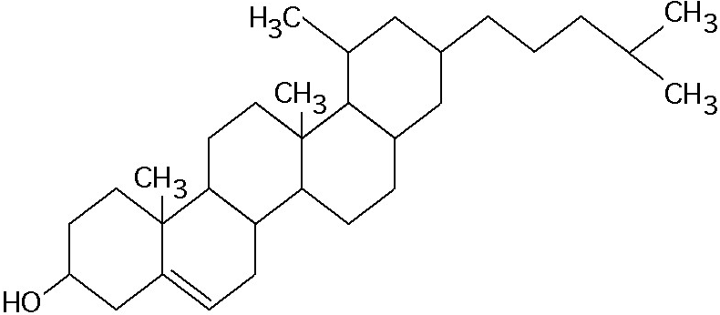

**17. What is the structure shown in the figure above?**A) pentose molecule B) fatty acid molecule C) steroid molecule D) oligosaccharide molecule

**18. Which of the following categories includes all others in the list?**A) monosaccharide B) disaccharide C) starch D) carbohydrate E) polysaccharide

**19. Which of the following statements concerning unsaturated fats is true?**A) They are more common in animals than in plants.   
B) They have double bonds in the carbon chains of their fatty acids.   
C) They generally solidify at room temperature.   
D) They contain more hydrogen than do saturated fats having the same number of carbon atoms.   
E) They have fewer fatty acid molecules per fat molecule.

**20. The molecular formula for glucose is C₆H₁₂O₆. What would be the molecular formula for a polymer made by linking ten glucose molecules together by dehydration reactions?**A) C₆₀H₁₂₀O₆₀ B) C₆H₁₂O₆ C) C₆₀H₁₀₂O₅₁ D) C₆₀H₁₀₀O₅₀ E) C₆₀H₁₁₁O₅₁