**1. What is the term for metabolic pathways that release stored energy by breaking down complex molecules?**

**Respiration Quiz 1** (Name Number

A) anabolic pathways

B) catabolic pathways

C) fermentation pathways

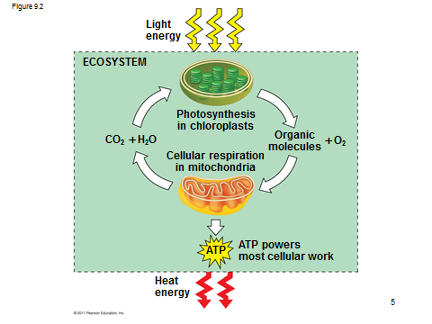

**2. The molecule that functions as the reducing agent (electron donor) in a redox or oxidation-reduction reaction**A) gains electrons and gains potential energy.

B) loses electrons and loses potential energy.   
C) gains electrons and loses potential energy.

D) loses electrons and gains potential energy.

[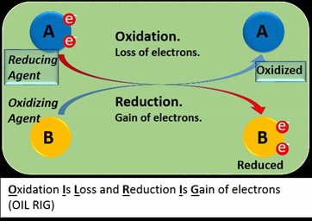](https://www.google.ps/url?sa=i&rct=j&q=&esrc=s&source=images&cd=&cad=rja&uact=8&ved=2ahUKEwibtoHctKnhAhUK36QKHcxxCnAQjRx6BAgBEAU&url=https://study.com/academy/lesson/reducing-agent-definition-examples-quiz.html&psig=AOvVaw2hds0dmfTi0X0DEslS4IVC&ust=1554019671035545)

**3. Which of the following statements describes the results of this reaction?   
C₆H₁₂O₆ + 6 O₂ → 6 CO₂ + 6 H₂O + Energy**

A) C₆H₁₂O₆ is oxidized and O₂ is reduced.

B) O₂ is oxidized and H₂O is reduced.   
C) CO₂ is reduced and O₂ is oxidized.

D) C₆H₁₂O₆ is reduced and CO₂ is oxidized.   
E) O₂ is reduced and CO₂ is oxidized.

[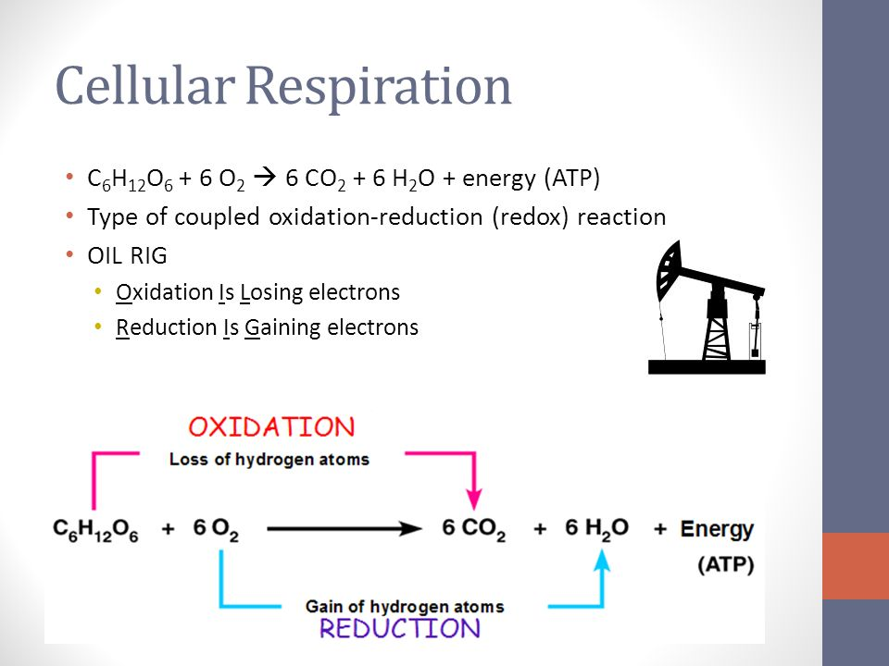](https://www.google.ps/url?sa=i&rct=j&q=&esrc=s&source=images&cd=&cad=rja&uact=8&ved=2ahUKEwi8rqiKtanhAhVKjqQKHb7-DhkQjRx6BAgBEAU&url=https://slideplayer.com/slide/8081621/&psig=AOvVaw2xnExtoGzhYZmpBOy-N-hy&ust=1554019802038589)

**4. When a glucose molecule loses a hydrogen atom as the result of an oxidation-reduction reaction, the molecule becomes**

A) hydrolyzed.

B) hydrogenated.

C) oxidized.

D) reduced.

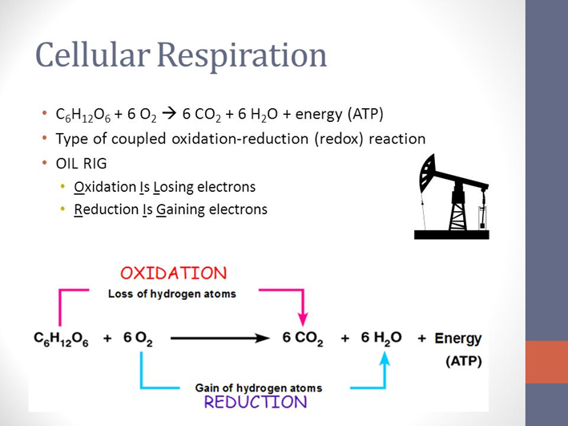

**5. Which of the following statements describes NAD⁺?**A) NAD⁺ is reduced to NADH during glycolysis, pyruvate oxidation, and the citric acid cycle.   
B) NAD⁺ has more chemical energy than NADH.   
C) NAD⁺ is oxidized by the action of hydrogenases.   
D) NAD⁺ can donate electrons for use in oxidative phosphorylation.   
E) In the absence of NAD⁺, glycolysis can still function.

**6. Where does glycolysis take place in eukaryotic cells?**A) mitochondrial matrix

B) mitochondrial outer membrane

C) cytosol

[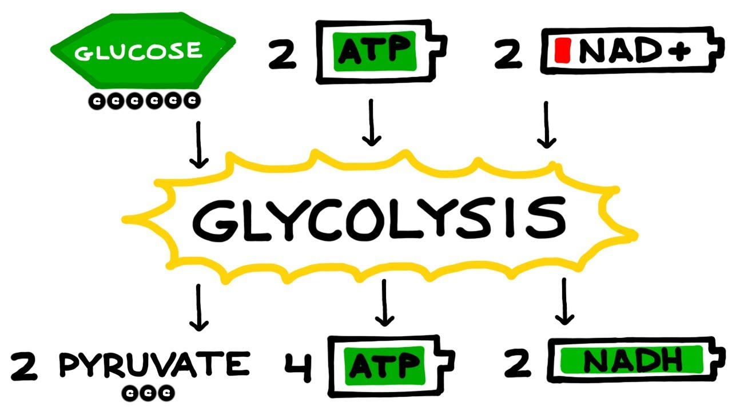](https://www.google.ps/url?sa=i&rct=j&q=&esrc=s&source=images&cd=&cad=rja&uact=8&ved=2ahUKEwjusLSft6nhAhURsKQKHaFDAIUQjRx6BAgBEAU&url=https://www.youtube.com/watch?v=-X7WeHnUuuc&psig=AOvVaw0MJNJTsWIlNc35u5xKZvFz&ust=1554020359871127)

**7. The ATP made during glycolysis is generated by**A) substrate-level phosphorylation.

B) electron transport.

C) photophosphorylation.

D) chemiosmosis.

[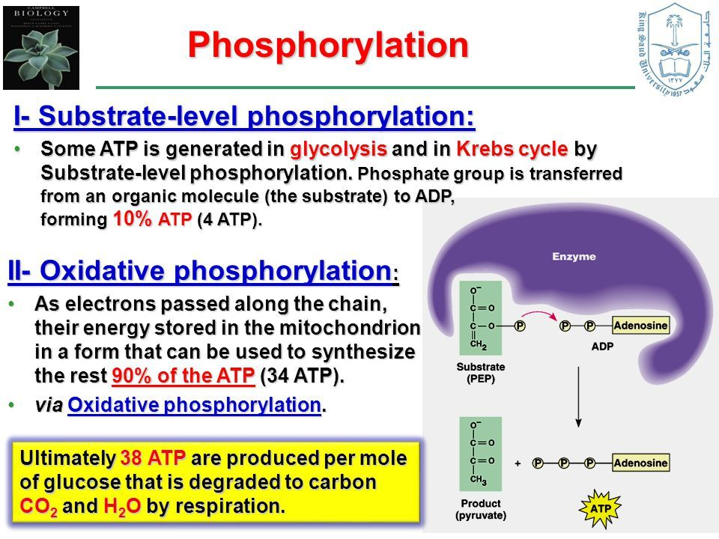](http://www.google.ps/url?sa=i&rct=j&q=&esrc=s&source=images&cd=&cad=rja&uact=8&ved=2ahUKEwjTxea7t6nhAhUPNOwKHVNJBE0QjRx6BAgBEAU&url=/url?sa=i&rct=j&q=&esrc=s&source=images&cd=&ved=&url=https://www.pinterest.com/pin/825636544161543676/&psig=AOvVaw30vAgwp2D8If1aCRu2eWqJ&ust=1554020436286083&psig=AOvVaw30vAgwp2D8If1aCRu2eWqJ&ust=1554020436286083)

**8. The oxygen consumed during cellular respiration is involved directly in which process or event?**A) glycolysis

B) accepting electrons at the end of the electron transport chain   
C) the citric acid cycle

D) the oxidation of pyruvate to acetyl CoA

[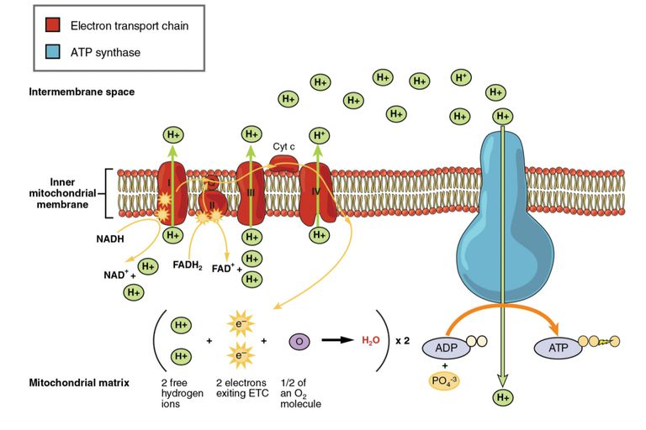](https://www.google.ps/url?sa=i&rct=j&q=&esrc=s&source=images&cd=&cad=rja&uact=8&ved=2ahUKEwjrtqrjt6nhAhVS46QKHZFoDK4QjRx6BAgBEAU&url=https://www.thoughtco.com/electron-transport-chain-and-energy-production-4136143&psig=AOvVaw2VWP5XtUYUUOOVPOTekdYi&ust=1554020523929474)

**9. Which process in eukaryotic cells will proceed normally whether oxygen (O₂) is present or absent?**A) electron transport

B) glycolysis

C) the citric acid cycle

D) oxidative phosphorylation

[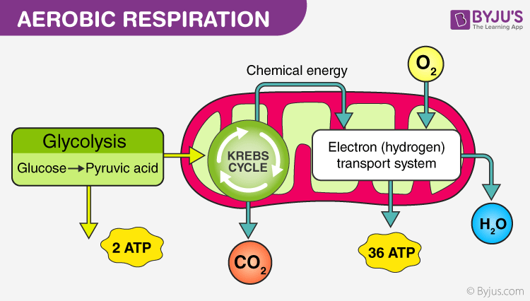](https://www.google.ps/url?sa=i&rct=j&q=&esrc=s&source=images&cd=&cad=rja&uact=8&ved=2ahUKEwiY9Kz_t6nhAhXMwKQKHVYgChYQjRx6BAgBEAU&url=https://byjus.com/biology/aerobic-respiration/&psig=AOvVaw1Gu8hg3FQpLuzxB7L4fkd9&ust=1554020590656245)

**10. Substrate-level phosphorylation accounts for approximately what percentage of the ATP formed by the reactions of glycolysis?**

A) 0%

B) 2%

C) 10%

D) 38%

E) 100%

**10. During glycolysis, when each molecule of glucose is catabolized to two molecules of pyruvate, most of the potential energy contained in glucose is**A) transferred to ADP, forming ATP.

B) transferred directly to ATP.   
C) retained in the two pyruvates.

D) stored in the NADH produced.

[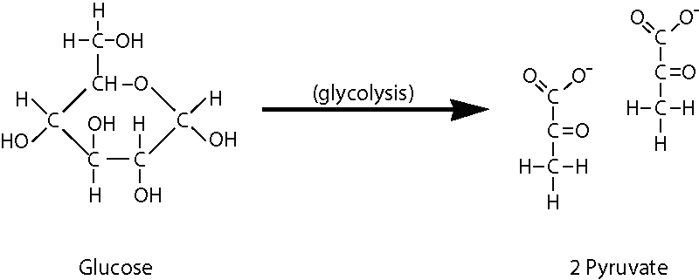](https://www.google.ps/url?sa=i&rct=j&q=&esrc=s&source=images&cd=&cad=rja&uact=8&ved=2ahUKEwjF2u2guKnhAhXKy6QKHZTrC-QQjRx6BAgBEAU&url=https://courses.lumenlearning.com/wm-biology1/chapter/reading-glycolysis-2/&psig=AOvVaw0plrlBpBswu0U1hhvucvWr&ust=1554020666094780)

**11. In addition to ATP, what are the end products of glycolysis?**A) CO₂ and H₂O

B) CO₂ and pyruvate

C) NADH and pyruvate

D) CO₂ and NADH

[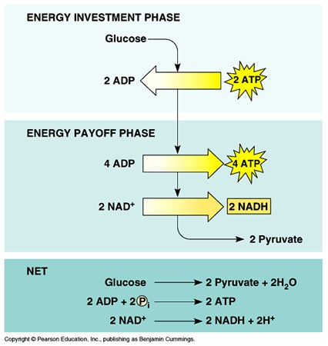](https://www.google.ps/url?sa=i&rct=j&q=&esrc=s&source=images&cd=&cad=rja&uact=8&ved=2ahUKEwjp9IK6uKnhAhUlMuwKHXcPBZQQjRx6BAgBEAU&url=https://alevelbiology.co.uk/notes/glycolysis/&psig=AOvVaw0PbKSsVkwihxUYMgw6-6pg&ust=1554020707260527)

**12. Starting with one molecule of glucose, the energy-containing products of glycolysis are**A) 2 NAD⁺, 2 pyruvate, and 2 ATP.

B) 2 NADH, 2 pyruvate, and 2 ATP.   
C) 2 FADH₂, 2 pyruvate, and 4 ATP.

D) 6 CO₂, 2 ATP, and 2 pyruvate.

[](https://www.google.ps/url?sa=i&rct=j&q=&esrc=s&source=images&cd=&cad=rja&uact=8&ved=2ahUKEwjp9IK6uKnhAhUlMuwKHXcPBZQQjRx6BAgBEAU&url=https://alevelbiology.co.uk/notes/glycolysis/&psig=AOvVaw0PbKSsVkwihxUYMgw6-6pg&ust=1554020707260527)

**13. Why is glycolysis described as having an investment phase and a payoff phase?**A) It both splits molecules and assembles molecules.

B) It attaches and detaches phosphate groups.   
C) It uses glucose and generates pyruvate.

D) It uses stored ATP and then forms a net increase in ATP.

[](https://www.google.ps/url?sa=i&rct=j&q=&esrc=s&source=images&cd=&cad=rja&uact=8&ved=2ahUKEwjp9IK6uKnhAhUlMuwKHXcPBZQQjRx6BAgBEAU&url=https://alevelbiology.co.uk/notes/glycolysis/&psig=AOvVaw0PbKSsVkwihxUYMgw6-6pg&ust=1554020707260527)

**14. The transport of pyruvate into mitochondria depends on the proton-motive force across the inner mitochondrial membrane. How does pyruvate enter the mitochondrion?**A) active transport

B) diffusion

C) facilitated diffusion

D) through a channel

[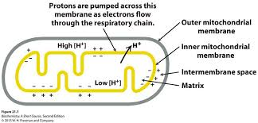](http://www.google.ps/url?sa=i&rct=j&q=&esrc=s&source=images&cd=&cad=rja&uact=8&ved=2ahUKEwjjzeyIuanhAhXFjqQKHR2zA1wQjRx6BAgBEAQ&url=/url?sa=i&rct=j&q=&esrc=s&source=images&cd=&ved=&url=https://www.ccrc.uga.edu/~rcarlson/bcmb3100/Chap21&psig=AOvVaw0WBwNnNLBuUL_w2PclDSjv&ust=1554020813611033&psig=AOvVaw0WBwNnNLBuUL_w2PclDSjv&ust=1554020813611033)

**15. During cellular respiration, acetyl CoA accumulates in which location?**A) cytosol

B) mitochondrial outer membrane

C) mitochondrial inner membrane   
D) mitochondrial intermembrane space

E) mitochondrial matrix

[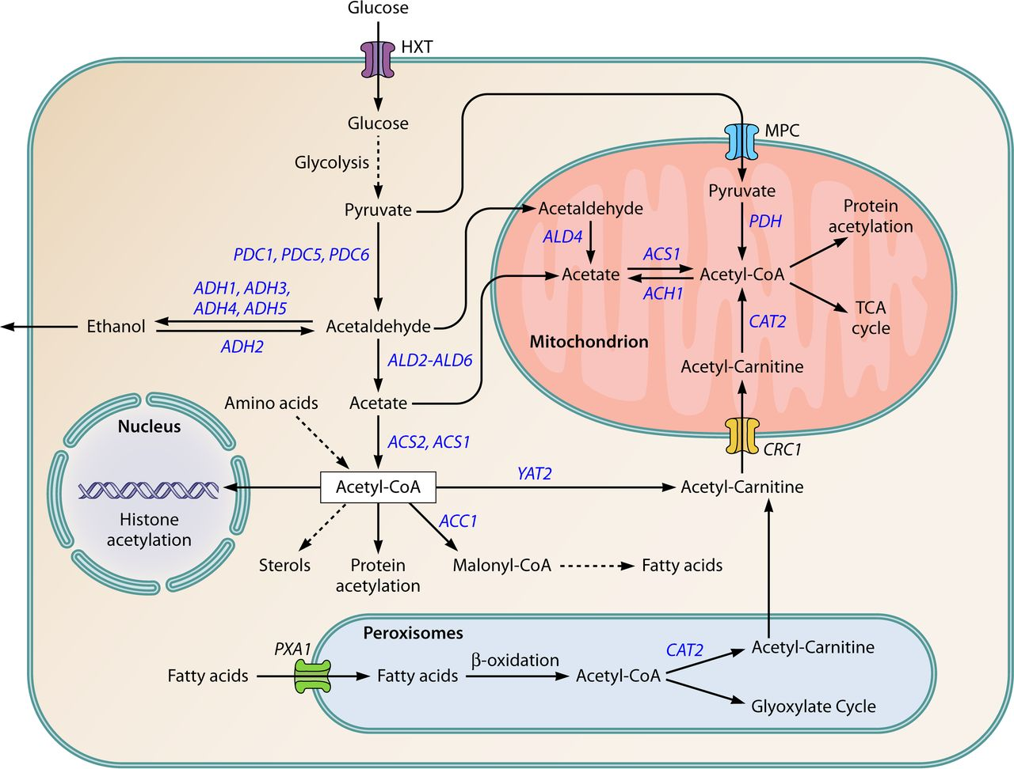](https://www.google.ps/url?sa=i&rct=j&q=&esrc=s&source=images&cd=&cad=rja&uact=8&ved=2ahUKEwiwo-WvuanhAhVNqaQKHQjgCgUQjRx6BAgBEAU&url=https://ec.asm.org/content/13/12/1472/figures-only&psig=AOvVaw2FaT7LWT5SMMyOKHv-w6do&ust=1554020949482397)

**16. During aerobic respiration, electrons travel downhill in which sequence?**A) food → citric acid cycle → ATP → NAD⁺

B) food → NADH → electron transport chain → oxygen   
C) glucose → pyruvate → ATP → oxygen

D) glucose → ATP → electron transport chain → NADH

[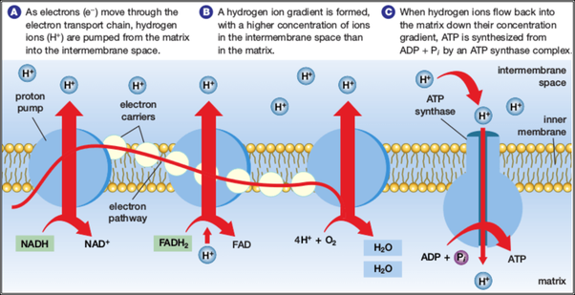](https://www.google.ps/url?sa=i&rct=j&q=&esrc=s&source=images&cd=&cad=rja&uact=8&ved=2ahUKEwiD4Y7YuanhAhXNPOwKHf3NChgQjRx6BAgBEAU&url=https://www.quora.com/What-is-the-function-of-the-electron-transport-chain-during-cellular-respiration&psig=AOvVaw3ad9Sg7S67WfDhpWqjs8kP&ust=1554021050296463)

**17. Where are the proteins of the electron transport chain located?**A) cytosol

B) mitochondrial outer membrane

C) mitochondrial inner membrane   
D) mitochondrial intermembrane space

E) mitochondrial matrix

[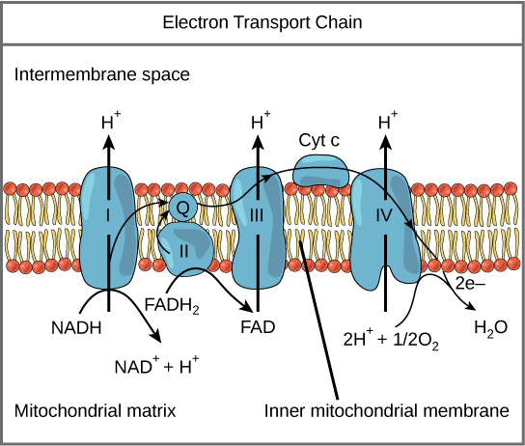](https://www.google.ps/url?sa=i&rct=j&q=&esrc=s&source=images&cd=&cad=rja&uact=8&ved=2ahUKEwi_4eKBuqnhAhWEzKQKHdmzCPIQjRx6BAgBEAU&url=https://courses.lumenlearning.com/wm-biology1/chapter/reading-electron-transport-chain/&psig=AOvVaw0fxQ6f01nh9-QLDeL7oh9f&ust=1554021129921515)

**18. In cellular respiration, the energy for most ATP synthesis is supplied by**A) high energy phosphate bonds in organic molecules.

B) a proton gradient across a membrane.

C) converting oxygen to ATP.

D) transferring electrons from organic molecules to pyruvate.

**19. During aerobic respiration, which of the following directly donates electrons to the electron transport chain at the lowest energy level?**A) NAD+

B) NADH

C) ATP

D) ADP + Pi

E) FADH2

[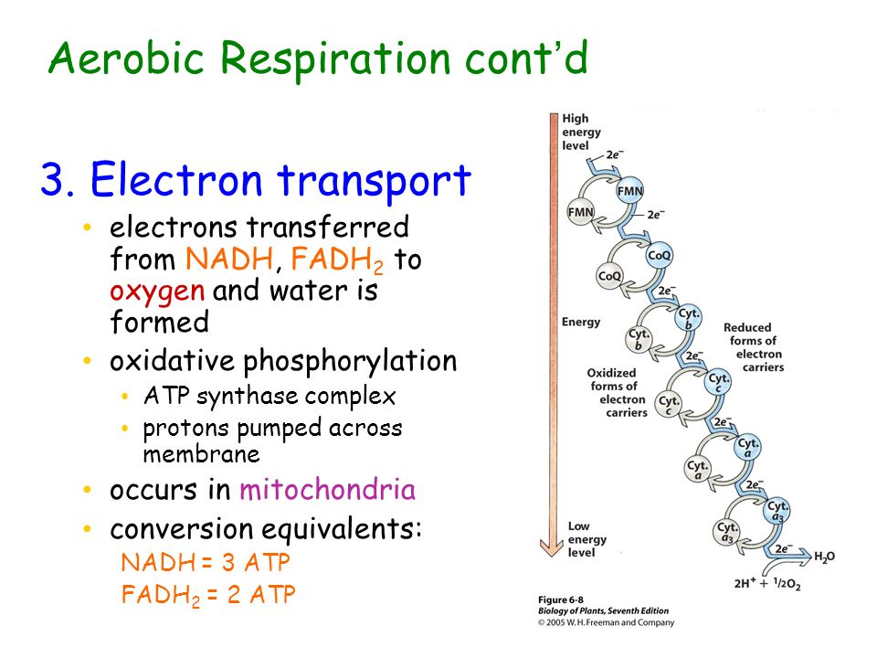](https://www.google.ps/url?sa=i&rct=j&q=&esrc=s&source=images&cd=&cad=rja&uact=8&ved=2ahUKEwiOlpX4uqnhAhUSNOwKHRWyCOQQjRx6BAgBEAU&url=https://slideplayer.com/slide/224689/&psig=AOvVaw22VasFom1wmqLqxiEtC_l8&ust=1554021310444982)

**20. The primary role of oxygen in cellular respiration is to**A) yield energy in the form of ATP as it is passed down the respiratory chain.   
B) act as an acceptor for electrons and hydrogen, forming water.   
C) combine with carbon, forming CO₂.

D) combine with lactate, forming pyruvate.

[](https://www.google.ps/url?sa=i&rct=j&q=&esrc=s&source=images&cd=&cad=rja&uact=8&ved=2ahUKEwiOlpX4uqnhAhUSNOwKHRWyCOQQjRx6BAgBEAU&url=https://slideplayer.com/slide/224689/&psig=AOvVaw22VasFom1wmqLqxiEtC_l8&ust=1554021310444982)

**21. During aerobic respiration, H₂O is formed. Where does the oxygen atom for the formation of the water come from?**

A) carbon dioxide (CO₂)

B) glucose (C₆H₁₂O₆)

C) molecular oxygen (O₂)

[](https://www.google.ps/url?sa=i&rct=j&q=&esrc=s&source=images&cd=&cad=rja&uact=8&ved=2ahUKEwiOlpX4uqnhAhUSNOwKHRWyCOQQjRx6BAgBEAU&url=https://slideplayer.com/slide/224689/&psig=AOvVaw22VasFom1wmqLqxiEtC_l8&ust=1554021310444982)

**22. In chemiosmotic phosphorylation, what is the most direct source of energy that is used to convert ADP** + Pi to ATP?   
A) energy released as electrons flow through the electron transport system   
B) energy released from substrate-level phosphorylation   
C) energy released from movement of protons through ATP synthase, against the electrochemical gradient   
D) energy released from movement of protons through ATP synthase, down the electrochemical gradient   
E) No external source of energy is required because the reaction is exergonic.

[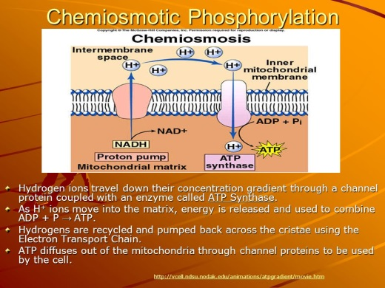](https://www.google.ps/url?sa=i&rct=j&q=&esrc=s&source=images&cd=&cad=rja&uact=8&ved=2ahUKEwimqZHAu6nhAhWF2KQKHQ3JDOUQjRx6BAgBEAU&url=https://slideplayer.com/slide/4088619/&psig=AOvVaw2UgsznfXlXSdXYPM8qRGVo&ust=1554021500872638)