



Cell Lap

**Student : Saif Alawi_1201821.**

**Instructor : Abdallah Abutaha.**

**Teacher Assistant : Deema Mohsen.**

**Date & Day Of Experiment : 13/4/wed.**

**CELLULAR FRACTIONATION**

**BY DIFFERENTIAL CENTRIFUGATION**

**Objective**

The aim of these research is to use differential centrifugation ”The sedimentation rate of organelles and other subcellular particles is utilized to separate them” to fractionate “separate subcellular parts and confine organelles and other subcellular parts from each other” homogenized rat liver cells.

**Introduction**

The utilization of homogenization and differential centrifugation strategies has made it conceivable to concentrate on many disconnected, film bound organelles. The course of open cell fractionation in isotonic support is homogenization and the ensuing disengagement of organelles is cell fracture. The core, mitochondria, and various plastids were clear focuses for investigation, since they are somewhat huge, and should be visible under a light magnifying lens. Every organelle has properties (size, shape, and thickness for instance), which make them unique in relation to different organelles inside a similar cell. In the event that the cell is delicately opened, the store of its organelles can be segregated. Confinement of organelles requires the utilization of certain methods from the utilization of straightforward strainers, gravity sedimentation or differential testimony, to ultracentrifugation in thickness angles.

**Materials & methods**

Fresh rat liver, H- & HB-buffers 6.7, Homogenizer, Petri dishes, ice, 8 mM CaCl₂ in H-buffer, 50 ml centrifuge tubes, Vortex, Centrifuge, Micropipettes and tips, Scalpels and scissors, 150 mM KCl in 10 mM HEPES, pH 7.4, mas of rat liver was weighed.

**Procedure**

1_Fasting a rat overnight. This lessens the substance of glycogen and fat in the liver.

2_Kill the rat and promptly eliminate its liver and weigh it rapidly (place it in a pre-weighted container and gauge the recepticle and liver) and spot it in ice containing H-support" (homogenizing cradle) on: 280 mM sucrose, 10 mM HEPES, 100 μM EGTA pH 7.4".HB-cushion = “H-cradle + 0.05% sans bsa unsaturated fat (to eliminate free unsaturated fats and lipids”.HB-cushion For a homogeneous work of 10% (w/v) (i.c., for every gram of liver, add 9 mL of HB-cradle).

3_While you are on the ice, tenderly cut it into the liver and pour the arrangement once (to eliminate the blood).

4_Add a similar measure of chilled HB-buffer and cleave the liver into little pieces with scissors or a sharp edge.

5_Move to the blender tube and homogenize with an engine homogenizer (up to 10-15 strokes) while keeping it cool.

6_Homogeneous centrifugation to eliminate cell garbage and whole cells at 400 x g for 5 min.

7_Gather the supernatant (SN): This is the whole homogenate. Give 2 mL of ice to the following trial (mark tube H) and record the volume of the rest of. Complete cylinder volume H “overweight before centrifuge 22.3g”.

8_Centrifuge the remainder of the homogenate for 15 minutes at 4000 x g. This gives us centers. Eliminate the supernatant (SN) in an Centrifuge and resuspend the atomic pellet in a similar volume (as in the past advance) from cradle H (keep the suspension on ice in the N tube).

9_Centrifuge SN₂ at 12,000 x g for 15 minutes. This gives the mitochondrial portion.

10_Eliminate the supernatant (SN₁) in a perfect rotator tube ”19.3g_supernatant, 1.7g_ppt”, and resuspend the mitochondrial pellets in a similar volume (in sync 7) from the H-cradle (keep the suspension on ice in tube M).

11_Add 80 mM CaCl to SN, to get a safeguard grouping of 8 mM CaCl, in a 10-crease cradle stock, 1 mL of CaCl₂ was utilized per 9 ml for instance). Delicately mix and Centrifuge at 20,000 x g for 25 min at 4 °C. These give a microsomal part advanced in lysosomes.

12_Cautiously eliminate and dispose of the supernatant. Assuming the creature is famished, the glycogen will shape a white granule now and mind should be taken to isolate it from the supernatant, lighter microsomes and heavier glycogen.

13_Resuspend the pellets (containing the lysosomes) in a similar volume (in sync 7) of 150 mM KCI in 10 mM HEPES pH, pH 7.4 (keep the suspension on ice in tube L).

14_Take an aliquot from each example and attempt to imagine it under a light magnifying lens utilizing a hemocytometer. what do you see? Could you at any point decide the components of cores or mitochondria? makes sense of.

**conclusion**

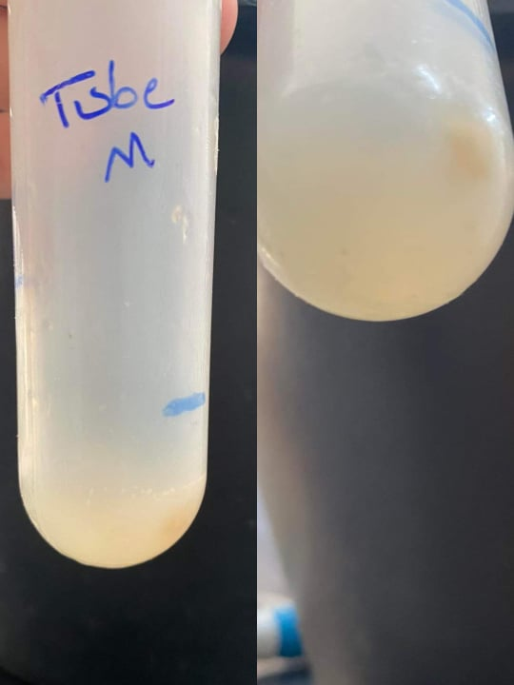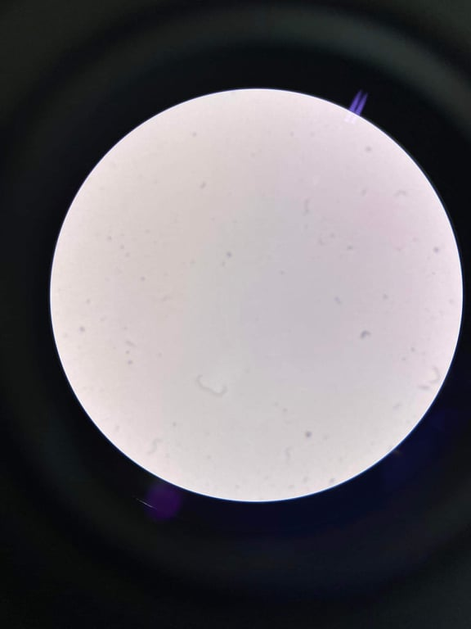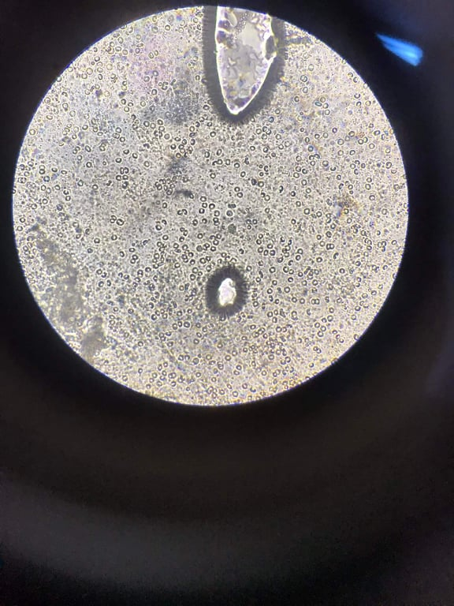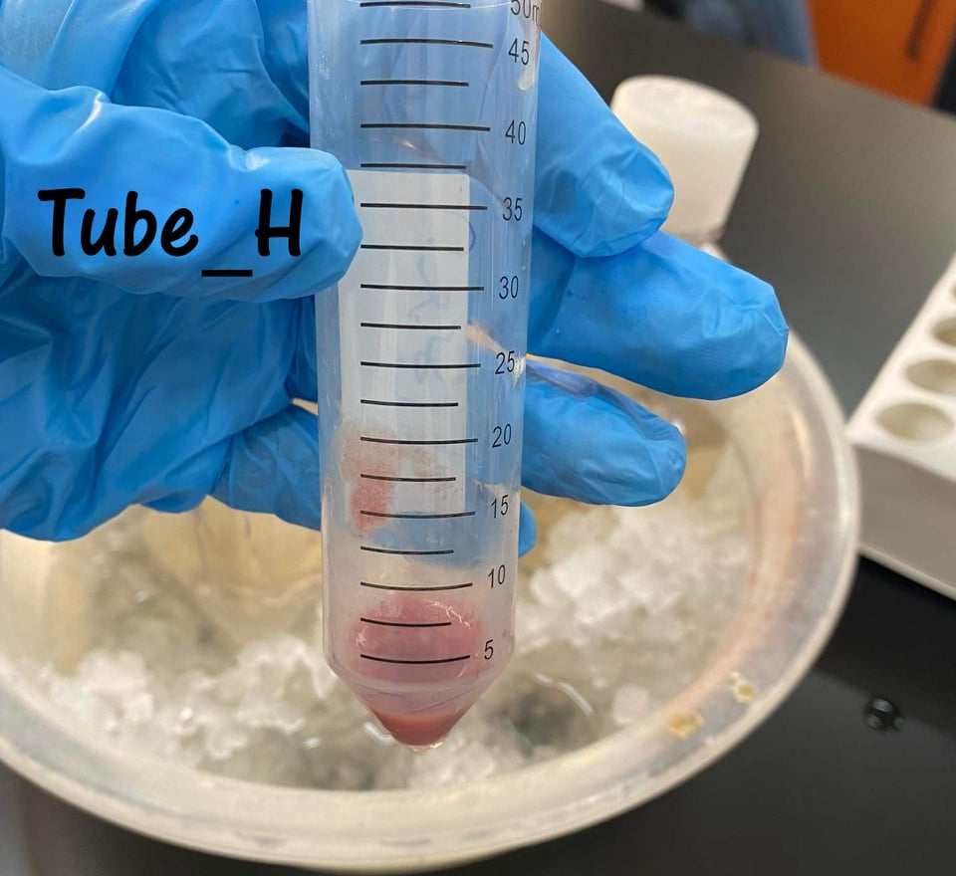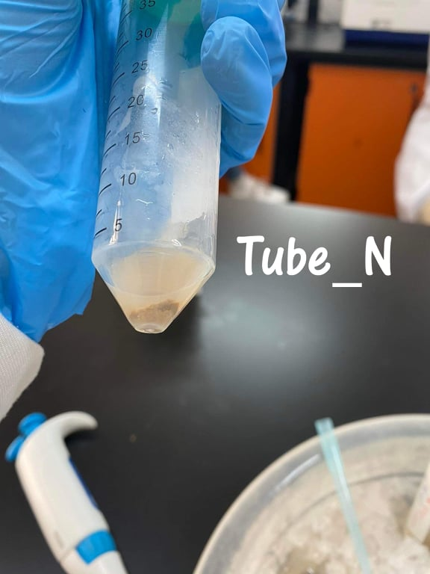From this investigation we can notice a climbing request as follows: tube_1...tube_2...tube_4...tube_3, that is Reliable with the grouping of the mitochondrial part in each cylinder. Accordingly, we can infer that as the centralization of the mitochondrial division builds the response rate. We placed a sample from each tube under the microscope, where it appeared in the first tube homogenates, and in the second tube the nucleus, and in the third tube mitochondria, and in the fourth microsomes.

**Questions**

1_Rat's liver is basically the same as humans. What's more, rat's liver contains high measures, everything being equal.

2_To keep up with organelles from exploding or contracting (To keep them in an isotonic arrangement), To keep up with the PH.

3_To keep chemicals from annihilation, as they can be disturbed at high temperatures, and to restrain the movement of catalysts while putting away them.

4_This is because of the tapping system that leaves a portion of the supernatant on the pellet, which leaves no unadulterated pellet.

6_Utilizing the techniques of physical chemistry: straightforward strainer, gravitational sedimentation, or ultracentrifugation methods.

7_Glucose-6-phosphatase that is found in the microsomal division (L cylinder), they are not unadulterated, as they contain different lysosomes.