Birzeit University

**Biology and Biochemistry Department**

**BIOL 244**

**Cell Biology lab**

**Experiment 3&4: Cellular fractionation by differential centrifugation and Analysis of subcellular fraction I.**

**Student Name: Heba Al-Khateeb**

**Student ID: 1191480**

**Partners names: Zena alyan - Roaa osama - Ghadeer Sameer - Salsabeel arman**

**Instructor: Dr. Abdallah Abu Taha**.

**Teacher Assistance: Deema Mohsen**

**Date of Experiment: 11&18 -4-2022**

**Submission Date: 11-5-2022**

**Titles: Cellular fractionation by differential centrifugation**

**and Analysis of subcellular fraction.**

**Objectives: The aim of this experiment was learn about homogenization techniques and how to use a differential centrifugation to isolate many cell organelles like nucleus, mitochondria from a rat liver and the finally step was to get mitochondrial pellet and also measurement the rate of reaction.**

**Introduction: Differential centrifugation is a procedure that is used to deeply analyse certain organelles by separating them from others considering their size and density. we can prepared a isotonic sucrose as the medium for homogenate cells, this process mean rupture tissue structure-to-form a suspension or emulsion.**

**Then, we used a dichlorophenolindophenol DCPIP “reduction”(to change color from dark blue “oxidize” to colorless “reduce”). we used a sodium azide to stopped an ETC and low fluorescent form and that azide decreases their concentration.**

**The searching of organic chemistry and specific interested is appeared within the analysis of succinate dehydrogenase the enzyme included within the electron transfer responses in all kingdoms of life Succinate dehydrogenase is dependable for catalyzing the oxidation of succinate to fumarate inside the citrate corrosive cycle. all enzymes within the cycle are found inside the mitochondrial lattice. ; however an special case to usually succinate dehydrogenase and its coenzyme flavin adenine dinucleotide (FAD)). The enzyme complex (often represented by E-FAD) is firmly bound to the inward membrane of the mitochondrion permitting its simple confinement). Upon segregation of this E-FAD it is conceivable to degree the succinate to fumarate response by checking the lessening of an manufactured electron acceptor; for illustration, the Slope reagent 2,6 dichlorophenolindophenol (DCPIP). When this redox dyc is oxidized it is blue and when diminished it is colorless hence straightforward spectrophotometry can be employed to take after this redox alter). In arrange to utilize this artificial electron acceptor, the ordinary way of electrons in the elgetron transport chain must be blocked. This is often accomplished by including sodium azide to the response blend This barm restrains the exchange of electrons from Complex IV (cytochrome a3) to the ultimate acceptor, oxygen, so that the electrons cannot be passed along the going before cytochromes and Ubiquinone (too called coenzyme Qe) Instep these electrons are picked up by DCPIP. The decrease of DCPIP by E-FADH2 can at that point be measured at 600 nm through the watched blue to colorless color change. Therefore the aim of the present study was to Measure the rate of the convert the succinate to fumarate by succinate dehydrogenase enzyme.**

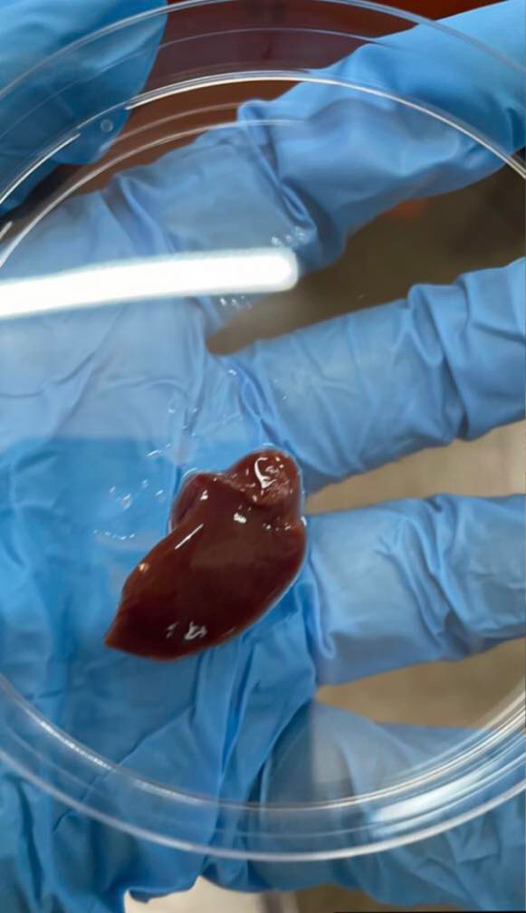 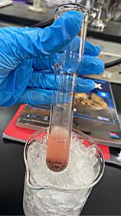

**Figure1: preparing the rat liver to starting of experiment.**

**Materials and Methods:**

**Fresh rat liver \H-&HB-buffers \homogenizer \Ice \petri dishes \8 mM CaCl2 in H-buffer \50ml centrifuge tubes \vortex \centrifuge \ Micropipettes and tips \scalpels and scissors \150 mM KCL in 10 mM HEPES, pH 7.4 \Mitochondrial fraction “tube M” from pervious experiment \Nuclear fraction “tube N” \Assay buffer (0.3M mannitol, 6mM KH2PO4, 14mM K2HPO4, 10mM KCL, 5Mm MgCL2, PH 7.2 \40mM sodium azide \50mM succinate \200mM malonate \0.5mM DCPIP \plastic cuvettes \spectrophotometer \micropipettes \5Mm ice bucket.**

**Methods:**

**In experiment 3, 1.1g of rat liver was gotten and the petri dishes was putted it by homogenization and was separated. Then, 9.9% HB-buffer was added to remove and clean blood while it inside ice to save it, the homogenate technique was gotten to remove the cell debris and the unbroken cells at 400xg for 5 min. after that, supernatant was taken and put 1.5 in tube (tube H) “total volume of tube H= 10.5”. Then, SN1 on a centrifuge was used at a speed of 4000 within 15 minutes, a core was deposited. After that, SN2 on a centrifuge was used at a speed of 12000 in 15 minutes, mitochondria was produced. Then, SN3 was used at 20,000 in 20 minutes, the microsomal fraction was produced including lysosomes.**

**In experiment 4, the wavelength was prepared in spectrophotometer at 600nm. Then, 11 tubes was prepared and all tubes at room temperature except ice-cold mitochondrial suspension (MS) from experiment previously. The MS was taken for tube 8 by heating in oven or by boiling in water bath and was cooled it by ice. Then, the various solutions was added to the tube except (MS tube) and was covered it with parafilm and mixed it. The spectrophotometer balance was reset on zero before measuring the absorbance with Blank1 for Tube 1 and the process was repeated for the rest of the tubes. Then, the mitochondria (M) was added and absorbance readings was taken at time t0, also the MS was added to five tubes and mixed it. Finally, the absorption measurement was taken after for 5 minutes for 40 minutes from each tube and all reading was record.**

**Results:**

* **We Separated rat liver to 3 organs and we showed nuclei, mitochondria and microsomal fraction (lysosome) and save them by put in ice and we showed them under microscope.**

* **The absorption will be increased with concentration of ms increased and the absorption will be decreased with increase time.**

|  |  |  |  |  |  |
| --- | --- | --- | --- | --- | --- |
|  | 5min | 10min | 15min | 20min | 25min |
| Blank1 | **0.000A** | **0.000A** | **0.000A** | **0.000A** | **0.000A** |
| 1 | **0.707A** | **0.703A** | **0.702A** | **0.035A** | **0.034A** |
| Blank2 | **0.000A** | **0.000A** | **0.000A** | **0.000A** | **0.000A** |
| 2 | **0.617A** | **0.566A** | **0.557A** | **0.546A** | **0.540A** |
| Blank3 | **0.000A** | **0.000A** | **0.000A** | **0.000A** | **0.000A** |
| 3 | **0.594A** | **0.500A** | **0.484A** | **0.469A** | **0.470A** |
| Blank4 | **0.000A** | **0.000A** | **0.000A** | **0.000A** | **0.000A** |
| 4 | **0.580A** | **0.535A** | **0.528A** | **0.591A** | **0.520A** |
| 5 | **0.132A** | **0.175A** | **0.174A** | **0.175A** | **0.182A** |
| 6 | **0.580A** | **--- MS was added with 1-5 tubes and not measured** | **--- MS was added with 1-5 tubes and not measured** | **--- MS was added with 1-5 tubes and not measured** | **0.506A** |
| 7 | **0.568A** | **0.491A** | **0.490A** | **0.488A** | **0.490A** |
| 8 | **0.628A** | **0.541A** | **0.533A** | **0.529A** | **0.527A** |
| 9 | **0.630A** | **0.360A** | **0.212A** | **0.126A** | **0.093A** |

**“Table 4.1. Tubes for SDH assay”**

**Discussion:**

**At present, centrifugation is the most common method for separation and isolation of cells and subcellular particles. The technique can be used the study of many isolated, membrane bound organelles so we was put this process for the sample step by step till desired molecules were observed. During cellular fractionation the temperature should be kept around 4 degree Celsius to protect DNA and proteins from degradation and to make centrifugation efficient.**

**The experiment talks about the importance of using differential centrifugation in the cellular fractionation process. We worked on 8 samples, it important to happen interaction in them, We used a homogenizer technique to separate the cell into three parts (rat liver) and isotonic buffer. We used important materials like: ice to protect a cell, H-buffer to remove a blood, centrifuge the homogenate to remove unbroken cells and used a rat Liver cells because it contains a large amount of mitochondria and it responsible for many metabolic activities. After that, we calculated a total volume of many tubes like: tube H (SN1), tube N (nuclei) SN2, tube M (mitochondria), SN3, and tube L (lysosome), SN4.**

**In the next experiment, we used the citric acid cycle and krebs cycle to discover a tube M (mitochondria) and we used a mitochondrial fraction to measure a rate of the reaction in vitro. We used enzyme (succinate dehydrogenase "SDH"), this enzyme work like assistant factor " in this process it turn FAD to FADH2 in the following equation:**

**Succinate + FAD Fumarate + FADH2.**

**also We used a dichlorophenolindophenol DCPIP “reduction” (to change color from dark blue “oxidize” to colorless “reduce”).**

**- Tube1 is lose a mitochondria so it be constant but after 20 minutes, the tube collapsed, so an error occurred in the measurements.**

**- Tube2 is have all things so it be decrease (interaction is little because the volume of mitochondria is 0.18).**

**- Tub3 is have all things so it be decrease (interaction is big because the volume of mitochondria is 0.54).**

**- Tube4 is have all things so it be decrease**

**- Tube5 is have all things and also malonte so it’s a competitive inhibitors, it make a inhibition of succinate (interaction not happen but we have a mistake in this tube, a pink color appeared)**

**- Tube6 is lose azide(not happen reduction DCPIP so it remains oxidize (blue as we think( but MS was added with 1-5 tubes and not measured Immediately so we did not take readings.**

**- Tube7 is lose succinate so not happen interaction.**

**- Tube8 is a heated so it denaturation of enzyme (not happen interaction.)**

**The absorption will be increased with concentration of ms increased and the absorption will be decreased with increase time.**

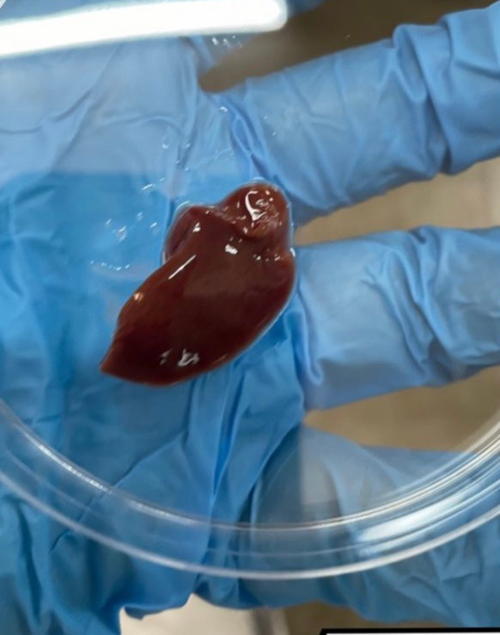 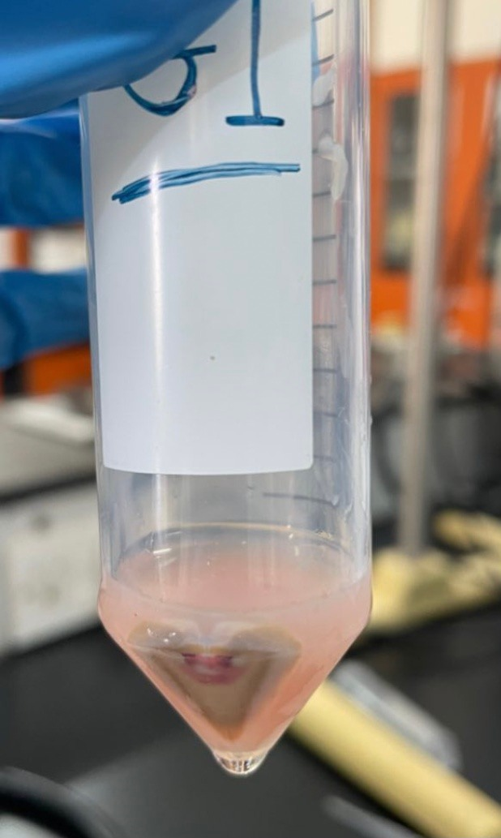 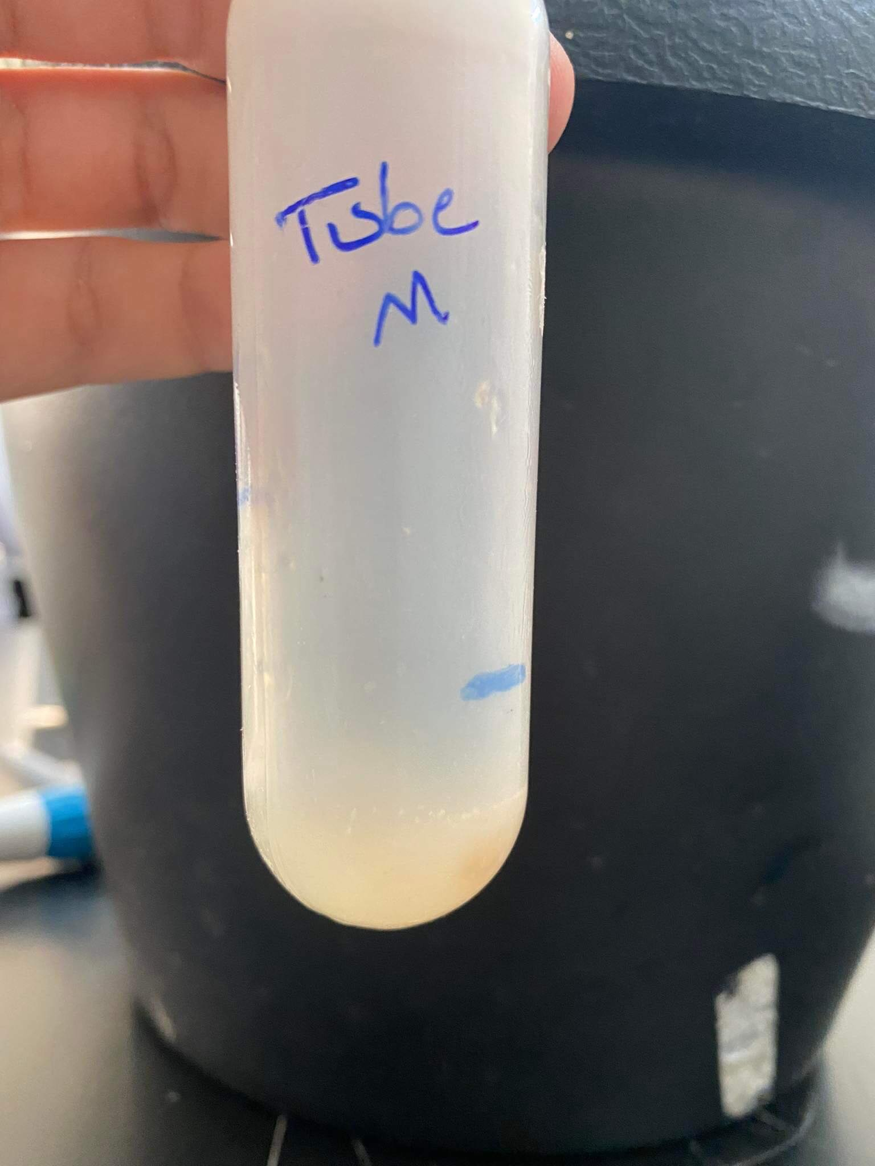 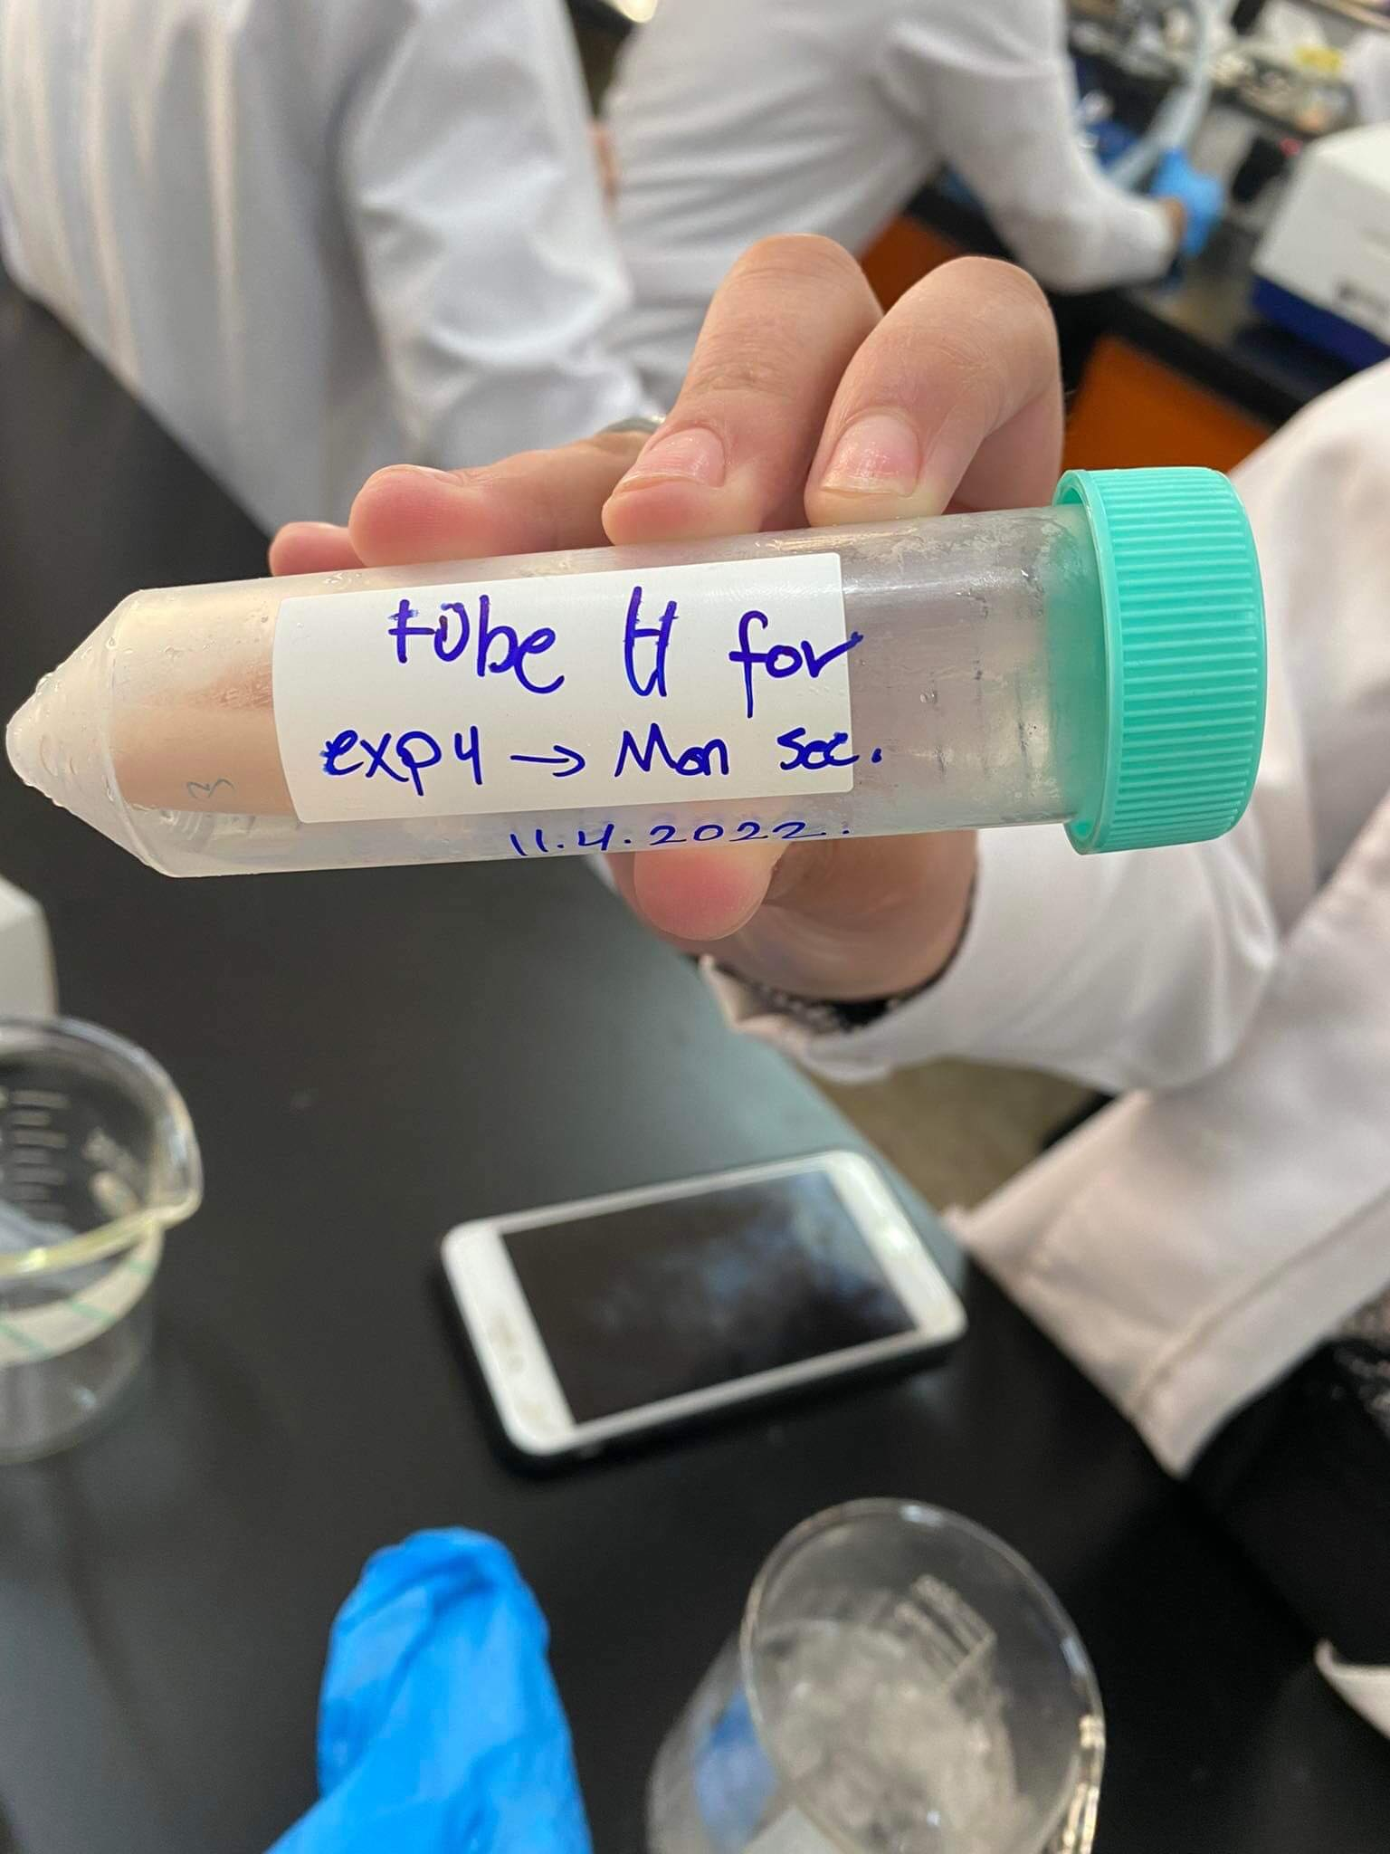 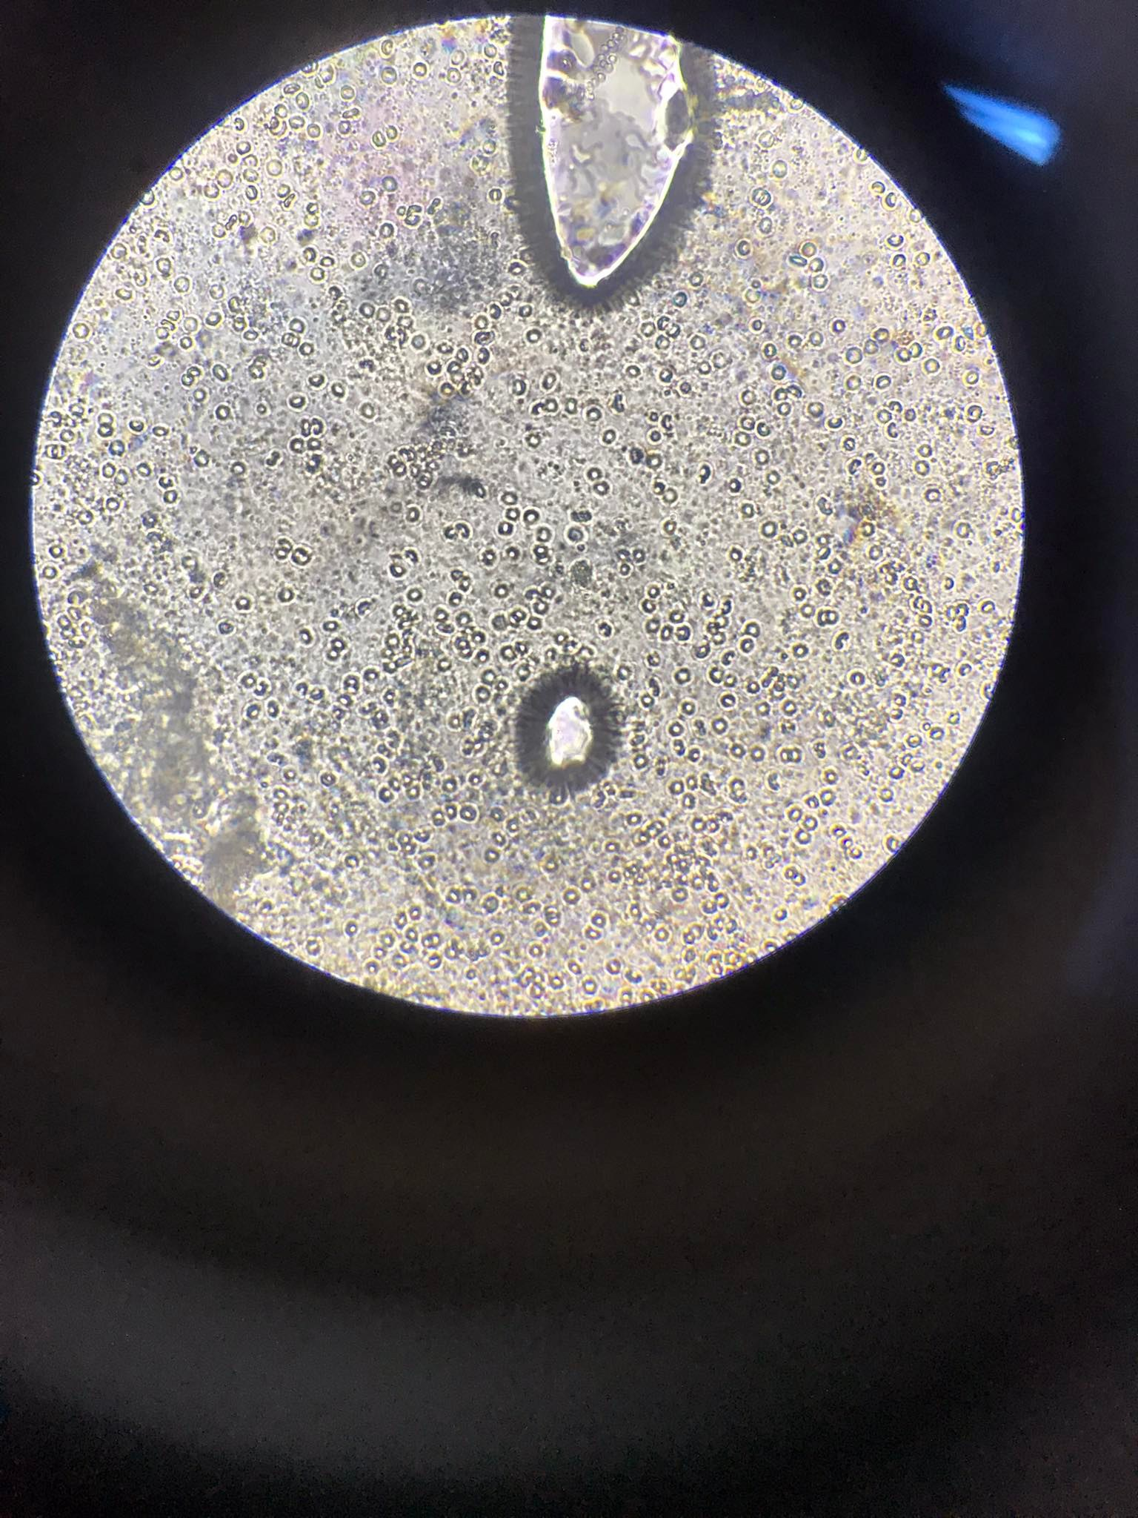

**Figure 2: The steps of Separate rat liver to 3 organs: nuclei, mitochondria and microsomal fraction (lysosome) and save them by put in ice and we showed them under microscope.**

**Conclusion:**

**Density-gradient centrifugation is a good method for separating samples based on their size and density, while maintaining their purity completely, better than differential fractionation. On experiment4, we noticed it is simple to conclude that as the concentration of succinate dehydrogenase increments, the rate that succinate is oxidized to fumarate increments as well. Nevertheless, expansim of malonate and lessening the sum of succinate or azide moderates down the response rate since of their intelligent with succinate dehydrogenase**

**References:**

Graham, J. (2002). Preparation of crude subcellular fractions by differential centrifugation. *TheScientificWorldJOURNAL*, *2*, 1638-1642.

Claude, A. (1946). Fractionation of mammalian liver cells by differential centrifugation: II. Experimental procedures and results. *The Journal of experimental medicine*, *84*(1), 61-89.

Morgenthaler, J. J., Zuber, T., & Friedli, H. (1985). Influence of heparin and calcium chloride on assay, stability, and recovery of factor VIII. *Vox sanguinis*, *48*(1), 8-17.

DeCaprio, J., & Kohl, T. O. (2019). Using Dounce homogenization to lyse cells for immunoprecipitation. *Cold Spring Harbor Protocols*, *2019*(7), pdb-prot098574.

King, T. E. (1967). [58] Preparation of succinate dehydrogenase and reconstitution of succinate oxidase. In *Methods in enzymology* (Vol. 10, pp. 322-331). Academic Press.

Maison-Peteri, B., & Etienne, A. L. (1977). Effects of sodium azide on photosystem II of Chlorella pyrenoidosa. *Biochimica et biophysica acta*, *459*(1), 10-19.

**Questions:**

**Q1: Why was “liver” chosen as the target organ for cellular fractionation?**

* **because the structure of liver is same of human and it play an important role in metabolism and Liver cells are responsible for many metabolic activity and its abundance of mitochondria**

**Q2: Why was homogenation and subsequent suspension of organelles done in H-buffer?**

* **There are features make H buffer that contain sucrose one of the most useful buffers, because isotonic buffers are used to homogenize tissues properly. The H- buffer contains 280 m M sucrose that is isotonic and does not hinder enzymes' activity in animal tissues also not react chemically with organelles so prevents the mitochondria lysis during the process.**

**Q3: Why were all steps carried out in relatively lower temperatures (centrifuges were fixed to 4°C and organelles were stored at -70°C)?**

* **All the centrifugation steps were carried out at low temperatures to adjust the heat revealed by friction force against the rotating speed of the centrifuge so temperature must be kept around 4 degree Celsius to protect DNA and proteins from degradation Organelles were stored at -70°C to inhibit the cellular damage and inactivate the enzymes that lysis the cells and To make centrifugation and fractionation effectively.**

**Q4: Make a graph using Excel to plot the change in RCF (in g) as a function of the change in RPM, using 3 values of radii, 5, 10 and 15 cm.**

**Q5: Why do you think that the organelles obtained with this method are not absolutely pure?**

* **Totally pure organelle fractions cannot be obtained with differential fractionation since this method separates organelles based on their size and density.**

**Q6: Can you suggest an additional or alternative method to better purify these organelles?**

* **Density-gradient centrifugation is a good method for separating samples based on their size and density, while maintaining their purity completely, better than differential fractionation.**

**Q7: Can you measure ER-marker enzymes? In which fraction? Are they pure? Why or why not?**