|  |  |  |
| --- | --- | --- |
| Cell Biology |  |  |
| **Student:** Saif Alawi_1201821.  **Date of Experiment:** 21/4/Mon. | **Instructor:** Dr. Abdullah Abu Taha**.** | **Assistant:** Ms. Dema Mohsen. |

|  |
| --- |
| A N A LY S I S OF  S U B C E L L U A L R  F R A C T I O N S I I |

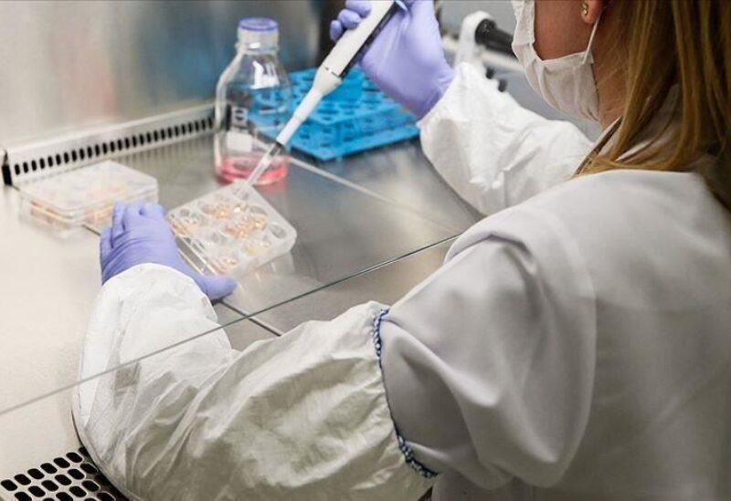

**the Objective**

The previously isolated nuclear component (Tube N) will be examined microscopically to provide more data about the nuclei as well as the approximate size of the nucleus, as well as to determine the quantity of DNA.

**Introduction**

The nucleus is a membrane-bound organelle in eukaryotic cells that houses chromosomes that convey genetic material. It is not found in prokaryotic cells.

Ribosomes, which are large molecular assemblies, are also present in the nucleus.

DNA is a naturally occurring molecule that acts as the principal carrier of information in living organisms.

DNA is a nucleotide-rich double-stranded molecule with a lengthy motif.

A nucleotide sequence. RNA is a single-stranded nucleotide chain that is shorter than DNA.

Spectrophotometry is a popular and inexpensive method for detecting light absorption or the concentration of substances in solution. And we'll utilize it in this experiment to figure out how much DNA and proteins there are.

DNA Spectrophotometers, Wavelength 260nm, DNA, and other instruments can be used to quantify the amount of UV light absorbed by the bases.

Light is absorbed by nucleic acids.

The amount of DNA present is proportional to the amount of light absorbed in the sample. Because proteins absorb light at a certain wavelength, a spectrophotometer may be used to directly detect the concentration of a pure protein in solution (at 280 nm).

As a result, the A260 / A280 ratio is used to determine the purity of nucleic acids and proteins.

As part of the cleanest DNA, the ratio reaches 1.8. DNA absorbs 1.8 times more UV energy at 260 nm than it does at 280 nm.

**Materials** 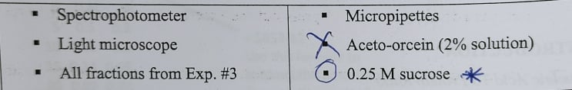

**Method**

1_All fractions were thoroughly dissolved and combined.

2_H1, H2, H3, H4, H5, N1, N2, N3, N4, N5, N6 tubes were classified (H is for heterogeneity, and N for nuclear fraction).

3_In test tubes, increasing dilutions of each portion were conducted sequentially.

4_As indicated in Table 5.1, multiply each time by 5.

5_For each tube, the absorbance values were measured at 260 nm.

6_The absorbance at 280 was measured using a tube containing A260 between (0.2-1)Nm.

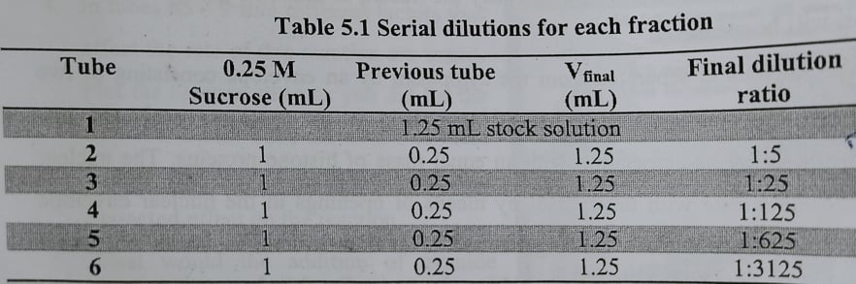

**Data&Results**

After completing the serial dilution process and determining the absorbance,

Readings were taken for each tube (Table 5.2).

Using the four absorber tubes in each percent, the DNA concentration is determined as follows:

A260 x 50 g/ml x dilution factor = DNA concentration (g/ml)

0.273 * 50 * 125 = 1706.25 mg/ml = 1.7 mg/ml is the predicted DNA concentration in the nuclear section.

0.540 * 50 * 125 = 3375 mg/ml = 3.425 mg/ml is the estimated DNA concentration in homogenate.

0.267 * 50 * 125 = 1668.75 mg/ml = 1.7 mg/ml is the predicted DNA concentration in the mitochondrial pellet.

Table 5.2: Homogeneity at 260 nm and absorption of dilute tubules from the nuclear fraction.

|  |  |  |  |  |  |
| --- | --- | --- | --- | --- | --- |
| Tube  Of Nuclear  Fraction | Reading at A 260 nm | Point B | Reading at A 260 nm | Tube of Mitochondrial  pellet | Reading at A 260 nm |
| N6 | 0.222 | H6 | 0.262 | M6 | 0.427 |
| N5 | 0.229 | H5 |  | M5 | 0.251 |
| N4 | 0.273 | H4 | 0.540 | M4 | 0.267 |
| N3 | 0.474 | H3 | 1.308 | M3 | 0.356 |
| N2 | 1.637 | H2 | 1.997 | M2 | 0.724 |
| N1 | 3.502 | H1 | 4.7 | M1 | 2.167 |

**DISCUSSION**

We can see from these data that the concentration of the DNA-containing fraction increases, as does the overall absorption. Furthermore, at the same dilution, the absorption of the dilute tube from the homogeneous fraction is larger than that of the nuclear fraction dilute tube and also higher than that of the mitochondrial dilute tube.

This means that the homologous tube's DNA concentration is higher than the nuclear segment's and mitochondrial pellet's DNA concentrations.

After determining the concentration of DNA in each nuclear fraction, mitochondrial fraction, and homologous fraction, We discovered that the homogenate has a higher quantity of DNA than both the nuclear fraction and the mitochondrial pellet. This is because the homolog contains all organelles, including DNA from both the nucleus and mitochondria, which are present in considerable levels in rat liver. The nuclear portion, on the other hand, has less than DNA because it is only found in the nucleus.

**Conclusion**

Finally, numerous other approaches may be employed to determine the purity of DNA in subcellular cells. One such technology is spectrophotometry, which makes use of as much DNA as possible.

To check for any protein contamination of the DNA-containing region, the absorption of light at 260 nm is compared to the absorption at 280 nm, which is the wavelength of maximal protein absorption.

**Questions**

1) It proposes that mitochondria and chloroplasts are endosymbiont membrane-bound organelles that evolved from bacterial cells that were endocytosed by an ancestor eukaryotic cell. (They have their

own DNA, RNA, and ribosomes as a result).

2) It's a dye that causes nuclear chromatin to turn red. Because the nucleoli do not readily stain with this dye, they appear as clear zones.

3) In the previous experiment, we utilized plastic cuvettes since we employed a wavelength of 600nm, which is visible light. However, because we employed a wavelength of 260 nm, which is in the Ultra-Violet area, quartz cuvettes were used in this experiment.