Birzeit University

**Biology and Biochemistry Department**

**BIOL 244**

**Cell Biology lab**

**Experiment 7&8: Isolation of chloroplasts from spinach leaves & the hill reaction and Effects of temperature & detergents on the permeability of biological membrane.**

**Student Name: Heba Al-Khateeb**

**Student ID: 1191480**

**Instructor: Dr. Abdallah Abu Taha**.

**Teacher Assistance: Deema Mohsen**

**Date of Experiment: 16&23-5-2022**

**Submission Date: 6-6-2022**

**Questions for Experiment 7:**

**Q1: What is the purpose of adding acetone to chloroplasts?**

We cut and grind the spinach and then soak it in acetone in order to extract pigments from the thylakoid membranes of the chloroplasts because acetone is a polar solvent that can absorb water.

**Q2: Calculate the total dye reduced at 10 minutes intervals, using the equation.**

From this equation: **Cr= Co (Ao-Ac) Ao**

**Tube 1 is a blank

In tube 2, the total dye reduced at 10 minutes (between T0 and T10) Cr = 0.5*10-3 (0.218-0.045)/0.218 = 3.96*10-4

In tube 3: Cr= 0.5*10-3 (0.207 -0.037)/0.207= 4.106*10-4

In tube 4: Cr = 0.5*10-3 (0.357-0.299)/0.357= 8.123*10-5

**Q3: Calculate the percent dye reduced and plot percent dye reduced per minute for tubes 2 through 4.**

**Percent Decrease = [(Orginal Value - New Value) / Orginal Value] × 100]**

Table 1. The absorbance with time

|  |  |  |  |
| --- | --- | --- | --- |
| Tube number | Tube 2 | Tube 3 | Tube 4 |
| Before | 0.218 | 0.207 | 0.357 |
| 5 min | 0.105 | 0.104 | 0.258 |
| 10 min | 0.045 | 0.037 | 0.299 |
| 15 min | 0.046 | 0.150 | 0.245 |

Table 2. The percent of reduced

|  |  |  |  |
| --- | --- | --- | --- |
| Tube number | Tube 2 | Tube 3 | Tube 4 |
| Before | 0 | 0 | 0 |
| 5 min | 51.83% | 49.75% | 27.73% |
| 10 min | 79.35% | 82.12% | 16.24% |
| 15 min | 78.89% | 27.53% | 31.37% |

Figure 1. the plot of reduced percent per minute

**Q.4: what was the purpose of using boiled chloroplasts?**

**When the chloroplasts are boiled, DPIP cannot be converted to DPIPH due to the difference of the neccessary enzymes found in the chloroplasts(the orginal enzymes get to damage) so the light processes of photosynthesis cannot occur without this reduction reaction.**

**Questions for experiment 8:**

**Q1: Plot the color intensity (absorbance) against the temperature.**

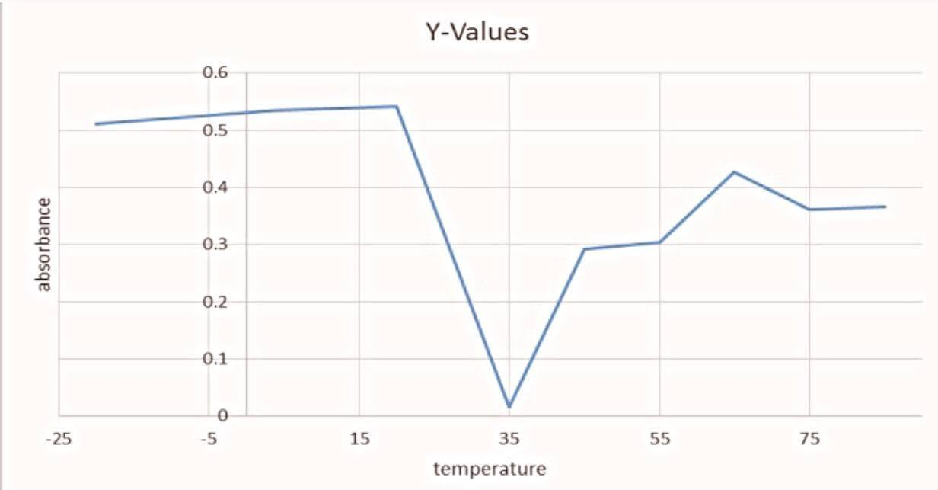

Relationship between Absorbance of Sage Leaves VS. Temperature.

**Q2: What is the effect of the temperature on the permeability of**

**membranes and why?**

**The relationship is variable between the temperature and the permeability of the membranes of the sage plant, and in both cases, high or low temperatures lead to an increase and sometimes a decrease in the permeability of the membranes, when the temperatures drop dramatically, this leads to the breakage of cells**

**Q3: In a table, calculate the percent hemolysis for each of the treatments.**

|  |  |
| --- | --- |
| Volume of Detergent | **Percent Hemolysis** |
| Blank | **0%** |
| 10 µL of Triton X-100 | **175%** |
| 5 µL of SDS | **2%** |
| 15 µL of SDS | **92%** |
| 50 µL of SDS | **165%** |
| 100 µL of SDS | **149%** |
| 5 µL of Progesterone | **5%** |
| 50 µL of Progesterone | **151%** |
| 5 µL of Hydrocortisone | **4%** |
| 50 µL of Hydrocortisone | **11%** |
| 50 µL of Hydrocortisone+ 10 µL of Triton X-100 | **197%** |

**The percent hemolysis can be calculated from the 100% lysis and the 0% lysis. Subtract the background absorbance (from the 0% lysis treatment) from all readings. The absorbance value that gives the 100% lysis is the benchmark that you will use to determine the percent lysis of each treatment.**

**Q4: After tabulating, the data (in 3) plot the percent hemolysis against the concentration of the SDS. Is there a correlation? How do you explain the results?**

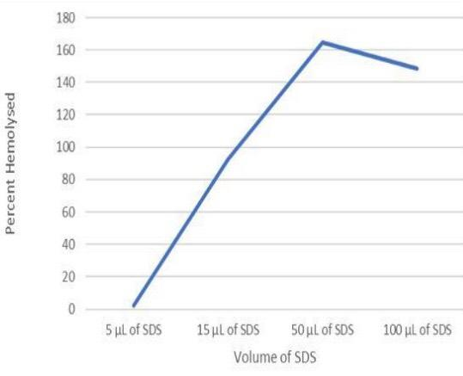

**Percent Hemolysis of Erythrocytes VS. Volume of SDS (ml)**

**We notice, as the concentration of SDS increases the percent hemolysis increases, however, we have an error at 50 µL of SDS, perhaps because we did not mix it well before measuring its absorbance or when pulling the pipette, we pulled out more because the detergent was sticky.**

**Q5: What is the effect of hydrocortisone on the permeability of membranes?**

**Hydrocortisone penetrates the membrane by having 3 hydroxyl groups that interact with the hydrophilic heads of the phospholipids, but its penetration becomes less than progesterone because the hydroxyl groups are scattered all over the molecule (anyway both of them increase the permeability of the plasma membrane).**