**Objective**

The aim of the experiment is purify chloroplasts, quantify their chlorophyll concentration, and assess their photosynthetic activity using fresh mallow leaves.

**Introduction**

All living creatures and bodily tissues are made up of cells, which are the smallest units that can exist on their own. Prokaryotes and eukaryotic cells are the two kinds of cells. The membrane-bound nature of the two cell types is the major difference. eukaryotic cells nucleus Aside from the nucleus, eukaryotic cells have Organelles can be found in a variety of forms in cells. The chloroplasts are crucial in this experiment.

Chloroplasts are organelles found in plant cells that use the photosynthetic process to convert light energy into relatively stable chemical energy. Photosynthesis is the process through which plants use sunlight, water, and carbon dioxide to make oxygen and energy in the form of sugar. During photosynthesis, plants absorb carbon dioxide (CO2) and water (H2O) from the air and soil. In the plant cell, water is oxidized, which means it loses electrons, but carbon dioxide is reduced, which means it gains electrons. Carbon dioxide is converted to glucose, while water is turned to oxygen. After that, the plant releases oxygen into the environment while storing energy in glucose molecules.

In this experiment, we extracted and purified chloroplasts from mallow leaves, and then observed Hill reaction activity in isolated chloroplasts using DCPIP dye, an excellent electron acceptor that changes color from blue to colorless when reduced by water hydrolysis.

**Method**

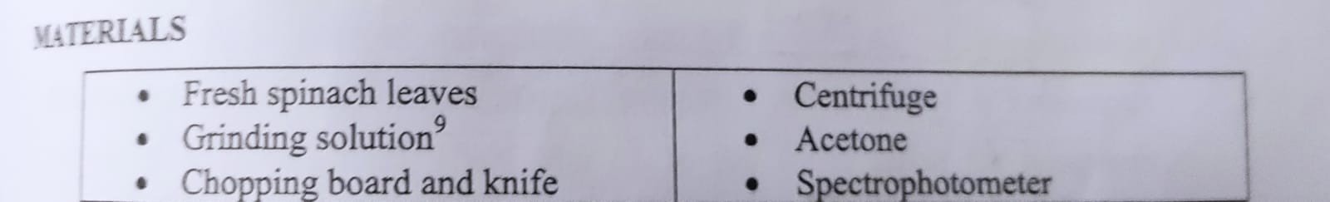

**Materials**

**Chloroplast isolation is a technique for isolating chloroplasts.**

1. Make an ice bath and chill all of the glasses ahead of time.

2. Remove the big veins from several fresh spinach leaves by tearing them away from the leaves. Leaf tissue (weighing 8 g of Diphenid)

3. Trim the tissue to the tiniest feasible size. Grind the tissue until smooth in an ice-cold slurry containing 15 ml of the grinding solution.

4. Strain the solution into a beaker using double-layered cheesecloth and crush the tissue pulp to remove any suspended particles.

5. Transfer the green suspension to a cool 50 ml tube and centrifuge for 1 minute at 4 °C at 200 x g to pellet unbroken cells and fragments.

6. Transfer the supernatant to a clean centrifuge tube and whirl for 7 minutes at 1,000 x g. The chloroplasts are contained in the granules generated after centrifugation. Remove the supernatant and discard it.

7. In 10 mL of cold suspension solution, resuspend the chloroplast granules. To gently dislodge the packed grains, use a glass stir bar. This is a suspension of chloroplasts for use in following processes.

8. Place the tube in an ice bucket and wrap it with aluminum foil.

9. Use a light microscope to examine the chloroplasts.

10. The outer membrane of the chloroplast is not damaged during the isolation method. We need to disrupt the outer membrane in order to research photophosphorylation. A cup of chloroplasts was freshly centrifuged and resuspended at 1000 x g for 7 minutes to burst the outer membranes. Resuspend the pellet in 10 mL of 35 mM NaCl after decanting and discarding the supernatant.

To collect the chloroplasts, immediately centrifuge the chloroplast suspension at 8000 x g for 5 minutes.

Decant the supernatant and resuspend the diluted suspension medium in 10 mL isotonic media with the chloroplasts (suspension buffer).

**Chlorophyll Content**

1. Pipette 1 Fill a centrifuge tube with 1 mL chloroplast suspension and 8 mL acetone. Mix thoroughly.

2. Add 1 mL distilled water, mix well, and centrifuge for 5 minutes at 1000 x g.

3. Fill the spectrophotometer with water at 652 nm. Step 2: Determine the absorbance of the supernatant.

4. Using the equation: mg chlorophyll ml = absorption, calculate the quantity of total chlorophyll in 1 ml of chloroplast solution. Page 7 of 34.5

5. Determine the dilution factor for the original chloroplast solution in order to dilute it with 35 mM NaCl, resulting in a chlorophyll concentration of 0.01 mg/mL.

**The Hill Reaction**

1. In 35 mM NaCl, dilute the chloroplasts to 0.01 mg/mL. (See step 5 in the previous exercise).

2. In a boiling water bath, heat 2.5 mL of the diluted solution. After five minutes, remove the inactivated chloroplasts from the boiling water and immerse them in an ice bath to cool. In the cold bath, keep the rest of the active chloroplast suspension.

3. Prepare the following four cuvettes:

|  |  |  |  |  |
| --- | --- | --- | --- | --- |
| Cuvette | Blanck_1 | Blanck_2 | Blanck_3 | Blanck_4 |
| 35 Mm Nac | 1 ml | 1ml | 1ml | 1ml |
| Heated CP | 0.3ml | 0.3ml | …. | …. |
| Active CP | …. | …. | 0.3ml | 0.3ml |
| Water | 0.6ml | 0.3ml | 0.3ml | 0.3ml |

4. Set the wavelength to 600 nanometers. To empty a file Spectrophotometer, use cuvette #1.

5. Rotate the huts No. 2 while adding 0.5ml of DCPIP dye. At 600 nm, measure the absorbance right away.

6. Separately, add 0.5 cc DCPIP dye to receptacles 3 and 4 (timing is crucial!). Measure and mix

Each cuvette should be absorbed. Keep track of the time of each reading.

7. Store cuvette No. 4 in a dark place. This has the effect of a "dark" control. Remove the cuvette after 30 minutes and measure the absorption.

8. For containers 2 and 3, make sure they are exposed to a bright light source. For 30 minutes, measure the absorbance every 5 minutes.

9. A graph showing absorption as a function of time.

**Data and Results**

Table 7.1 shows the readings for each cuvette every 5 minutes for 30 minutes based on the absorbance of the 4 cuvettes generated in the Procedure section:

**Table 7.1: Readings of absorbance for the 4 cuvettes for 30 minutes.**

|  |  |  |  |  |
| --- | --- | --- | --- | --- |
| Cuvettes\time | Cuvette  #1_blank | Cuvette  #2_Inactive | Cuvette  #3_Active | Cuvette  #4_Dark |
| 0 minute | $$0$$ | $$0.165$$ | 0.090 | $$0.096$$ |
| 5 minute | $$0$$ | $$0.094$$ | 0.021 | $$0.053$$ |
| 10 minute | $$0$$ | $$0.151$$ | 0.087 | $$0.059$$ |
| 15 minute | $$0$$ | $$0.144$$ | 0.057 | $$0.063$$ |
| 20 minute | $$0$$ | $$0.139$$ | 0.039 | $$0.053$$ |
| 25 minute | $$0$$ | $$0.099$$ | 0.022 | $$0.037$$ |
| 30 minute | $$0$$ | $$0.098$$ | 0.014 | $$0.024$$ |

**Figure 7.1: plot of Absorbance vs. Time for Active and Inactive tube Discussion**

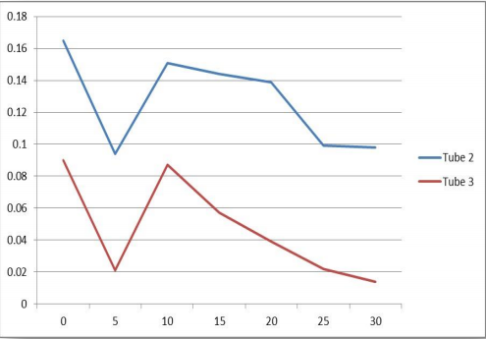

**Discussion**

The mallow leaves weighed 8 g after the experiment, and the chlorophyll solution had a 0.2 absorbance.

Following the computations, based on the following equation:

According to the preceding table, the extracted chlorophyll concentration was 0.06 mg/ml (7.1). The readings in each cuvette differ from the readings in the other cuvette. Depending on the components in the tube, the reading will sometimes increase and sometimes drop.

The absorbance of cuvette #1, which is used to discharge the spectrophotometer, is always zero.

Because the cuvette contains inactivated chloroplasts, all Enzymes that make up plant systems are lost, the expected result of absorbance all the time for cuvette #2 is that the reading remains relatively constant, but our results were often variable, increasing and decreasing, increasing and decreasing again. The cuvette may have been exposed to and altered by light, which might explain these results.

Absorption reduced with time in cuvette No. 3, which contained active chloroplasts. For cuvette #4, we computed that the total dye was lowered 30 minutes after the experiment began, and the absorbance remained almost constant throughout.

Finally, tube No. 4 had active chloroplasts but was quickly placed in the dark when the reaction began. As a result,

The amount of dilute dye in tube No. 3 was smaller than in tube No. 3, which was exposed to ambient light. This is because these reactions need the use of light-conducting molecules, such as chlorophyll molecules.

It becomes excited and transfers the energy to the remainder of the photosynthesis process.

Dcpip degradation is a device that causes water to oxidize and pass its electrons to it. As a result, putting the tube in the dark caused the reaction to halt.

However, performing a DCPIP downgrade after removing it from the cabinet and before evaluating its absorption reduced the amount of DCPIP decrease. Another reason for the error might be because the cabinet wasn't properly sealed, allowing light to flow in.

**Questions**

**Q1)** The addition of acetone is used to extract chlorophyll from

chloroplasts.

**Q2)**

Cr is a dye that has been decreased in moles per liter (M)....... The initial dye concentration in moles per liter (0.5*10-3 M) is C0...... A0 is the initial absorbance of the combination...... The absorbance of the combination at the conclusion of the experiment is denoted by Ac.

Cr of inactive= C0(A0-AC) A0=0.5*10-3(0.165-0.151) 0.165= 4.24*10-5M Cr of active cuvette= C0(A0-AC) A0=0.5*10-3(0.090-0.087) 0.090= 1.6*10-5M Cr of dark cuvette= C0(A0-AC) A0=0.5*10-3(0.096-0.059) 0.096= 1.92*10-4 M Cr of active cuvette

**Q3)**

calculate the percent dye reduced and plot percent dye reduced

per minute for tubes 2 through 4.

Cr = C0(A0-AC) \A0Page 14

For tube 2: Cr= 4.24*10^-5M, Percent Dye Reduced= 4.24*10^-3%

For tube 3: Cr= 1.6*10^-5M, Percent Dye Reduced= 1.6*10^-3 %

For tube 4: Cr=1.92*10^-4 M, Percent Dye Reduced= 0.0192%

**Table 7.2: Percent Dye Reduced for every 5-minute interval**

|  |  |  |
| --- | --- | --- |
| Time | Tube 2 (inactive) | Percent dye reduced |
| T0 | 0.165 | 0.0% |
| T5 | 0.094 | 0.0215% |
| T10 | 0.151 | -0.0303% |
| T15 | 0.144 | 2.32x10^-3% |
| T20 | 0.139 | 1.74x10^-3% |
| T25 | 0.099 | 0.0144% |
| T30 | 0.098 | 5.05x10^-4% |

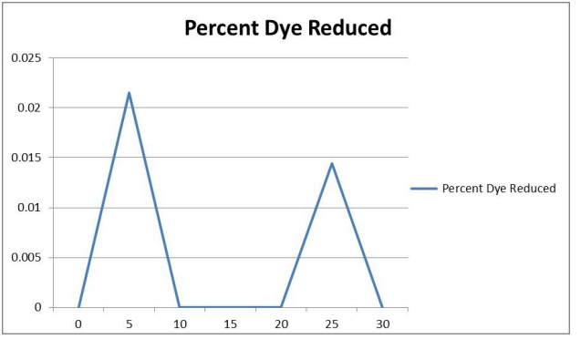

**Table 7.3: Percent Dye Reduced for every 5-minute interval**

|  |  |  |
| --- | --- | --- |
| Time | Tube 3 (active) | Percent dye reduced |
| T0 | 0.090 | 0.00% |
| T5 | 0.021 | 0.038% |
| T10 | 0.087 | -0.157% |
| T15 | 0.057 | 0.017% |
| T20 | 0.039 | 0.016% |
| T25 | 0.022 | 0.016% |
| T30 | 0.014 | 0.018% |

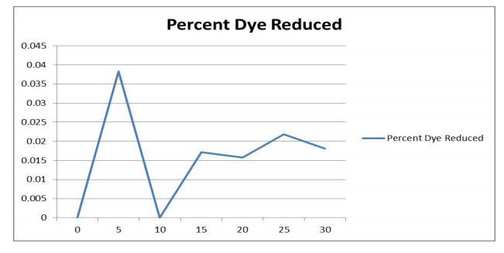

**Table 7.3: Percent Dye Reduced for every 5-minute interval**

|  |  |  |
| --- | --- | --- |
| Time | Tube 4  (Dark) | Percent dye reduced |
| T0 | 0.096 | 0.00% |
| T5 | 0.053 | 0.0224% |
| T10 | 0.059 | -5.66x10^-3% |
| T15 | 0.063 | -3.39x10^-3% |
| T20 | 0.053 | -3.39*10^-3% |
| T25 | 0.073 | 1.51*10^-4% |
| T30 | 0.024 | 0.0176% |

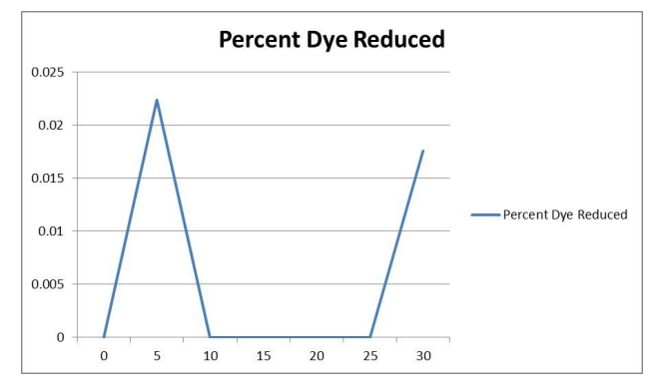

**Q4)** Boiling chloroplasts were used to demonstrate that temperature disrupts the photosynthetic system, rendering chlorophyll inactive.