

**Birzeit University**

**Biology and Biochemistry Department**

**Microbiology Lab**

**BIOL.230**

**Environmental plate for growth of bacteria**

**Aya Manassrah 1202109**

**Khitam Mahmmoud 1191862**

**Nagham Totah 1200817**

**Suhyla Mohtaseb 1193109**

**Dr.Emilia Rappocciolo**

**Mr. Mahmoud Rawajbeh**

**Date of experiment: 24.3.2022**

**Date of report submission: 9.4.2022**

**Environmental plate for growth of bacteria**

**Objectives:**

Bacteria are collected and sampled in several different places around us, then the sample is placed inside Petri dishes and left for a period of time to monitor the growth of bacteria inside and study the number of colonies that have grown in different conditions. Compared to the rest of the results and other groups.

**Introduction:**

Microbes are tiny organisms that are often unicellular and invisible to the naked eye. Microbes are all around us, even inside our bodies, in the food we eat or in the water we drink. Very small organisms are often difficult to understand and identify, but microbiological techniques and updates allow scientists to grow microbes in focus that make them visible. Microbes include: bacteria, fungi, and viruses. Through the use of specialized growth media known as LB agar, a single bacterium can rapidly multiply and grow within it to form a colony of identical bacteria that can be seen with the naked eye. Students are provided with sterile plates containing solid growth media so that they can collect samples from different places and place them inside the agar to see how much microbes can grow during a certain period inside the solid growth plates.

**Materials:**

Cotton swabs

nutrient Agar plates

Fluid( water)

**Methods:**

Prepare the materials to start the experiment, the experience is that see microorganisms in different environments. **First stage is microbial flora**, in this stage take 1agar plates and divided into three sections, we take a sample of the nose, nails and mouth with cotton swab and each separate unit is placed on agar plates. **Second stage is microbial in air,** take6 agar plates, first agardon’t open, keep it closed and not introduce any bacteria from it environment. Second agar stay open 5 minutes on the, third agar stay open 10 minutes, fourth agar stay open 15 minutes, fifth stay open 20 minutes. Sixth agar stay open 30 minute, all the agar All the agar plates in the second stage, we keep them open at different times to see the effect of bacteria in the environment in the agar plates. **Third stage microbial flora in objects,** take 1 agar plates and divided into two sections, we take a sample of the phone but when I take the sample from phone I need little fluid on cotton swab after that take the sample by wet cotton swab, and sink with cotton swab and each separate unit is placed on agar plates.

**Data & Results:**

* **Pictures**

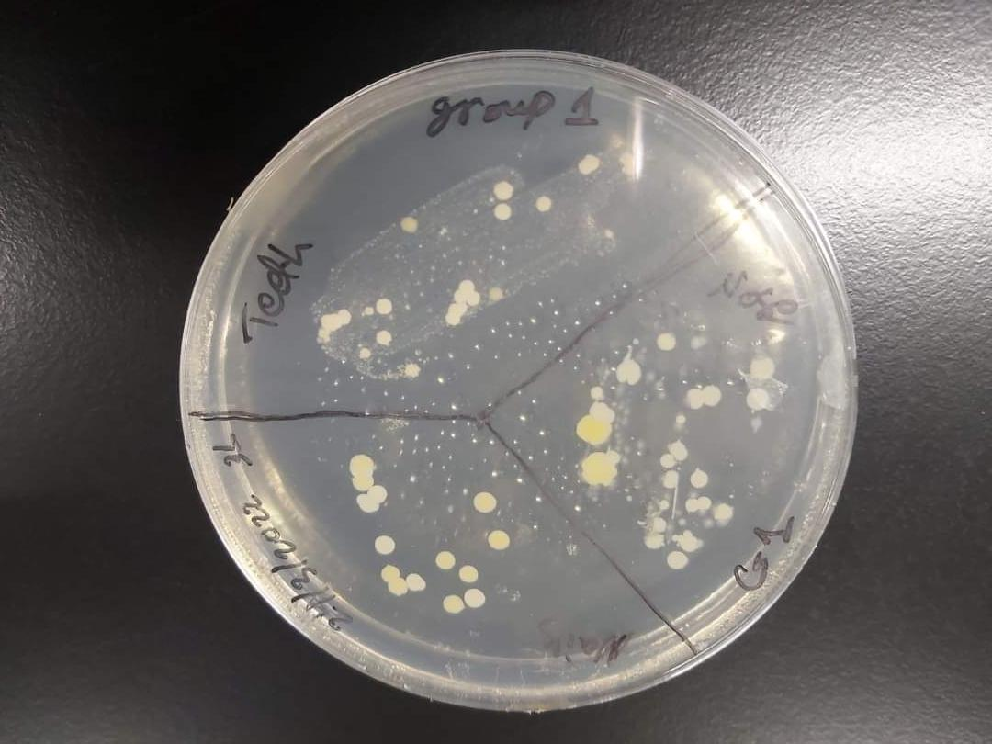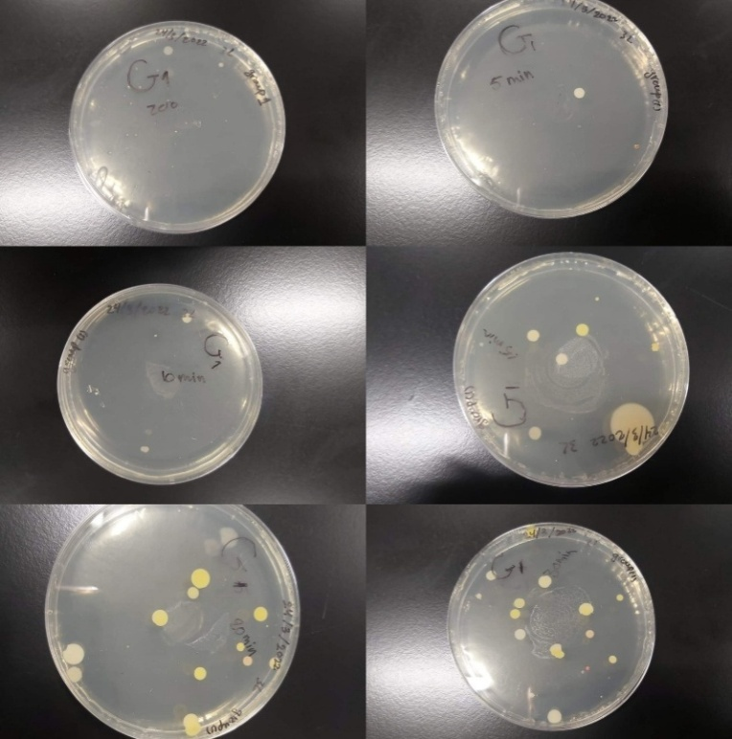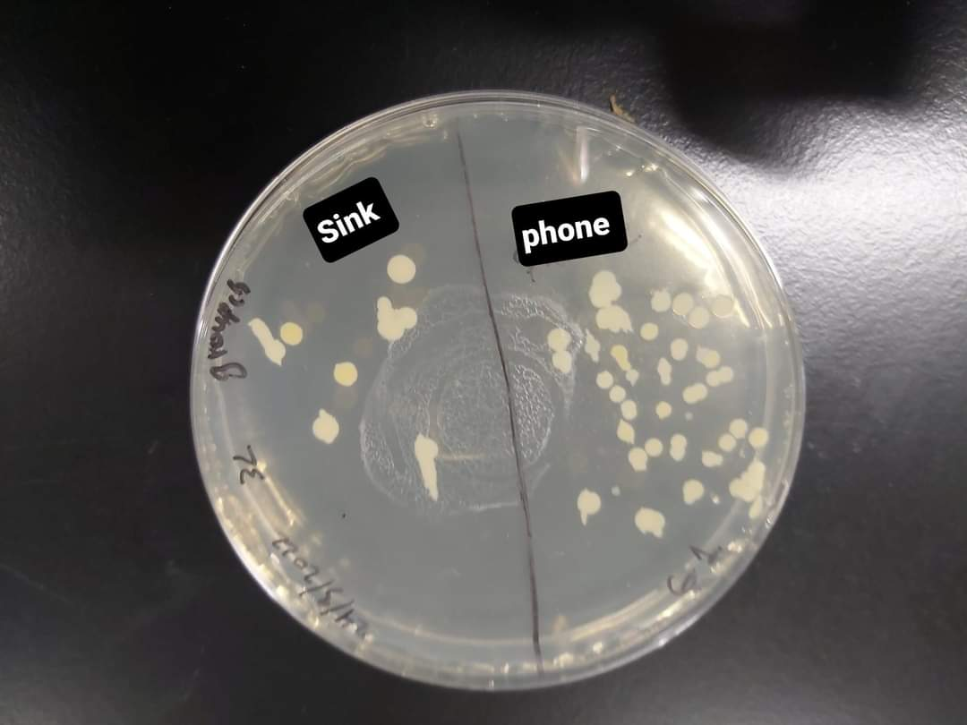 **Figure ( 1 ):** The first group took samples from the teeth, nails and nose in the first picture while in the second picture the samples took from lab corridor, then third picture took from the

phone & sink.

**Figure ( 2 ) :** The Second group took samples from the eyes, nails and teeth in the first picture

while in the second picture the samples took from outside(garden). then third picture took from the phone & door.

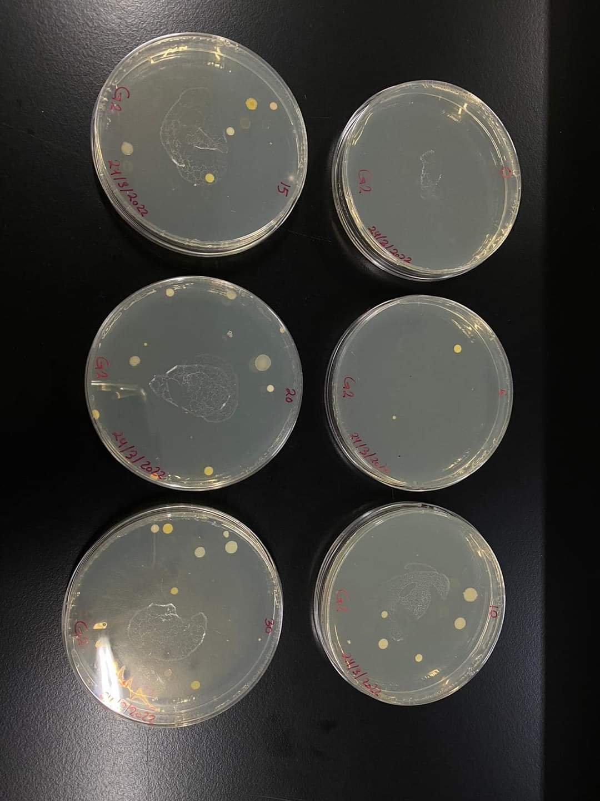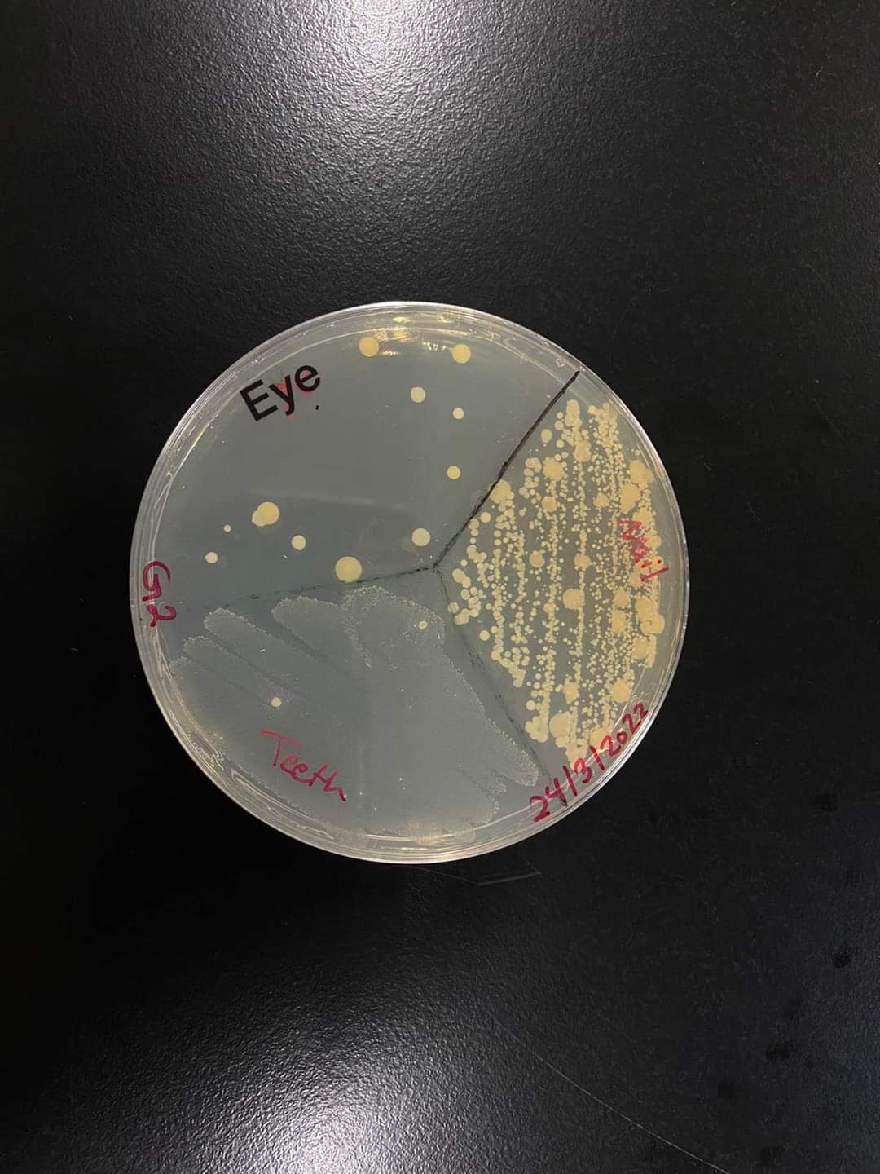 **( 1 ) ( 2 )**

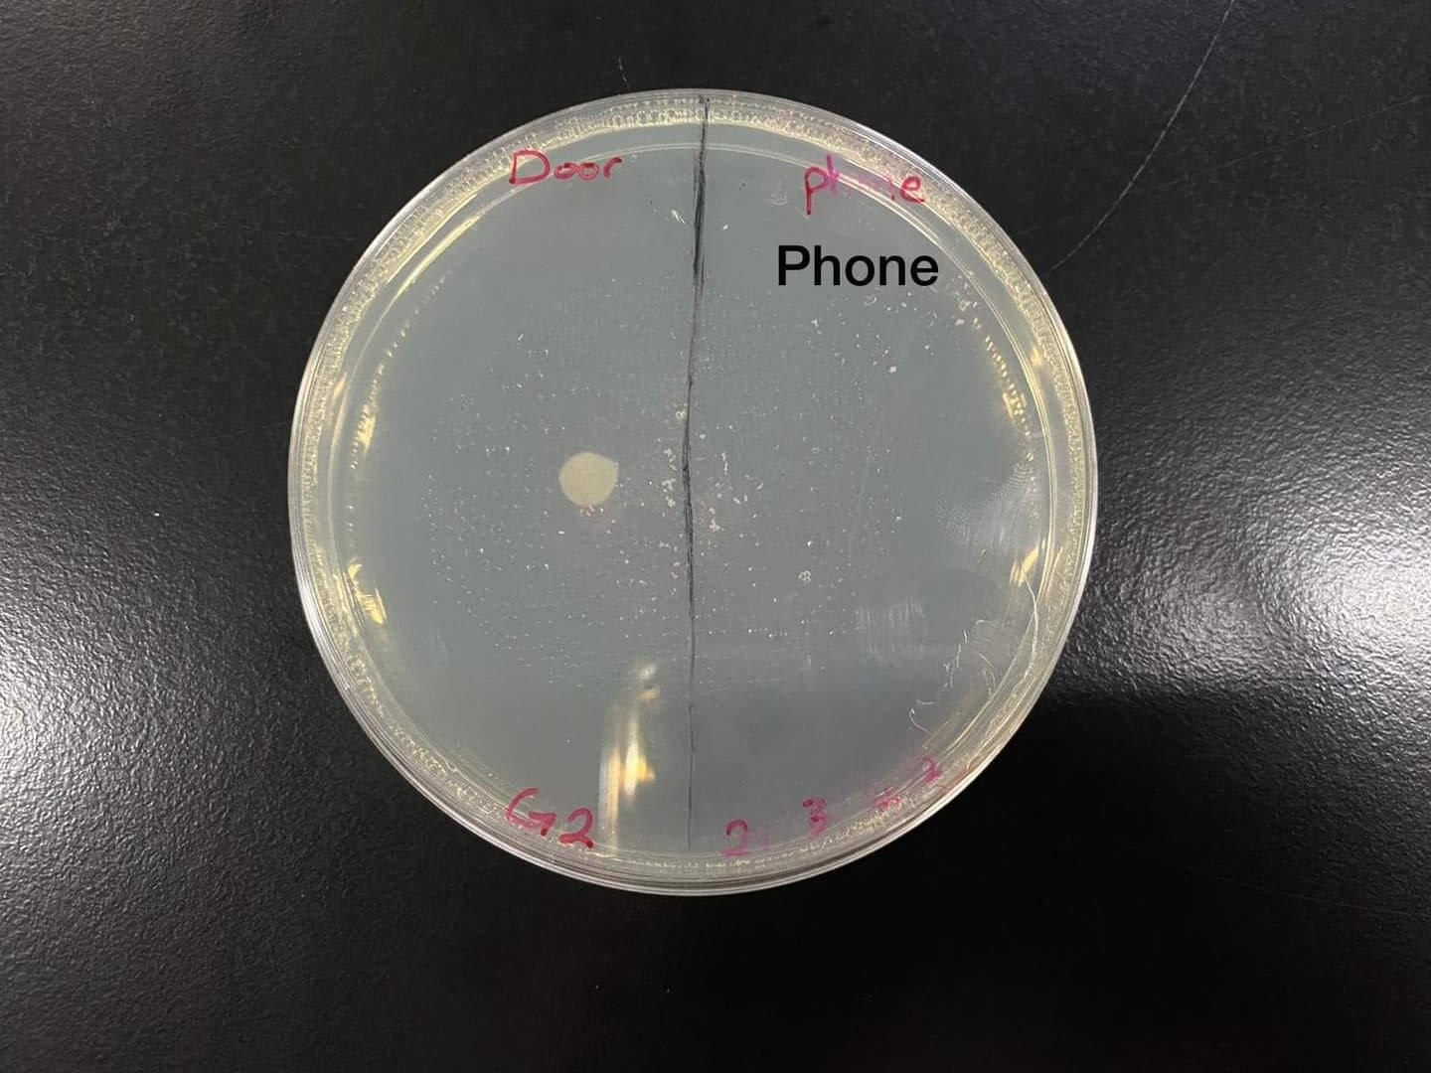

**Figure ( 3) :** The third group took samples from the eye, nails and teeth in the first picture while in the second picture the samples took from the laboratory, then third picture took from the bath and bench.

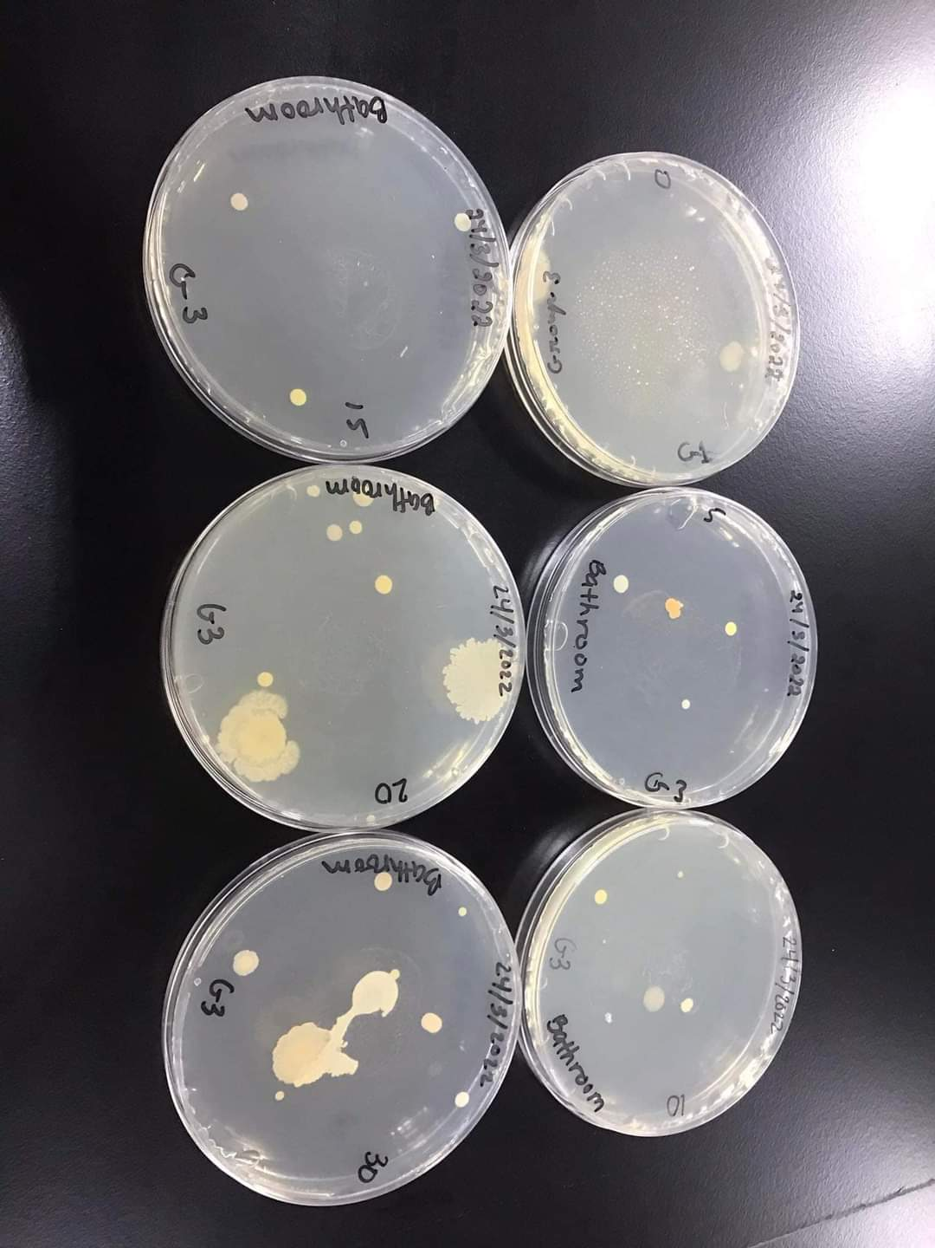

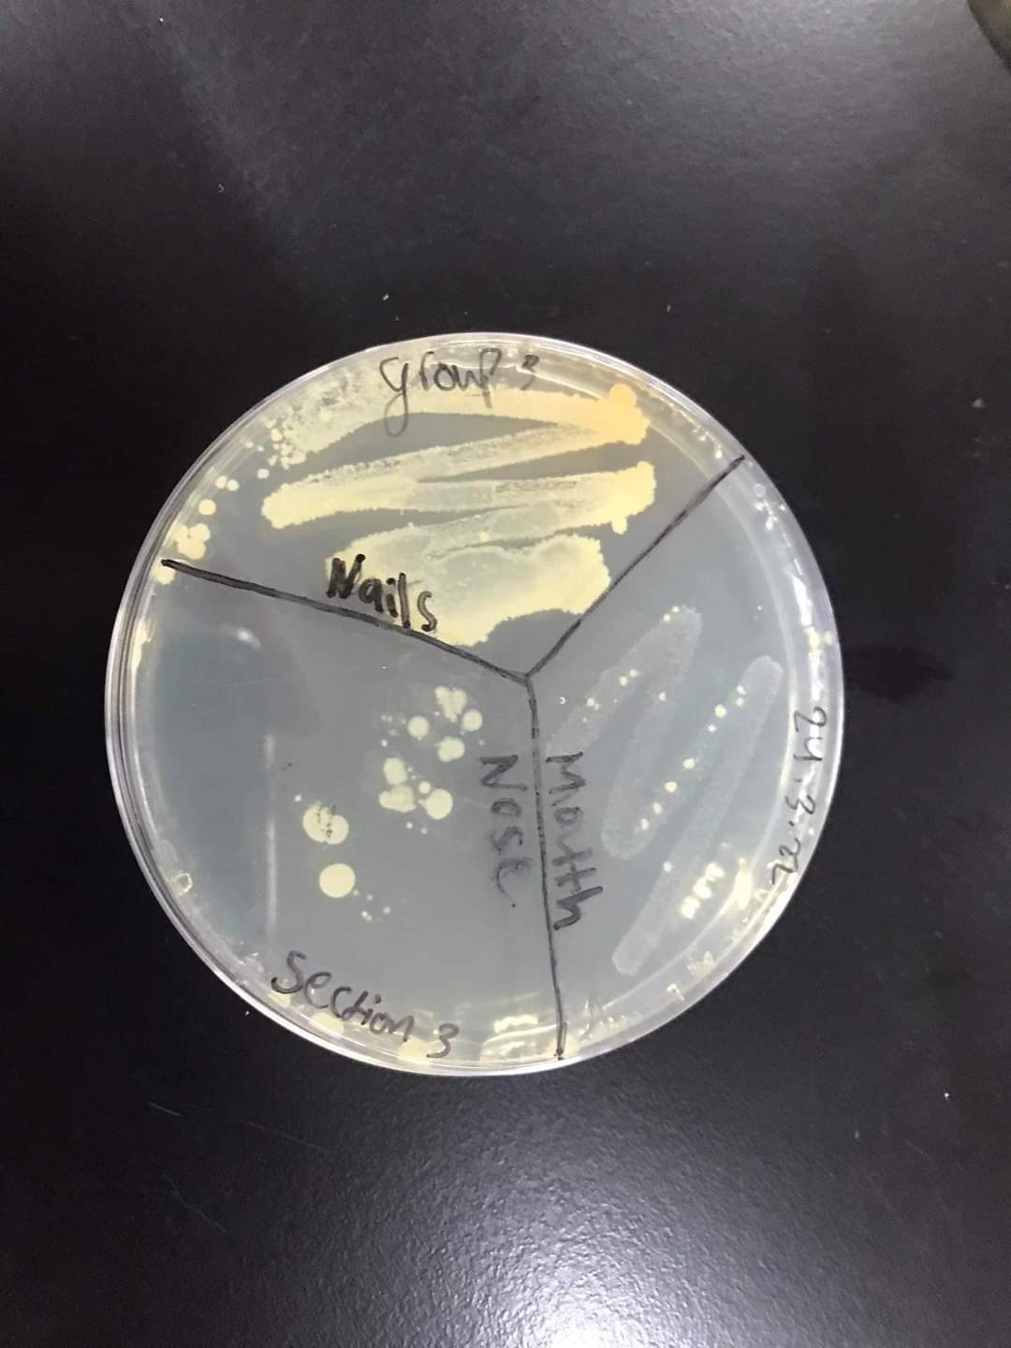**(1)**

**(2)**

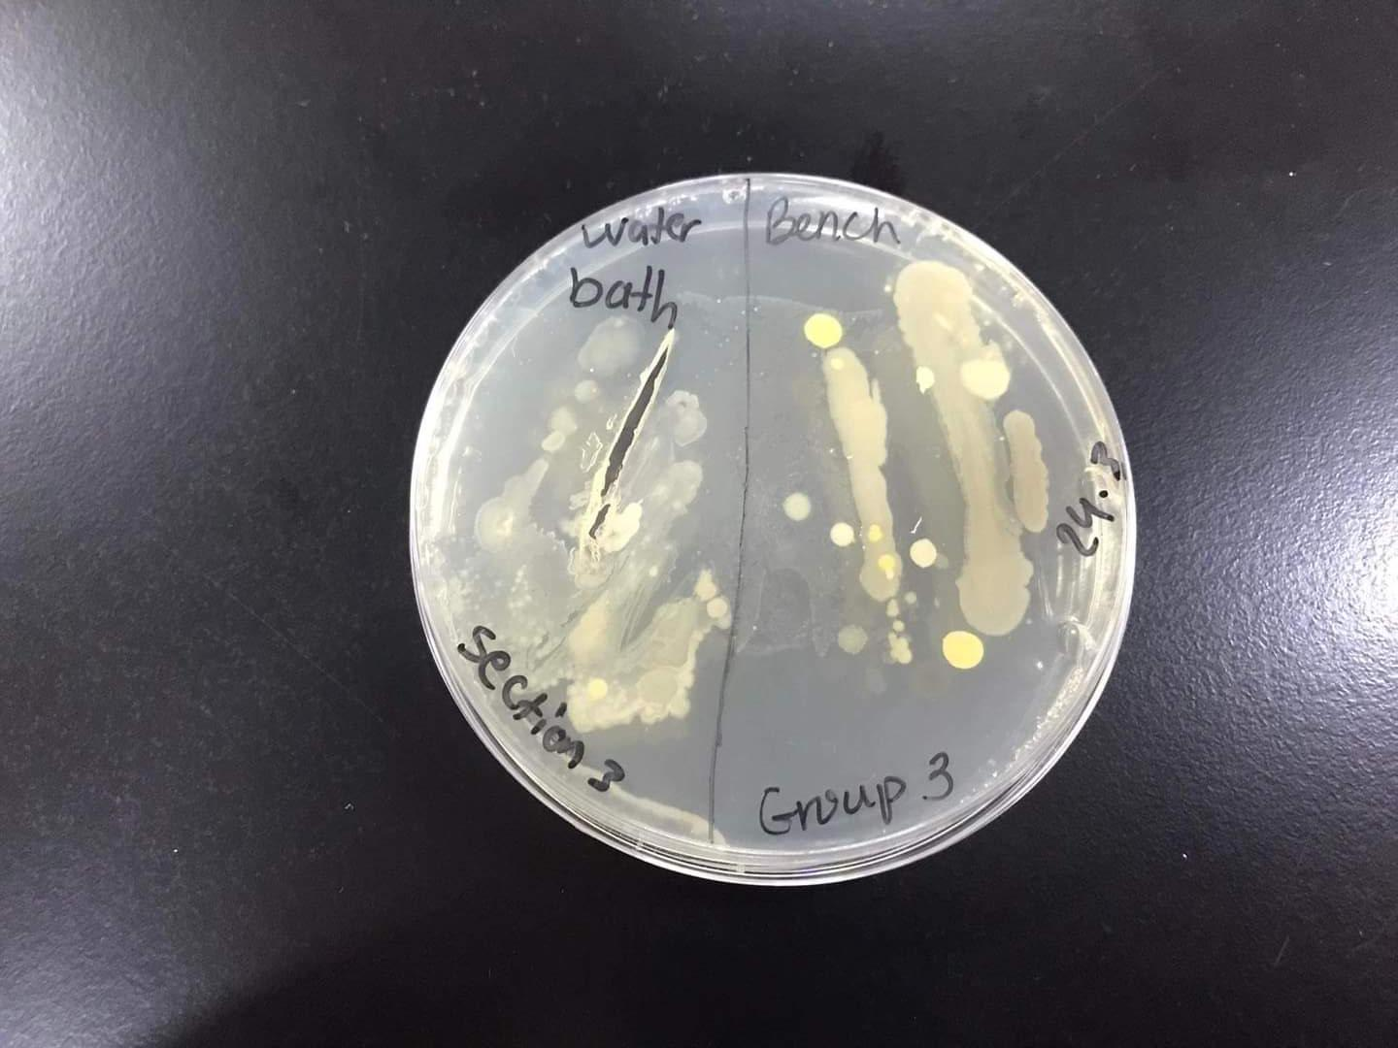

**Figure ( 4 ) :** The Fourth group took samples from the nose, nails and teeth in the first picture while in the second picture the samples took from the bathroom, then third picture took from the sink and bench.

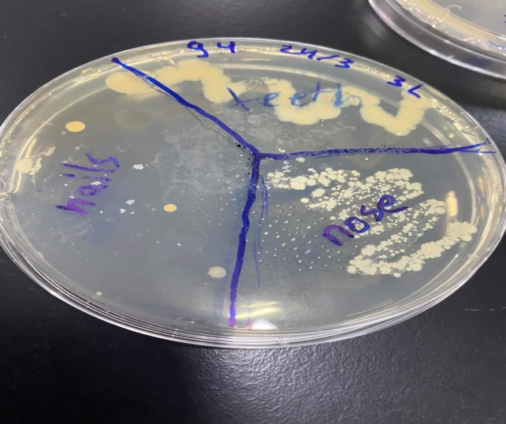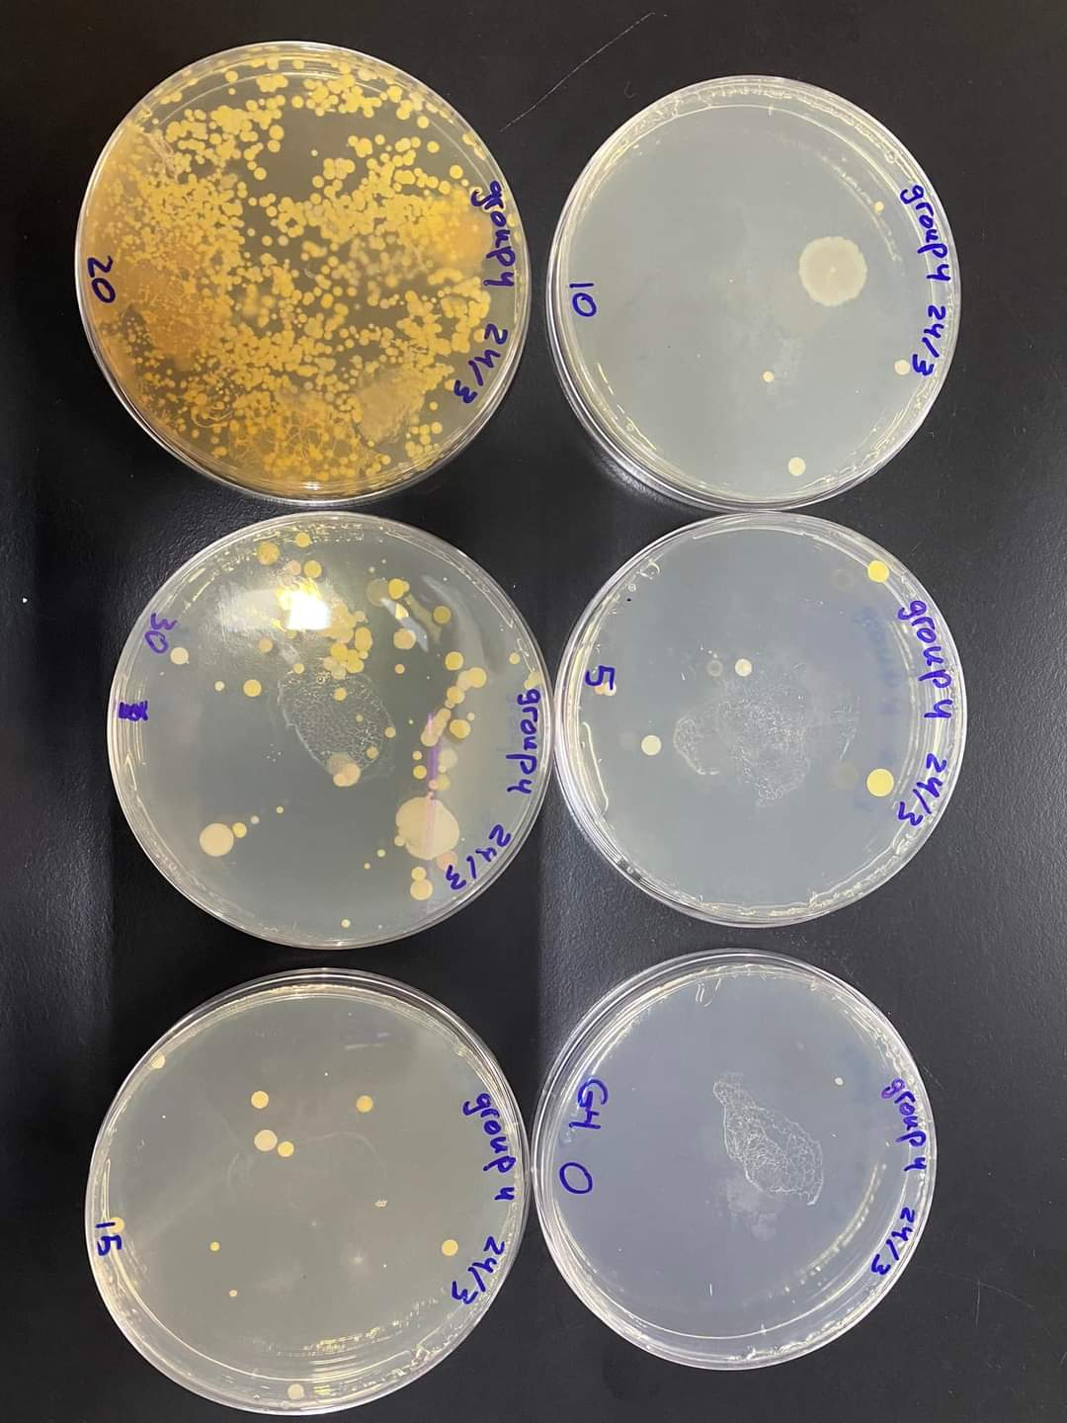

1. **(2)**

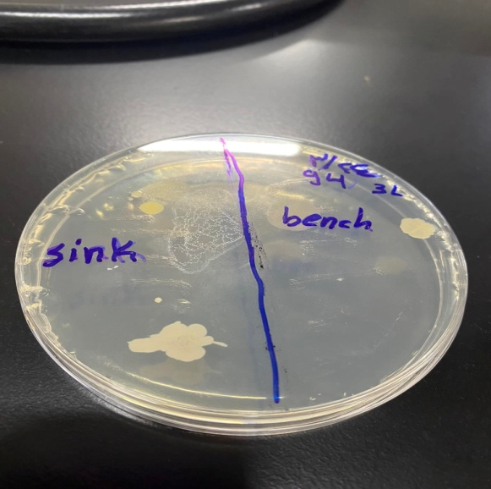

**Discussion**

The growth of microorganisms depends on both the nutrient supply and their tolerance of the environmental conditions present in their habitat at any particular time. Each microorganism has a specific temperature range in which it can grow. The same rule applies to other factors such as pH, oxygen level, and salinity. For instance, rapid, unlimited growth ensues if a microorganism is exposed to excess nutrients. Such growth quickly depletes nutrients and often results in the release of toxic products. The surfaces and secretions of man and animals and different environments are also heavily colonized with bacteria. In this lab, samples of bacteria were taken from various environments such as (air, surfaces, human body parts). To reach to the purpose of verifying the presence of Microorganisms in various environments. The experiment was done by four groups, each group used eight petri dishes, the six ones used for the microbial content of the air, and one petri dish for the samples of body parts such as( nails, nose, teeth, eyes…etc), and the last one was used for the microbial content of the surfaces. For group 1 the samples were taken from the lab corridor, and the results of this group are shown in the data & result part. The petri dish at zero time was closed but it’s contaminated, maybe because the petri dish is moved slightly so it enable some bacteria to enter the dish. The petri dish that’s closed after 5 min, there was 1 colony of bacteria. Bacteria grow depending on its surrounding environment elements. This the same for the remaining petri dishes, the number of bacterial colonies increases when the time of the opened petri dishes increases. The remaining 2 petri dishes, the first one contains bacterial colonies from the teeth, nails, and nose, the highest numbers of colonies was in the nose then the nails, and then the teeth. If the sample was taken from dry part of the body or object, you should take some water by sterile cotton swab and mix it with the sample place that you would like to take from. If the sample place was wet, there is no need to humidify it by water. The last petri dish contains bacterial colonies from the surfaces( Sink, phone), the high numbers of bacterial colonies that’s taken from the phone screen demonstrates that it’s very contaminated by microorganisms from different sources such as( hand, tables, air, fluids…etc). For group 2 , the samples of the microbial content of the air were taken from the Lab. The samples of microbial content of some body parts were taken from the eyes, teeth, and nails, the highest bacterial colonies were in the nail. And the last sample of the microbial content of the objects was taken from the phone and door, the highest contamination of bacteria was in the door. For group 3 the microbial content of the surfaces was taken from the bath & bench. And the microbial content of the body was taken from the mouth, nails, nose. For group 4 the microbial content of the surfaces was taken from the bench & Sink, & the microbial content of some body parts was the same of the group 1.

**Conclusion:**

In conclusion, Through the experiment that was done we can see how to find bacteria easily because they are located everywhere we can imagine, so we found that when we collected samples from many different places(air, surfaces, some human body parts) and planted them in agar how bacteria colonies form clearly in the petri dishes.

**References:**

* Prescott, Harley, and Klein’s, microbiology, Seventh Edition.