

**Biology and Biochemistry Department**

**General Microbiology laboratory**

**Unknown #18**

**Name:** Yafa Nimer Ahmad Abu Layya

**ID:** 1201212

**Section1**

**Lab Instructor:** Dr. Emilia Rappocciolo

**Teacher Assistant:** Ms. Lina Abuattiyeh

**Date and day of experiment:** 30 of May. 2022, Monday

**Date and day of report submission:** 7th of June. 2022, Monday

**Unknown #18 sample test**

* **Introduction:**

The sample number I got is 18, it contains two types of bacteria, it is assumed that each type will be determined and the appropriate treatment for it with antibiotics at the end of this experiment.

* **Day1:**

The inoculating loop is sterilized, and then a sample is taken from tube 18, tertiary streaking for bacteria done, and put the plate in incubator at 37 Celsius degrees for 24h.

(I forgot to take a picture of the result).

* **Day2:**

Two types of isolated colonies appeared, one was small (1) and the other was large (2), a sample was taken from each colony and grown on its own plate and then on UTI Agar after it was divided into two halves, after which they were placed in the incubator.

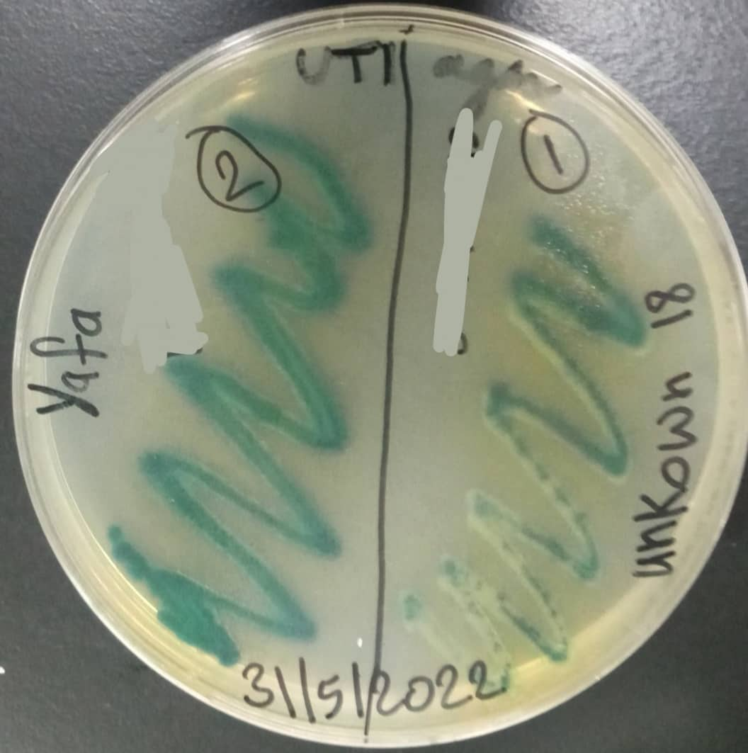

Figure1: UTI Agar result.

From this picture: it is possible to know the two types of bacteria in the sample through the colors. Bacteria No. 1 is supposed to be colorless, but a green color appeared in it; this could be due to lack of good sterilization, or error in taking the colony, so the bacteria in this case is P. aeruginosa. As for bacteria number 2, it's E. faecalis.

* **Day3:**

A sample was taken from the plate of each bacterium and grown in a tube containing NS and then compared with MacFarland, then cultured on new plates by spreading method and then 4 types of antibiotics are placed on each plate (CXM30, VA5, AMC30, CIP5), then it was placed in the incubator.

* **Day4:**

The diameter of each of these visible circles was measured in order to determine the appropriate antibiotic to treat this type of bacteria. The result was as follows:

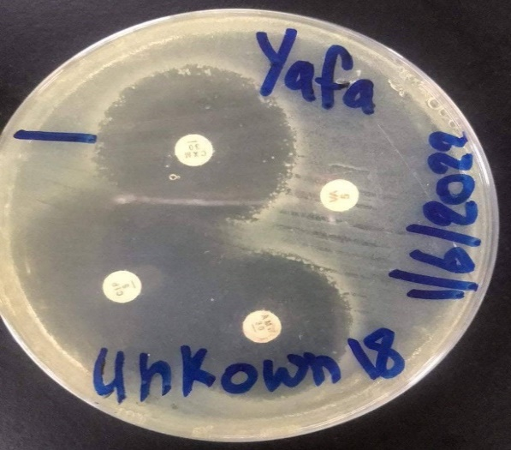

Figure2: The effect of antimicrobials on P. *aeruginosa*.

AMC30 diameter is 2.9cm.

CXM30: 3.2cm.

CIP5: 4cm, this type of antibiotic is very effective for treating this type of bacteria.

VA5:0, resistance (can’t treat it).

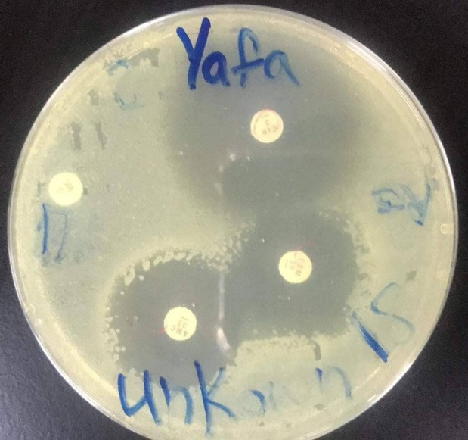

Figure3: The effect of antimicrobials on E. *faecalis.*

AMC30: 2.5cm

CXM30: 2.7cm

CIP5: 3.5cm, good in treating it.

VA5: 0, resistance to bacteria.