

**Biology and Biochemistry Department**

**General Microbiology laboratory**

**Environmental plate for growth of bacteria**

**Yafa Nimer Ahmad Abu Layya 1201212**

**Partners name and ID:**

Majd Odeh 1202717

Ibraheem Ayyad 1202314

Inas Rajabi 1171765

**Lab Instructor:** Dr. Emilia Rappocciolo

**Teacher Assistant:** Ms. Lina Abuattiyeh

**Date and day of experiment:** 28th of March. 2022, Monday

**Date and day of report submission:** 18th of April. 2022, Monday

**Environmental plate for growth of bacteria**

* **Objectives:**

1. To reveal of the presence of bacteria in the environment (Microbial flora, air, objects).

2. To note the difference between these areas.

* **Introduction:**

Our body is home to many microorganisms, they live with us on the surface (Internal and external) and we can find it everywhere. These microorganisms could be pathogenic or nonpathogenic (It's normal to found and don't cause a disease).

There are many ways that help us see and identify the bacteria in the environment around us, such as cultivating them in a nutrient medium suitable for their growth (Agar plate). In this experiment we will see if there are any microorganisms that cover things or in the air and the number of it to compare them.

* **Materials:**

1. Nutrient agar plates. -sterile without microorganisms-

2. Cotton swabs. -sterile and close-

3. Normal Saline 0.9% NaCl -to moisturize it if it is dry-

* **Methods:**

This experience is divided into three sections: detection of the presence of bacteria in the environment in the Microbial flora in our bodies, air and objects.

**1.Microbial flora: -**

An agar plate must be brought and divided into 3 thirds, from the outside by drawing on the same plate then put a label for each part based on the area from which the sample will be taken, the date of the experiment and the number of the group you work with.

Then, sterile and closed cotton swabs are brought and wiped well on a surface such as the skin, hair, mouth, and because it is a dry surface, you must use Normal Saline to moisturize, and so on for the other two parts. And then you put this plate upside down in the incubator for 24 hours at a temperature of 37 degrees.

**2.Microbial content of the air: -**

In the last part, you have to bring 6 plates, and you put a label for each of them based on the number of minutes it will remain open, with the date of the experiment and the work team.

One of these plates will not open at all and won’t be exposed to the air at all (0 minutes) and is called the control plate, and the next one is opened for 5 minutes, then 10 minutes, 15, 20 and 30 minutes, and each plate is closed when its specified time expires, and then we put all of these plates in the incubator for 24 hours at a temperature of 37 degrees. -you should do this part in different places, like: inside the lab, outside it, in the bathroom, in the cafeteria, or the garden, etc.…).

**3. Microbial content of objects: -**

A new agar plate is brought and divided into two halves, and following the same steps, a label is placed for each half according to the part from which the sample will be taken, and the date and number of the group you are working with is specified.

After that, cotton swabs are brought and used to wipe on things like the door and the incubator, we moisten them because they are dry surfaces, then we grow bacteria on these agar plates using the simple streaking, and then put this plate in the incubator upside down on the same conditions in which the first plate was placed.

* **Results:**

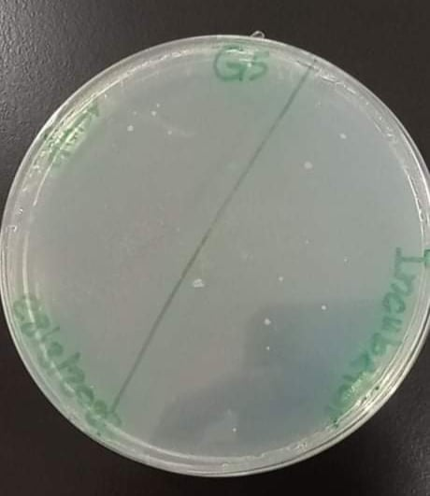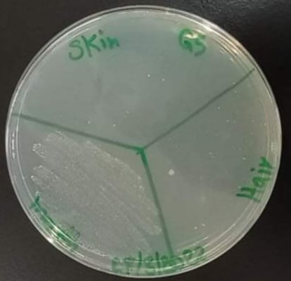

Picture1: Microbial flora in our bodies. Picture3: Microbial content of objects.

We took the sample from skin, hair and mouth. from the incubator and the door.

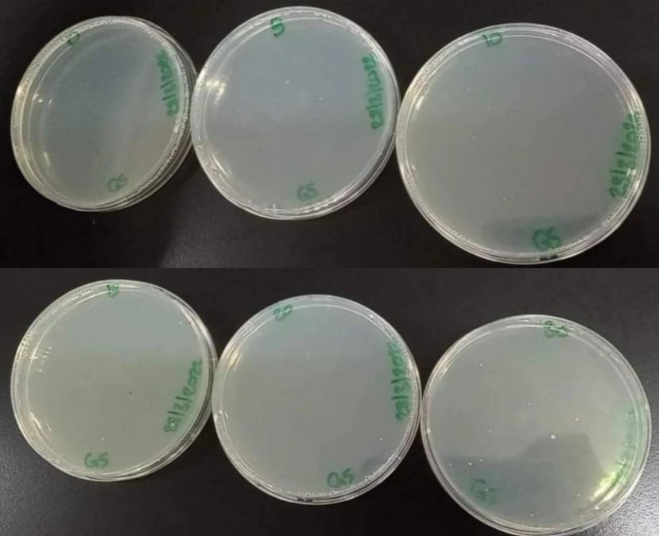

Picture2: Microbial content of the air

* **Discussion:**

As I said before, bacteria take our bodies and everything that surrounds us as their home. We did this experiment to prove this and so that we can identify these bacteria surrounding us and that are inside us. First of all, you shouldn’t clean or sterilize anything, because we want to make bacteria grow so that we can study them.

First, we brought 8 agar plates and put them on the bench and took samples from different areas of the surrounding environment, the result was in the first picture (Microbial flora in our bodies) the number of bacteria in the mouth takes the first place, followed by the hair and then the skin, because the mouth receives many foods and drinks and is exposed to the entry of many microbes from the air when opening it, or talking, etc. As for the hair, it is clean because of the constant showering and cleaning. As for the skin, the sample was taken from the area of the hands, which is considered one of the cleanest areas and the least contaminated with bacteria, because it is always sterilized and is constantly cleaned and washed.

After that we took 6 plates and went to the cafeteria and the results were as shown in the second picture (Microbial content of the air). We find that the plate that was closed after 30 minutes have the most containing bacteria, and the least of them was the dish that was opened for 5 minutes and we notice this when comparing these plates with the control plate that wasn’t opened. Finally, and from this we conclude that the growth of microbes increases with the increase in the time that the plate is exposed to the air, (that is, the relationship is direct between time and the growth of microbes). -Although we were in the cafeteria, the plates didn’t contain as many bacteria as expected-.

As for the third picture, it talks about the microbial content of the objects, one taken from the door and the incubator, and we used only one dish in it to detect the presence of microbes and bacteria on things, we see that the amount of bacteria on the door was not high, because the door is constantly wiped and cleaned and is not touched much (from the area from which we took the sample), as for the incubator, it is opened and used by many people (the sample was taken from the hand) so it contains on the largest number of bacteria.

* **Conclusion:**

In the end, we come to the conclusion that microbes are found everywhere around us and, on our bodies, and that some of them can be harmless and don’t cause diseases, but that their presence helps in many good things, and we concluded that the longer the exposure time of the thing to the air increases the probability It collected more microbes, and when these bacteria were grown in the agar plate, they appeared clearly and we were able to see and distinguish between them.

* **References:**

Laboratory manual.

My own notes.