

**Biology and Biochemistry Department**

**General Microbiology laboratory**

**Effects of physical agents on bacterial growth**

**Yafa Nimer Ahmad Abu Layya 1201212**

**Partners name and ID:**

Majd Odeh 1202717

Ibraheem Ayyad 1202314

Inas Rajabi 1171765

Baha’ Yasin 1203122

**Section1- Group5**

**Lab Instructor:** Dr. Emilia Rappocciolo

**Teacher Assistant:** Ms. Lina Abuattiyeh

**Date and day of experiment:** 9th of May. 2022, Monday

**Date and day of report submission:** 2nd of June. 2022, Monday

**Effects of physical agents on bacterial growth**

* **Objectives:**

To find out how environmental and physical conditions affect the growth of bacteria, including:

1. Observe how temperature affects spore-forming and non-spore-forming bacteria.

2. Knowing the effect of osmotic pressure on bacterial growth.

3. Knowing how radiation (especially ultraviolet) affects the growth of bacteria.

* **Introduction:**

It is very important to know the factors that affect the growth of bacteria in order to prevent the spread of the disease to humans, as the binary fission process -in which bacteria reproduce- may be affected by several factors, including chemical and physical. As for the physical effects, such as: temperature, osmotic pressure, radiation, each of them affects the growth of bacteria in a different way, where there are bacteria that grow at high temperatures and others at low, and there are types that tolerate salinity or that excess salt kills them and prevents their growth, The growth of bacteria is also affected when exposed to ultraviolet rays.

* **Mterials:**

1.Microorganisms: E. *coli*, S. *aureus*, B. *subtilis*, M. *luteus*.

2.Nutrient agar plates as a control

3.Nutrient agar with 5,10,15% of NaCl.

4.Nutrient agar plates (بشكل عام يعني).

5.Cotton swabs (sterile and close).

6.Different temperatures at 4, 37, 55, 75, 95 degrees Celsius.

7.Sterile glass tube.

8.Loop-full inoculating.

9.UV light.

* **Methods:**

3 types of bacteria were used and exposed to different physical conditions that affect their growth as follows:

**1.Osmotic pressure: -**

4 nutrient agar plates should be fetched and each of them divided into two parts, (correct labeling done) only one is used as a control plate for comparison, the remaining three being one of which one is 5% NaCl, the second is 10% and the third is 15%, E. *coli* and S. *aureus* in each half of the space designated for it on these plates, and then they are placed in the incubator at a temperature of 37°C, for 24 hours.

**2.Temperature: -**

Different temperatures are used, such as: 4, 37, 55, 75, 95 degrees Celsius, as well as two plates of nutrient agar so that each of them is divided into 8 sections and each section is named according to the number of minutes that have been worked in, which are: 0, 5, 10, 15, 20, 30, 40, 50 minutes, the number is 0 control for comparison, the whole loop is sterilized and both B. *subtilis* and E. *coli* bacteria are taken and cultured on the section written above 5 minutes and then the plate is placed in the place where It contains the required temperature from each group and is taken out after 5 minutes, and so on until the expiration of the time, after which it is placed in the incubator at a temperature of 37°C for 24 hours.

**3.Radiation: -**

8 nutrient agar plates are used, and M. *luteus* is grown on each of them, and then we expose them to ultraviolet rays as follows: the first one is Lid on (and the cover is present without removing it), and the remaining 7 are exposed as follows: for 1, 5, 10, 30, 45, 50, 60 seconds, and each time a love heart-shaped paper is placed with the cover removed, and after completion, these plates are placed in the incubator at a temperature of 37°C for 24 hours.

* **Results:**

**1.Osmotic pressure:**

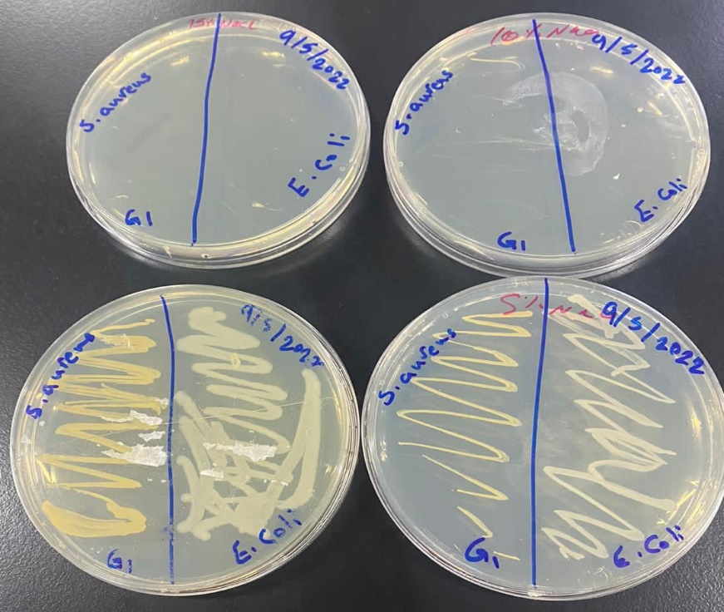

Figure1: Nutrient agar with a different concentration of NaCl for group1**.**

**G2:**

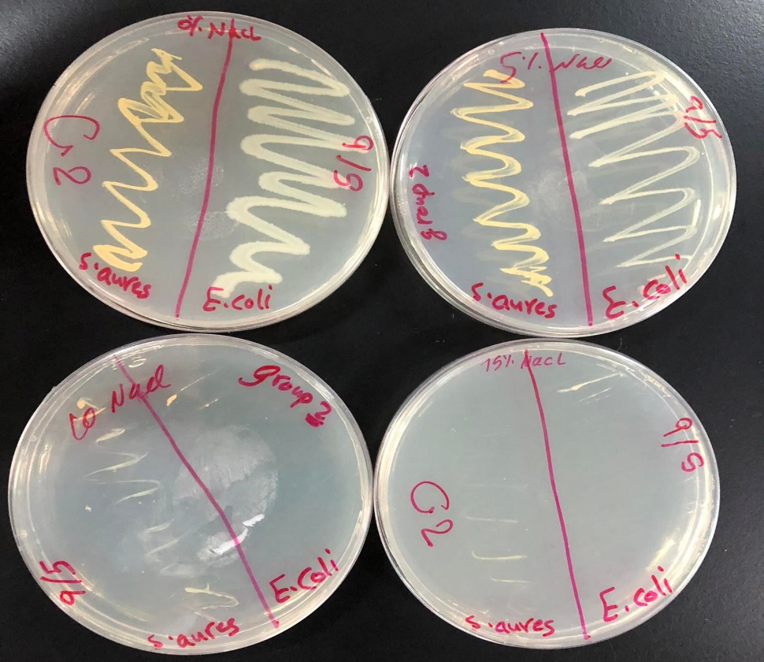

Figure2: Nutrient agar with a different concentration of NaCl for group2.

**G3:**

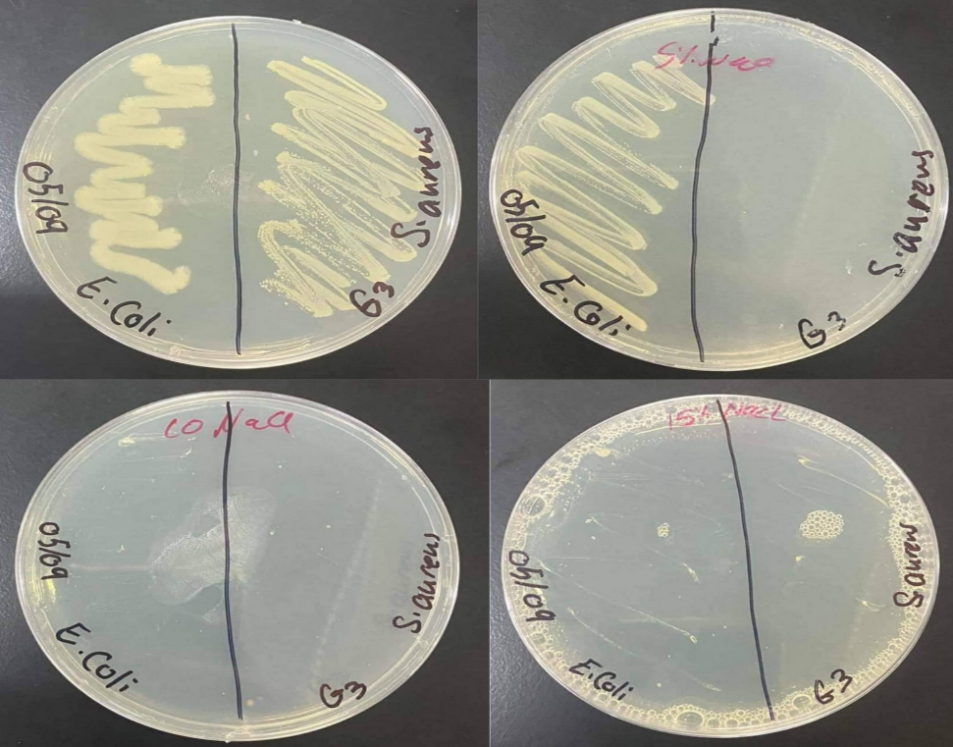

Figure3: Nutrient agar with a different concentration of NaCl for group3.

**G4:**

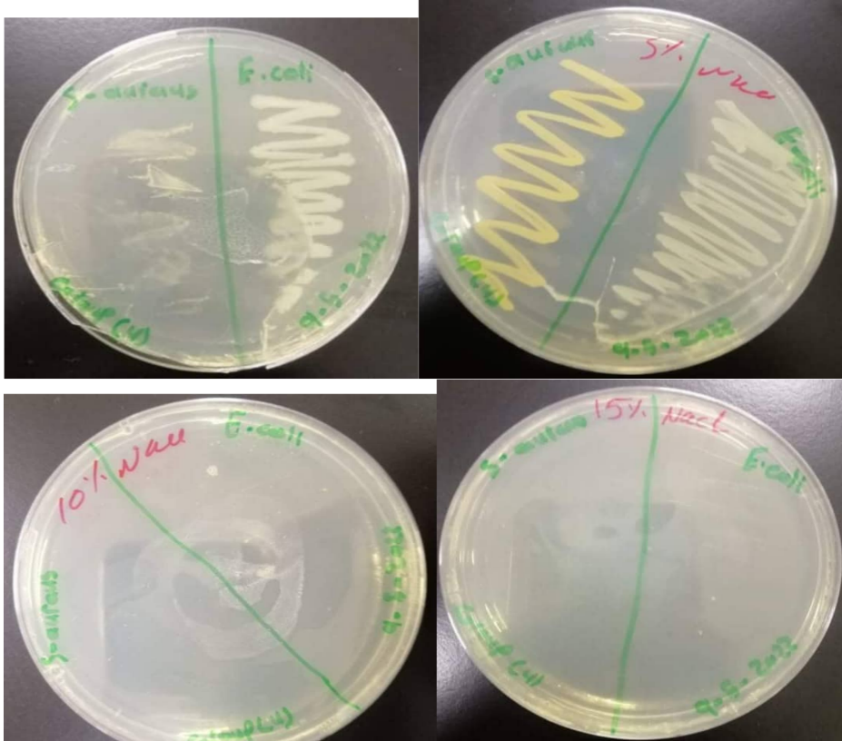

Figure4: Nutrient agar with a different concentration of NaCl for group4.

**G5:**

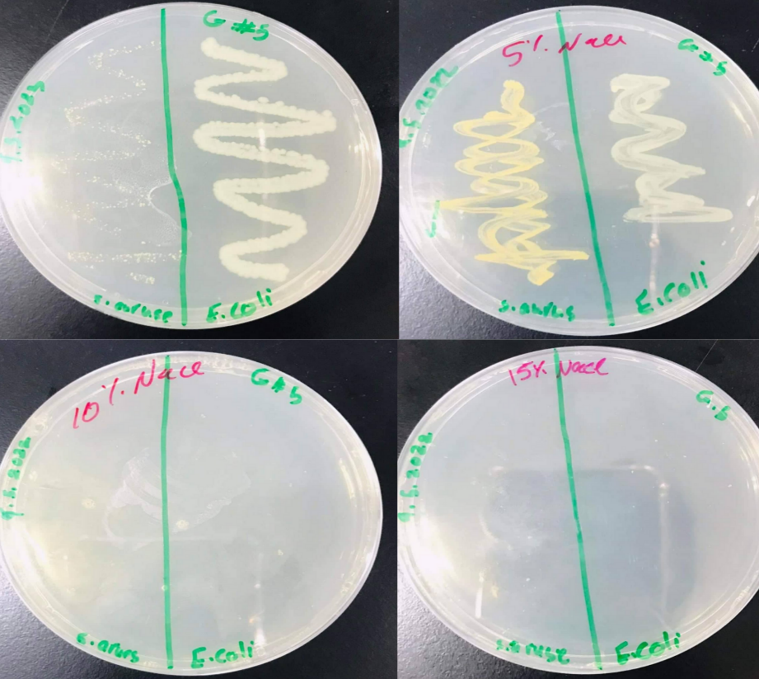

Figure5: Nutrient agar with a different concentration of NaCl for group5.

|  |  |
| --- | --- |
| **Percentage of NaCl on E. *coli*** | **Effect** |
| 5% | Optimum growth |
| 10% | Damage of the cell |
| 15% | No growth |

Table1: NaCl effects of E. *coli.*

|  |  |
| --- | --- |
| **Percentage of NaCl on S. *aureus*** | **Effect** |
| 5% | Optimum growth |
| 10% | Slightly growth |
| 15% | No growth |

Table2: NaCl effects of S. *aureus.*

**2.Temperature:**

G1= 4°C.

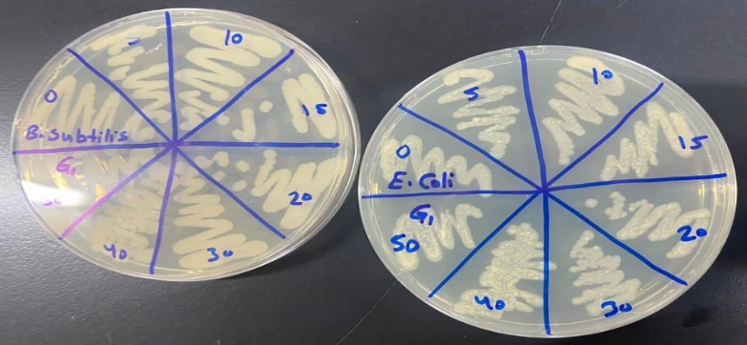

Figure6: Nutrient agar with a different bacterium at temperature 4°C for group1.

G2= 95°C.

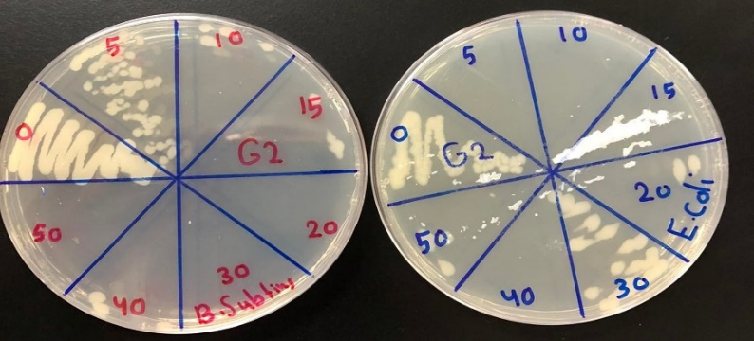

Figure7: Nutrient agar with a different bacterium at temperature 95°C for group2.

G3=75°C.

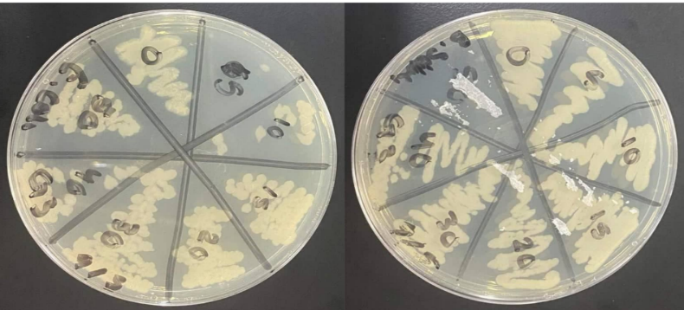

Figure8: Nutrient agar with a different bacterium at temperature 75°C for group3.

G4= 55°C.

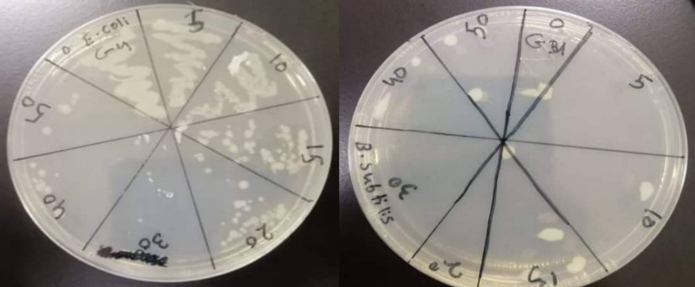

Figure9: Nutrient agar with a different bacterium at temperature 55°C for group4.

G5= 37°C.

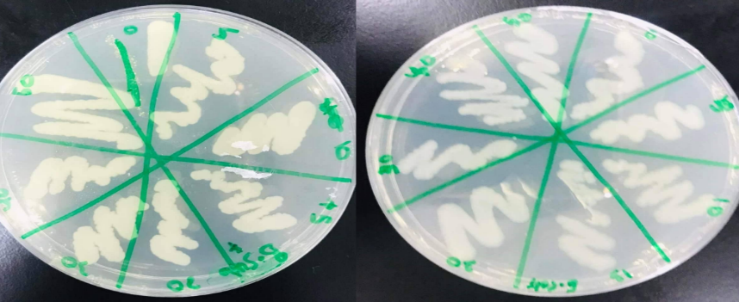

Figure10: Nutrient agar with a different bacterium at temperature 37°C for group5.

Table 3: temperature effects on **E. *coli*.**

|  |  |  |  |  |  |
| --- | --- | --- | --- | --- | --- |
| **Time (mins)** | **Temperature/ Effects** | | | | |
|  | 4°C | 37°C | 55°C | 75°C | 95°C |
| 0 | Optimum growth | Best growth | Optimum growth | Best growth | Optimum growth |
| 5 | Good growth | 95% growth | Good growth | No growth | No growth |
| 10 | 95% growth | 95% growth | 85% growth | Low growth | No growth |
| 15 | 95% growth | 95% growth | 50% growth | 80% growth | Very low growth |
| 20 | 85% growth | 95% growth | Slightly growth | 80% growth | Low growth |
| 30 | 80% growth | 95% growth | No growth | 85% growth | 80% growth |
| 40 | 90% growth | 95% growth | Low growth | 75% growth | No growth |
| 50 | 90% growth | 95% growth | Very low growth | 90% growth | 10% growth |

Table4: temperature effects of **S. *aureus.***

|  |  |  |  |  |  |
| --- | --- | --- | --- | --- | --- |
| **Time** | **Temperature/ Effects** | | | | |
|  | 4°C | 37°C | 55°C | 75°C | 95°C |
| 0 | Best growth | Optimum growth | Very low growth | Optimum growth | Best growth |
| 5 | 95% growth | 95% growth | No growth | Good growth | 90% growth |
| 10 | 90% growth | 95% growth | 5% growth | Good growth | Low growth |
| 15 | 50% growth | 95% growth | Low growth | Good growth | 5% growth |
| 20 | 75% growth | 95% growth | No growth | 85% growth | No growth |
| 30 | 95% growth | 95% growth | No growth | 95% growth | No growth |
| 40 | 85% growth | 95% growth | Low growth | 90% growth | 5% growth |
| 50 | 85% growth | 95% growth | Low growth | No growth | No growth |

**3.UV radiation:**

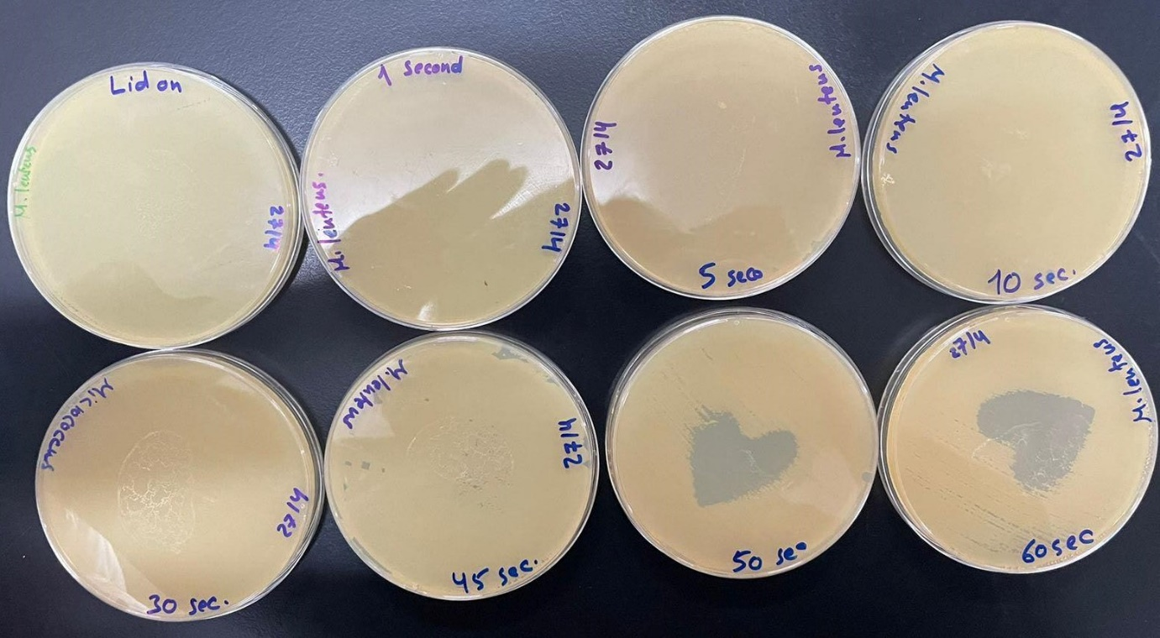

Figure11: Nutrient agar with a different expose to UV radiation through 60sec.

Table5: UV effects on **M. *luteus*.**

|  |  |
| --- | --- |
| **Time** | **Percentage** |
| Lid on | 0% |
| 1 second | 0% |
| 5 second | 0% |
| 10 second | 0% |
| 30 second | 0% |
| 45 second | 5% |
| 50 second | 95% |
| 60 second | 100% |

* **Discussion:**

This experiment includes a varying amount of bacterial growth under many different factors, including, as I mentioned earlier: temperature, osmotic pressure, and radiation. We conducted this experiment in order to study and determine the effects of each of these conditions on the growth of S. *aureus*, E. *coli*, B. *subtilis*, and M. *luteus*.

First each of the five groups brought in 4 nutrient agar plates, we cut them in half, labeled etc., we cultured bacteria inside one of these plates (using loop-full inoculating) without concentrating because it is a control plate used for comparison, then We brought another plate and added both types of bacteria (S. *aureus*, E. *coli*) to 5% NaCl, and then we cultured it on the plate, and then we repeated these same steps, but with a concentration of 10% and 15%. The results showed that in the first plate (the control plate) there was a good and normal growth for both types of bacteria, because they were grown normally, except for group number 5, due to the dilution of bacteria before culturing it “by mistake”, in 5% NaCl, all groups showed in their results a large growth of bacteria, but in a lighter way than the control plate, except for the second group of S. *aureus* type, which No growth appeared, and this is a false result. As for 10% of NaCl, a slight growth of S. *aureus* bacteria appeared, except for groups 4 and 5 (false result). Finally, in 15% NaCl, there is no growth for both types of bacteria in all groups. Based on these results, it was proved that S. *aureus* is halotolerant because it was able to coexist with dissolved concentrations although it may show better growth without adding solute, while E. *coli* is non-halophile which means that it grows better in media which contains less than 0.2 molar of salts, it was completely spoiled when the concentration of NaCl increased. In the groups that showed wrong results, this may be due to not using a sufficient number of bacteria, or that the ring was not cooled well, which led to the killing of bacteria, or the use of another type of bacteria that does not grow in these concentrations.

After that, each group brought two plates of nutrient agar, and they were divided into eight sections and labeled, etc., and most importantly, different times were chosen, starting from 0, 5, 10, 15, 20, 30, 40, and finally 50 minutes, and each group took A specific temperature range to work on is 4, 37, 55, 75 and 95°C. B. *subtilis* and E. *coli* bacteria were first cultured at minute 0 and were not exposed to any temperature at all, where this temperature is used for comparison, and then Cultivation at minute 5 and each group exposes the plate to its own temperature, and so on until the expiration of the time, and then all plates are placed in the incubator at a temperature of 37°C for a period of 24 hours. First, the first group that worked at a temperature of 4°C, we find that there was a natural growth in the 50 minutes for both types of bacteria used and this is a correct result. For the second group that worked at a temperature of 95°C, at minute 0 there was a natural growth for both types of bacteria, but when 5 minutes differences began to appear, in E. *coli* at 5, 10, 15 minutes the bacteria did not grow because they were killed, but at 20, 30 (the bacteria appeared more than other areas), 40, 50 minutes began to appear slightly Very, this is a normal result because this type of bacteria cannot withstand the temperature of 95°C, and it dies, as for B. *subtilis*, at 5, 10, 15 minutes, there was a very slight growth of bacteria, and then it did not grow at all, because it is killed so that it cannot bear the high temperatures of this degree. As for the third group that worked at a temperature of 75°C, we find that bacteria grew at all times for both types, but the growth of E. *coli* was slightly more, and this is evidence that both are able to coexist at the temperature that was worked on. And the fourth group that worked at a temperature of 55°C, the growth of bacteria in it at 0, 5, 10, was normal, but at 15, 20 it began to decrease and at the rest of the minutes there was no appearance of it, and this is evidence that it died, and this is true because this type B. *subtilis* is supposed to have the same growth over time, but it didn’t appear at any time or that its appearance was little, and this is a mistake and the reason is either not cooling Loop inoculating and thus killing bacteria due to heat, or not enough bacteria developed. As for the fifth and last group, which worked at a temperature of 37°C, which is the temperature of the incubator, the growth of both types of bacteria was normal and increased with time. Based on all these results, we conclude that bacteria are types, some of which withstand high temperatures due to their ability to form spores that are difficult to break and are able to resist heat such as B. *subtilis*, but they die at temperatures higher than 95°C, and some of them cannot tolerate High temperatures and quickly die, and this is an example of E. coli, which I said can withstand temperatures between 4-45.

Ultraviolet radiation has a wide range of effects on humans, and it will certainly have an effect on microbes. In this experiment, we took 8 nutrient agar plates and labeled them, etc., and M. *luteus* bacteria were cultured on the plates, and each of them took a certain time during which it was exposed to different amounts of radiation, and it was as follows: 0 seconds so that the lid is never opened and it is called (Lid on), and then the plate is exposed to ultraviolet rays for one second with the cover open and a paper in the shape of a heart is placed, and then at 5 seconds, and at 10, 20, 30 seconds and in all of these, no effect of ultraviolet rays appeared on the bacteria so that the plates remained as they are, In the 45th second some differences appeared so that the rays began to work on affecting the bacteria and killing them, at 50 seconds the shape of the heart appeared, and at the 60th second the heart was completely completed, because all the bacteria in the area exposed to the rays had been killed. M. *luteus* is a Gram-positive bacterium and has a yellow pigment that should protect it from UV rays, giving it the ability to live under such harsh conditions, DNA is the main cause of cellular damage caused by radiation. Based on these results, it is concluded that there is a direct relationship between the time of exposure to UV rays and the number of bacteria that are killed.

* **Conclusion:**

In the end in general, and like every living thing in life, we find that there are many different physical factors that have a strong influence on the growth of bacteria, including heat, radiation, and concentrations of different salts. Bacteria are types and the ability of each type to withstand the physical conditions to which it is exposed varies from one type to another.

* **References:**

Laboratory manual.

My own notes 😊