

**Biology Department**

**Environmental plate**

[**Emilia Rappocciolo**](https://ritaj.birzeit.edu/bzu-msgs/inbox?mttid=104&classid=148047&termid=1192)

**Adnan Abu Arqoub 1182551**

**Date of experiment 26th Feb 2020**

**Objectives**

To identify the properties of bacteria in the surrounding environment ( Human body, Random objects , Open air)

**Introduction**

Bacteria are prokaryotic, which means that they do not poses membranes around their organelles, also they do not have a membrane around the single chromosome they have (haploid). Bacteria could live in any environment on Earth, from sever environment to everyday environment, on phones, desks , and on the human body and inside of it (Flora). In this experiment samples had been collected from different surfaces to observe the bacteria found from them.

**Materials**

* Six Petri dishes (Agar dishes)
* Cotton swabs

**Methods**

In a septic conditions the petri dishes had been put to streak the samples in them , four of the petri dishes had been specified for the open air , one petri dish had been specified for the objective sample , last petri dish had been specified for the Flora sample.

For the open air sample , one petri dish had been kept closed for controlled sample ( 0 Minutes ) , the three left petri dishes had been opened in the same time in the garden next to trees for 20 minutes , 40 minutes and 60 minutes each petri dish had been closed after its specific time had past

For the objective sample the petri dish had been divided for three sections for three different samples from three different objects (phone screen ,Door knob, toilet seat ) to pick up the samples, the cotton swab had been dipped into normal saline 0.9% then the phone screen had been swapped ( while moving the tip of the swap to guarantee picking the samples ) the same thing had been done on the door knob and toilet seat. (using the Bunsen burner to sterile the tip of the normal saline 0.9% bottle after each use)

For the flora sample the petri dish had been also divided for three sections for three different body parts ( Hand , Nostrils , mouth ) for the hand sample the cotton swab had been dipped into normal saline 0.9% after sterilization to guarantee picking up the samples, for the mouth and nose samples there is no need to dip the swab in normal saline 0.9% cause these body parts are wet.

After putting the samples in there specific place in the petri dishes, the samples had been put into an incubator for the growth of the bacteria over night

**Data and results**

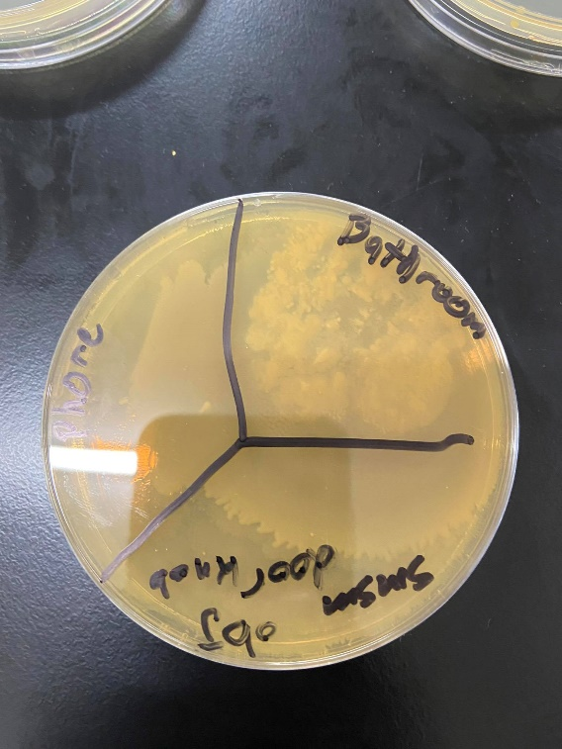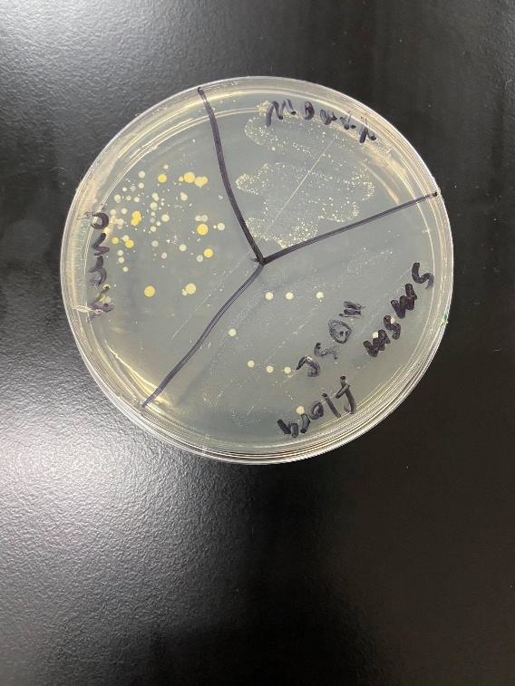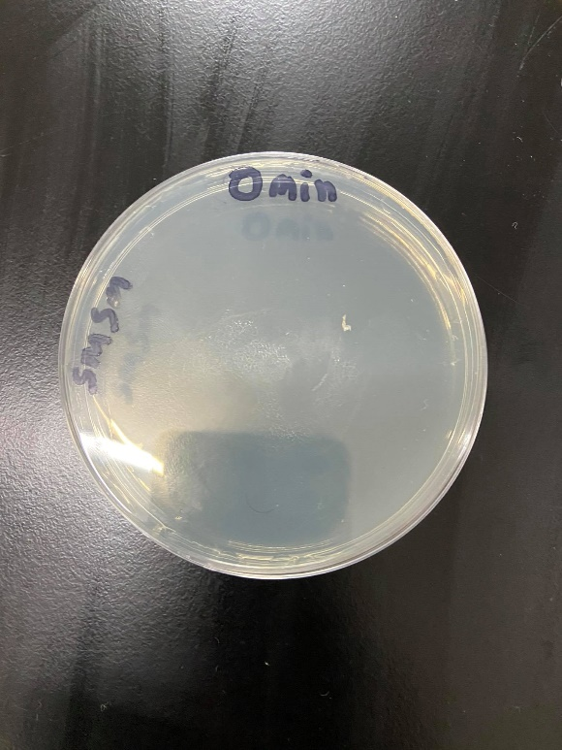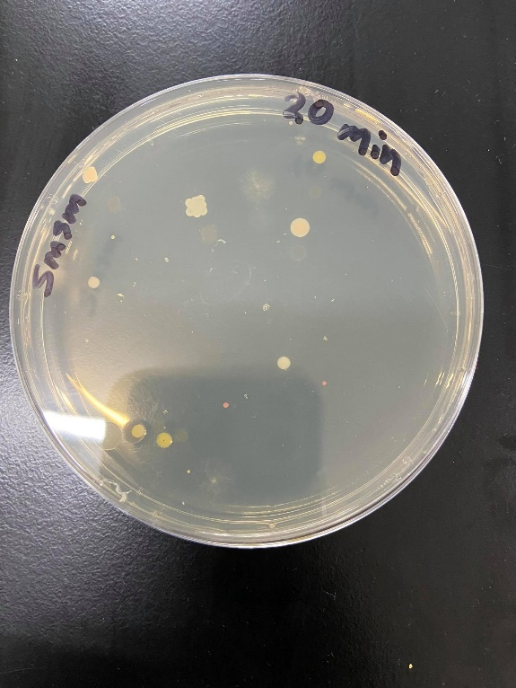

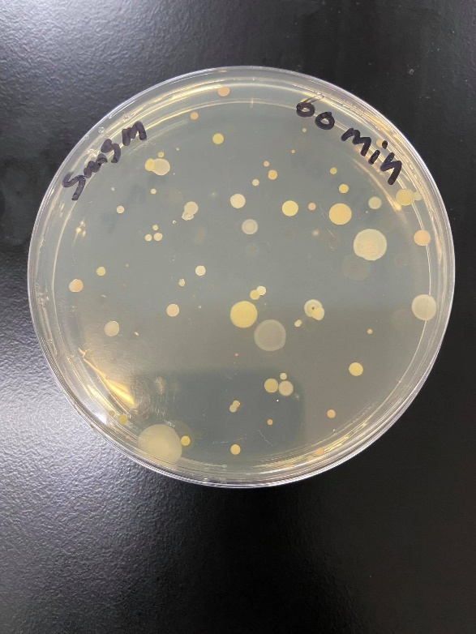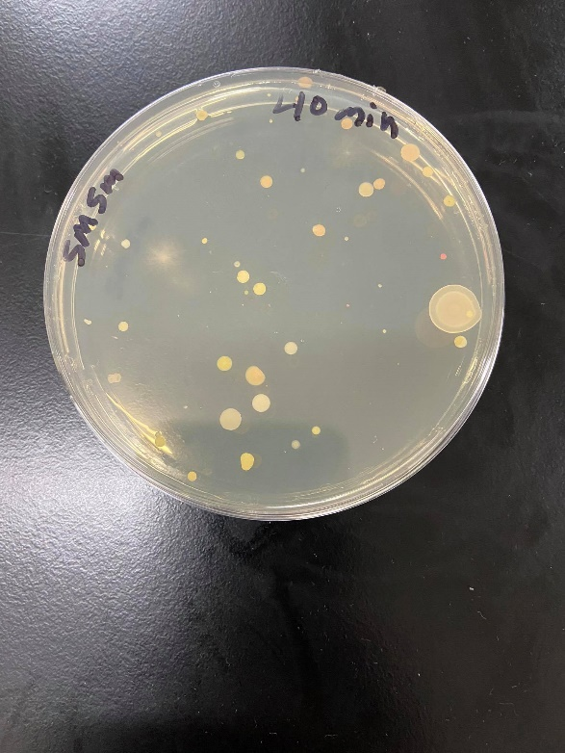

**Discussion**

In the open air experiment the petri dishes exposed to the air -after incubating- had variety of bacteria number and type, for instant the controlled sample had zero bacterial colonies in it or any different type of colony , in the petri dish that had been exposed to the air for 20 minutes the appearance of few bacterial colonies and one fungi colony, in the 40 minutes dish more colonies and different types are showing, in the 60 minutes dish a lot of colonies of different type including 2 fungi colonies appears covering the dish, this supports that bacteria like Micrococcus, Aerococcus, and Staphylococcus exists in the open air

In the objective petri dish a bacteria from the toilet sample had overgrown the other two samples so the two remaining results where unobservable, However. A lot of the university students use the bathroom on daily basis E.coli could be found as traces from using these toilets.

In the flora petri dish the mouth sample has different and a lot of colonies which is normal for the oral cavity many micro organisms colonise the mouth, over 700 species live on the hard and soft tissues and teeth in the mouth. For the nose sample some bacteria usually get stuck in the nasal hairs like Staphylococcus epidermidis , Staphylococcus aureus, Streptococcus pneumoniae .

**Conclusion**

As made clear in this experiment, bacteria is living on almost every place and environment ,it also gives use an idea about the variety of bacteria and how number of it could differ from place to place .

**References**

# [Mancinelli](https://www.ncbi.nlm.nih.gov/pubmed/?term=Mancinelli%20RL%5BAuthor%5D&cauthor=true&cauthor_uid=677875) & [Shulls](https://www.ncbi.nlm.nih.gov/pubmed/?term=Shulls%20WA%5BAuthor%5D&cauthor=true&cauthor_uid=677875).(1977). Airborne Bacteria in an Urban Environment.

# [Live Science Staff](https://www.livescience.com/author/live-science-staff). (2011). Germs Really Are Everywhere (Infographic)

# [Kilian](https://www.nature.com/articles/sj.bdj.2016.865#auth-1), [Chapple](https://www.nature.com/articles/sj.bdj.2016.865#auth-2), [Hannig](https://www.nature.com/articles/sj.bdj.2016.865" \l "auth-3), [Marsh](https://www.nature.com/articles/sj.bdj.2016.865#auth-4), [Meuric](https://www.nature.com/articles/sj.bdj.2016.865#auth-5), [Pedersen](https://www.nature.com/articles/sj.bdj.2016.865#auth-6), [Tonetti](https://www.nature.com/articles/sj.bdj.2016.865" \l "auth-7),  [Wade](https://www.nature.com/articles/sj.bdj.2016.865#auth-8) & [Zaura](https://www.nature.com/articles/sj.bdj.2016.865" \l "auth-9) .(2016). The oral microbiome – an update for oral healthcare professionals.

# Savolainen S, Ylikoski J, Jousimies-Somer H.(1986). [The bacterial flora of the nasal cavity in healthy young men.](https://www.ncbi.nlm.nih.gov/pubmed/3547601)