

Microbiology Lab section #3

BIO.243

Environmental plate

Name & ID : sara ameera 1192125

Partner : noor safi , heba azzam , aya arouri

Instructor : Dr emelia

T . A : shahd

Data of experiment : 12 /April / 2021

Gaol :

Seeing bacteria spread in our body and in our surrounding environment, through their cultivation and growth as bacterial colonies  
Seeing the bacteria colonies and the extent to which the growth of these colonies is affected by the surrounding environment.

Identify different types of bacteria according to their places of growth and the appropriate environment for growth

Introduction :

Bacteria are microorganisms that cannot be seen with the naked eye, there are large numbers of bacteria on the skin in all areas of the human body, there are also bacteria inside the body in all body systems, and the only place where bacteria are lacking is the eye, the majority of bacteria are in the human body It does not harm it thanks to the protective effects of the immune system.

Bacteria grow to a certain size and then reproduce by binary division, which is a type of asexual reproduction. Under ideal conditions, bacteria can grow and divide very quickly, and their numbers can double within 9.8 minutes.

Some types of bacteria, while still reproducing asexually, form more complex reproductive structures that aid the proliferation of newly born cells.

In laboratories, bacteria are usually grown using a solid or liquid medium. The solid environment is used in materials such as wages that are used in the cultures of isolated bacteria chains, while the liquid environment or liquid medium is usually used when measuring growth or large numbers of cells. And the use of liquid medium occurs even in the cells of the stage of formation and facilitates the process of dividing the bacterial culture and even its transfer, despite the difficulty of isolating the bacteria from the liquid medium. The medium chosen for its use (the medium is determined by specific additives feeding it or removing it or by adding antibiotics) may help in determining the type of organisms

Most laboratory techniques are used to grow bacteria to high levels of nutrients to produce large numbers of cells cheaper and faster.

Materials:

-cotton swabs

-nutrient agar plates

-normal salaine

-human body

-timer

methods

The students were divided into groups, a section in the laboratory, a section in Hall 120 in the science building, a section outside the building, the necessary tools were taken, there are 3 plates, nothing was placed in them, they were only exposed to direct air for different periods of time (0, 10,30 45 minutes

As for the other plates, samples were taken from our body (hair and behind the ear).

Samples were cultivated by taking the cotton swap and taking a sample from the required place, implanting it in the plate in a spiral form, then using another cotton swap and taking another sample from a different area.

Result :

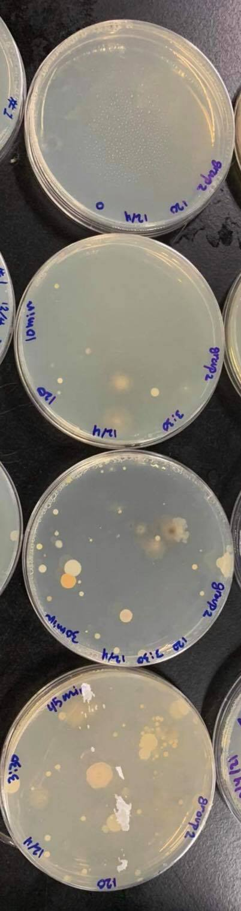

The bacteria "methylocapsa gorgona", the newly discovered air bacteria, we see that the agar that was not exposed to the air, we did not see any bacteria in it

As for the person exposed to 10 minutes of air, there are bacteria with slight pollution, so also the plate that was exposed to the air for half an hour, the pollution is very large, but not more than the person exposed for 45 minutes !!!

Aerobic bacteria were present in the three plates exposed to air, and the difference between them was the amount of contamination in each of them.

The results were compared with the other groups, a difference was noted, the reason for this was due to the places of distribution, that is, the amount of exposure to air, the amount was different in the three groups

Also, the reason may be due to non-compliance with the time specified in closing plates

This led to different results

The other group plants :

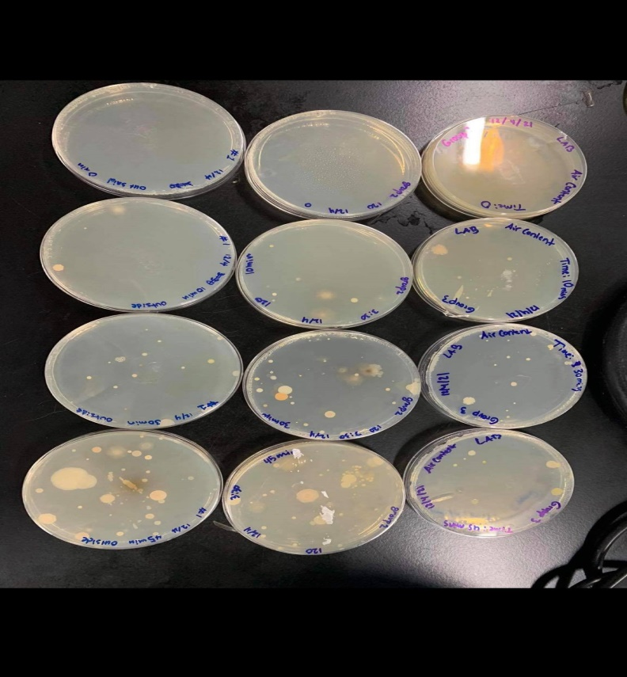

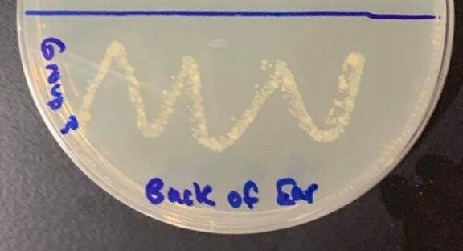

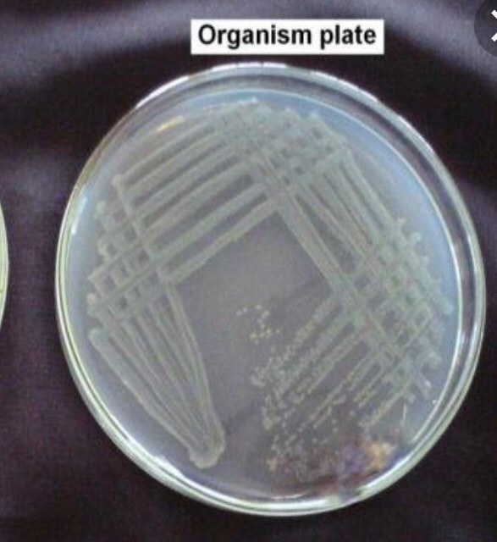 Pseudomonas aeruginosa  
  
  
  
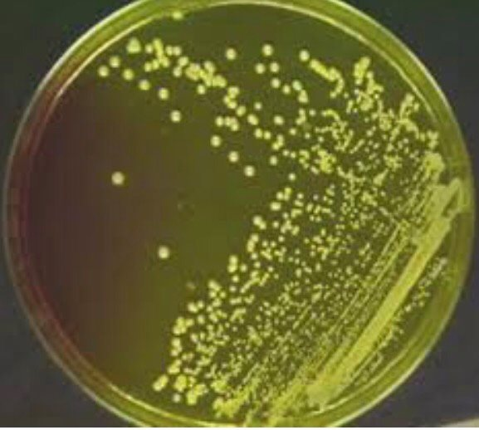 Staphylococcus aureus

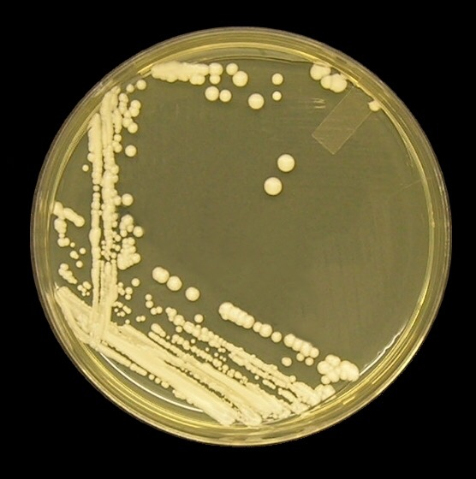 Candida albicans

(Pseudomonas aeruginosa ,Staphylococcus aureus ,Candida albicans) .

These are the bacteria found near the ear, and they are also the cause of some ear infections

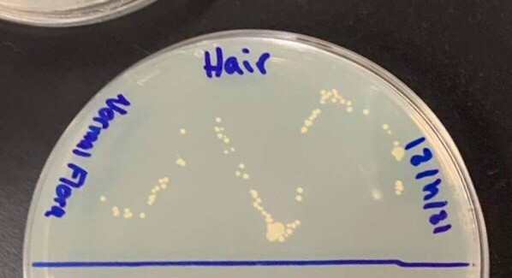

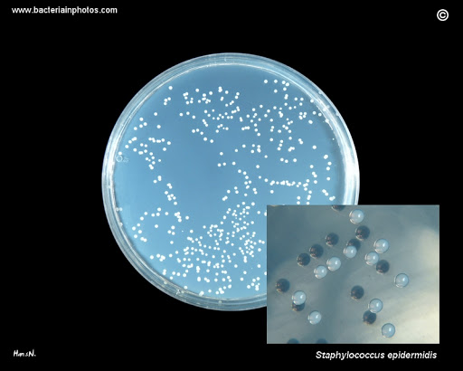 S. epidermidis

Propioni bacteria , S. epidermidis are the bacteria found on the scalp

Discussion :

The experiments showed great results, as pictures of bacteria in the air and the body showed. Each bacteria grows in its own environment that contains factors that help it grow and multiply, such as temperature, pH, and food.

These factors quickly control the amount and speed of growth, it was a wonderful experience, it could be mistakes that almost happened, it is possible if the time was not determined accurately when the aerobic bacteria were detected, not enough samples were taken to cultivate the bacteria and the contamination appeared alone, two samples were taken in the same cotton swap Thus, two types of bacteria appeared in the same plate.

Refferens :

-manual

- <https://www.ncbi.nlm.nih.gov/pmc/articles/PMC6137140/>

- <https://www.medicalnewstoday.com/articles/324132>

-https://www.google.com/search?q=pseudomonas+aeruginosa+on+agar+plate&tbm=isch&source=iu&ictx=1&fir=

- <https://www.ncbi.nlm.nih.gov/pmc/articles/PMC4833760/>

<https://pubmed.ncbi.nlm.nih.gov/2216049/>