

**Birzeit University**

**Biology and Biochemistry Department**

**Microbiology Lab**

**BIOL.230**

**Chemical effects on bacterial growth**

**Aya Manassrah 1202109**

**Dr.Emilia Rappocciolo**

**Mr. Mahmoud Rawajbeh**

**Date of experiment: 12.05.2022**

**Date of report submission: 11.06.2022**

**Group1**

**Chemical effects on bacterial growth**

* **Objectives**

The aim of this experiment is to examine the effects of certain chemicals and antibiotics on the growth of Escherichia coliand *Staphylococcus aureus* bacterial species. As well as finding the Minimum Inhibitory Concentration (MIC), and Minimum Bactericidal Concentration (MBC) for certain antibiotics.

* **Introduction**

The growth of microorganisms can be controlled by the usage of many chemical agents, that would kill microbes (bactericidal) or inhibit the growth of microbes (bacteriostatic). The effect of chemical agents may vary, Some chemicals decrease antimicrobial presence in an area or on a surface (decontaminant). Others are not used to remove all contaminants; instead, reduce the amount of contamination by killing some pathogenic bacteria and fungi (disinfectant). Others kill or inhibit microorganisms but are safe for human tissues (antiseptic). Antibiotics, however, are metabolic products of microorganisms that are used to kill or inhibit the growth of other microorganisms and can be used on or inside patient. To determine the effectiveness of a certain antibiotic on a certain microbe **the Kirby-Bauer method** is used. It is done by measuring the diameter of the zone of inhibition (the zone where no microbial growth is observed) around a given antibiotic disc, after the disc is placed in a Mueller-Hinton agar petri dish cultured with a certain microbe. The measurement of the zone is then compared to standards, to determine if the bacteria is sensitive to the antibiotic (killed or inhibited by it), or resistant to it (unaffected). As uncalculated large doses of antibiotics are not healthy for human use, medical microbiologists have defined the MIC and MBC as critical amounts of an antibiotic that can be depended on in drug production. Minimum Inhibitory Concentration (MIC) is the lowest concentration of an antimicrobial drug that will inhibit the visible growth of a microorganism after overnight incubation. It can be determined by broth dilution methods after a culture has been isolated, and identical doses of bacteria are cultured in wells of liquid media containing progressively lower concentrations of the drug. The MIC would be the last well containing clear (not turbid) medium.However, Minimum Bactericidal Concentration (MBC) determines the lowest concentration at which an antimicrobial agent will kill a microorganism. It is complementary to the MIC test. That after determining the MIC, the liquid media well containing the microbe and antibiotic MIC and the previous two wells are plated onto agar dishes. And using the method of viable count as a proxy measure of bacterial viability, the number of colony-forming units (CFUs) can be determined; finally, the dish that .

* **Materials**
* **Effect of disinfectants & Antiseptics on bacterial growth.**

1. E.coli & S.aureus stock cultures
2. McFarland Standard
3. Nutrient- agar broth cultures
4. Sterile Cotton swabs
5. 150mm Muller – Hinton agar plates
6. Disposable sterile inoculating loops
7. Ethanol 95%
8. Stainless steel tweezers
9. Discs submerged in Disinfectants & antiseptics: Detol, Listerine, 95% Ethanol, 70% Ethanol, H2O(control).

* **Effect of Chemotherapeutic agents on bacterial growth.**

1. E.coli & S.aureus stock cultures
2. Nutrient –agar broth cultures
3. McFarland standard
4. Sterile cotton swabs
5. Disposable sterile inoculating loops
6. Ethanol 95%
7. Stainless steel tweezers
8. 150mm Muller –Hinton agar plates
9. Antibiotic discs: AMP10, C/P 5, AMC 30, OX1 .

* **Minimum Inhibitory Concentration (MIC) and Minimum Bactericidal Concentration (MBC).**

1. Antibiotic stock solution 1000 mcg/ml
2. Sterile 96 wells plates
3. Stock cultures of E.coli & S.aureus
4. Nutrient agar plates
5. Multichannel micropipette
6. Sterile pipette tips
7. Sterile diluents(Muller-Hintonbroth)

* **Methods**

**Effect of disinfectants and antiseptics on bacterial growth.**

* The Bunsen burner was lighted, and the flame was adjusted so that it had 2 blue cones (inner, and outer), to create aseptic conditions.
* The nutrient-agar plates were labelled with all the disinfectants so that the control (water) was made in the middle.
* Using the sterile inoculating loop a small amount of the stock culture of *E. coli* was taken off on the loop tip.
* The inoculating loop was then submerged in nutrient-agar broth cultures and the solution was shaken several times to get a homogenous solution.
* The turbidity of the culture was then compared with the McFarland standard (the turbidity of our solution ought to have been near the standard’s turbidity).
* A sterile cotton swab was dipped in the broth culture, then swabbed in several directions in a way that made the whole Muller-Hinton agar plate inoculated equally.
* The tweezers were sterilized by submerging its tip with ethanol 95% and then it was gently passed above the flame and cooled under aseptic conditions.
* Using the sterilized tweezers, a disc (from the previously submerged discs) of each disinfectant was drained briefly to eliminate excessive liquid and then placed on its labelled position on the plate.
* The same method was done for the *S. aureus*.
* Then the 2 plates were incubated at 37C

**Effect of Chemotherapeutic agents on bacterial growth.**

* The same method above was repeated for both *E. coli* and *S. aureus*, except that the antibiotic discs were dry rather than submerged in a liquid, and there is no control.

**Minimum Inhibitory Concentration (MIC) and Minimum Bactericidal Concentration (MBC).**

* 0.1 ml of the sterile diluent was pipetted into the wells numbered 2-12.
* 0.2 ml of the Ciprofloxacin antibiotic was pipetted into the well numbered 1.
* Serial dilution was done by pipetting 1000 μL of each well and transferring them to the next well (between 1-11). The last 1000 μL from well #11 was discarded.
* 1000 μL of the bacterial inoculum was pipetted into 1-12.
* Well #1 had a 500 μL concentration of the antibiotic, and well #12 had 0 μL (negative control), Positive control had only antibiotic in it.
* The wells were put in the incubator at 37 C
* After incubation, the wells were examined, and the last clear well was considered the MIC.
* 1000 μL of the cultures of the MIC well and the previous 2 wells, were pipetted on 3 nutrient-agar plates.
* The broth was spread using a sterile hook spreader (sterilized using the same method of sterilizing the tweezers in part 1).
* **Data & Results**

**Effect of disinfectants and antiseptics on bacterial growth**

After 24 hours of incubation of both *E. coli* and *S. aureus* plates, containing the antimicrobial discs, the following results were obtained:

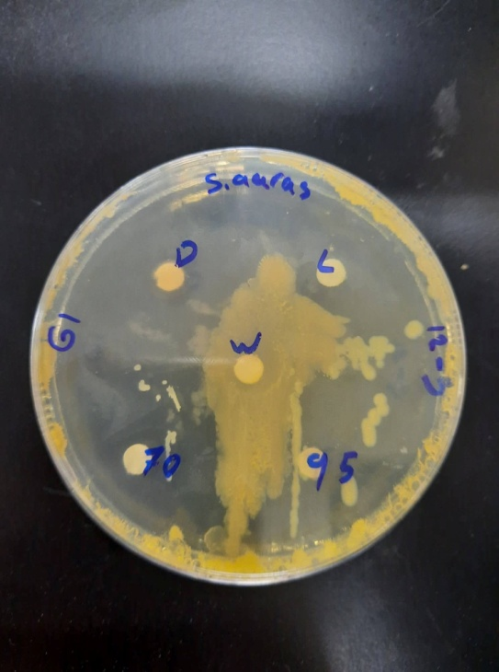 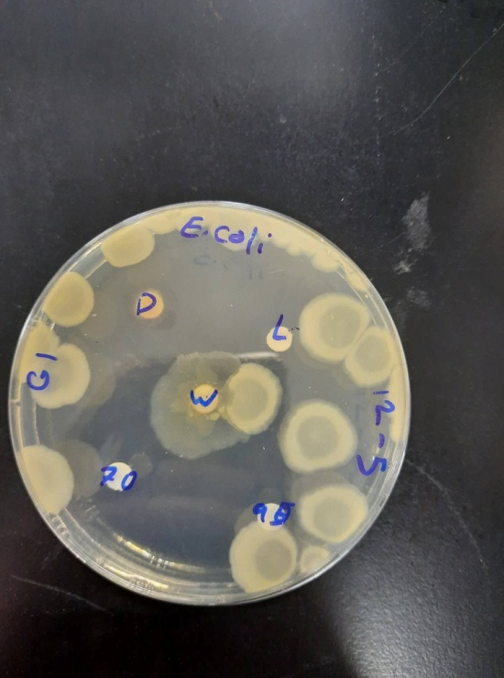

Fig 1: The results obtained after 24 hours of incubation of the *E. coli* plate (left), and *S. aureus* plate (right) containing the antimicrobial discs.

**Effect of chemotherapeutic agents on bacterial growth**

After 24 hours of incubation of both *E. coli* and *S. aureus* plates, containing the antibiotic discs, the following results were obtained:

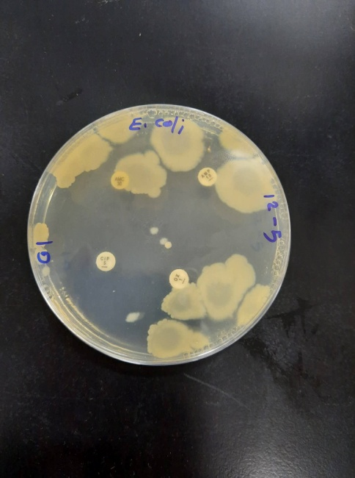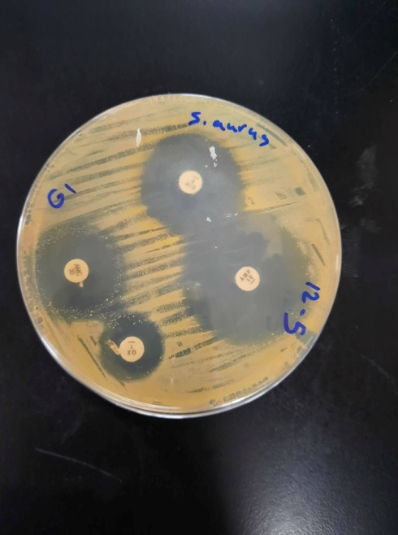

Fig 2: The results obtained after24 hours of incubation of the E. coli plate (left), and S. aureus plate (right) containing the antibiotic discs.

**Minimum Inhibitory Concentration (MIC) and Minimum Bactericidal Concentration (MBC).**

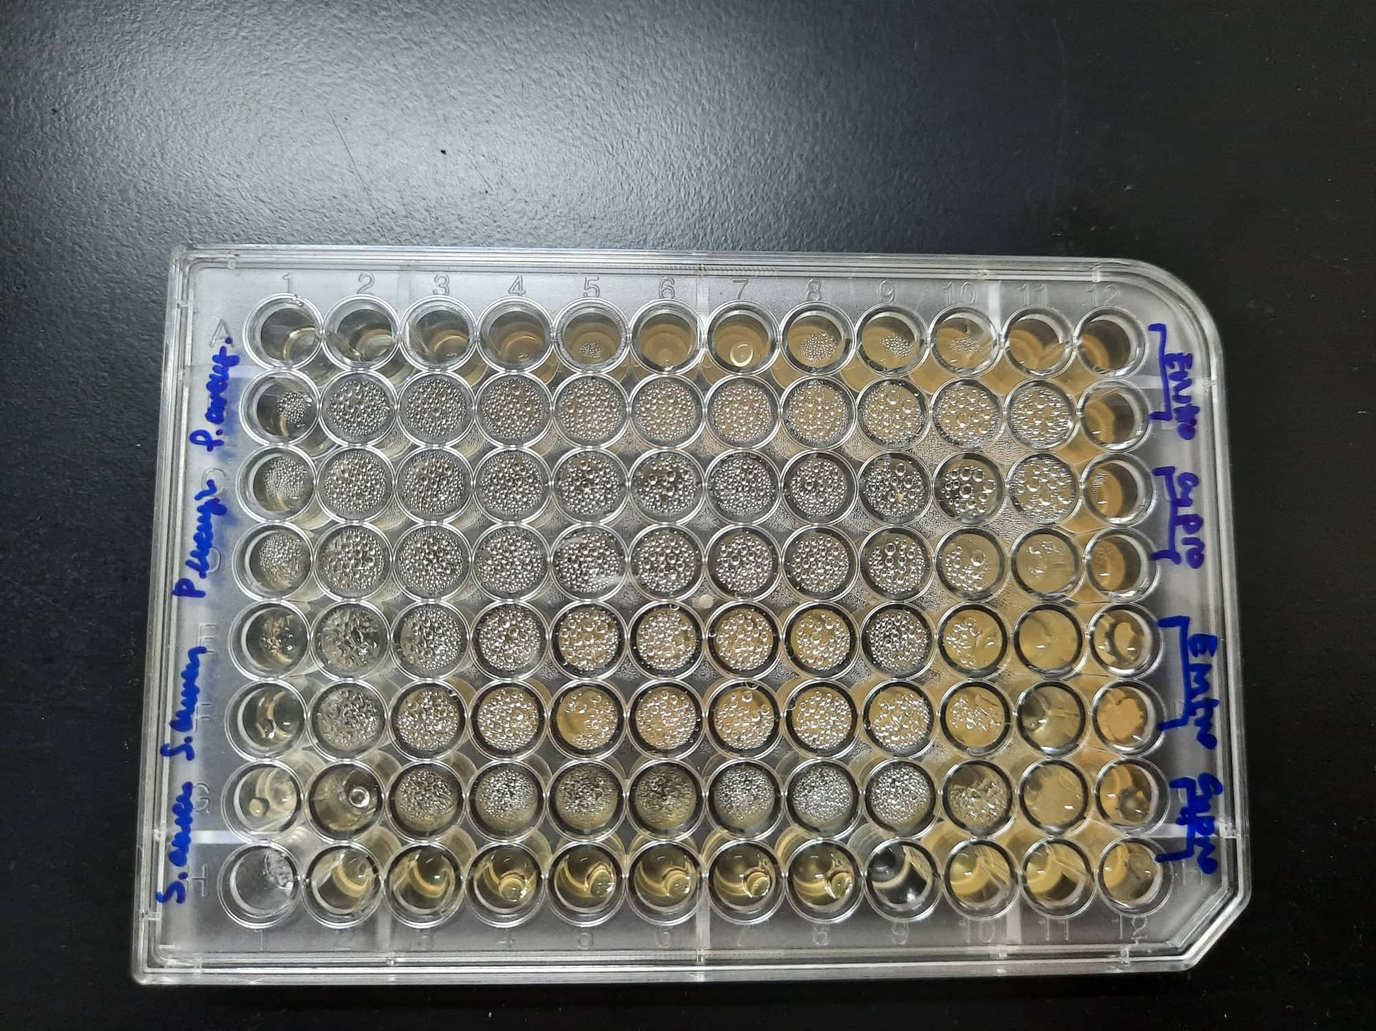

Fig 3: The results of the MIC and MBC test for Ciprofloxacin & Erythromycin antibiotic against *S.aureus* & P.aeruginosa.

* **Discussion**

The results show that different types of microorganisms vary in their response to antimicrobial agents, antiseptics, and antibiotics.In the part of antimicrobial agents against E. coli and S. aureus, Listerine had effect on both bacteria, as its inhibition zone was the same as the inhibition zone of the control (water), listerinedestroys the bacterial cell surface, inhibits biofilm growth,  and increases the time it takes for bacteria to grow back. On the other hand, Dettol was found to be very effective on both bacterial types, where the zones of inhibition were very same for both bacteria(*S.aureus & E.coli*). This is mainly due to the active ingredient in Dettol, which is Chloroxylenol, a chemical that is an antiseptic and disinfectant agent, which is shown to be most effective against Gram positive bacteria where it disrupts the cell wall due to its phenolic nature, however gram negative bacteria may be more resistant because of its more complex cell wall. For Ethanol had also a cidal effect on bacteria, as it dissolves its plasma membrane, and denatures cell’s proteins. It is clear in the S. aureus plate, that 70% ethanol had more antimicrobial activity than 95% ethanol. This correlates with the fact that as the concentration of water increases in the ethanol content (with an adequate concentration of ethanol itself) its cidal effect increases, as water decreases its evaporation rate and increases its penetration towards the inside of the cell. However, E. coli plate had a different result, where the disc of 95% ethanol had a larger inhibition zone than 70% ethanol disc as shown in figure1. This maybe because the disc of 95% ethanol had had excess of ethanol and wasn’t drained well before placing it on the plate, thus created a larger inhibition zone. However, ethanol generally has more effect on gram positive bacteria than gram negative as the later has an outer membrane that needs to be disrupted before disrupting the inner plasma membrane. S.aureus bacteria was sensitive to Ampicillin more than Ciprofloxacin more than Amoxicillin more than oxacillin as shown in Figure2. For E.coli Bacteria it was sensitive for all types of antibiotics like S.aureus.

( AMP, OX, AMC, C/P) as shown in figure2. For minimum inhibitory concentration(MIC) & Minimum Bactericidal concentration(MBC), S.aureus & P. aeruginosa was resistant to the Erythromycin antibiotic, & Ciprofloxacin has had a Bactericidal effect on both S.aureus & P.aeruginosa Bacteria as shown in figure3.

* **Conclusion**

To conclude, microbial growth may be adversely affected by many chemicals, that may either kill the microorganisms, or inhibit its growth. However, our experiment showed that the antimicrobial activity of each chemical is influenced by a variety of factors, including the concentration of the chemical agent, the type and nature of the microorganism itself, and its resistance ability to the mechanism used by the agent against the microbe.

* **References**

Prescott, Harley, and Klein’s, microbiology, Seventh Edition.