

Biology and Biochemistry department

GENERAL MICROBIOLOGY- [BIOL243](https://ritaj.birzeit.edu/bzu-msgs/type?mttid=104&classid=184658)

Lab Report

**Laboratory 9**: Effect of physical agents on bacterial growth

**Name:** Noor Sulaiman **ID#:** 1200174

**Lab Instructor:** Dr. [Emilia Rappocciolo](https://ritaj.birzeit.edu/student/view_office_hr?employee_id=3538)

**Teacher assistant:** Ms. Deema A Mohsen

**Section No:** 6

**Partners name and ID:** Wala Abo Makho-1200144

Thekra Abo Fanoun-1200320

Sama Tartir-1200141

**Date of experiment:** November 29, 2021

**Date of submission:** December 18, 2021

**Effect of physical agents on bacterial growth**

**⸸ Objectives:**

In this experiment the effect of physical agents on bacterial growth was observed. For instance the effect of osmotic pressure on it was tested by culturing the bacteria on agar plates containing different concentrations of salt. Also the effect of temperature on spore-forming and non-spore forming bacteria was examined in addition to the effect of ultraviolet light on bacteria and wavelength around 260-265 nm was used.

**⸸ Introduction:**

Microorganisms such as bacteria have many effects and uses in our lives in the field of medicine, food production and water microbiology. Therefore, controlling bacterial growth and knowing the factors affecting it is especially important in our lives. Among these factors, physical factors like temperature, osmotic pressure, filtration and radiation.

The temperature that the bacteria need for its growth was found to be from about 0℃ to 90℃, within this range the different species and strains vary in their minimum and maximum growth temperature which determines if they are psychrophiles, mesophiles and thermophiles. Moreover, the composition of the growth medium effect the temperature at which growth of microorganism take place. Whentemperature increase the enzyme activity will increase. But if the temperature become too high the enzyme will denature and the enzyme activity will be reduced. (Hugo, 2012)

Long ago, before the existence of microorganisms was recognized, large concentrations of salts were used to prevent food spoilage. Water flow out of semi permeable membranes like the cytoplasmic membrane of microorganisms to the side of higher concentration of solute. The bacterial growth rate for most bacteria will diminish when the osmolarity increased in a hypertonic condition. (Mert and Dizbay, 1977)

There’s two type of radiation that can affect the bacterial growth the ultraviolet radiation and the ionizing radiation. Microbial DNA absorb UV light and causes adjacent thymine bases to bond together covalently forming thymine-thymine dimers. Consequently, the replication of the DNA strand will terminate because the nucleotides won’t complementary base pair each other.

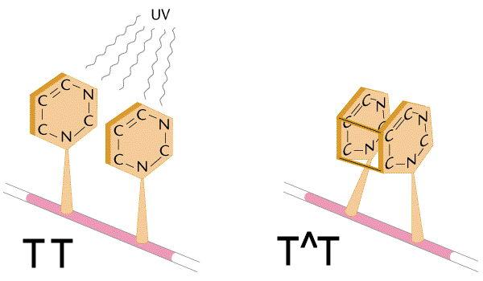Ionizing radiation, such as gamma rays, alpha, beta and X-rays

can disrupt DNA molecules and proteins by producing radicals.

Figure1: thymine-thymine dimers

**⸸ Materials & Methods:**

When the effect of osmotic pressure on bacterial growth was investigated, nutrient agar was used as a control and nutrient agar with 5% NaCl, 10% NaCl and 15% NaCl was utilized, then plates were divided in half and inoculating loop was used to streak one half of each plate with *E.coli* and the other half with *S. aureus*. After that plates was incubated at 37℃ for 24 hours.

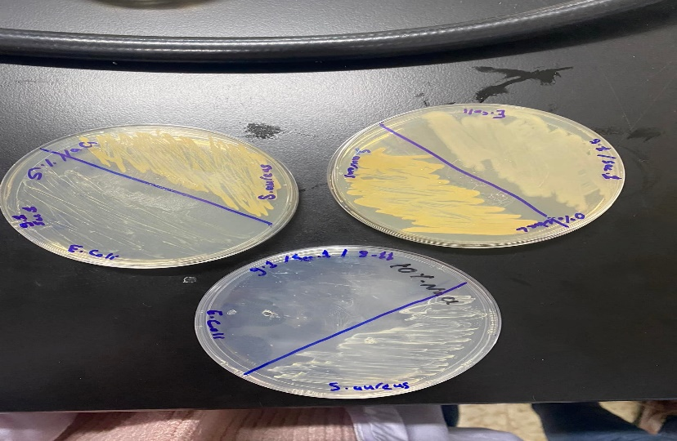

Figure2: some plates from the osmotic pressure experiment

However when the effect of temperature on spore-forming and non-spore forming bacteria was examined, 2 ml of *E.coli* and *B. subtilis* was incubated at 4℃, 55℃, 75℃ and 100℃. Agar plate was divided into 5 sections, section 1,2,3,4 and 5 was inoculated furthermore was put in refrigerator/ autoclave for 0, 30, 60, 90, 120 minute respectively. Later, plates were incubated at 37℃ for 24-48 hours.

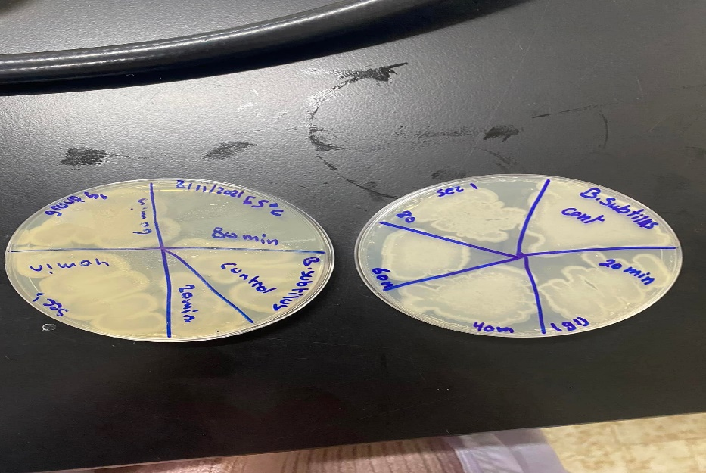

Figure3: plates from temperature experiment

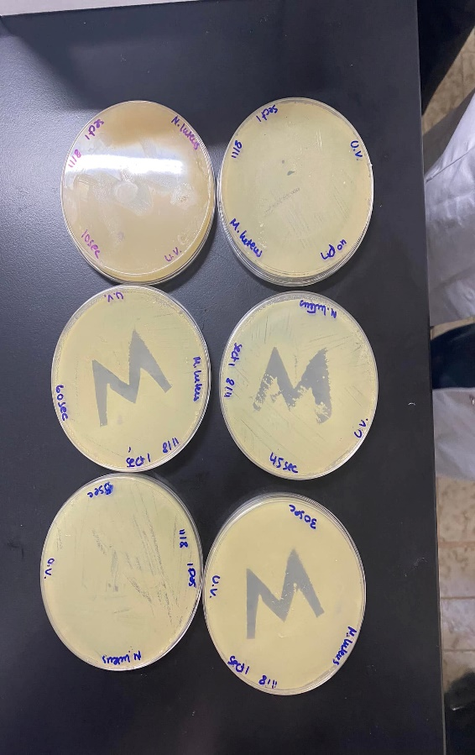 Although when effect of ultraviolet light on bacteria was conducted, sterile swabs were used to streak 5 nutrient agar plates with *Micrococcus luteus*. Next 3 of the plates was exposed to UV light as follows: the lid was removed of each plate and a piece of cardboard with specific letter or shape was placed over the top of the agar. The first plate was exposed to UV light for 1 second, the second plate for 5 seconds, and the third plate for 10 seconds. The lids was replaced and plates was incubated at 37℃ for 24 hours. For the fourth plate: the lid was left on, the cardboard was layed over the plate, and also it was exposed to UV light 60 seconds. At last plate was incubated at 37 ℃ for 24 hours with the other plates. The fifth plate was used as a non-irradiated control and was incubated at 37℃ for 24 hours with the other plates.

Figure 4: plates from UV experiment

**⸸ Data & Results:**

**\*Here the correct results were displayed at the beginning and then the results of the groups were displayed.**

**Table 1:** results of the effect of osmotic pressure on bacterial growth experiment.

|  |  |  |
| --- | --- | --- |
| NaCl concentration | *S. aureus* | *E.coli* |
| control | Grew | Grew (less than S. aureus) |
| 5% NaCl | Grew ( less than the control) | Grew (less than the control) |
| 10%NaCl | Still growing much less  ( grows with great difficulty) | No growth |
| 15% NaCl | No growth | No growth |

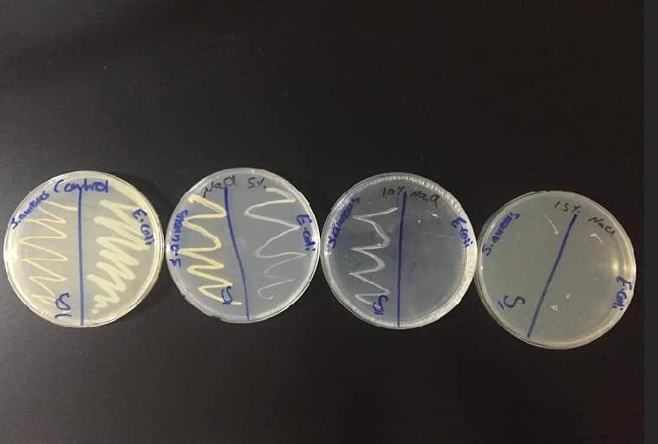

Figure 5: the correct result of osmotic pressure experiment.

**Table 2:** results of the effect of temperature on spore-forming and non-spore forming bacteria experiment.

|  |  |  |
| --- | --- | --- |
| temperature | *E. coli* | *B. subtilis* |
| 4℃ | 0,30,60,90,120 minutes we have cells all times – didn’t effect cells in anyway- | Everything growing |
| room temprature | Everything growing | Everything growing |
| 37℃ | Everything growing (but less than B. subtilis) | Everything growing |
| 55℃ | 0 min - grow  20 min- grow (little less than 0)  40 grow (less than 20)  90 -120 min-no growth | Everything growing |
| 100℃ | Only time 0 has growth | Only time 0 has growth |

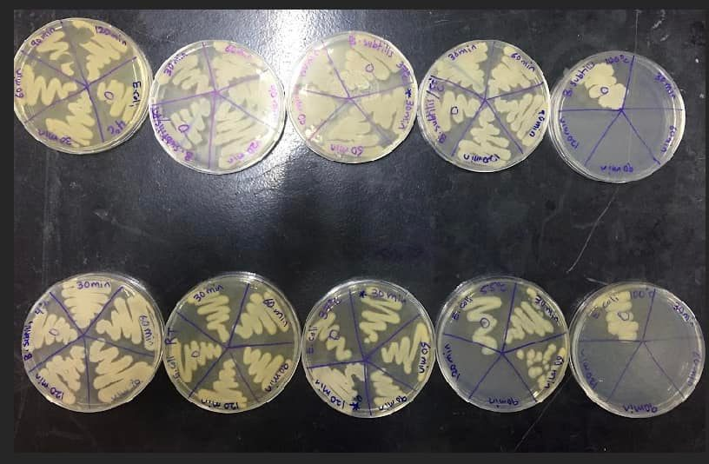

Figure 6: the correct result of temperature experiment.

**Table 3:** results of the effect of ultraviolet light on bacteria experiment.

|  |  |  |
| --- | --- | --- |
| Time of exposing | *B. subtilis* | *Micrococcus luteus*. |
| control | There’s no effect the plate still full with cells | The plate full with cells (there’s no clear zone ) |
| 5 seconds | Still no effect | The shape appear (there’s zone) but there’s cells that weren’t killed. |
| 10 seconds | Still no effect | The shape appear (there’s zone) |
| 15 seconds | Still no effect | The shape appear (there’s zone) |
| 30 seconds | The shape start to appear but still there’s a lot of cells in the zone which are not kill | The shape appear (there’s zone) |
| 45 seconds | The shape appear more , and cells in the zone are much less | The shape appear (there’s zone) |

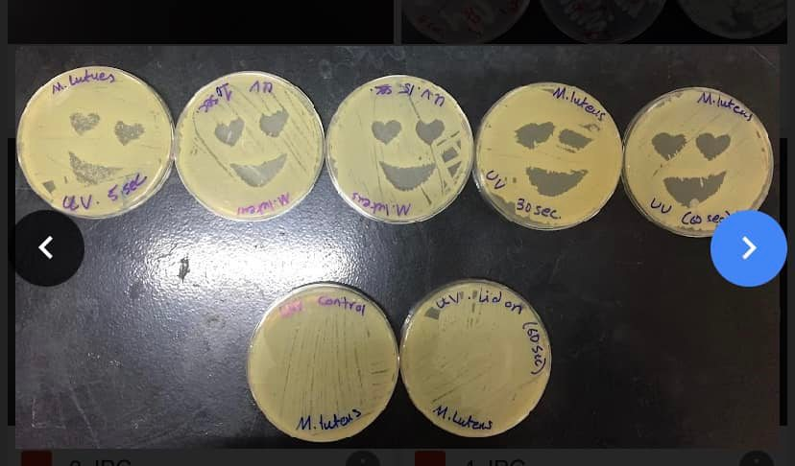

Figure 7: the correct result of the UV experiment – *M. luteus*-

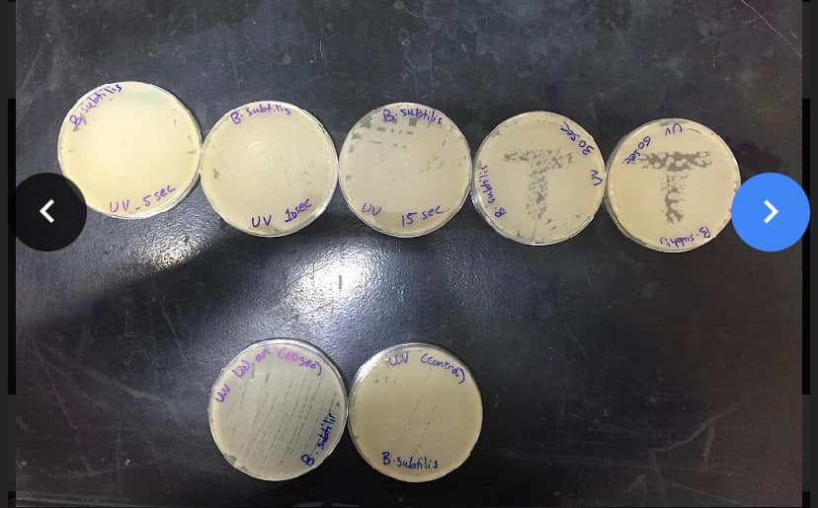

Figure 8: the correct result of the UV experiment –*B. subtilis*-

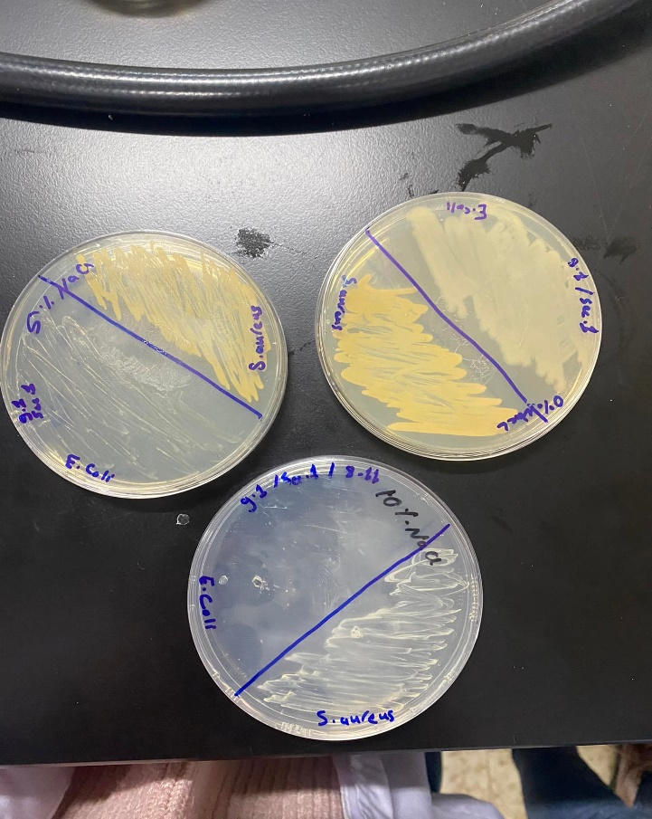**⸸Results from groups:**

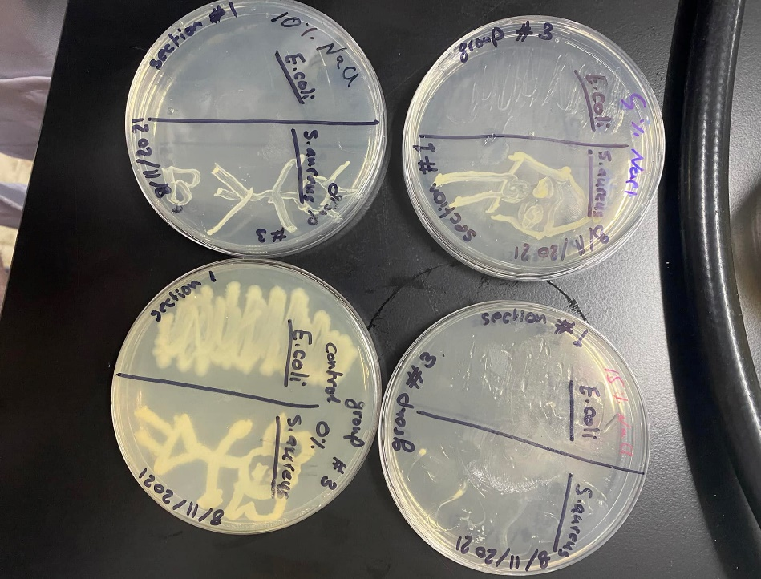

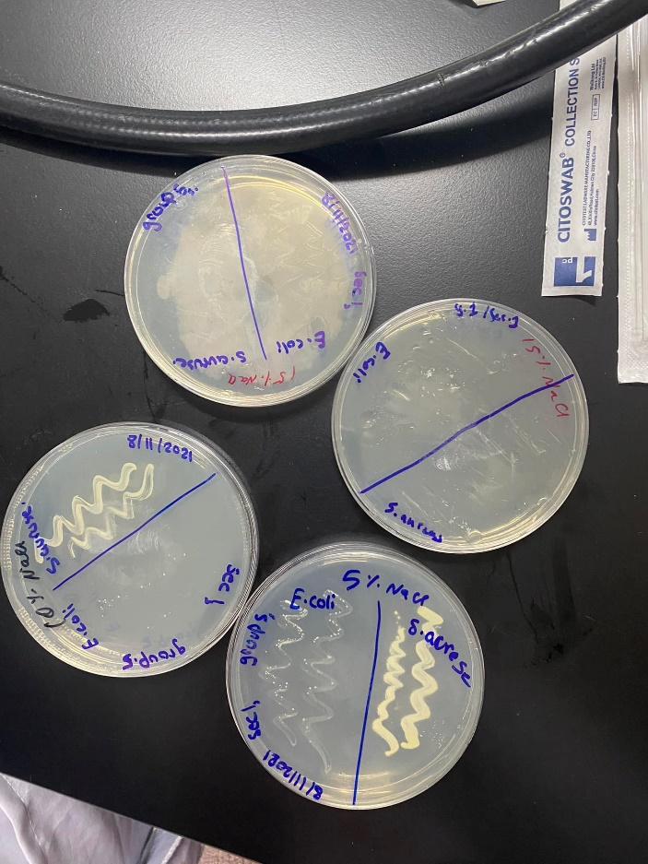

Figure 9: group’s results for the osmotic pressure experiment

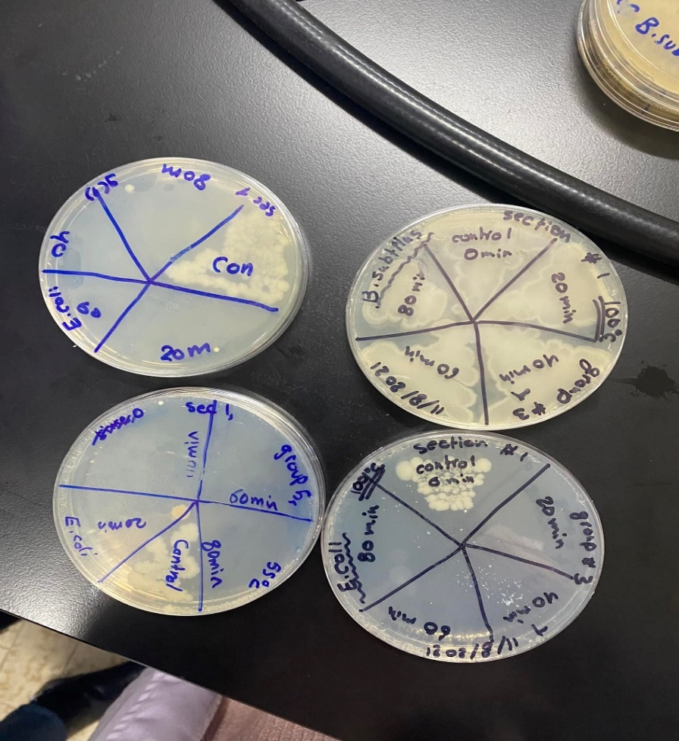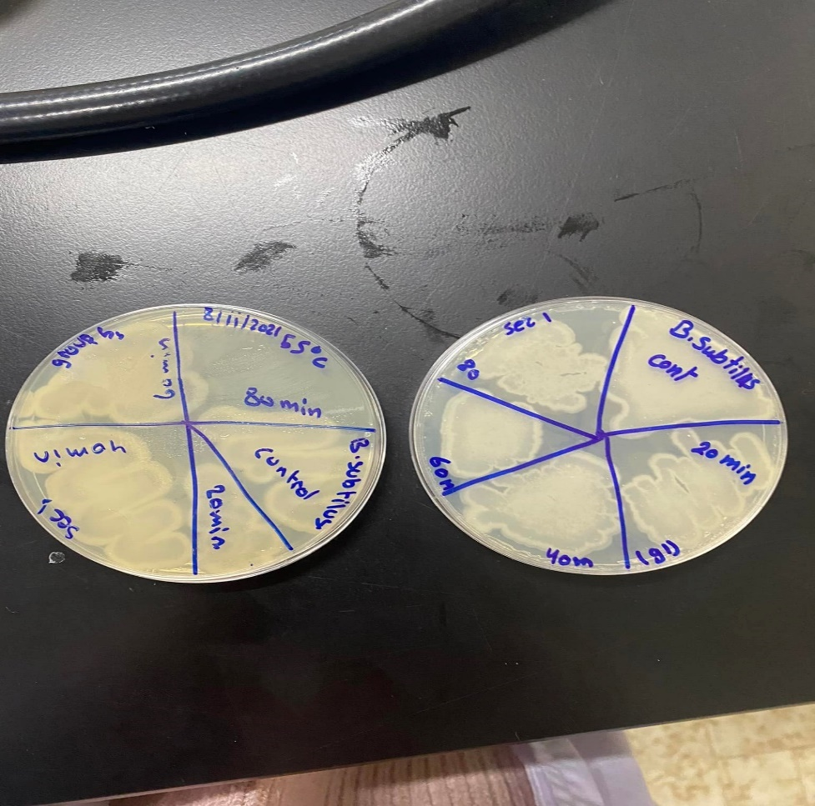

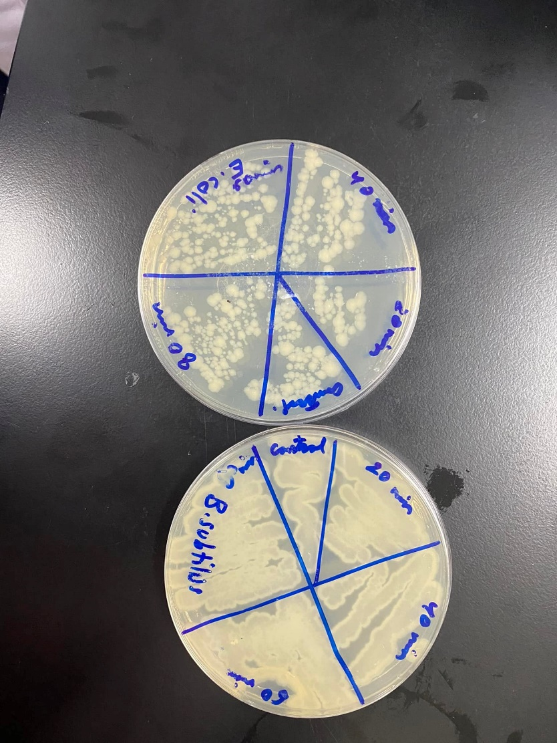

Figure 10: group’s results of temperature experiment

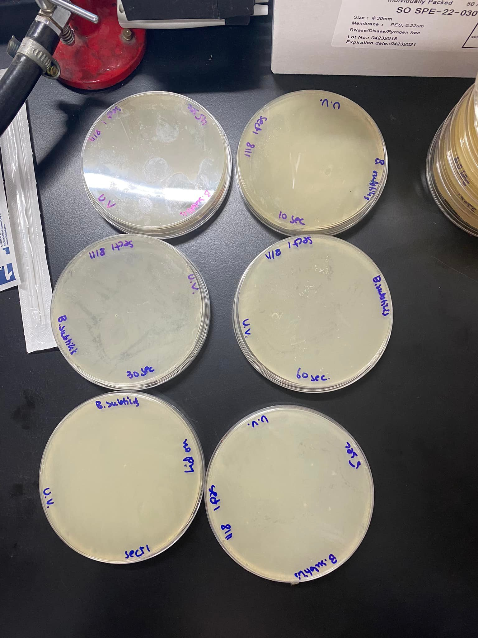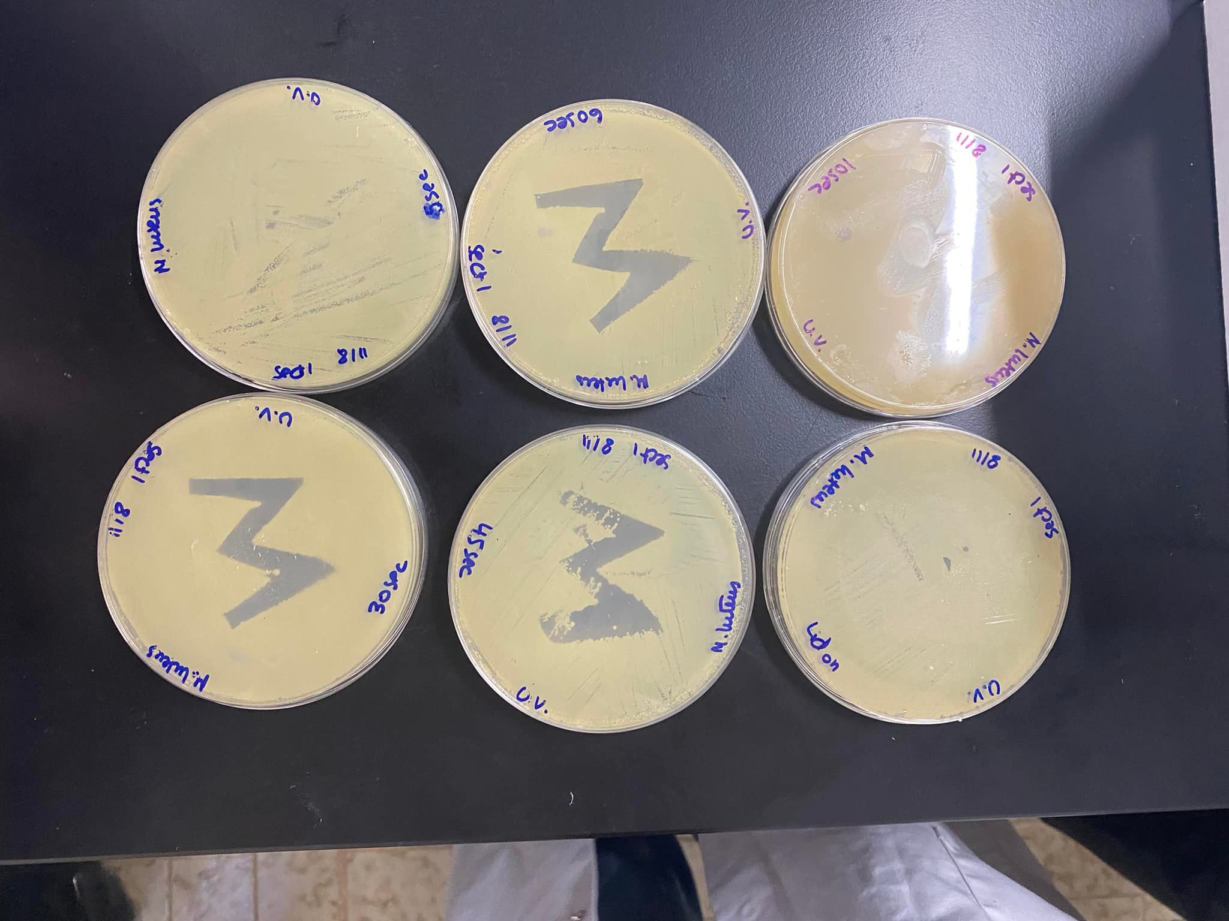

Figure 11: groups result of UV experiment.

**⸸ Discussion:**

**\*The correct results were discussed first, then the results of the groups.**

After the plates were removed from the refrigerator and the results were analyzed. The understanding of the effect of physical agent on microbial growth was made clearer.

**Effect of osmotic pressure on bacterial growth:**

Water was drawn out of the cell by salt as a consequence the cytoplasmic membrane was shrunk (plasmolysis). The bacterial growth was inhibited by reducing the amount of water available to bacteria (dehydration). As a result metabolism which was maintained through stable arrangement of water-solute system regulated by osmosis was affected. Modifications of the phospholipid structure of the cell membrane were happened and even cell death. *E. coli* wasaffected more than *S. aureus* because its nonhalotolerant. *S. aureus* is halotolerant bacteria which can tolerate up to 10% NaCl, that’s why there’s no growth in 15% NaCl. (Sochocka M, 2011)

**Effect of temperature on spore-forming and non-spore forming bacteria:**

If the temperature was increased the enzymatic activity will increase but if temperature was become too high enzymes was affected by it and specifically their active sites, the shape of active was changed and the substrate no longer fit. The reaction rate was affected or the reaction may stop. The thermophilic *B. subtilis* grows within temperature range of 50℃ to 70°C. Endospore was formed by it which was made it survive in extreme environmental conditions. Accordingly it was survived at 4℃, RT, 37℃and 55℃ but at 100℃ it was grown only in the control section. *E.coli* is a mesophilic bacterium, this explains the difference in the growth rate between it and *B. subtilis* under high temperature conditions. (Blaby et.al, 2012)

**Effect of ultraviolet light on bacteria:**

Ultraviolet light (UV light) lies in wavelength from about 100 nm to 400 nm. The cidal wavelength of UV light lie in the 260 nm - 270 nm range where it was absorbed by the DNA molecule and modification or breaking bond was caused. Thymine-thymine dimers were formed so nucleotides weren’t able to base pair with thymine dimers and the replication of that DNA strand was terminated. As was mentioned before, endospore was formed by *B. subtilis* which was made stronger by them to survive in harsh condition such as UV light. This explains why not all the cells were killed by the UV. For *M. luteus,* endospore wasn’t formed by it. Therefore, ultraviolet light was able to kill the cells exposed to it, and the shape began to appear after a few seconds of exposing (after 5 seconds). Also the UV light has very poor penetrating power so the plate’s cells were covered with the lid weren’t killed.

**Groups results:**

The groups result of the osmotic pressure experiment match the correct results and there wasn’t any error. Moreover the UV light experiment was the same as the correct results.

For the temperature experiment: in one group, there’s no growth of *B. subtilis* at 55°C also other group have growth just in the control, maybe they didn’t streak well. Other group have growth of *B. subtilis* at 100℃ in all sections while in 4℃ growth occur just in the control section. Perhaps a confusion occurred between the plates and they label them wrongly.

**⸸ Conclusion:**

In conclusion we were able to understand the effect of different physical agent on bacterial growth and how we can use them to control or limit growth. We know examples of microorganisms that grow with different optimal temperature as well as the ones that grow in different concentration of salt. We also know the advantages of forming endospores. Our results were generally correct due to following precise steps and carrying out the procedure in aseptic conditions. After the completion of this experiment, we are now aware of the sensitivity of the microorganism to the ultraviolet light, temperature and osmotic pressure. We can also use the information we obtained in the future as a tool in drug or food production.

**⸸ References:**

Hugo, W. (2012). *Inhibition and destruction of the microbial cell*. Elsevier. Accessed at December 15, 2021.

# [Ian K. Blaby](https://journals.asm.org/doi/10.1128/AEM.05773-11#con1), [Benjamin J. Lyons](https://journals.asm.org/doi/10.1128/AEM.05773-11#con2), [Ewa Wroclawska-Hughes](https://journals.asm.org/doi/10.1128/AEM.05773-11" \l "con3), [Grier C. F. Phillips](https://journals.asm.org/doi/10.1128/AEM.05773-11#con4), [Tyler P. Pyle](https://journals.asm.org/doi/10.1128/AEM.05773-11#con5), [Stephen G. Chamberlin](https://journals.asm.org/doi/10.1128/AEM.05773-11#con6), [Steven A. Benner](https://journals.asm.org/doi/10.1128/AEM.05773-11#con7), [Thomas J. Lyons](https://journals.asm.org/doi/10.1128/AEM.05773-11#con8), [Valérie de Crécy-Lagard](https://journals.asm.org/doi/10.1128/AEM.05773-11" \l "con9), [Eudes de Crécy](https://journals.asm.org/doi/10.1128/AEM.05773-11" \l "con10). (December 16, 2012). Experimental Evolution of a Facultative Thermophile from a Mesophilic Ancestor. Accessed at December 16, 2021.

Mert, H. H., & Dizbay, M. (1977). The effect of osmotic pressure and salinity of the medium on the growth and sporulation of Aspergillus niger and Paecilomyces lilacinum species. *Mycopathologia*, *61*(2), 125-127.‏ Accessed at December 16, 2021.

Sochocka M, Boratyński J. Osmoregulacja--ważny parametr rozwoju bakterii [Osmoregulation--an important parameter of bacterial growth]. Postepy Hig Med Dosw (Online). 2011 Nov 22;65:714-24. Polish. doi: 10.5604/17322693.966604. PMID: 22173436. Accessed at December 17, 2021.