***Evolution of land plants***

[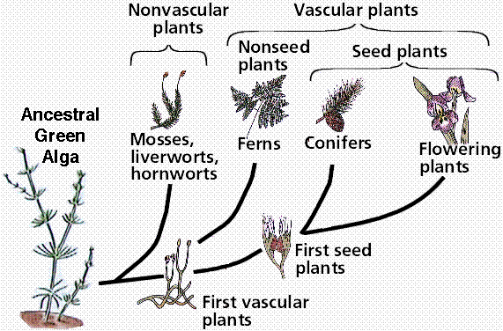](https://www.google.ps/url?sa=i&rct=j&q=&esrc=s&source=images&cd=&cad=rja&uact=8&ved=2ahUKEwiGhurSl8neAhXRMewKHTuADXgQjRx6BAgBEAU&url=https://edu.glogster.com/glog/chapter-23-plant-evolution-and-biology/28neponrbd6&psig=AOvVaw1vn3_RAIiaoC_20CQzXhFR&ust=1541917084094361)

[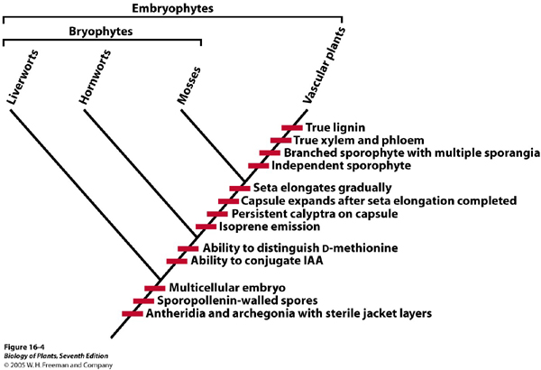](http://www.google.ps/url?sa=i&rct=j&q=&esrc=s&source=images&cd=&cad=rja&uact=8&ved=2ahUKEwjgyr3BmMneAhXIGuwKHRcdCIgQjRx6BAgBEAU&url=http://www.bio.miami.edu/dana/226/226F09_18.html&psig=AOvVaw0aRKlUNz-b-M-dqhdQ0GW3&ust=1541917499251908)

[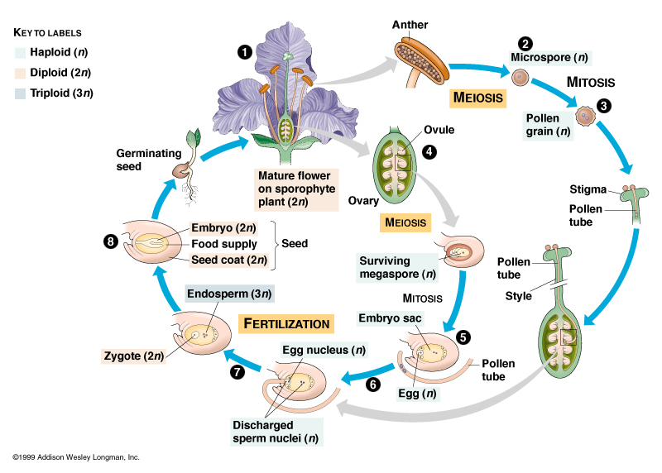](https://www.google.ps/url?sa=i&rct=j&q=&esrc=s&source=images&cd=&cad=rja&uact=8&ved=2ahUKEwif7Lz5mMneAhURMewKHbzLBXkQjRx6BAgBEAU&url=https://www.mun.ca/biology/scarr/Angiospermae.html&psig=AOvVaw31lZDcvp1IwxgVG8FTvdhv&ust=1541917633303233)