

**BIOLOGY and BIOCHEMISTRY DEPARTMENT**

Midterm Exam Botany –BIOL241**-** (FORM ABA) First Semester 20/21

Instructor: Prof. Dr. Jamil Harb Date: 12.12.2020

**Student Name : No.**

***Question One (for multiple choice questions you may choose more than one options; f*or ‘True or False’ questions, correct the wrong sentences).**

1. **Collenchyma cells are not elastic, since**  they become thick at maturity .
2. **Organic compounds are moved in plant body through**  phloem .
3. **Water exits plant leaves mainly through** xylem .
4. **Parenchyma cells differ from collenchyma cells in** cell wall .
5. **Which of the following is a living simple tissue involved as strengthening tissue for the plant body?**

A. xylem and phloem B. collenchyma C. sclerenchyma D. parenchyma

1. **Vascular cambium produces....**

(a) secondary xylem to the outside &  secondary phloem towards the inside of the stem

(b) cork cambium, parenchyma tissue, phloem and xylem.

(c) secondary xylem to the inside &  secondary phloem towards the outside of the stem

(d) a + b

(d) None of the above

1. **The bark of a dicot stem consists of..**

(a) epidermis, parenchyma and primary phloem

(b) phloem, xylem, cork cambium and cork.

(c) phloem, cortex, cork cambium and cork

(d) phloem, xylem, cortex, cork cambium and cork

(f) none of them is correct

1. **The oldest part of the wood is called......**

(a) heartwood (b) sapwood (c) annual rings (d) none of the above

1. **Annual rings consist partly of...**

(a) loose rings of xylem in the spring/summer

(b) tight rings of xylem in the spring/summer

(c) loose rings of xylem in the autumn/winter

(d) tight rings of phloem in the autumn/winter

1. **Which one of the following eventually becomes cork?**

(a) Secondary xylem

(b) Bark

(c) Vascular cambium

(d) Secondary phloem

(e) none of the above

1. **What plant tissue is responsible for primary growth in plants?**
   1. Vascular Cambium
   2. Cork Cambium
   3. Apical meristem
   4. None of the above
2. **Plant growth is attributed mainly to**

a. Mitosis b. Transpiration c. Morphogenesis

d. Differentiation e. all of the above

1. **The life cycle of a flowering plant involve(s)**

a. formation of haploid cells b. formation of gametophytes

c. formation of zygotes d. formation of triploid cells (endosperms)

f). formation of sporic

1. **Megasporogenesis involves**

a. meiotic division of diploid cells that are part of the ovule

b. meiotic division of diploid cells found in the anther

c. mitotic division of microspore to form pollen grains

d. mitotic division of megaspore to from embryo sac

f). mitotic division of megaspore mother cell (diploid cell) to form megaspore

1. **The major transitional meristems are the**

a). protoderm, procambium, and ground meristem.

1. tracheids, vessel elements, and sieve tube members.
2. shoot tip, root tip, and axillary buds.
3. **Cells in the region of cell elongation (roots) are**

a. younger than cells in the region of maturation

b. older than cells in the region of maturation

c. as old as the cells in the region of maturation

d. None of the above: .

1. **The three vegetative organs of the plant body are**
2. dermal, ground, and vascular
3. parenchyma, collenchema, and scelernchyma
4. protoderm, ground meristem, and procambium
5. apical meristem, vascular cambium, and cork cambium
6. b + c
7. Root, stem & leaves
8. **True or False: false :** Endodermis ~~prevents~~ the movement of all minerals through the roots. Allow(control) .
9. **Endodermis**

a. is found in both roots and stems

b. is found in the epidermis of roots

c. is found in the cortex of stems

d. is found in the vascular bundles of leaves

e. all of the above

d). is found in stem

1. **True or False:** Pericycle is part of ~~the stem.~~ **: of the root**

. .

1. **Embryophytes** 
   1. include all green living organisms
   2. include all flowering plants
   3. include all plants that produce seeds
   4. all of the above
   5. f). C and B
2. **The living sieve tube members found in the phloem do NOT normally have:**a. nuclei b. plasma membranes. c. cell walls. d. cytoplasms.
3. **True or False: false :** Vessel elements are part of a well differentiated tissues.

. Non living cells – Dead cells .

1. **Lateral roots arise from**

a. the vascular bundle b. the cortex. c. the endodermis

d. the pith e. pericycle

1. **A plant with three leaves per node is said to have leaf arrangement.**

a. spiral b. helical c. opposite

d. whorled e. None of the above___________

1. **With dicot leaves,**

a. palisade mesophyll cells are densely packed

b. spongy mesophyll cells are densely packed

c. lower epidermis has much more stomata than upper epidermis

d. upper epidermis has much more stomata than lower epidermis

e. None of the above

1. **True or False: true :** Epidermis formed from the protoderm is both competent and determined tissue.

. .

1. **True or False: true :** Through the process of megagametogenesis, both egg (1n) and polar nuclei (1+1) are formed.

. .

1. ***Give titles for the following***

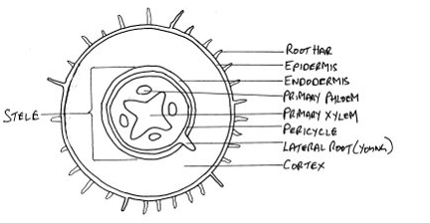

. young dicot root .

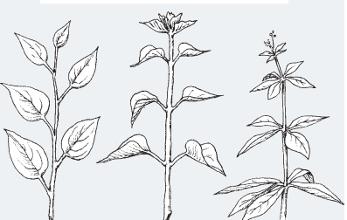

. leaf arrangement on the stem .

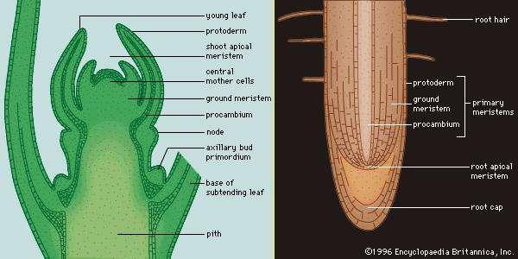

. Apical Meristems .

1. **Give a title for the following figure and state the function of procambium, protoderm, and ground meristem.**

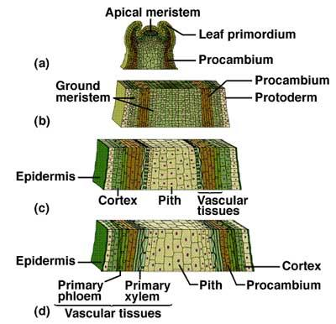

**Title:**

Primary meristems (Part of the plant body) .

**Functions**

-Procambium: He is a meristematic tissue concerned with providing the primary tissues of the vascular system.

-Protoderm: He is the primary meristem in vascular plants that gives rise to epidermis. (GROWTH)

-Ground meristem: Photosynthesis, respiration, storage, support.

**36. In the space provided below, explain the major differences between xylem and phloem.**

1). Xylem: transport and stores water and water soluble molecules - Phloem: transport sugars, proteins and other organic molecules

2). Xylem: The water is transferred against gravity (from below to top, i.e. from roots to leaves) – phloem: It transfers organic matter and sugars with gravity (top to bottom) from leaves to roots.

**37. Define**

1. Bisexual flower: the both stamen and carpel are present.
2. Microgametogenesis: Microspore -----Mitosis-🡪 sperm cell, tune cell (he contain 3 cells)
3. Cork cambium: It grows on the edges of the stem.
4. Double fertilization: one sperm (haploid body) and egg (haploid body) fertilization takes place and produces a zygote (one diploid cell)
5. Seed: It is inside the ovules and is able to develop inti another plant.
6. Megasporophyte: error the correct (megasporogenesis)