

BIOLOGY and BIOCHEMISTRY DEPARTMENT

First QUIZ Botany –BIOL241**-** First Semester 20/21

# **Student Name: No.**

***Question One (Multiple Choice and True or False)***

**For all ‘True or False’ questions, correct the wrong sentences.**

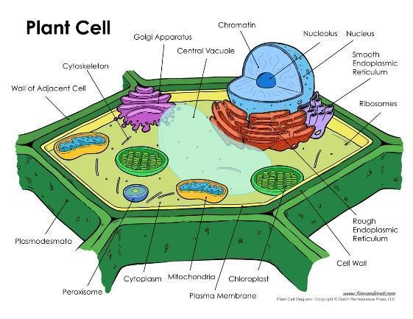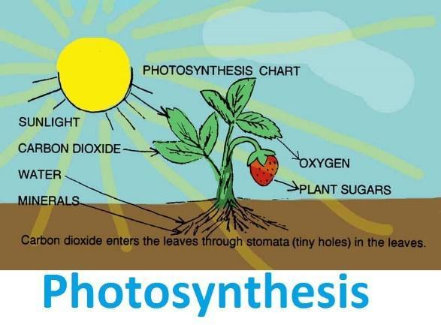

1. **Water and minerals are moved from soil to leaves through xylem.**
2. **Water exits plant leaves mainly through** **stomate.**
3. **Cells in the region of cell division (roots) are**

a. younger than cells in the region of maturation

b. older than cells in the region of maturation

c. as old as the cells in the region of maturation

d. other answer or combination: .

1. **The three vegetative organs of the plant body are**
2. dermal, ground, and vascular
3. parenchyma, collenchema, and scelernchyma
4. protoderm, ground meristem, and procambium
5. apical meristem, vascular cambium, and cork cambium
6. b + c
7. Other combination or answer: Stems, roots, and leaves.
8. **Endodermis**

a. is found in both roots and stems

b. is found in the epidermis of roots

c. is found in the cortex of stems

d. is found in the vascular bundles of leaves

e. all of the above

f. Other answer or combination: Is found in roots .

1. **True or False: True :** Pericycle is part of the root.
2. **True or False: False :** Tubers are not modified leaves. Modified stems.
3. **True or False: False :** Tracheids are well differentiated tissues. Parenchyma.
4. **Lateral roots arise from**

a. the vascular bundle b. the cortex. d. the endodermis

e. the pith g. Other answer or combination: Pericycle.

1. **A plant with two leaves per node is said to have opposite leaf arrangement.**

a. spiral b. helical c. opposite

d. whorled e. other answer or combination: ___________

1. **With dicot leaves,**

a. palisade mesophyll cells are densely packed

b. spongy mesophyll cells are densely packed

c. lower epidermis has much more stomata than upper epidermis

d. upper epidermis has much more stomata than lower `epidermis

e. Other answer or combination: ______________________________

1. ***Give titles for the following***

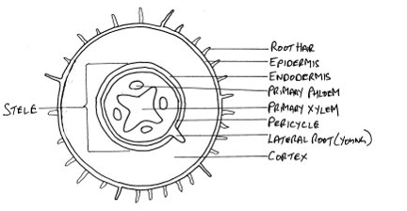

**Young dicot root**

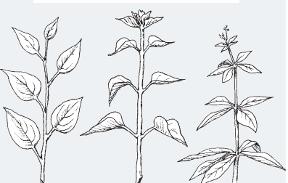

**Leaf arrangement on the stem**

1. **What are the major differences (external and internal) between monocot and dicot leaves  
   EXTERNAL:   
   The MONOCOTS have parallel major veins that run the length of the blade.  
   The DICOTS have a multi branched network of major veins.  
   INTERNAL:   
   Parenchyma can be found in dicots while it cannot be found in monocot.**