**Birzeit University**

**Department of Biology and Biochemistry**

**BIOL241 (Botany)**

**Quiz One (14.09.2020)**

**Name: Number:**

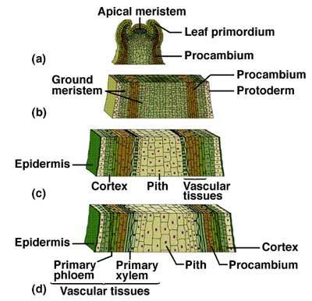

**(1) Give a title for the figure above**

The Plant Body

**(2) Explain the major processes from (a) to (d)**

A). Grow by division at meristems develop into leaves, other shoots, and even flowers.

B). Ground tissue system: Body of the plant, Photosynthesis, support, storage.

C). Epidermis: single layer of cells that forms a boundary between the plant and its extremal environment. It protects against water loss, regulates gas exchange, absorbs water (H2O) and mineral nutrients, and excretes metabolic components.

D). Vascular tissue: Transport materials, throughout plant.

**(3) State the function of the following tissues:**

* **Procambium**: He is a meristematic tissue concerned with providing the primary tissues of the vascular system**.**
* **Protoderm:** He is the primary meristem in vascular plants that gives rise to epidermis**. (GROWTH)**
* **Ground meristem:** Photosynthesis, respiration, storage, support.

**(4) What are the functions of (a) epidermis**: Protects against water loss, in addition to regulating gases.

**and (b) primary xylem:** Transport and stores water and water soluble molecules, and dissolved minerals upward from roots into the shoots**.**

**(5) Define and draw the** first root growing from a seed

It is the first member of the plant and its direction is down.

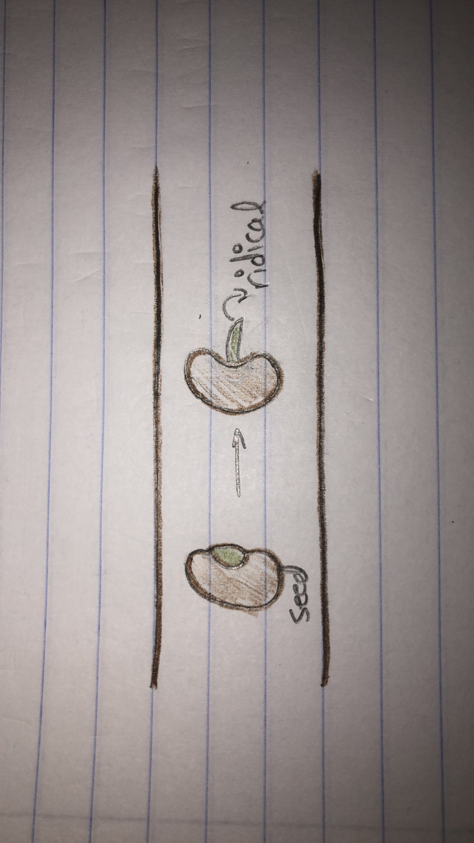

**(6) What are the two kinds of plant growth?**

1. Primary and secondary
2. Lateral and outward
3. Xylem and phloem
4. Vascular and cork

**Read and understand**

The root has the most primitive anatomy of the **three** vegetative plant organs. There is a single-cell layer of **epidermis**, a cortical region of ground tissue, and a single solid cylinder of vascular tissue. The root epidermis is equivalent to and continuous with that in stem and leaf, but both waxy **cutin** and **stomata** (openings) are absent in young portions of the root.

The vascular tissue is partially coalesced into a solid **vascular cylinder**. In the cross section, you see a circle representing these tissues. The central portion of tissue comprises the **xylem** area. Here the very large-diameter cells have thick walls that pick up the *red dye*, indicating the presence of **lignin**. Lignin is a brittle chemical that makes xylem cell walls very tough. The difference between cotton and wood is the presence of lignin! Why would a tube that conducts water and minerals up a plant need to have tough walls? You will see that unlike the cortex cells, the xylem cells lack any kind of cytoplasm; **mature xylem cells are dead**.

Near the periphery (edge) of this central disc of vascular tissue, you will find discrete bundles of **phloem**. The phloem tissue has two distinct cell types, but both have **thin-green-stained walls**. One phloem cell type is large in diameter, has a very “simple” cytoplasm, and conducts water and carbohydrates down the plant from the leaves. These **sieve tube elements** lack a nucleus, plastids, and vacuoles; the cells are connected end to end and the fluid flows from one sieve tube element to the next through pores in the end-walls of each cell. Between sieve tube elements are **companion cells**. These are smaller in diameter and have a densely-staining complex cytoplasm. These cells are indeed companions for the sieve tube elements. They carry out the biochemistry needed to keep the sieve tube elements alive! The molecules of life pass from companion to sieve through **plasmodesmata** in the sidewalls of these two cells.

In the space provided below, diagram a **cross section of a root**. You need only show the layers and a few (less than 10) cells in each region. Label your diagram by connecting lines to your drawing from the provided labels.

**Discuss the underlined words:**

**Epidermis**: single layer of cells that forms a boundary between the plant and its extremal environment**.**

**Stomata:** a pore responsible for the rate of gas exchange.

**Lignin:** Is a brittle chemical that makes xylem cell walls very tough**.**

**Three vegetative plant organs:** There are three levels of integrated organization in the vegetative plant body.

**Thin-green-stained walls:** Cell walls composed mostly cellulose**.**

**Vascular cylinder:** Are the bundles of vascular tissue that run within the core of plant stem and roots**.**

**phloem:** Is the living tissue in vascular plants that transports the soluble organic compounds made during photosynthesis**.**

**Sieve tube elements**: are specialized cells that are important for the function of phloem which is highly organized tissue that transports organic compounds.

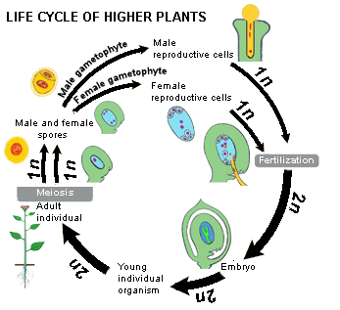

**Define and draw**

1. **Bisexual flower:** The flowers which contain both male and female reproductive organs are known as full or bisexual flowers.

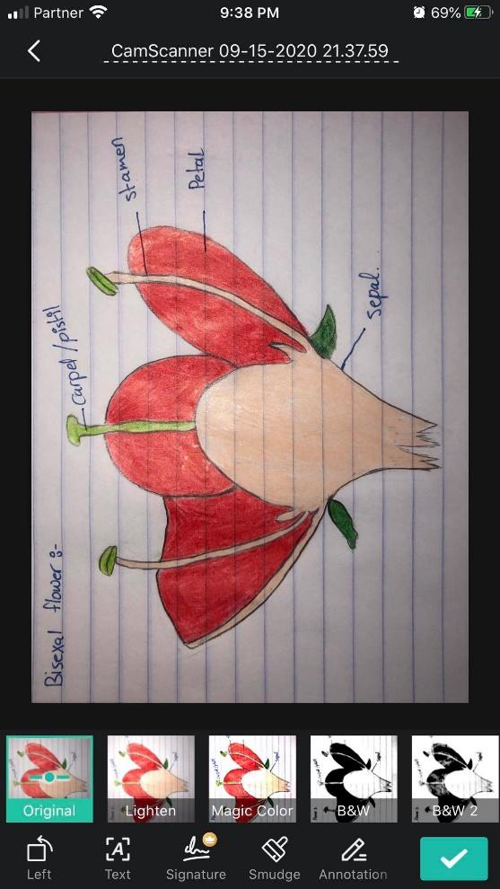

1. **Seed:** capable of developing into another plant.

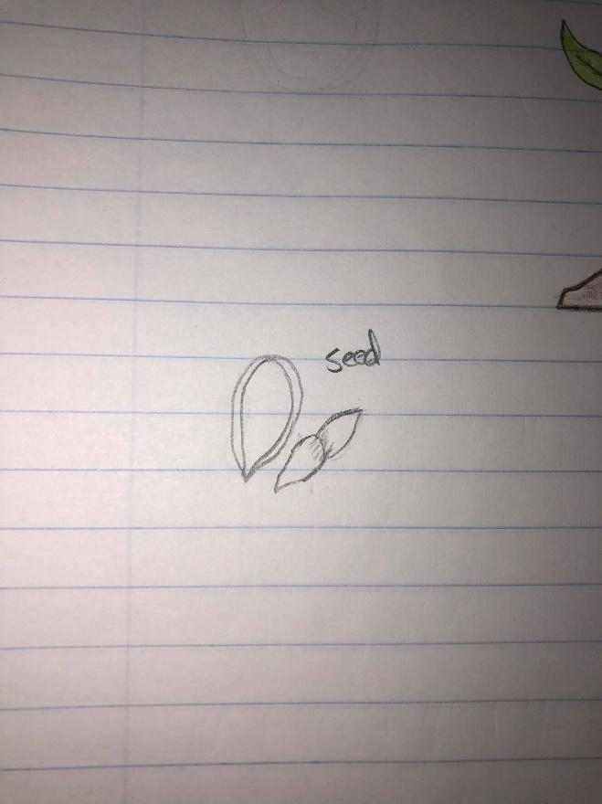

1. **Baby plant:** He is present inside the seed which develops into a new plant, the embryo gives to rise to a small core and radical.

