***Effect of physical agents on bacterial growth***

* **Objective:-**To distinguish between different type of physical agents on the growth of bacteria.
* **Introduction:-**Control of microorganisms is essential in order to prevent the transmission of diseases and infection, stop decomposition and spoilage, and prevent unwanted microbial contamination.  
  Among numerous physical agents exerting their deleterious effect on microorganisms only a few have been applied to sterilisation or disinfection used for medical purposes. Temperature is the most important agent, which from one side in a very wide range enables supporting of metabolic processes of psycho-, mezo- and thermophilic microorganisms.
* **Material:-  
  1- Effect of osmotic pressure on bacterial growth:-**  
  a- Stock cultures of *Staphylococcus aureus* and *Escherichia coli.*b- Nutrient agar with 5% NaCl, Nutrient agar with 10% NaCl, Nutrient agar with 15% NaCl. **2- Effect of temperature on spore-forming and non-spore forming bacteria:-**a- Stock cultures of *Escherichia coli* and *Bacillus subtilis.*b- Nutrient agar plates.  
  c- Water bath. **3- Effect of ultraviolet light on bacteria:-**a- Stock cultures of *Escherichia coli* and *Bacillus subtilis.*b- Nutrient agar plates.  
  c- Sterile swabs.  
  d- Cardboard.
* **Methods:-  
  1- Effect of osmotic pressure on bacterial growth:-**a- One plate of each of the following media was divided in half.  
  b- Inoculating loop was used to streak one half of each plate with *Escherichia coli* and the other half with *Bacillus subtilis.*c- The plates were incubated at 37oC for 24 hours. The findings were recorded.  
    
  **2- Effect of temperature on spore-forming and non-spore forming bacteria:-**  
  a- 2ml of *Escherichia coli* and *Bacillus subtilis* were incubated at the following temperatures for 90 minutes: 0oC, RT(Room Temperature), 37oC, 55oC, 75oC, 98oC.  
  b- A nutrient broth agar plate was divided into 5 sections and inoculated from the tubes with a single straight stroke.(One section with the original culture was inoculated as control)  
  c- The two plates were incubated at 37oC for 24-48 hours and the presence or absence of bacterial growth were recorded.  
    
  **3- Effect of ultraviolet light on bacteria:-**  
  a- Sterile swabs were used to streaked 8 Nutrient agar plates with *Escherichia coli* as follows:-  
  i- The swab was dipped into the culture.  
  ii- All of the excess liquid was removed by pressing the swab against the side of the tube.  
  iii- The plate was streaked so as to cover the entire agar surface with organisms.  
   b- Seventh of the plates were exposed to UV light as follows:-  
  i The lid of each plate was removed and placed a piece of cardboard with different shapes(birds, butterfly,…etc…) were cut out of it over the top of the agar.  
  ii- The first plate was exposed to UV light for 1 second, the second plate for 5 seconds, the third plate for 10 seconds, the forth plate for 15 seconds, the fifth plate for 20 seconds, the sixth plate for 35 seconds, the seventh plate for 60 seconds.  
  iii- The lids were placed and incubated at 37oC for 24 hours.  
  c- The last plate was used as an non-irradiated control , and incubated at 37oC for 24 hours with other plates.  
  d- The findings were recorded.  
    
  Note: Repeat the same procedure for *Bacillus subtilis* in UV light.
* **Results:  
  1- Effect of osmotic pressure on bacterial growth:-  
  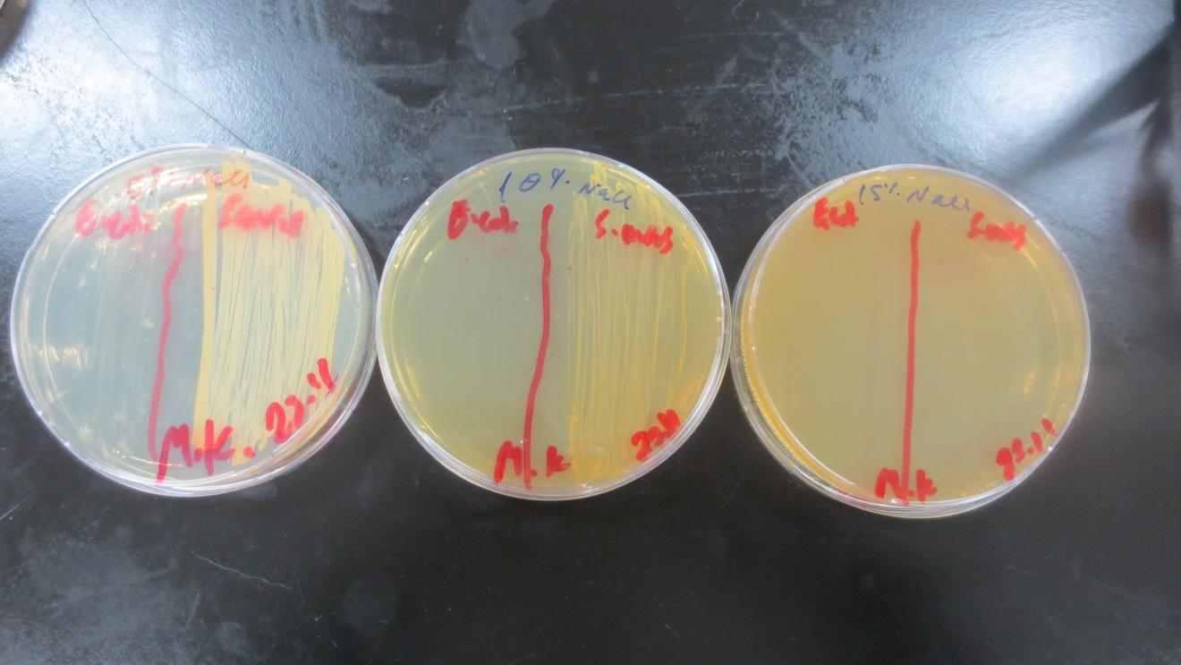**Figure 1 : A- 5% NaCl B- 10% NaCl C- 15% NaCl/ Left: *Escherichia coli/ Right Staphylococcus aureus* **2- Effect of temperature on spore-forming and non-spore forming bacteria:-  
  a- With regard to *Escherichia coli :-*** At zerooC : zero time use as control.

- After 30 minutes the growth somewhat decreased.

- After 60 and 90 minutes the growth remain the same.  
At RT: : zero time use as control.  
- After 30 minutes the growth remain the same.  
- After 60 and 90 minutes the growth somewhat decreased.  
At 37oC: zero time use as control.  
- After 30 minutes the growth somewhat decreased.  
- After 60 and 90 minutes the growth increased.  
At 55 oC : zero time use as control.  
- After 30 minutes the growth somewhat decreased.  
- After 60 and 90 minutes the growth much decreased.  
At 75 oC : zero time use as control.  
- After 30 minutes the growth somewhat decreased.  
- After 60 and 90 minutes the growth much decreased.  
 At 98 oC : zero time use as control.  
- After 30, 60 and 90 minutes no bacteria growth.  
**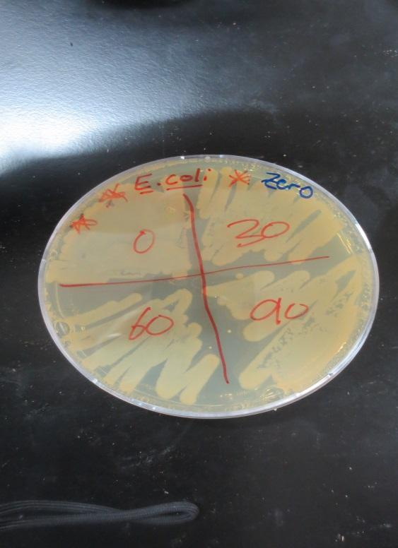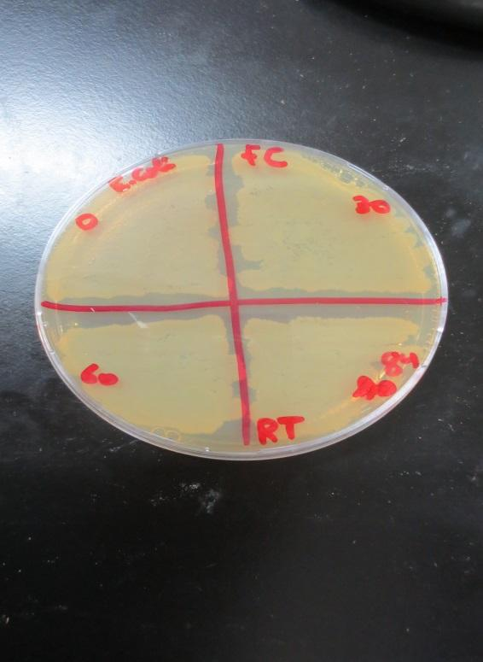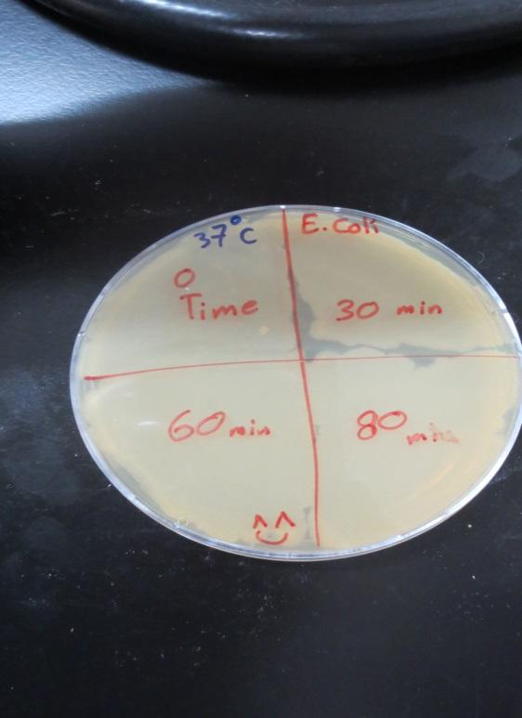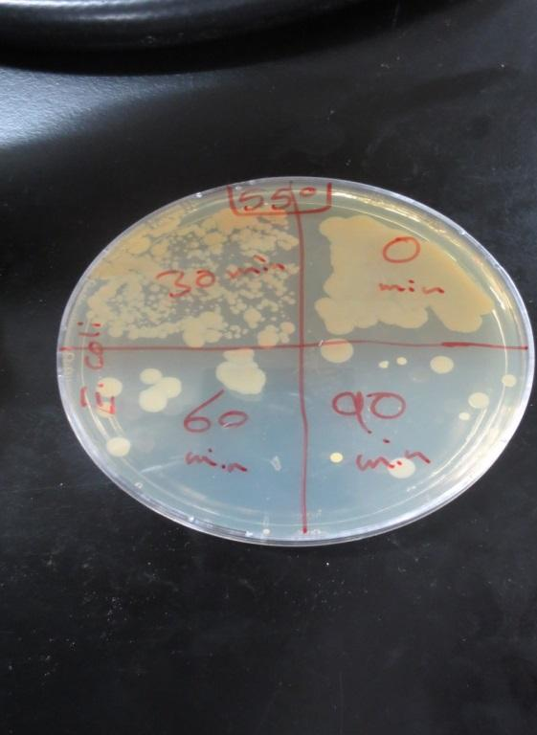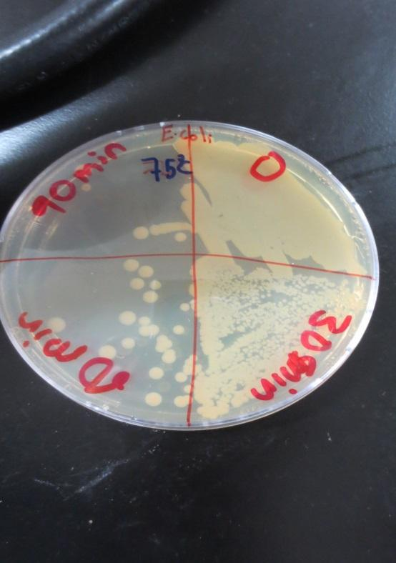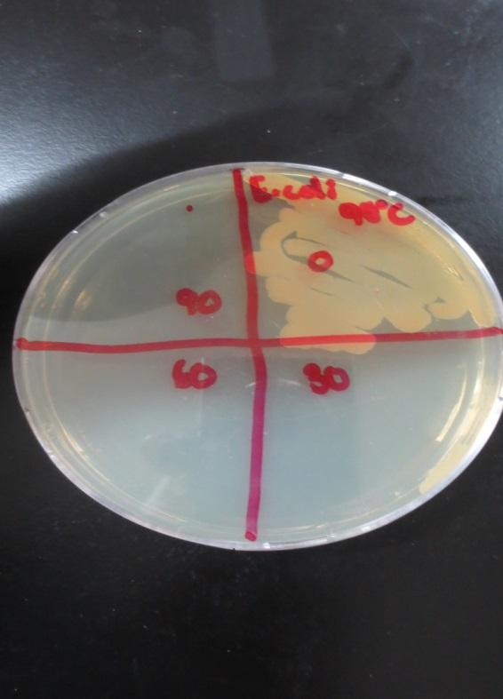  
  
 b- With regard to *Bacillus subtilis :-***At zerooC : zero time use as control.  
- After 30, 60 and 90 minutes the growth remain the same.  
At RT: : zero time use as control.  
a- After 30, 60 and 90 minutes the growth remain the same.  
At 37oC: zero time use as control.  
- After 30 and 60 minutes the growth remain the same.  
- After 90 minutes the growth decreased.  
At 55 oC : zero time use as control.   
 - After 30, 60 and 90 minutes the growth remain the same.  
At 75 oC : zero time use as control.  
- After 30 and 60 minutes the growth remain the same.  
- After 90 minutes the growth somewhat decreased.  
 At 98 oC : zero time use as control.  
- After 30, 60 and 90 minutes no bacteria growth.

**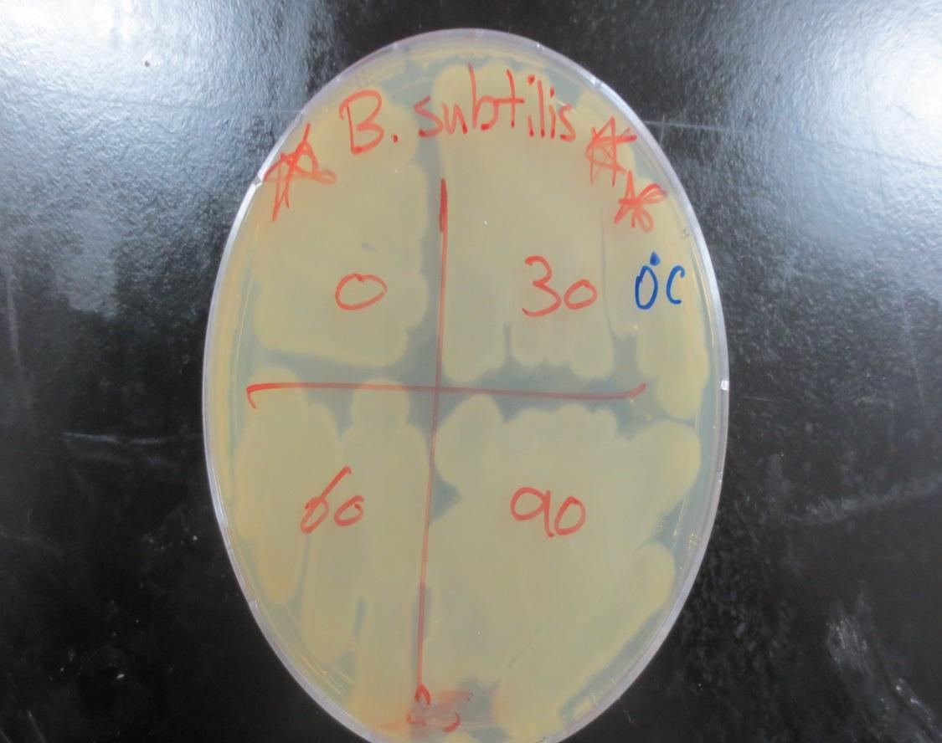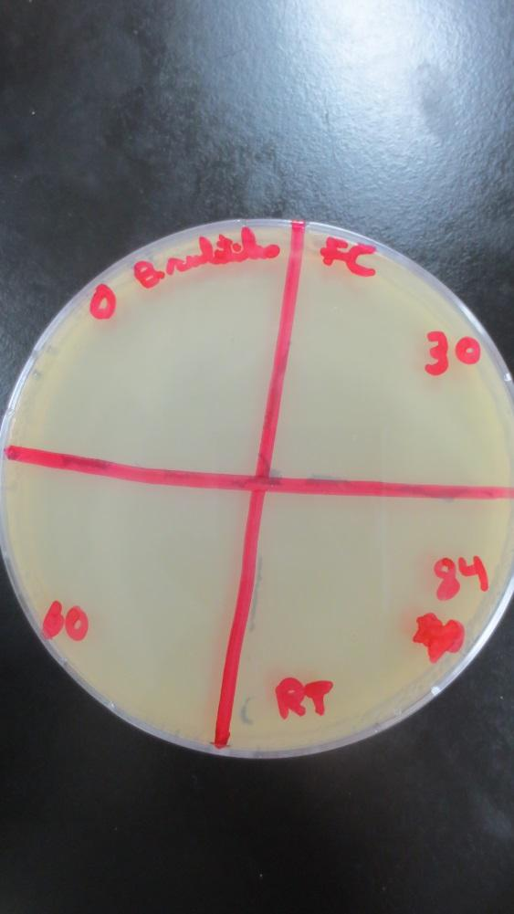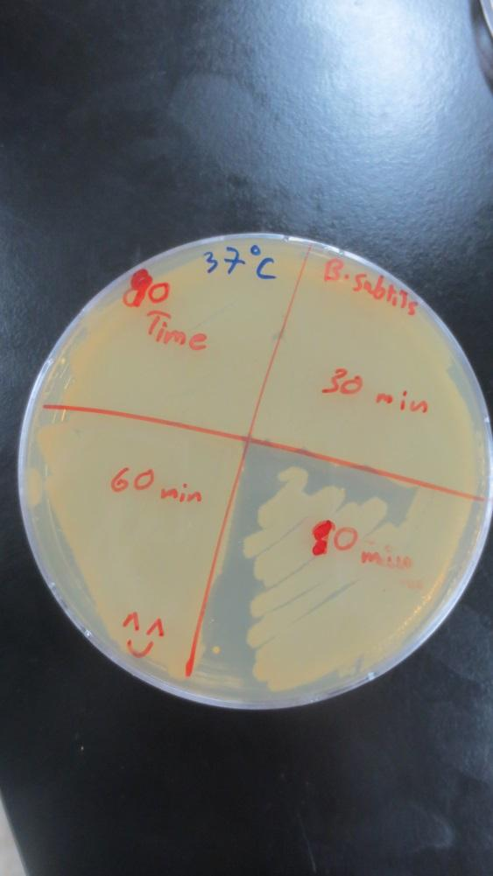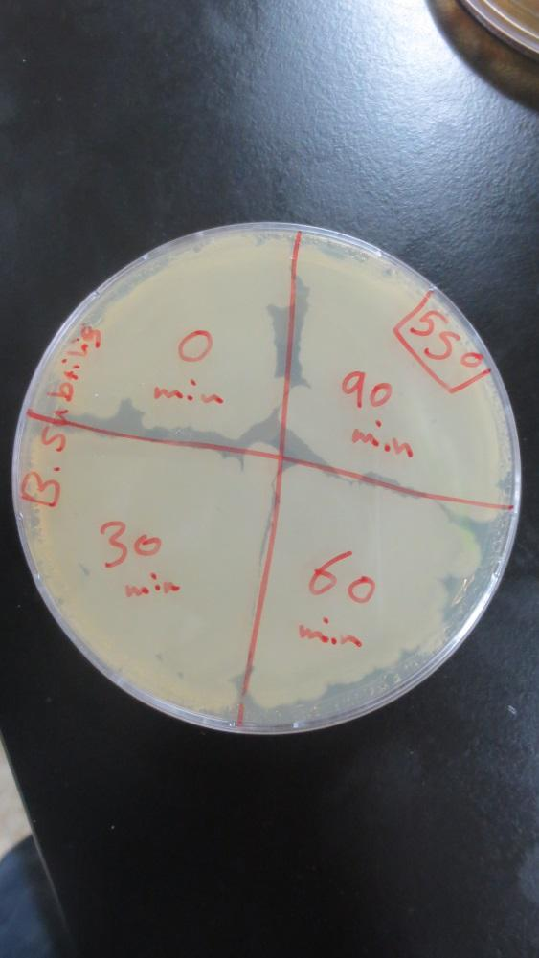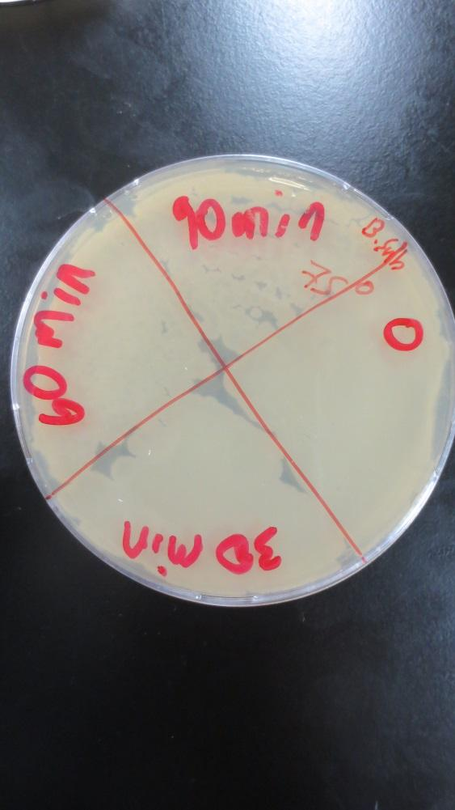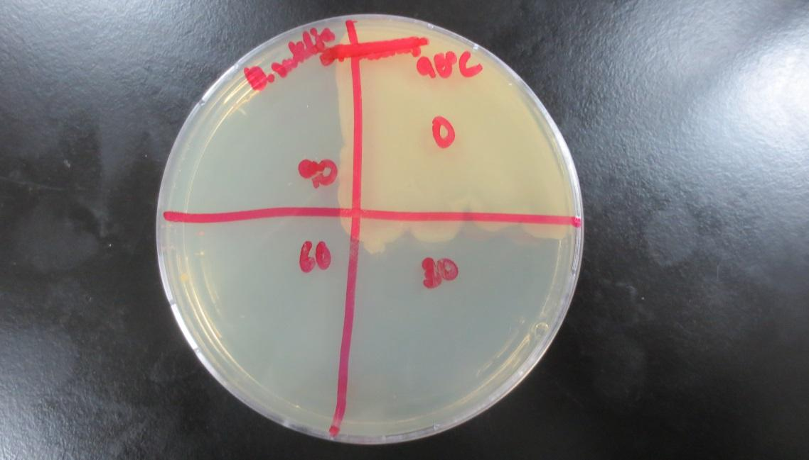  
  
  
  
  
  
3- Effect of ultraviolet light on bacteria:-  
  
a- With regard to *Escherichia coli***First plate us as control.  
Second plate after 1 second: the growth little bit decreased.  
Third plate after 5 seconds : the growth little bit decreased.  
Forth plate after 10 seconds : the growth somewhat decreased.  
Fifth, sixth, seventh and eighth plates after 15, 20, 35, 60 seconds :the growth decreased. **b- With regard to *Bacillus subtilis***All plates remain the same.  
  
  
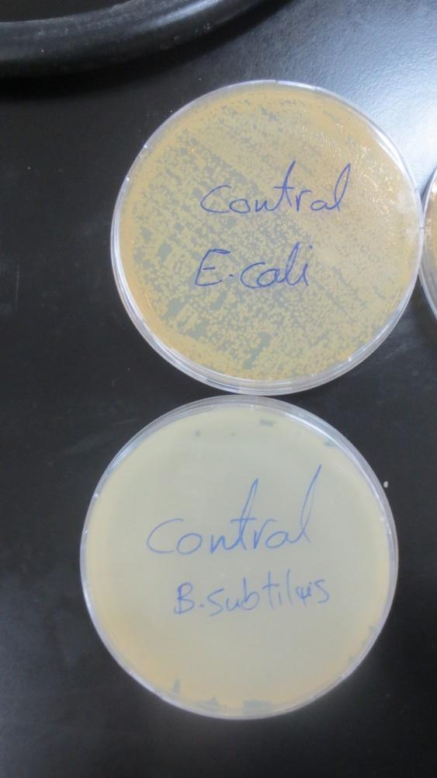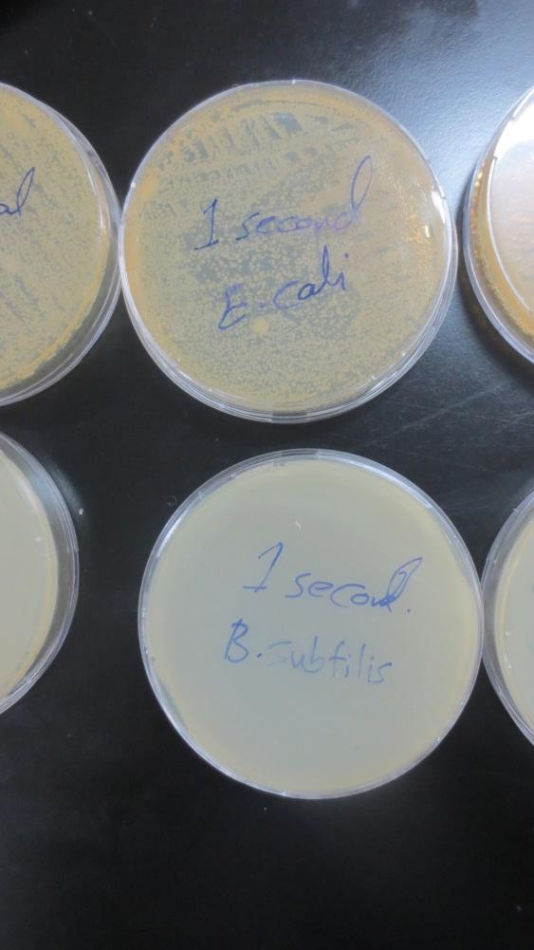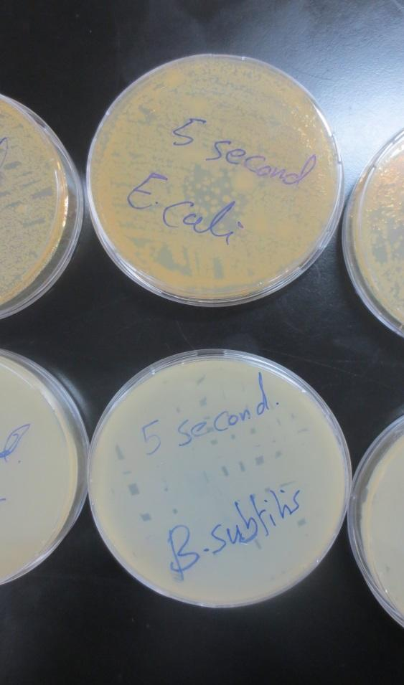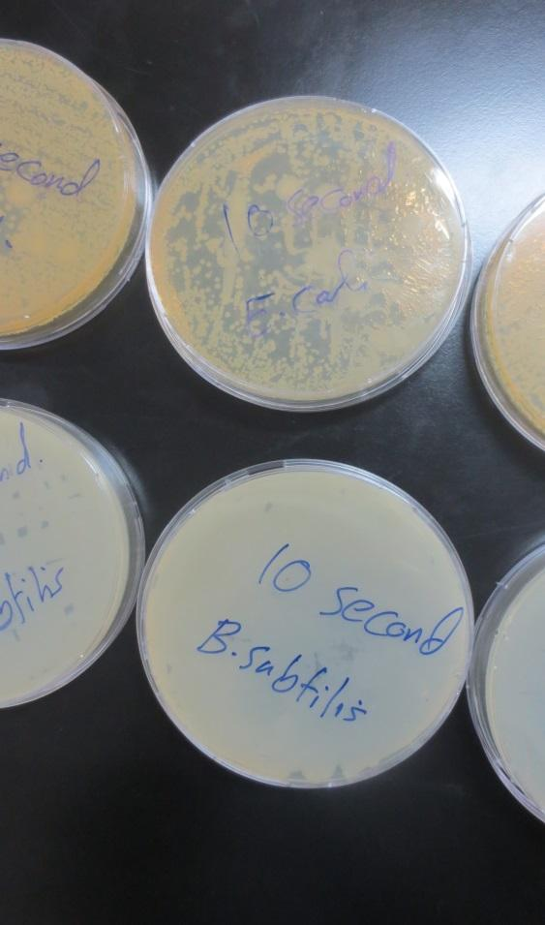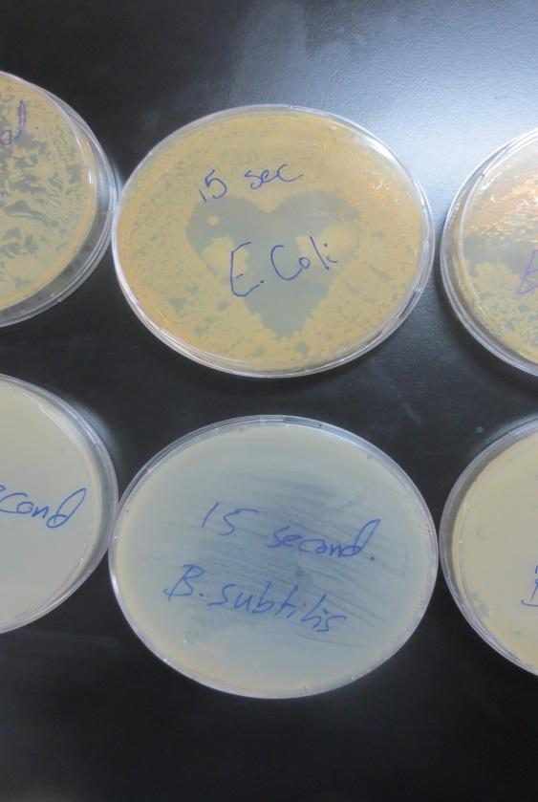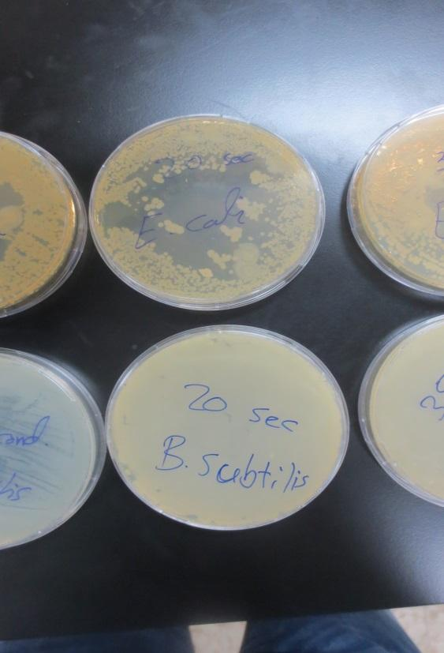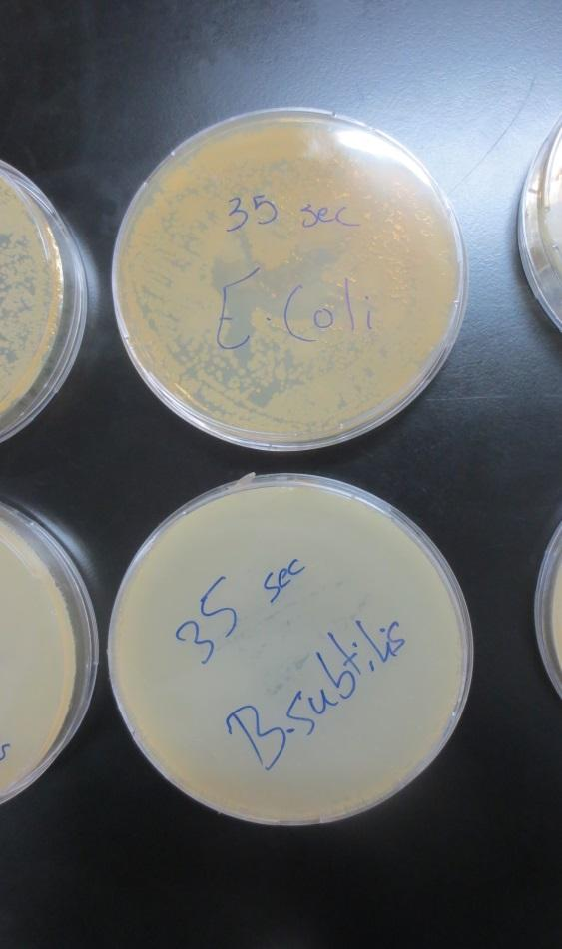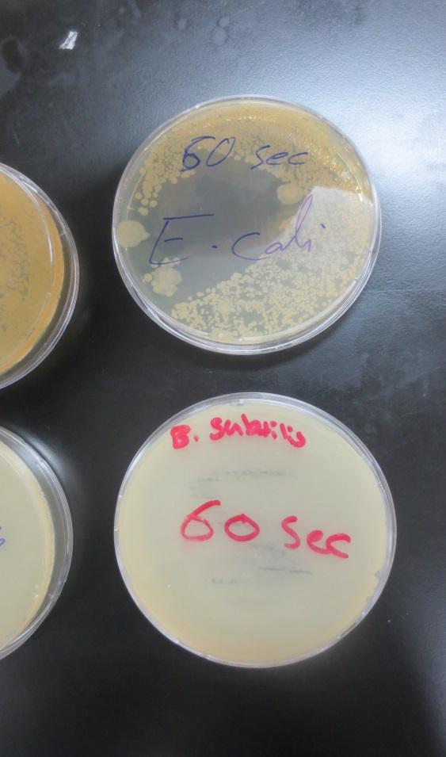

* **Discussion:  
  1- Effect of osmotic pressure on bacterial growth:-**  
  a- With regard to *Escherichia coli:-*In all plates no growth of *Escherichia coli*  observed.  
  b- With regard to *Staphylococcus aureus:-*Nutrient agar with 5% NaCl is the most growth of *Staphylococcus aureus* than nutrient agar with 10% NaCl   
  Nutrient agar with 15% there is no growth of *Staphylococcus aureus* observed.  
  **2- Effect of temperature on spore-forming and non-spore forming bacteria:-**  
     
  The result show that *Bacillus subtilis* is more resistant to temperature than *Escherichia coli* , because *Bacillus subtilis* can do spores that protect it from harmful environment. On the other hand, both type of bacteria died at 98 oC after a few minutes so spores in *Bacillus subtilis* died at that temperature. **3- Effect of ultraviolet light on bacteria:-**Observed: *Bacillus subtilisi* is more resistant to UV light than *Escherichia coli*, because *Bacillus subtilis* can do spores that protect it from harmful environment.
* **Conclusion:-**1- Heat is a widely used and highly effective method fo controlling microbial growth.  
    
  2- Refrigeration slows microbial growth; freezing stops growth, killing some organisms. Laboratory and medical specimens may be frozen on dry ice or at ultra-low temperatures for storage and transport.

* **References:-**<https://www.ncbi.nlm.nih.gov/pubmed/9432703>  
    
  <https://bio.libretexts.org/Labs/Microbiology_Labs_II/Lab_18%3A_Use_of_Physical_Agents_to_Control_of_Microorganisms>