Birzeit University

**Biology and Biochemistry Department**

**BIOL 243**

**Microbiology Lab**

**Experiment #8**

*Title: Chemical effects on bacterial growth*

**Student Name:** Muhammad Ibrahim Musleh

**Student ID:** 1162595

**Instructor:** Monther Metani

**Teacher Assistance:** Ayman Asi

**Date of Experiment:16-11-2017**

**Submission Date:23-12-2017**

Chemical effects on bacterial growth

* **Objective:-**To examine the effectiveness of various antiseptics and disinfectants on bacterial growth.
* **Introduction:-**Agents that prevent the growth(Static) of or kill(Cidal) microorganisms are called antimicrobial agents. Microorganisms vary in their sensitivity to particular chemical agents. Antimicrobial agents block active metabolism and prevent the synthesis of macromolecules needed for reproduction.
* **Materials:-  
  A) Effect of disinfectants and antiseptics on bacterial growth:-  
   1-*Escherichia coli* and *Staphylococcus aureus* stock cultures.  
   2-Nutrient Broth Agar Plates.  
   3-Sterile cotton swabs.  
   4-Generic disinfectants: Dettol, Ethanol, Listerine...etc.  
   5- Forceps  
    
  B) Effect of chemotherapeutic agents on bacterial growth:-  
   1- *Escherichia coli* and *Staphylococcus aureus* stock cultures.  
   2-Mac Farland standard.  
   3-150mm Muller-Hinton agar plates.  
   4-Antibiotic discs(Penicillin G, Bacitracin, Azithromycin, Ampicillin/Suibactam.  
    
  C) Minimum Inhibitory Concentration (MIC) and Minimum Bactericidal Concentration (MBC):-  
    
   1- Antibiotic Stock solution 1000 mcg/ml  
   2- Sterile 96 wells plates.  
   3- Stock cultures of  *Escherichia coli* and *Staphylococcus aureus.*  4- Nutrient agar plates.  
   5- Multichannel micropipette.  
   6- Sterile pipette tips.**
* **Methods:-  
  A) Effect of disinfectants and antiseptics on bacterial growth:-  
   1-One plate of nutrient agar is inoculated with *Escherichia coli* a sterile swab is dipped into a broth culture –Swabbed in several directions to make sure that the whole plate is inoculated.   
   2-Small disks of filter paper was dipped into three different kinds of generic disinfectant (Dettol ,ethanol ,CuSO4 ).  
  3- The discs was drained briefly and placed –by used forceps-on the surface of the plate.  
  4- The plate was marked on the bottom to identify which disinfectant was used.  
  5- The plate was incubated at 37oC.  
    
  Note: Repeat the same procedure on *Staphylococcus aureus*.  
    
    
  B) Effect of chemotherapeutic agents on bacterial growth:-  
   1- A standard turbidity inoculum of the test bacterium was prepared so that a certain density of bacteria will be spread on the plate.  
   2- A 150mm Mueller-Hinton agar plate was inoculated with the standardized inoculum so as to cover the entire agar surface with bacteria.  
   3- Standardized antibiotic-containing discs were placed on the plate.  
   4- The plate was incubated at 37oC for 24 hours.  
   5- The diameter of any resulting zoned of inhibition were measured in millimeters.  
   6- If the bacterium is susceptible, moderately susceptible, intermediate, or resistant to each antimicrobial agent.  
    
  Note: This procedure was repeat twice: one for *Staphylococcus aureus* and another for *Escherichia coli.*  
     
  C) Minimum Inhibitory Concentration (MIC) and Minimum Bactericidal Concentration (MBC):-  
   1- Sterile 96 well plates 1,2,3,4,….,12 was used.  
   2- 0.1ml was pipetted from MH(Mueller Hinton) Broth into wells numbered 2-12.  
   3- 0.2ml of the antibiotic solution(1000mcg/ml) was added into well number 1 and mix well.  
   4- A serial dilution was made starting from well number 1, by transferring 0.1ml from well number 1 to well number 2 and all the way were mixed and repeated to well number 11.  
   5- 0.1ml Was removed from well number 11 and discard.  
   6- Well tube number 12 was not added anything to it. (Well number 12 is a positive control)  
   7- Well number 1 will be contained 500 mcg/ml of the antibiotic after addition of the inoculum, and tube number 11 will be contained 0.5mcg/ml.  
   8- Multichannel pipette was used to transfer 0.1ml of bacterial culture to the wells 1-12.  
   9- The Sterile 96 well plates was incubated at 37oC for 18-24 hours and the result was recorded.**
* **Results:-  
  A) Effect of disinfectants and antiseptics on bacterial growth:-  
  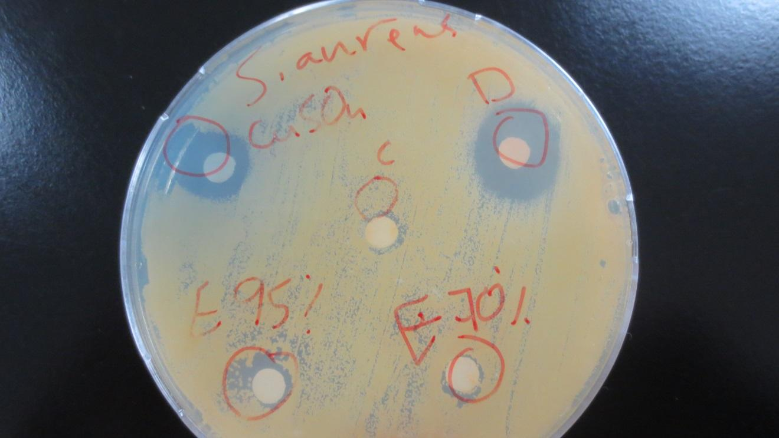**Figure 1: Effect of disinfectants and antiseptics on *Staphylococcus aureus* 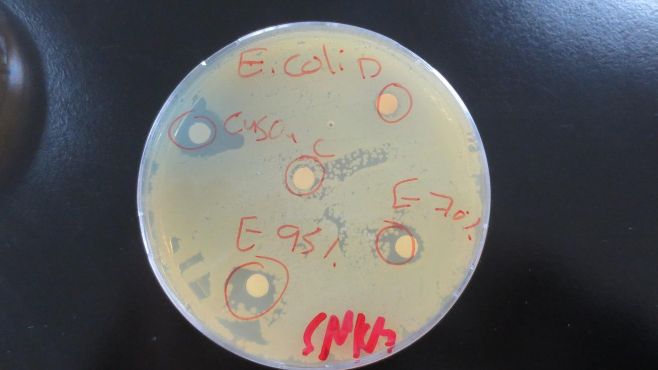Figure 2 : Effect of disinfectants and antiseptics on *Escherichia coli.*

| **Chemical/Antibotics** | *Staphylococcus aureus* | *Escherichia coli* |
| --- | --- | --- |
| **Control** | **6mm** | **6mm** |
| **Dettol** | **18mm** | **6mm** |
| **CuSO4** | **12mm** | **12mm** |
| **Ethanol 95%** | **8mm** | **12mm** |
| **Ethanol 70%** | **7mm** | **9mm** |

**Table 1 :** Effect of disinfectants and antiseptics on both type of bacteria **B) Effect of chemotherapeutic agents on bacterial growt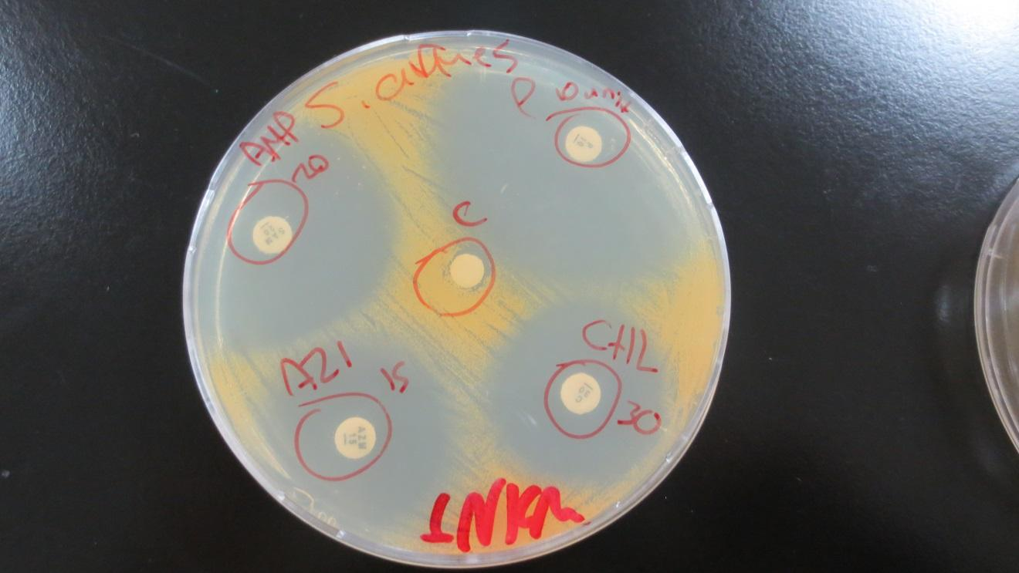**Figure 3 : Effect of chemotherapeutic agents on *Staphylococcus aureus* 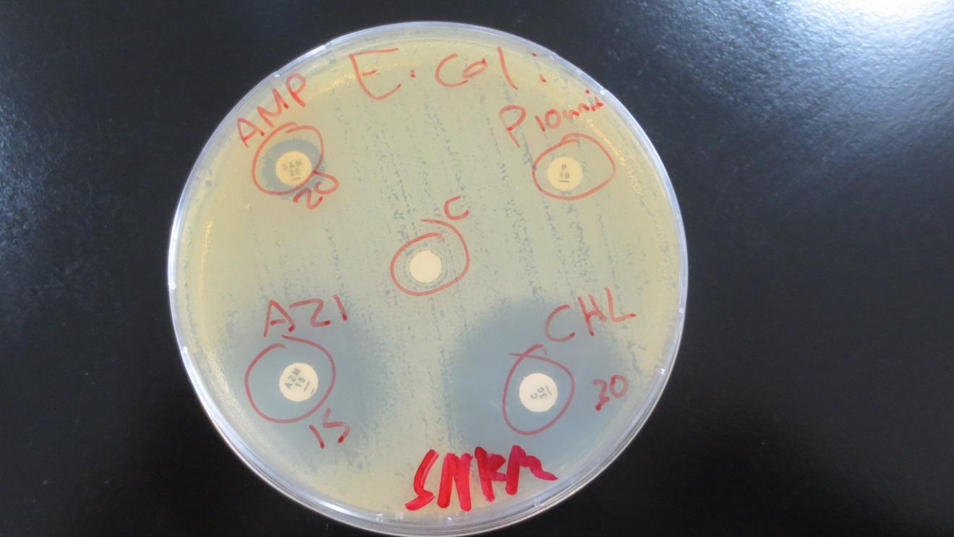Figure 4 : Effect of chemotherapeutic agents on *Escherichia coli.*

| **Chemical/Antibotics** | *Staphylococcus aureus* | *Escherichia coli* |
| --- | --- | --- |
| **Control** | **6mm** | **6mm** |
| **AMB**https://scontent.fjrs3-1.fna.fbcdn.net/v/t34.0-12/23758311_1583195355092541_1182954482_n.jpg?oh=6c5eff4c66055f3836369a01d2aeb645&oe=5A14B17C | **36mm** | **11mm** |
| **AZI** | **30mm** | **24mm** |
| **CHL** | **30mm** | **30mm** |
| **P 10** | **52mm** | **6mm** |

**Table 2 :** Effect of chemotherapeutic agents on both type of bacteria **C) Minimum Inhibitory Concentration (MIC) and Minimum Bactericidal Concentration (MBC):-  
  
  
  
  
  
  
  
  
  
  
  
  
  
  
Figure 5:** the effect of antibiotics (gentamicin & tetracycline) on  ***Escherichia coli***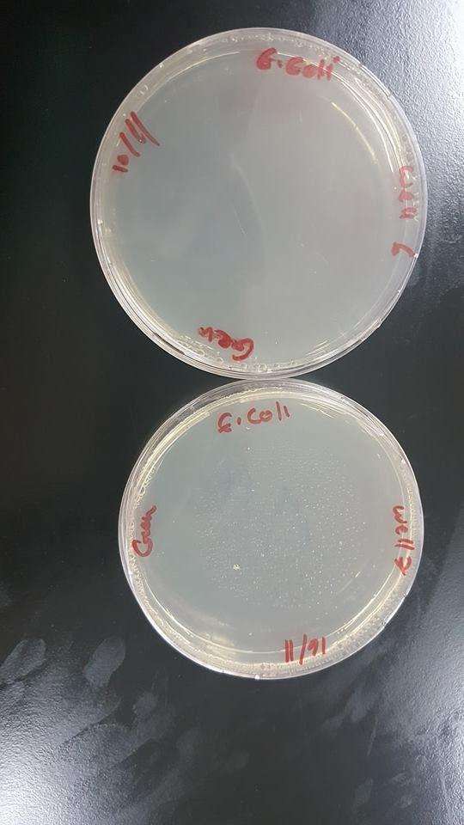

| Antibiotics | Gentamicin |
| --- | --- |
| *E.coli* | Well number8 |

**Table:3**: The MIC for Gentamicin used on ***Escherichia coli***Figure 6 : the effect of antibiotics  
on  ***Escherichia coli***

Table (4): antibiotics concentrations in each well in (µg/ml)

| 1 | 2 | 3 | 4 | 5 | 6 | 7 | 8 | 9 | 10 | 11 | 12 |
| --- | --- | --- | --- | --- | --- | --- | --- | --- | --- | --- | --- |
| 500 | 250 | 125 | 62.5 | 31.25 | 15.625 | 7.8125 | 3.90625 | 1.953125 | 0.97656 | 0.48828 | 0 |

** The concentration will be reduced by half in each well.

* **Discussion:-  
  A) Effect of disinfectants and antiseptics on bacterial growth:-  
   1- With regard to *Staphylococcus aureus*  
   Dettol is the most inhibitor from disinfectants then CuSO4 then ethanol 95% and then ethanol 70%   
  the actual result must be ethanol 70% more than ethanol 95% but I think this wrong happen because ethanol 95% is more volatile than ethanol 70% (i.e. when incubated bacteria some of ethanol 90% volatile to air).  
   2- With regard to *Escherichia coli* CuSO4 is the most inhibitor from disinfectants then ethanol 95% then ethanol 70% and then Dettol   
    
  Different bacterial type affects the effect of disinfectants.  
    
    
    
    
  B) Effect of chemotherapeutic agents on bacterial growth:-  
    
   1-With regard to *Escherichia coli* a-Penicillin G did not affect the growth of bacteria (*Escherichia coli* is resistant to Penicillin G)  
   b- Azithromycin did affect the growth of bacteria (*Escherichia coli* is moderately susceptible to Azithromycin).  
     
   c-Ampicillin/Suibactam did affect the growth of bacteria(Little bit) (*Escherichia coli* is intermediate to Azithromycin).  
    
   d-Chloramphenicol did affect the growth of bacteria (The most) (*Escherichia coli* is susceptible to Azithromycin).  
    
   2- With regard to *Staphylococcus aureus* a-Penicillin G did affect the growth of bacteria(*Staphylococcus aureus* is susceptible to Penicillin G).  
   b- Azithromycin did affect the growth of bacteria(*Staphylococcus aureus* is intermediate to Azithromycin).   
   c-Ampicillin/Suibactam did affect the growth of bacteria(Little bit) (*Staphylococcus aureus* is moderately susceptible to Ampicillin/Suibactam).  
   d-Chloramphenicol did affect the growth of bacteria(The most) (*Staphylococcus aureus* is intermediate to Chloramphenicol).  
    
  All of the chemotherapeutic agents affect the growth of *Staphylococcus aureus.*Note: The effect on *Staphylococcus aureus* is more than the effect on *Escherichia coli.* I think the reason is that *Staphylococcus aureus* ispositive gram.However *Escherichia coli* is negative gram.  
    
  C) Minimum Inhibitory Concentration (MIC) and Minimum Bactericidal Concentration (MBC):-  
    
  MBC/ MIC = 15.625(6)/ 3.90625(8) = 4, because ratio is equal 4 the drug is considered bacteriostatic(static).**
* **Conclusion:-  
    
  Antimicrobial agent are acts as inhibitor and killer of bacteria. Disinfectant agent is a strong agent to kill all the bacteria and antiseptic is an agent that inhibits the growth of bacteria. From experiment, we can conclude that effect of disinfectants are depend on the type of it. Furthermore, the wider the zone of inhibition, the more susceptible the bacteria against the disinfectant agent.**
* **References:**

**The effects of antibiotic usage in food animals on the development of antimicrobial resistance of importance for humans in Campylobacter and Escherichia coli.**