Bierzeit University

Biology and Biochemistry Department

Molecular Biology Lab.

Experiment 9 Report: Polymerase Chain Reaction

Instructor: Dr. Mahmmoud A. Srour

Aseel Abudayah : Teaching Assistance

By Roa Abudayah 1192923

Objectives :

the aim of these experiment is to use the general PCR technique to investigate the presence of the *Alu* element (TPA-25) in samples from human genomic from blood and other samples from the clinic in addition to use the RFLP PCR to detect the factor V Leiden (FVL) mutation followed by digestion using HindIII.

Introduction:

The polymerase chain reaction (PCR) is a molecular biology technique for amplifying an one or several copies of DNA over many orders of magnitude, resulting in thousands to millions of copies of a specific Nucleotide sequence. For a number of uses, PCR has become a standard and frequently crucial technology in biological and medical research labs. Denaturation, annealing, and extension are the three major stages in the PCR procedure.[1] The basic PCR concept is uncomplicated. It's a chain reaction, as the name suggests: One DNA molecule is utilized to make two copies, four copies, eight copies, and so on. Polymerases, which are enzymes that can link together individual DNA building pieces to produce long molecular strands, are responsible for this constant doubling. Polymerases need a quantity of DNA building blocks,(nucleotides), which are made up of the four bases adenine (A), thymine (T), cytosine (C) and guanine (G).They also require a primer, a tiny fragment of DNA whereby the building blocks are connected, and also a longer DNA molecule to serve as a template for generating the new strand. The enzymes will create precise duplicates of the templates if these three elements are provided. PCR is a technique for making many copies of a single nucleic acid strand. It's a technique for selectively amplifying a section of DNA.[1] All above components are combined in a tube , which is then placed in a machine that allows for three basic phases of DNA amplification. The principle of the device is a thermal cycler. The test tubes containing the PCR reaction mixture are put onto heat blocks. The machine regulates the block's temperature in discrete, accurate, pre-programmed stages.[2] The reaction sample was heated above the melting temperature of the target DNA's two complementary strands, allowing the strands to separate in a process known as denaturation. Hybridization or annealing is next, which a process that decreases the temperature to allow the appropriate primers to attach to the desired DNA segments. Annealing among primers and target DNA happens only when their sequences are complementary. When the temperature increases again, the DNA polymerase can expand the primers by adding nucleotides to the forming DNA strand. The number of copied DNA molecules doubles with each repetition of these three stages.[2]

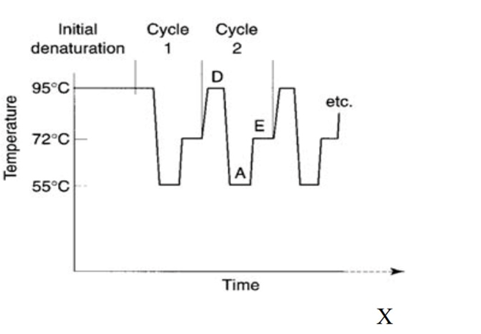

figure 1 demonstrating the temperature cycling of a PCR reaction

as PCR became one of the most important tools in the molecular biology there is a lot of types to this reaction such as: Qualitative PCR, Colony PCR, After exponential PCR, Standard PCR, After exponentional PCR and other types reach up to 30 type [3] and so are the applications of it extended in to many fields including microbiology, virology, dentistry, mycology and parasitology [4] and one of the most important applications are the diagnosis and detecting mutations. The importance of early detection in terms of diagnosis and treatment cannot be overstated. Traditional methods for detecting infection have a disadvantage in that the organism is selective and grows slowly. Many molecular ways for detecting mycobacteria have been created, one of which is the polymerase chain reaction (PCR).PCR amplification is a valuable technique with a wide range of uses in medicine. It's most commonly used to look for specific alleles, such as in the case of potential parents looking for genetic carriers, but it can also be used to identify disease and look for mutations in the growing embryo. In addition PCR can be used to quickly detect the identity of bacteria that were formerly unable to be cultured or required weeks to grow; it has transformed the diagnostic potential for contagious disorders.[5] as mentioned before there are a lot of types of PCR as well as the applications in this experiment beside the general reaction and its PCR-Restriction Fragment Length Polymorphism (PCR-RFLP) method that used widely in detecting the mutations and diagnosis RFLP is a process in which restriction enzyme sites on DNA samples are split into fragments (digested) by those restriction enzymes, and thus the resulting fragments are identified by gel electrophoresis stated by their lengths. Restriction endonucleases are specific enzymes that can cleave specific nucleotide sequences; because of that property, it is possible for them to discriminate nucleotide changes in DNA. Sometimes they can affect the loci other than the target one, but the important part of the procedure is the possible polymorphism or mutation loci to be detected whether the cleavage site is intact or not. If there is a change in the cleavage site of

restriction endonuclease, it will not cleave the site, or by addition of the mutation, there may occur a previously not existing cleavage site. [6] the following picture shows how the RFLP -PCR analysis detect a mutation cause a disease

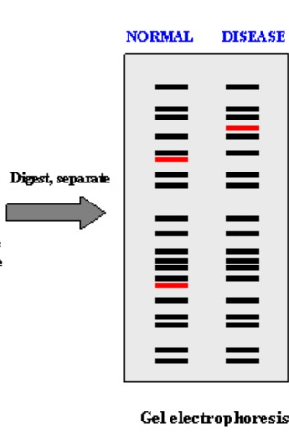

figure 2: shows how the analysis of a RFLP PCR [7]

Data and Results :

After preforming the general PCR reaction and RFLP-PCR the following data were obtained :

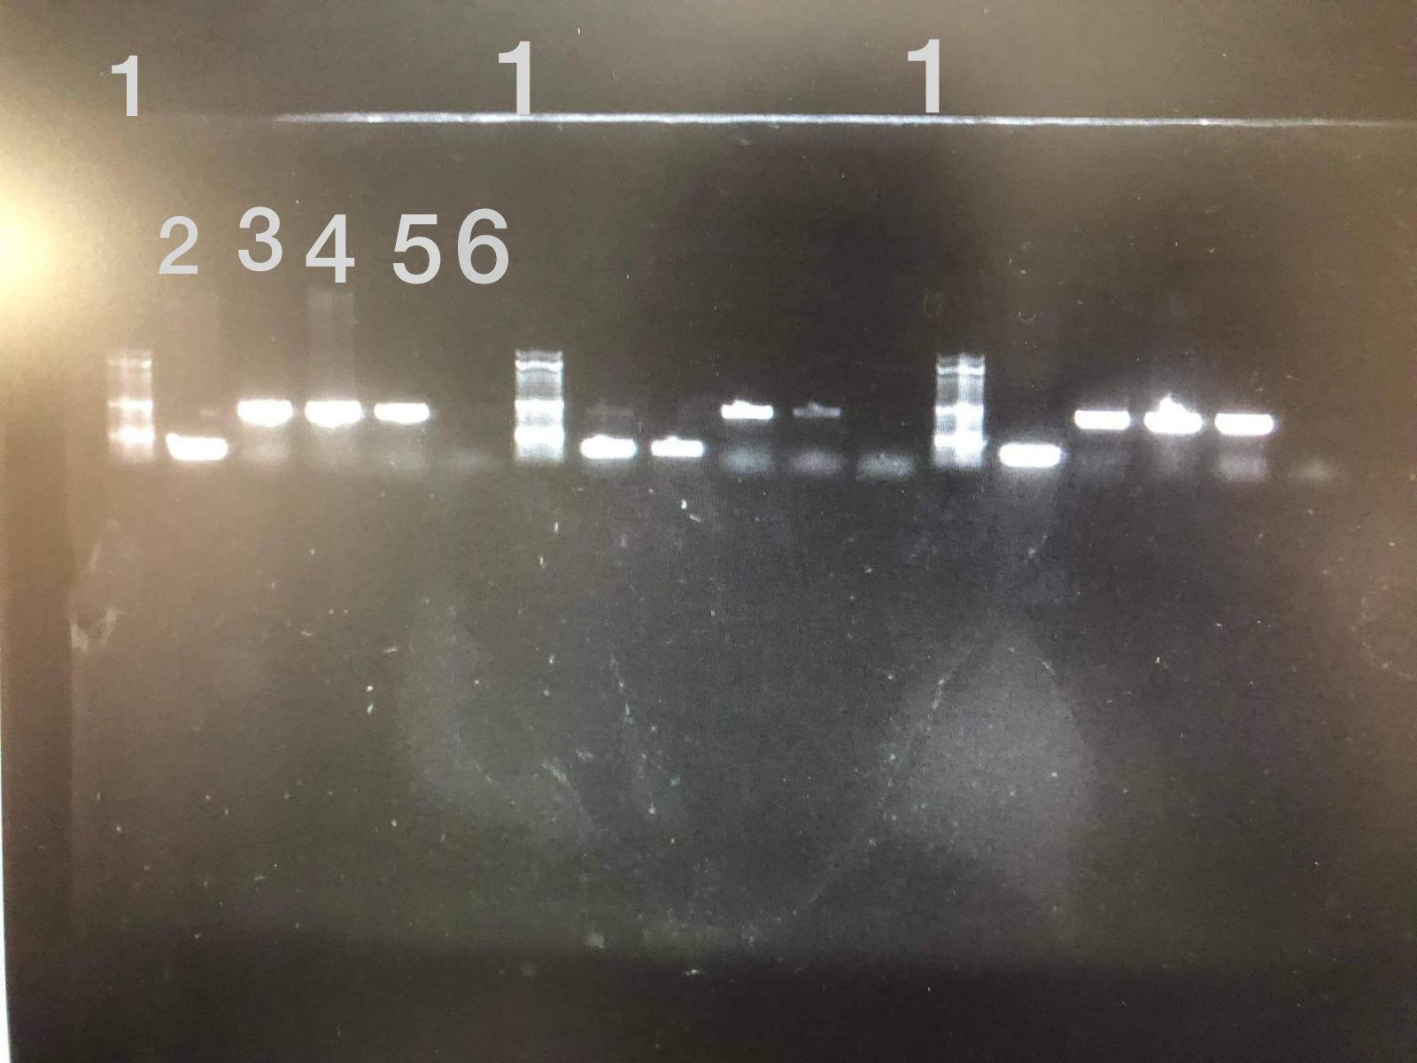

figure 3: 1.5 % agarose gel electrophoresis for PCR product using the oligonucleotide primers to identify the presence or absence of TPA-25 the numbers shows the following 1 the ladder 2 homozygous sample 3 homozygotes sample 4 mutant 5 buffy coat from RBC 6 non-template sample (control) on the left 50 bp ladder

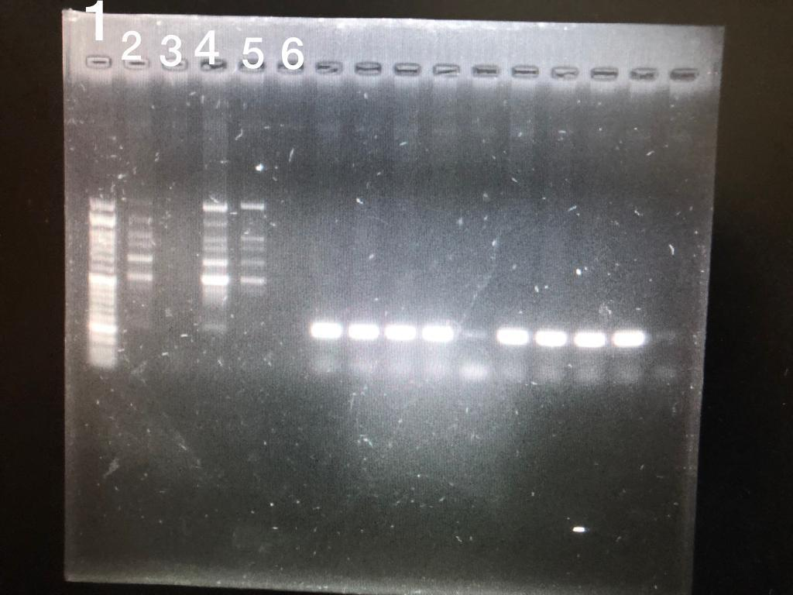

figure 4:1.5% agarose gel electrophoresis for RFLP-PCR product without digestion using primers to genotype (FVL) the number shows 1 the ladder 2homozygous sample 3 homozygotes sample 4 mutant 5 buffy coat from RBC 6 non-template sample (control) 50 bp ladder

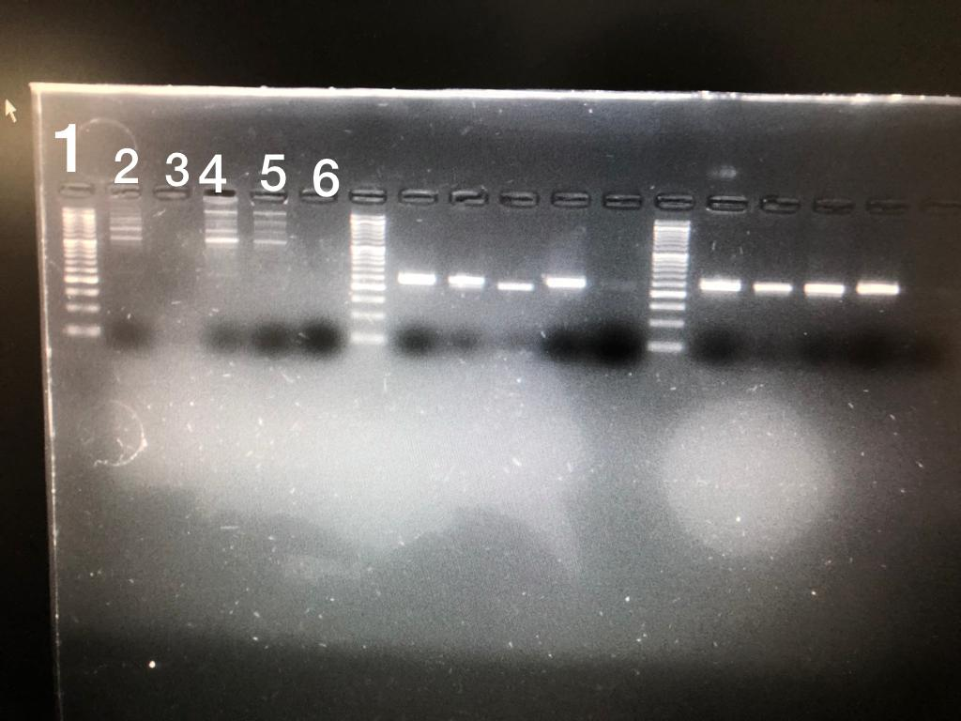

figure 5: 4% agarose gel electrophoresis for RFLP-PCR product using primers to genotype (FVL) and cut by HindIII the number shows 1 the ladder 2homozygous sample 3 homozygotes sample 4 mutant 5 buffy coat from RBC 6 non-template sample (control) 50 bp ladder

Discussion

Alu PCR is a quick and easy “DNA fingerprinting” method based on the parallel analysis of multiple genomic loci flanked by Alu repeating elements, which permits the identification of genetic polymorphisms and mutations in genomes of interest especially in humans. more polymorphic and mutagenic subsets of Alu subfamilies, can be targeted with Alu PCR primers that designed to target these types in particular. The number of amplification products produced by oligonucleotides (used in this experiment) intended to match the Alu consensus in a location of exact identity between the various Alu subfamilies and expected to be greater than that produced by primers designed to select target one or a few subfamilies. so the primers plays an important role in the yield [8] in this experiment five samples were amplified by general-PCR to investigate the presence of an dimorphic Alu element TPA–25 insertion and they were after performing the experiment we analyzed the PCR product by 1.5% agarose gel electrophoresis and the results are expected to be one of these genotypes : homozygotes if the band size was 400 bp it indicates the presence of TPA-25 , homozygous if the band size was 100 bp it indicates the absence of TPA-25 and heterozygotes if the 2 bands showed with the size (400 bp and 100) the product of the PCR was followed by agarose gel electrophoresis analysis and as figure 1 shows the first band after the ladder (band 2) is 100 bp indicating the absence of TPA-25 while bands 3,4 and 5 is 400 bp indicating the presence of TPA-25 and 6 is the control it was expected to be completely empty however it shows unclear and not permanent band it could be due to contamination of the samples as the smearing shows for the bands 2,3 and 4 .

Factor V Leiden (FVL) is a mutation in factor V that causes the breakage in factor V and factor Va to be eliminated. In homozygous or pseudo-homozygous FVL mutations, abnormality increases the risk of thrombosis. [9]in this experiment a RFLP-PCR technique was used to genotype the mutation the RFLP-PCR product was analyzed using 1.5% agarose gel electrophoresis it was expected to have a clear 241 pb then it must be followed by digestion using the restriction enzyme HindIII also analyzed by 4% agarose gel electrophoresis showing two possible genotype 241bp band indicating the wild type or two bands 209bp and 32bp indicating to have a mutation in the allele to compare the results were obtained by going back to the figures. by going back to figure 4 the samples showed as many visible bands along the columns for (2,4 and 5) which they are homozygous sample, mutant sample and buffy coat (respectively ) while sample 3 (homozygotes) did not show any result and that could do to an error at loading the product if the amount was small it will not have enough DNA to travel along the matrix and show as a band while sample 6 did not show any thing as expected it did not show any band to indicate any contamination (by comparing the non-template sample for the other groups it showed a light band indicating that contamination happened ) since it is not expected that the samples got contaminated the result must be a permanent 241 band despite its genotype that was identified further by using the RE HindIII the three genotypes are expected to be the wild type (-/-) it is homologous and it shows as 241bp band indicating the absence FVL of the second is mutation (-/+) and it heterozygous it shows as 209bp and light 32bp band indicating the presence of FVL the last genotype is mutation (+/+) homologous that shows as 209bp and shows as lower band than the normal band indicating the presence of FVL by going back to figure 5 the samples also showed as a many random bands along the column in this type of experiments that have a lot of reagents each one have its critical role in the reaction it is hard to detect and determine the source of error but it could be due to many things the most common is contamination but by looking at the non-template sample it was clear from any contamination but that did not mean that the other samples could be contaminated. and using the figures it is obvious that every source of error related to gel electrophoresis is canceled because the other groups got their results as expected however it could be better if the agarose matrix stayed a bit longer on the electrical current by referring to the pictures, we can conclude that there is no any thermal damage (since the other group result shows).

conclusion:

the PCR is one of the most important molecular biology tool that provide countless applications in the previous experiments general PCR and REPLF-PCR was performed each have it limitations that was reduced as much as possible by following the steps in the procedure precisely and quickly however the results was not as expected the first result for the general PCR would be better if the agarose gel stayed a little longer on the electrical current nevertheless it was as expected with literature for the control samples (2,3,4) while in the other part of the experiment the RFLP-PCR product appeared as a random visible bands along the column and some samples did not show any so obviously the further step (restriction digestion) also showed the same way

and since it is hard to determine the specific error and by looking at the other groups result the error must systematic error that affect the whole result and it is while RFLP-PCR preparation.

References

[1] + FIGURE 1 Joshi, M., & Deshpande, J. D. (2010). Polymerase chain reaction: methods, principles and application. International Journal of Biomedical Research, 2(1), 81-97.‏

[2] Garibyan, L., & Avashia, N. (2013). Polymerase chain reaction. The Journal of investigative dermatology, 133(3), 1–4. https://doi.org/10.1038/jid.2013.1

[3] Rajalakshmi, S. (2017). DIFFERENT TYPES OF PCR TECHNIQUES AND ITS APPLICATIONS. International Journal of Pharmaceutical, Chemical & Biological Sciences, 7(3).‏

[4] Valones, M. A., Guimarães, R. L., Brandão, L. A., de Souza, P. R., de Albuquerque Tavares Carvalho, A., & Crovela, S. (2009). Principles and applications of polymerase chain reaction in medical diagnostic fields: a review. Brazilian journal of microbiology : [publication of the Brazilian Society for Microbiology], 40(1), 1–11. https://doi.org/10.1590/S1517-83822009000100001

[5] Biochemistry, polymerase chain reaction - NCBI bookshelf. (n.d.). Retrieved June 6, 2022, from https://www.ncbi.nlm.nih.gov/books/NBK535453/

[6] Gormus, U., Selvi, N., & Yaylim-Eraltan, I. (2012). PCR-RFLP and Real-Time PCR techniques in molecular cancer investigations. In Polymerase Chain Reaction. IntechOpen.‏

[7] Biochemistry, polymerase chain reaction - NCBI bookshelf. (n.d.). Retrieved June 6, 2022, from https://www.ncbi.nlm.nih.gov/books/NBK535453/

[8] Cardelli, M. (2010). Alu PCR. PCR Protocols, 221–229. doi:10.1007/978-1-60761-944-4_15

[9]