**Birzeit University**

**Department of Biology and Biochemistry**

**BIOL111**

**Exp#5: Scientific Investigation –** **What Makes Fruit go Brown?**

**Name: Rayyan Khalil Mohammad Masri**

**ID: 1191184**

**Partners:  
Ahmad Yassin  
Salah Al-saher**

**Instructor: Dr.Mahmoud srour**

**TA: Demma Mohsen**

**Date of Experiment: 29/7/2021**

**Date of submission: 10/8/2021**

**Scientific Investigation –** **What Makes Fruit go Brown?**

**Objectives:**

To investigate the causes of fruit browning, and the factors that can help accelerate and prevent the process.

**Introduction:**

We observe usually that some fruit become brown if it stays along time without use it. Or if we cut it, then it will become brown faster. This is due to the oxygen and oxidize reaction in the fruit tissues. When the oxygen atoms inter to the injured tissue due to cutting the fruit, then polyphenol oxidize phenol and produce a melanin which make the color of the fruit become brown. We can study this phenomenon by test the reason of it, and what circumstances can prevent fruit browning. And all tests done by scientific investigations (Moon, Kwon, Lee , & Kim, n.d.)

**Materials and Methods:**

**\*Initial Observation:**

Two small pieces of a banana were sliced, then one of them was left as it,, and the other was crushed. They were placed next to each other in open air to observe which one goes brown first.

**\*First Investigation:**

Two banana pieces were sliced, one was soaked with 1% phenol, and the other was soaked in water. They were left soaked for two minutes, and then the liquids (phenol and water) were removed from both slices and 4 drops of catechol were added to them.

**\*Second Investigation:**

Four banana pieces were sliced, and each slice was soaked in one of the following solutions: 100°C water, 60°C water, 40°C water and 25°C water (room temperature). They were left soaked for two minutes, and then the water was removed from all slices and 4 drops of catechol were added to them.

**\*Fourth Investigation:**

Six banana pieces were sliced, and each slice was soaked in one of the following solutions: 5% ascorbic acid, 2.5% ascorbic acid, 1.5% ascorbic acid, 1% ascorbic acid, 0.5% ascorbic acid, and distilled water. The pieces were soaked for a total of two minutes, and then were cleared from the solutions.

**\*Fifth Investigation:**

Seven banana pieces were sliced, and each slice was soaked in one of the following solutions: solutions:2%HCL, 2%sodium hydrogen sulfate, 2%Citric acid, 2%Hydrochloric acid, 2% sodium chloride, 2%sucrose, boiling distilled water. They were left in the solutions for a total of two minutes, and then were cleared from the solutions, and 4 drops of catechol were added to them.

**Data and results**

**\*Initial Observation:**

The crushed banana was browned faster. And the banana which cut by hand was browned faster than which cut by knife.

**\*First Investigation:**

Table1: the time of the browning of the slice soaked in phenol and water

|  |  |
| --- | --- |
| liquid | Time to be brown(min) |
| 1% phenol | 1:30 |
| water | 1:44 |

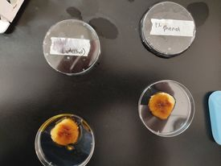

Figure 1: first investigation

**\*Second Investigation:**

Table 2: water bath at different temperature and time to be brown

|  |  |
| --- | --- |
| Solution | Time to be brown (min) |
| 250C water (RT) | 3:04 |
| 400C water | 3:33 |
| 600C water | 3:59 |
| 1000C water | 4:41 |

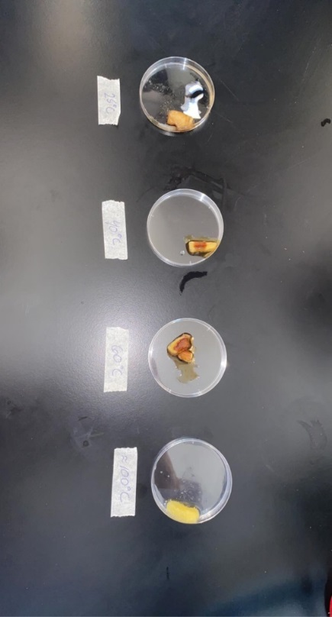

Figure 2: second investigation

**\*Fourth Investigation:**

Table 3: Ascorbic acid and time to be brown

|  |  |
| --- | --- |
| Solution | Time to be brown (min) |
| 5% ascorbic acid | 16:30 |
| 2.5% ascorbic acid | 9:00 |
| 1% ascorbic acid | 4:30 |
| 0.5% ascorbic acid | 3:00 |
| water | 1:30 |

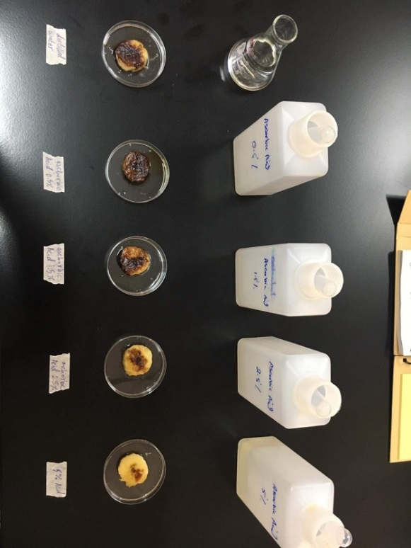

Figure 3 : fourth investigation

**\*Fifth Investigation:**

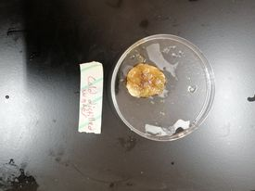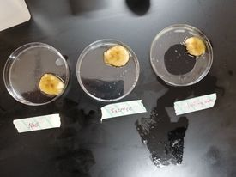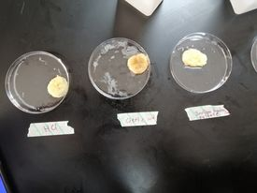Table 4: Chemicals and speed of browning

|  |  |
| --- | --- |
| Chemicals | The Speed of browning |
| HCl | Not browning |
| Citric acid | + |
| NaHSO4 | Not browning |
| NaCl | +++ |
| Sucrose | ++ |
| Boiling water | +++ |
| Cold water | +++++ |

Figure 4 : fifth investigation

**Discussion:**

**\*Initial observation:**

From the results, it can be noticed that the crushed slice of banana turned brown faster than the uncrushed one. That’s because cutting the banana damages its tissues, enabling oxygen to enter and perform oxidation with the enzymes, which causes the browning of the banana. When crushing the banana, the tissue damage is amplified, causing the oxidation process to happen faster than the uncrushed slice. [1]

**\*Investigation 1:**

Adding phenol to the banana did not affect on the result. Because the phenol will kill the small microorganism but browning of the fruit is not due to the microorganism. So phenol didn’t prevent the browning. [2]

**\*Investigation 2:**

In this investigation we used different temperature to see if the enzymes control the reaction. And this was done by see the rate of browning of banana at different temperature.

The result show that if the temperature increase, then the rate of browning will decrease. And this because the browning happens because of the reaction between the polyphynol enzyme and the Oxygen in the air. And increasing the temperature will denature the enzymes. So there is no oxidizing reaction occur in the high temperature. And if increase the temperature the concentration of the enzymes will decrease which decrease the reaction and decrease the browning. [3]

**\*Investigation 4:**

From the result of this investigation, it can be concluded that when the concentration of the ascorbic acid (known as Vitamin C) increases, the time needed for the banana color to change increases. If the concentration of the ascorbic acid increases to a certain point, there will be no color change. That’s because the ascorbic acid can work as an anti-oxidant to keep the fruit from darkening. [4]

**\*Investigation 5:**

The experiment show that there are some chemicals slow or prevent the browning and other speed up it. The hydrochloric acid can reverse the reaction and prevent browning. So adding it on the banana will prevent it from browning. The citric acid is weaker than HCl so it slow down the reaction, then it will be browning after a long time.

Also the sodium hydrogen sulfate(IV) will affect on the banana since it will react with the oxygen in the air and produce sodium hydrogen sulfate (IV) which dry the banana by osmosis. So it used as preservation of food.

NaCl is faster. Because it will increase the ionic concentration in the banana which speed up the oxidize reaction. So it fasts the reaction of browning.

Sucrose make it take time to browning because it will decrease the solving of oxygen in the enzyme which slow down the reaction.

Boiling water will affect on the enzymes which make the reaction slower (or prevent it at high temperature) such as in investigation 2. But in our experiment the water temperature was not reach to boiling water temperature. So it slow down the browning but didn’t prevent it.

Cold water is the optimum condition of the reaction. And it increases the resolving of oxygen so it increases the oxidation reaction. So the banana was browned faster. [5]

**Conclusion:**

At the end of this experiment, it was concluded that food browning occurs because of the reaction between the enzymes in the fruits and the oxygen (Oxidation), and it has nothing to do with microorganisms. It was also concluded that temperatures lower than 40C or higher than 60C can reduce/completely stop this reaction because of the denaturation of enzymes. Lastly, it was observed that different chemicals can work as anti-oxidants, delaying/stopping the oxidation from happening.

**References:**

[1] I. *Investigating what makes fruit go brown*. (2009).  Practical Biology. https://practicalbiology.org/technology/food-production/investigating-what-makes-fruit-go-brown

[2] *Fruit and vegetables: Enzymic browning*. (2019, July 17). IFST. https://www.ifst.org/lovefoodlovescience/resources/fruit-and-vegetables-enzymic-browning

[3] *Investigating different browning reactions: teacher notes*. (2020). Education in Chemistry. <https://edu.rsc.org/download?ac=502886>

[4] Zepp, M. (2021, April 19). *Preserving Color and Preventing Browning of Foods*. Penn State Extension. https://extension.psu.edu/preserving-color-and-preventing-browning-of-foods

[5] *PREVENTION OF ENZYMATIC BROWNING IN FRUIT AND VEGETABLES*. (2013, October). Core. https://core.ac.uk/download/pdf/236407761.pdf