## Birzeit University

## Bio 111

Department of Biology and Biochemistry

**Experiment No. 8**

Cellular Activities

……………………………………………………………………………..

Student’s Name: **Hamza AlHasan**. Student’s No.: 1181636

Partner’s Name :

* Shima Balawneh 1172591
* Wisam Makho 1211540 - Amr
* Instructor: Dr. **Jamil Abu Sadah**
* **Teacher Assistance: Yousef .**

Date: 2-6-2022

* **Objective:**

**\*The Aim of the experiment :**

To learn about the effect of some factories like : temperature and light on the rate of photosynthesis. And to note and study the fermentation process by using different carbohydrates (some types of sugar .

**The method used:**

By measuring the volume of oxygen collected in the test tubes under different conditions and measuring the volume of carbon dioxide collected in fermentation tubes.

* **Introduction:**

All cells have reactions insides them to stay at living and these reactions called metabolism and its divided to anabolism (using light to do the reaction ) and to catabolism ( breaking molecules to extract energy ) like photosynthesis and fermentation .

- Photosynthesis is a method that the planets used it to made the food and this the reason that is the plants called Phototrophic organisms and its made the food in the chloroplasts in the Plant leaf by using the light of the sun and the water and by Presence the CO2 by the following equation witch called the general equation of photosynthesis:

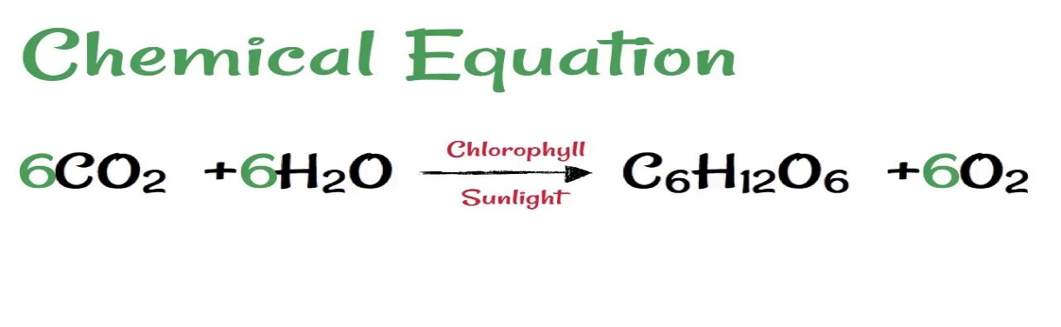

And this pathway involves light reaction : light energy is captured by the chlorophyll pigments and is converted to chemical energy (ATP) by photophosphorylation. A water molecule splits into O2 and electrons and protons (H'), which are eventually transferred through a series of protein complexes to the coenzyme NADP forming NADPH. Energy of electron transport is stored in a proton gradient that is used to generate ATP. The products of light reactions provide the energy and reducing power for the carbon assimilation reactions. And Calvin cycle that the carbon atom from carbon dioxide (CO2) is incorporated into organic molecules that are essential to provide energy for plant cells and for the whole biosphere for that matter.

- Fermentation:

We can assume it by the opposite of the photosynthesis because it converte the sugar consist in the photosynthesis to acid , gasses or alcohol to extract the energy from it and it not supply ATP directly as in photosynthesis but its supply NaD+ that helps glycolysis continue with the production of 2 ATP molecules per glucose and in this process we got an atoms of CO2 by following equation that’s called the general equation of the ferementation:



In this experiment we will learn what is the effect of different factors on cellular activities photosynthesis and fermentation by measuring the volumes of O2(ml) and CO2(ml).

* **Material And method :**

This experiment consist of two parts :

**Part 1: Photosynthesis**

First, 1000ml of sodium bicarbonate (NaHCO3) were put in a 100ml beaker. Then 30 green leaves were added to the beaker. And funnel was placed and inverted on the top of the leaves and sure that all the leaves inside the funnel

. The end of the funnel was covered with a graduated test tube filled

with sodium bicarbonate. The beaker was placed under a source of light. As photosynthesis proceeds oxygen gas is released and collected in the inverted graduated test tube. At regular time intervals how much oxygen is released were measured , the experiment is carried out under different environmental conditions: At room light in 50 °C water , at room light and room temperature, at room temperature under ,40Watt light bulb

at room temperature in the dark, at room temperature under 150 Watt bulb and With water rather than sodium bicarbonate.

**Part 2 : Fermentation :**

Sex fermentation tubes had a test solution was taken((10%sucrose.. 10%glucose , 10%glalactose.. 10%molasses.. 10%fructose.. water as a control) for each group there is a fermentation tubes.

Then in a beaker, 0.5 grams of dry yeast measured and 20ml of a test solution was added to it, It was mixed then it was left at room temperature for 5 minutes. After room temperature incubation, the solution was stirred gently and it was poured into on fermentation tube slowly . (make sure to tip the fermentation tube so the tail of the tube completely fills with the solution and that no air bubbles evolve and make sure to label your fermentation tube. the tube was placed in the 37 incubator and then start your timer But make sure that first reading should be zero to zero time point. The timer was read 10 minutes, the

test tube was removed from the incubator and then the distance was measured from the tip of the tail to the level of the solution. This considered as reading (volume of co2) at time 10 minutes .Return the tube to the incubator for 10 more minutes and then the procedure was

repeated. Reading is taken every 10 minutes for a period of 60 min. finally after 60minutes all reading was collected and discussed.

* Data:

-**Photosynthesis:**

Table-1: Volume of O2 (in ml) collected in the graduated test tubes under different environmental conditions for 70 minutes.

|  |  |  |  |  |  |  |  |
| --- | --- | --- | --- | --- | --- | --- | --- |
| Time | Room light /room temp  (control) | Dark/ room temp | 40w/room temp | 150w/room temp | On ice/room light | 50c/ room light | Water |
| 0 | 0 | 0 | 0 | 0 | 0 | 0 | 0 |
| 5 | 0 | 0 | 0 | 0.1 | 0 | 0.1 | 0.1 |
| 10 | 0 | 0 | 0 | 0.1 | 0 | 0.2 | 0.1 |
| 15 | 0 | 0 | 0 | 0.2 | 0 | 0.3 | 0.1 |
| 20 | 0 | 0 | 0.5 | 0.2 | 0.1 | 0.9 | 0.1 |
| 25 | 0 | 0 | 0.9 | 0.3 | 0.1 | 1.3 | 0.2 |
| 30 | 0 | 0 | 1 | 0.3 | 0.1 | 1.5 | 0.2 |
| 35 | 0.1 | 0 | 1 | 1.3 | 0.1 | 1.7 | 0.2 |
| 40 | 0.2 | 0 | 1 | 2 | 0.2 | 2 | 0.2 |

* **Fermentation:**

Table-2: Volume of CO2 (in ml) collected in the graduated centrifuge tubes for 60 minutes .

|  |  |  |  |  |  |  |
| --- | --- | --- | --- | --- | --- | --- |
| Time  (min) | 10%  Sucrose | 10%  Fructose | 10%  Glucose | 10%  Galactose | 10%  Molasses | Water |
| 0 | 0 | 0 | 0 | 0 | 0 | 0 |
| 10 | 1.4 | 1.4 | 1 | 0.4 | 2.5 | 0 |
| 20 | 7.3 | 5 | 5 | 1 | 6.2 | 0 |
| 30 | 9.1 | 8 | 8 | 1.7 | 8.1 | 0 |
| 40 | 9.1 | 8.2 | 9 | 2 | 8.7 | 0 |
| 50 | 9.1 | 8.2 | 9 | 2.4 | 8.7 | 0 |
| 60 | 9.1 | 8.2 | 9 | 2.7 | 8.7 | 0 |

* **Results :**

**Describe the rate of the photosynthesis :**

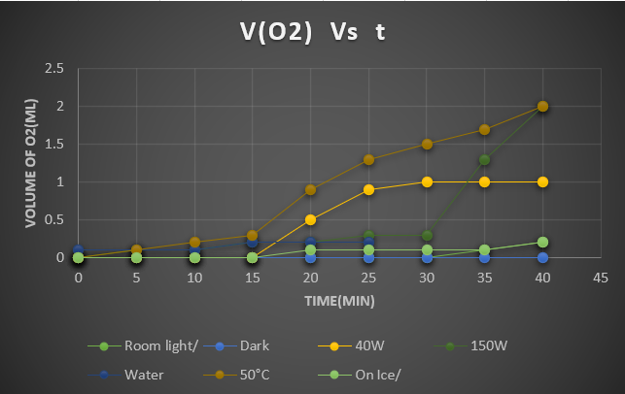

Figure-1

**Describe the rate of the Fermentation:**

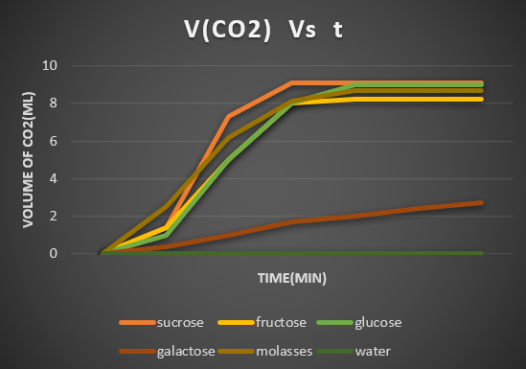

Figure-2

* **Discussion:**

From the result and data that we reach and take it by our experiment and by the figure-1 that we shown ( all factories such as at room temperature ice room and different light once at 40 watt and twice at dark room and other at 150 watt and other we take it as shown in table -1 vs time) we notes that the rate photosynthesis was changed (the volume of the O2 in each case was changed) by changes the factories .

As we see in the table of data when we use the water insisted of Sodium Bicarbonate (NaHCO3) in the beaker no any thing was happened and no any volume of O2 was resulted in the tube ( the rate of the photosynthesis has the lowest rate ) because the water didn’t have a CO2 that’s too important to complete the reaction or to happens the reaction .

For the condition of dark/ room temperature its have the same result that it happens when we use the water ( no photosynthesis reaction was happened ) because in the dark room there isn’t a light also that’s important to happening the photosynthesis reaction as it showed in the equation .

At Room light /Room temperature by notes the data and the figure-1 we see that the rate of the photosynthesis was changed over the interval of time .It was sometimes increased and some time constant for over the time that we taken it and In general, with the passage of time, the rate of photosynthesis increases until it reaches a state in which the rate is constant and is not subject to increase and this condition was a control to compare all our result with it.

When we use the 40 watt/ room temperature the result we taken was shown on taple-1 , firstly time the rate of photosynthesis(volume of O2) was small change and constant for along time when we do the experiment and at the final time it was changed to 0.5 ml , our experiment for this part and our result wasn’t true as the theoretically result that should we take it and we take the condition of 150 watt/ room temperature ( we establish the temperature and increased the light intensity ) and we see that the rate of the photosynthesis was increased by increase the light and stopped increasing at some moment. When we establish the temperature and increased the light intensity the rate of photosynthesis should be increased over the time Until it reaches a moment when the rate is the highest it can be called stationary point ( at this point photosynthesis have the max value by depending on the light density ) and after this the rate state constant and didn’t change and we can Clarify it by the figure-3 in the next page.

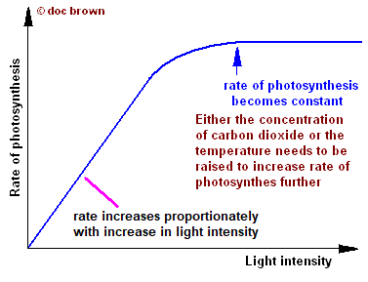figure-3

By establish light intensity (at room light) and changing the temperature by increasing it to 50 c degree and comparing the results we see that the rate of photosynthesis increasing faster at higher temperature than a small temperature and the rate was higher by increasing the temperature because there was an enzyme worked best by increasing temperature and the rate have a maximum value its called optimal photosynthesis rate at optimal temperature between 35 and 52 c degree. And after this temperature and by staying the increasing of temperature the rate started to decreasing Until you get to that the rate equal zero and we can Clarify it by figure-4.

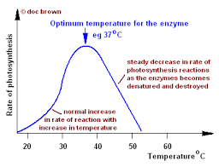

Figure-4

Figure- 5 describe the factories that the photosynthesis depend on and describe the relationship between them .

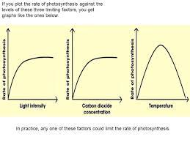 figure-5

Figure-2 in general described the rate of fermentation (volume of CO2 in the reaction ) in an interval of time equal 60 min by changing the type of sugar was used in all parts ,note that the volume of CO2 on the tubes depend on the type of sugar that we used in the tube .

As we see at the figure-2 and the data in table-2 ( depending on the result of this part ) that the fermentation rate when we use the molasses is the best or the faster and higher rate of all sugar that was used , the second sugar that have the approximately rate is sucrose but it’s a small rate than the rate of molasses . However, ., the sucrose curve is always as high as or higher than the glucose and fructose curves.

Next we decided to compare the rate of fermentation of glucose and fructose, the two compounds that make up sucrose. We hypothesized that the disaccharide would ferment more slowly because it would first have to undergo hydrolysis. In fact, Fig. 2 shows that the two sugars give off CO2 at about the same rate in the first 20 min and then after 20 min fructose come to have a large rate than the rate of glucose . fructose have a large rate because owns an enzyme that could Cracking bonds in sugar but glucose didn’t have tis enzyme .

* **Conclusion:**

_ The are some errors that’s affected on our result in this experiment such that may be some tubes and the beakers that we used may be dirty and not perfect clean and this will affect on some result.

_ In general, the result was accepted in our experiment but there is some error on the result of condition 40 watt/ room temperature its not accepted as it theoretically and we can explanation it by : may be this reaction needs along time to happens and should be wait another time, The light was not confined as required and the light we used does not exactly represent sunlight in terms of its validity for photosynthesis.

_We can accepted all result in the second part of the experiment .

* **References :**
* Jeremy M. Berg, John L. Tymoczko and Lubert Stryer, Biochemistry, 6th edition, W.H. Freeman and Company, 2007, pages 205-237
* Fugentius Lugemwa, Decomposition of Hydrogen Peroxide, Chemical Educator, April 2013, pages 85-87
* Dr.Ahed Abdulkhaliq & Dr.Sabrin H . Albetuni,BIOLOGY 111 LAB MANUAL ,2018, Cellular Activities, Pg 45&46.

-