# Question # 1 :

Estimate f'(x) , f''(x) for each xk ,, k=0,1,2,3,…10

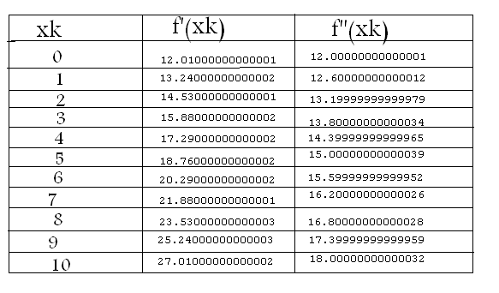The output is in this table

# Question # 2 :

Estimate the integral

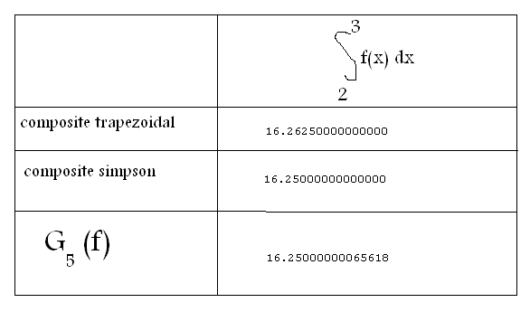

Moving in the code

# Introduction