

***Math Department***

***Math 330***

***Project # 3***

Name

Wala Qasim Al-Ramoni (1090223 )

Instructure Name : Hani Kabajah

Section : ( SMW 13:00 – 13:50 )

Date : wednesday 27-4-2011

# Question # 1 :

Estimate f'(x) , f''(x) for each xk ,, k=0,1,2,3,…10

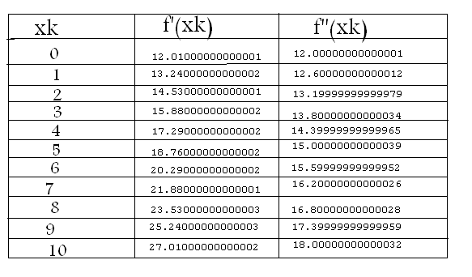The output is in this table

# Question # 2 :

Estimate the integral

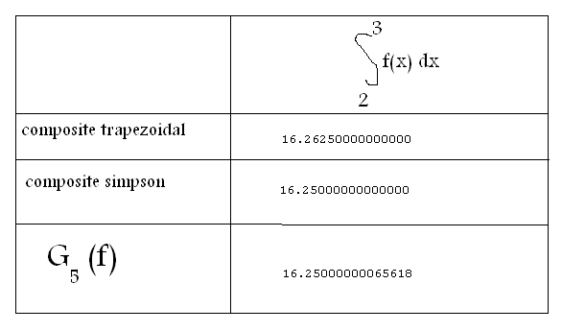

Moving in the code

# Introduction

This project contain 6 files the most important one is project4.m

When doing run do run to this file ( ok ). This is the code written in it

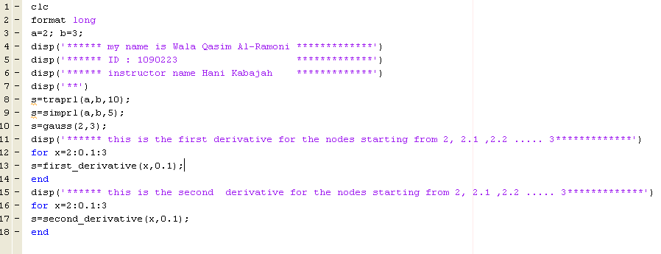

Note that " a " is the beginning of the interval while " b " is the end of it .

Note that this line

**s=traprl(a,b,10);**

will call the code in the file traprl.m

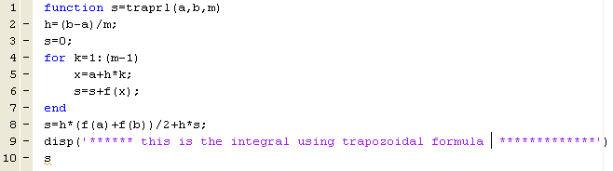here's the code of this file which will compute the integral using traposoidal formula

Note that this line

s=simprl(a,b,5);

will call the code in the file simprl.m

here's the code of this file which will compute the integral using simpsons formula

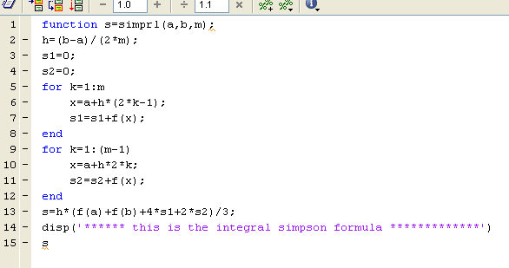

note that this line

**s=gauss(2,3); will call the code exisi in the file gauss.m**

**which will compute the integral using G5(f)..**

**this is the code**

**because the line is to long I put it in a notpad so that to see it clear**

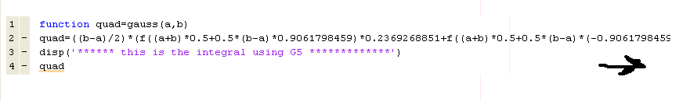

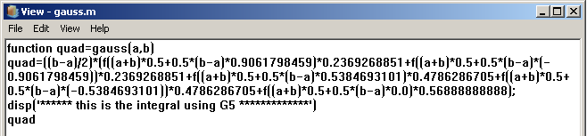

**Note that this line**

**s=first_derivative(x,0.1)**

will call the code in the file first_derivative.m

here’s the code of it which’ll compute the first derivative of the integral

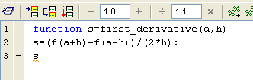

Note that this line

**s=second_derivative(x,0.1);**

**will compute the second derivative of a point by calling this function exist in second_derivative.m**

