Math Department
Math330

Project #2
Name : Wala Qasim Al-Ramoni (1090223 )
Instructure Name : Hani Kabajah
Section : 3 ( SMW 13:00 – 14:50 )
Date : wednesday 10-4-2011

Explaning the code
First : there's a three file just do run for "project3.m"
Note that the other files must be in the same dictionary that "project3.m " is in
When doing run for it .
Now as you can see this is the code in project3.m.
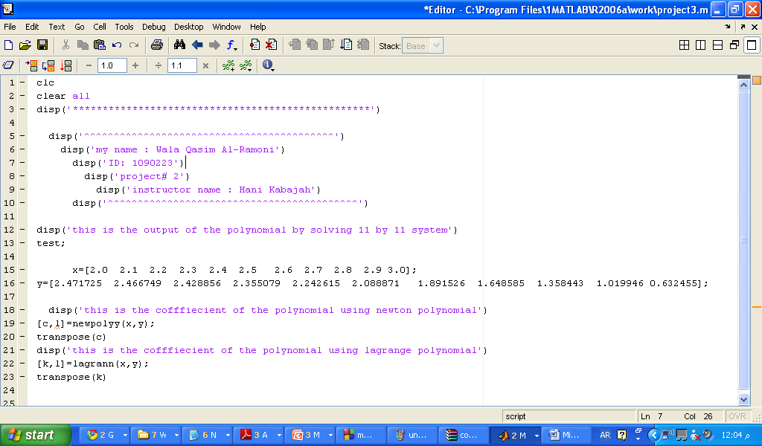
clc
clear all
disp('**************************************************')

disp('^^^^^^^^^^^^^^^^^^^^^^^^^^^^^^^^^^^^^^^^^^')
disp('my name : Wala Qasim Al-Ramoni')
disp('ID: 1090223')
disp('project# 2')
disp('instructor name : Hani Kabajah')
disp('^^^^^^^^^^^^^^^^^^^^^^^^^^^^^^^^^^^^^^^^^^')

disp('this is the output of the polynomial by solving 11 by 11 system')
test;

x=[2.0 2.1 2.2 2.3 2.4 2.5 2.6 2.7 2.8 2.9 3.0];
y=[2.471725 2.466749 2.428856 2.355079 2.242615 2.088871 1.891526 1.648585 1.358443 1.019946 0.632455];

disp('this is the cofffiecient of the polynomial using newton polynomial')
[c,l]=newpolyy(x,y);
transpose(c)
disp('this is the cofffiecient of the polynomial using lagrange polynomial')
[k,l]=lagrann(x,y);
transpose(k)

note that this line
[c,l]=newpolyy(x,y);
Will call the function newpolyy which exists in the file newpolyy.m
Here it is
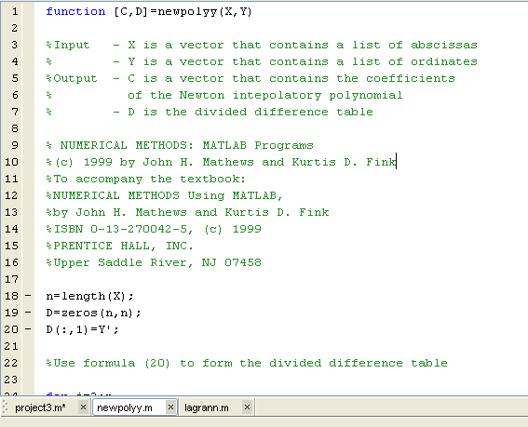
And this is the code
function [C,D]=newpolyy(X,Y)

%Input - X is a vector that contains a list of abscissas
% - Y is a vector that contains a list of ordinates
%Output - C is a vector that contains the coefficients
% of the Newton intepolatory polynomial
% - D is the divided difference table

% NUMERICAL METHODS: MATLAB Programs
%(c) 1999 by John H. Mathews and Kurtis D. Fink
%To accompany the textbook:
%NUMERICAL METHODS Using MATLAB,
%by John H. Mathews and Kurtis D. Fink
%ISBN 0-13-270042-5, (c) 1999
%PRENTICE HALL, INC.
%Upper Saddle River, NJ 07458

n=length(X);
D=zeros(n,n);
D(:,1)=Y';

%Use formula (20) to form the divided difference table

for j=2:n
for k=j:n
D(k,j)=(D(k,j-1)-D(k-1,j-1))/(X(k)-X(k-j+1));
end
end

%Determine the coefficients of the Newton interpolatory polynomial

C=D(n,n);

for k=(n-1):-1:1
C=conv(C,poly(X(k)));
m=length(C);
C(m)=C(m)+D(k,k);
end

note that this line
[k,l]=lagrann(x,y);
Will call the function lagrann which exist in lagrann.m file here it is
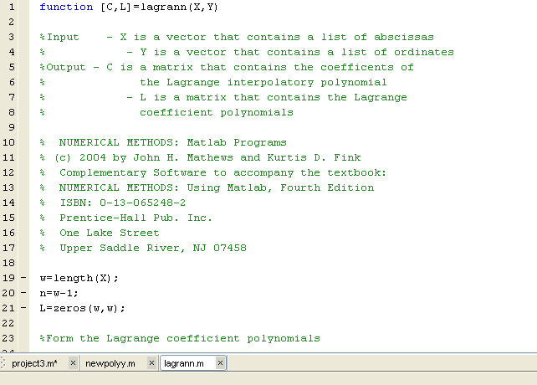

And here it's code
function [C,L]=lagrann(X,Y)

%Input - X is a vector that contains a list of abscissas
% - Y is a vector that contains a list of ordinates
%Output - C is a matrix that contains the coefficents of
% the Lagrange interpolatory polynomial
% - L is a matrix that contains the Lagrange
% coefficient polynomials

% NUMERICAL METHODS: Matlab Programs
% (c) 2004 by John H. Mathews and Kurtis D. Fink
% Complementary Software to accompany the textbook:
% NUMERICAL METHODS: Using Matlab, Fourth Edition
% ISBN: 0-13-065248-2
% Prentice-Hall Pub. Inc.
% One Lake Street
% Upper Saddle River, NJ 07458

w=length(X);
n=w-1;
L=zeros(w,w);

%Form the Lagrange coefficient polynomials

for k=1:n+1
V=1;
for j=1:n+1
if k~=j
V=conv(V,poly(X(j)))/(X(k)-X(j));
end
end
L(k,:)=V;
end

%Determine the coefficients of the Lagrange interpolator
%polynomial

C=Y*L;

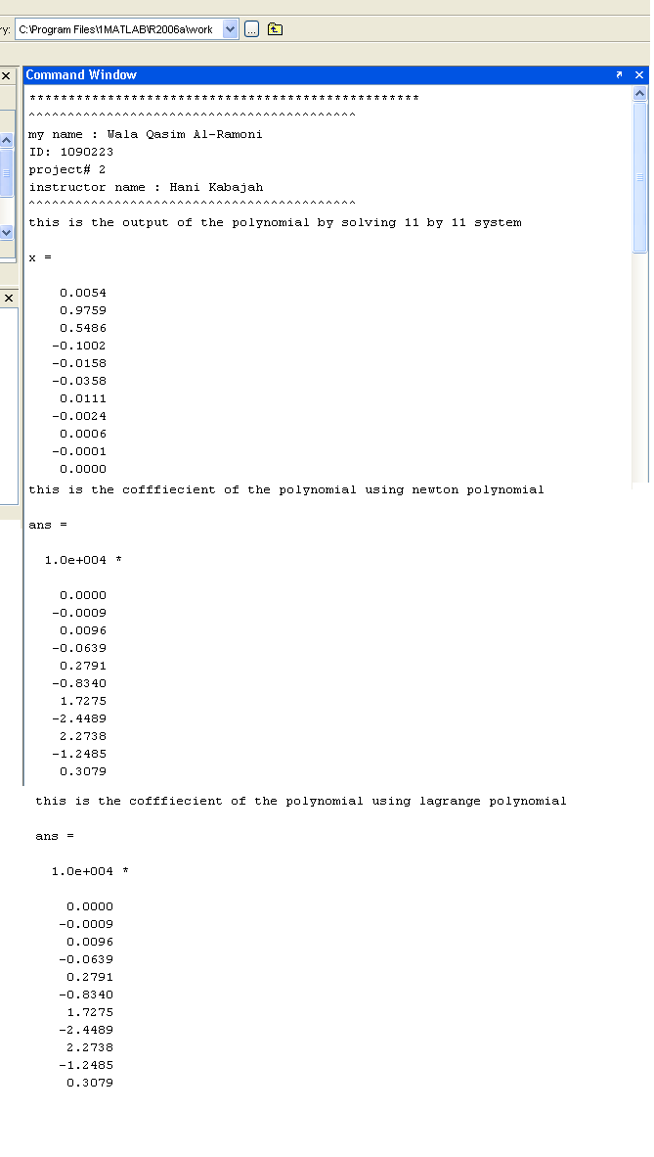
When run project3.m we get these output

