**Physics Department Physics 211**

**Speed of sound in air**

|  |  |
| --- | --- |
| **Name** | **Laith Marzouka .** |
| **ID #** | **1160827 .** |

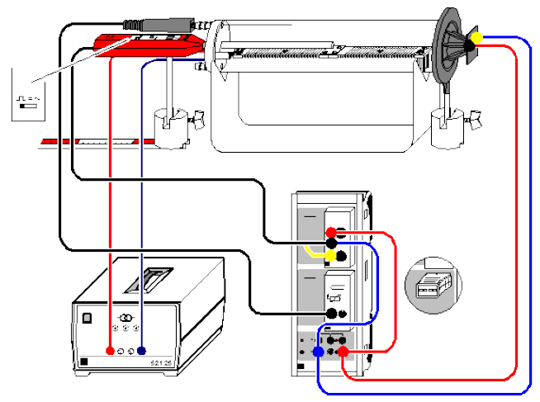

**Abstract:**

* The aim of this experiment: To determine the speed of sound at zero Celsius and at room temperature.
* The method used: By heating the medium which sound travels through and measuring the speed every $5 C^{0}$, and plotting the speed vs. the temperature
* The main results:

$$c_{room temperature }=\left(366 ±6\right) m/s$$

$$c_{zero}=303 m/s$$

$$γ=1.17±0.03$$

**Theory:**

Sound waves are mechanical waves which need medium to transfer. They transfer as pulses or compression waves (longitudinal wave). The speed of sound waves depends on the properties (compressibility and density) and the temperature of the medium.

It was found that the speed of sound in air depends on its ability to be compressed (Bulk modulus ) and its density $ρ$ as in eq. (1)

$c= \sqrt{\frac{κ}{ρ}}$ (1)

The bulk modulus is related to the pressure of air $P$ via the relation $κ=γP$, thus eq. (1) will be

$c= \sqrt{γ\frac{P}{ρ}}$ (2)

where $γ$ is the adiabatic coefficient. From a classical point of view, when a sound pulse is formed there is no enough time to exchange heat between the pulse and the surrounding which means that this process is adiabatic and so the adiabatic coefficient is needed.

Air at standard conditions of temperature and pressure, at room temperature and at atmospheric pressure, as be safely treated as ideal gas. Using the ideal gas law $P=NRT/V$ and $ρ=NM/V$ eq. (2) will be

$c= \sqrt{γ\frac{RT}{M}}$ (3)

where $R=8.315 J/{\left(mol.K\right)}$ is the molar gas constant, T is the absolute temperature and $M$ is the molar mass of the air. The molar mass of dry air is about $0.0289 {Kg}/{mole}$. $N$ and $V$ are the number of moles and the volume of the gas respectively. The numerical value of $γ$ is about $1.4$ for dray air. Additionally, to use temperature in degrees Celsius $\left(℃\right)$ we will use this relation $T=ϑ+273.15$.Then

$$c= \sqrt{γ\frac{R}{M}\left(ϑ+273.15\right)}$$

$$c= 331.3\sqrt{1+\frac{ϑ}{273.15}}$$

Using the first two terms of the Taylor expansion of the above equation

$c= 331.3+0.606ϑ$ (4)

It is clear that the main factor on the speed of sound in air is the temperature. Eq. (4) represents the speed of sound in air as a function of temperature. The relation is linear with the y-intercept = $331.3$ represents the speed of sound in air at zero Celsius $c\left(0\right)$.

From eq. (2) we can see that $γ= c^{2}\frac{ρ}{P}$, and so at zero Celsius

$γ= {c\left(0\right)}^{2}\frac{ρ\left(0\right)}{P\left(0\right)}$ (5)

where $P\left(0\right)$ and $ρ\left(0\right)$ are the pressure and density of air at zero Celsius respectively. From literature $ρ\left(0\right)=1.292 {Kg}/{m^{3}}$ and $P\left(0\right)=1.013×{10}^{5} Pa$

**Apparatus:**

We will use the apparatus shown in Fig. (1) below

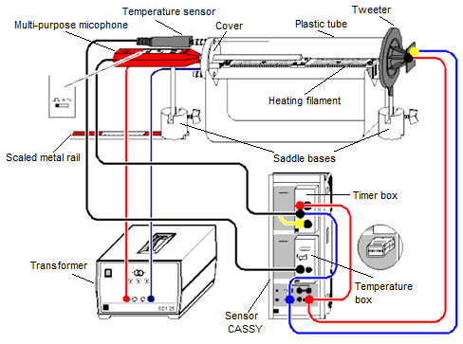

Fig. 1: Apparatus for speed of sound experiment

**Procedure:**

1. Connect the apparatus as shown in Fig. (1) above. Connect the sensor CASSY to your computer.
2. Insert the multipurpose microphone approximately 1 cm deep into the middle hole of the cover and align it so that it moves parallel to the plastic tube when displaced. Set the function switch of the multipurpose microphone to the "Trigger" mode . Do not forget to switch the microphone on.
3. Lay the scaled metal rail immediately under the saddle base.
4. Plug the timer box at input A and the temperature box at input B on Sensor-CASSY; set the maximum output voltage at the voltage source S.
5. load the settings of the CASSY Lab. 2 software with 

* Set the timer box to measure the transit time ${∆t}_{A1}$ (choose transit time ${∆t}_{A1}\left(E→F\right)$, choose **invert edges** and then determine the **range** of time) and choose **Manual Recording**. Choose the Voltage source $S_{1}$ and determine the fraction time (it is suitable to choose $frac time<0.8$). (see Fig. 2)

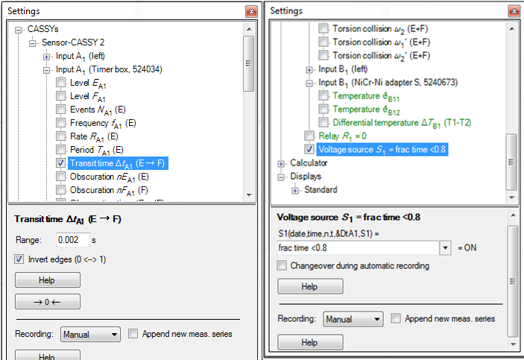

**Fig. 2: Load settings of the Cassy Lab. 2 so it can measure the transit time**

|  |  |
| --- | --- |
| * Set the temperature box (NiCr-adapter S) to measure the temperature $ϑ$ (choose $Temperature ϑ_{B11}$). Determine the **range** of temperature and choose **Manual Recording.** (see Fig. 3) | Fig. 3: Loading settings of the Cassy Lab. 2 so it can measure temperature |

* In parameters define the distance $s$ between the microphone and the tweeter (don’t enter the value of $s$ at first, you will enter the value later after step 7 below). In formulas define equation to calculate the speed of sound $c=s/{{∆t}_{A1}}$ (note to write $∆$ you must write $\&D$). (see Fig. 4)

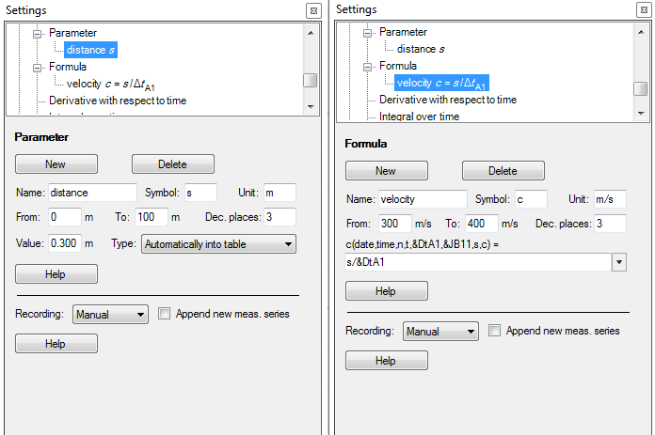

Fig. 4: Loading settings to calculate the speed of sound

* In display determine the graphs to be drawn while taking measurements (graph of $c vs. ϑ$ and ${∆t}_{A1} vs. n$ where $n$ represent the number of times you take the measurement).(see Fig. 5)

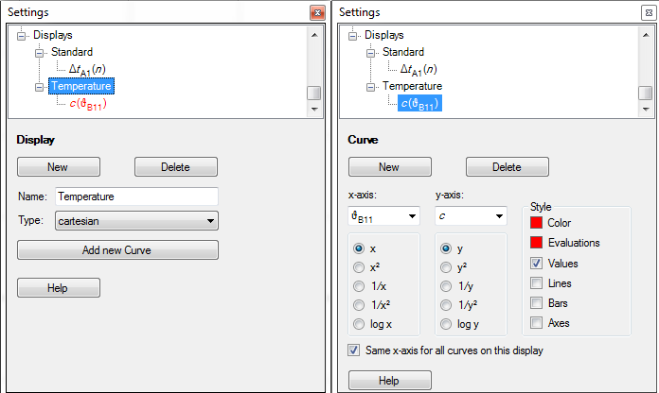

Fig. 5: Loading settings to draw speed of sound as a function of temperature

1. Measuring speed of sound at room temperature

* Store multiple single measurements of the transit time with. Determine the mean value of the transit time in the diagram using **Draw Mean.** (see Fig. 6: note that this also determines the error in the average value)

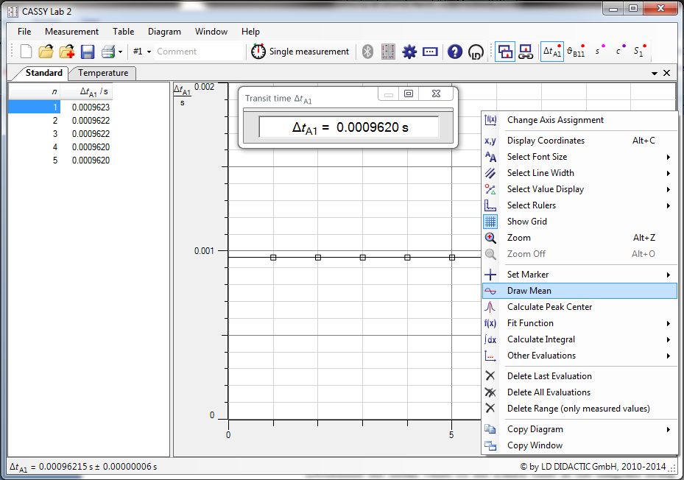

Figure 6: Finding the average value of the transit time

* Slide the multipurpose microphone all the way into the plastic tube and read off the change in distance $∆s$ from the scaled metal rail.
* Store multiple single measurements of the transit time with. Determine again the mean value of the transit time in the diagram using **Draw Mean.**
* Calculate the speed of sound using $c={∆s}/{∆t}$ where $∆t$ is the change in the transit time.

1. Determining the distance $s$ between the microphone and the tweeter

* Pull out the universal microphone
* At room temperature, determine the transit time ${∆t}_{A1}$ again and, using the speed of sound $c$ already determined, calculate the distance $s=c.{∆t}_{A1}$ and write this value in the parameters where you defined $s$ before. (as in Fig. 4 above the value of $s$ is $0.300 m$)

1. Measuring speed of sound as a function of temperature

* Connect the heating filament to the voltage supply (12 V / approx. 3.5 A) via the sockets in the cover of the apparatus.
* Save the current transit times with (e.g. every 5 °C). Once you save the transit time at any temperature the speed of sound will be evaluated immediately as you defined $c=s/{{∆t}_{A1}}$ in the setting at first.

**Safety notes:**

The plastic tube of the apparatus for sound and speed can be destroyed by excessive temperatures.

* Do not heat it above 80 °C.
* Do not exceed the maximum permissible voltage of 25 V (approx. 5 A) for the heating filament.

**Data and Calculations:**

* Speed of sound at room temperature

|  |  |  |
| --- | --- | --- |
| $$n$$ | $$s_{1}= 0.41 ± 0.001 m$$ | $$s_{2}= 0.195 ± 0.001 m$$ |
| $${∆t}_{{A1}_{s1}}(s)$$ | $${∆t}_{{A1}_{s2}}(s)$$ |
| 1 | **0.0009203** | 0.0003182 |
| 2 | **0.0009085** | 0.0003293 |
| 3 | **0.0009122** | 0.0003200 |
| 4 | **0.0009128** | 0.0003310 |
| 5 | **0.0009117** | 0.0003265 |
| $$Avg.$$ | $$t_{1,avg}= 0.000913 ± 0.000001 s$$ | $$t_{2,avg}=0.0003250 ±0.0000025 s$$ |



$∆s=s_{1}-s_{2}=$ $0.41-0.195=0.215 m$

$∆t=t_{1,avg}-t_{2,avg}=$ $0.000913-0.0003250=0.000588 s$

$c=\frac{∆s}{∆t}=$ $\frac{0.215}{0.000588}=366 m/s$

$\frac{∆c}{c}=\frac{∆s_{1}+∆s_{2}}{∆s}+\frac{∆t_{1}+∆t_{2}}{∆t}=$ $\frac{0.001+0.001}{0.215}+\frac{1×{10}^{-6}+2.5×{10}^{-6}}{0.000588}=\frac{2}{215}+\frac{1}{168}=0.015$

$∆c=c×\left(\frac{∆s_{1}+∆s_{2}}{∆s}+\frac{∆t_{1}+∆t_{2}}{∆t}\right)=$ $366×0.015=6 m/s$

* Speed of sound as a function of temperature
* The distance $s$ between the microphone and the tweeter

|  |
| --- |
| $${∆t}_{{A1}_{s1}}(s)$$ |
| **0.0009292** |
| **0.0009282** |
| **0.0009425** |
| **0.0009413** |
| **0.0009348** |
| $${∆t}_{A1,avg}= 0.000935 ± 0.000004 s$$ |

$s=c.{∆t}_{A1}=$ $365.6 ×0.000935=0.342 m$

* Take a measurement every 5 °C

|  |  |  |
| --- | --- | --- |
| $$n$$ | ϑ °C | $$c (m/s)$$ |
| 1 | 28.2 | 321.543 |
| 2 | 33.2 | 320.770 |
| 3 | 38.1 | 328.857 |
| 4 | 43.6 | 334.448 |
| 5 | 47.4 | 329.128 |
| 6 | 51.7 | 333.983 |
| 7 | 56.8 | 338.983 |
| 8 | 62.7 | 342.466 |

The sound velocities are plotted in the **Temperature** display as a function of the temperature while the measurements running. By fitting a straight line eq. (4) can be confirmed easily. From the graph $c vs. ϑ$ find

* The speed of sound at zero Celsius
* The adiabatic coefficient at zero Celsius

From the plotted graph, at $y=0$, we obtain the speed of sound at 0 ̊C:

$y_{-}intercept=c\left(0\right)=303 m/s$.

As well as, $the adiabatic coefficient at zero Celsius is obtained$

$By using the following Formula:$

$γ=c^{2}\frac{ρ}{P}$*, where $ρ\left(0\right)=1.292 kg/m^{3}$, and $P\left(0\right)=1.013×{10}^{5}Pa$*

$γ={(303)}^{2}×\frac{1.292}{1.013×{10}^{5}}=1.17$

$Δγ=2\frac{\left(Δy_{-}intercept\right)}{y_{-}intercept}×γ=2\frac{\left(4.12\right)}{303.34}×1.17=0.03$

$γ=1.17±0.03$

**Results and Conclusion:**

|  |  |  |
| --- | --- | --- |
| At room temperature | $$c = 366±6 m/s$$ | |
| At zero Celsius | | $$c = 303 m/s$$ |
| The adiabatic coefficient at zero Celsius | | $$γ =1.17±0.03$$ |

The theoretical value of the speed of sound at room temperature is 343 m/s

$Discrepancy=\left| c_{theo}-c_{exp}\right|=\left|343-366\right|=23 ̊C$

$2×Error>?Discrepancy →2×6=12<23$

So, the result of speed of sound at room temperature is not accepted.

The true value of the adiabatic coefficient is $1.4$, so by the discrepancy test, our obtained value is not accepted within errors estimated.

Temperature affects the speed of sound significantly. Sound travels through hot air quicker. When the temperature is high, the air molecules gain more kinetic energy resulting in faster movement of sound waves between its molecules.

The results were not accepted due to many random errors. Most commonly, noise in the lab affects the experiment. Also, the temperature was high the day the experiment was done, this results in a higher speed of sound as stated above which makes sense of the high value we obtained. As well as, the computer program had an unstable values which affected the readings.

Moreover, we could not have enough readings since the temperature was already high, and we couldn’t heat the medium more than 65 degrees, so that the plastic tube of the apparatus is not destroyed.

**GRAPH**

|  |  |
| --- | --- |
| $$T (°C)$$ | C (m/s) |
| 28.2 | 321.543 |
| 33.2 | 320.770 |
| 38.1 | 328.857 |
| 43.6 | 334.448 |
| 47.4 | 329.128 |
| 51.7 | 333.983 |
| 56.8 | 338.983 |
| 62.7 | 342.466 |

|  |  |  |
| --- | --- | --- |
|  | **slope** | **y-intercept** |
|  | 0.617875 | 303.3366 |
| **error** | 0.088517 | 4.119496 |