
Physics Department
Physics 211

Experiment No.2
Freely Falling Objects.
Student’s Name: Remah Dahdoul Student’s No.: 1181771
Partner’s Name: Nadea Jamal Partner’s No.: 1180433
Partner’s Name: Ameed Mahajna Partner’s No.: 1181623

Section: 1

Date: 13\11\2019.
Instructor: Mr. Nihad Abu-Awwad .
Abstract:
1)The aim of the experiment: to determine the acceleration due to gravity in Birzeit university.
2)The method used: by using a time measuring device to measure the time needed for a ball to fall freely from different heights to the ground.
3)Apparatus:
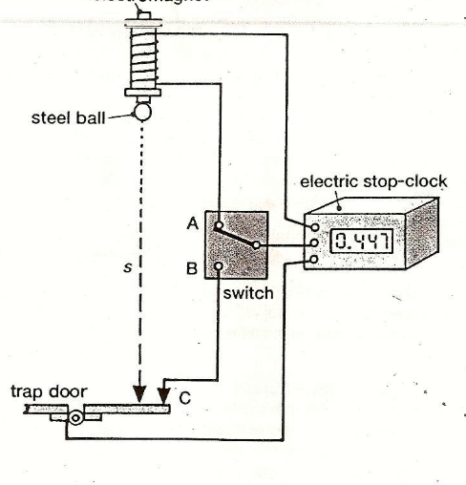
4)Main result:
g_{avg}=8.9±0.2 m/s²
Theory:
An object falling near the earth's surface will have a nearly constant
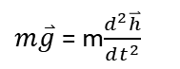
acceleration g ≈ 9.8 m/s².
Applying Newton's second law:
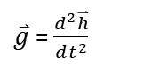
The solution of this differential equation is:
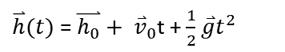
But, if we choose h₀ to be zero, and if the object is dropped from rest, then
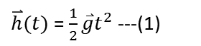
the equation becomes:

That means:
//A logh VS logt graph gives a slope = 2 and y-intercept = log(0.5g).
In this experiment, we replace 2 to α, and show that α equals to 2, or near
to it with some experimentally errors. And then, we find g from y-intercept
of the graph.
After finding α, we graph h VS t^{α}, and find g from its slope (the slope here
represents 0.5g from equation (1)).
Procedure:
1- A ball was dropped from known height, and the time needed to hit the
ground was measured by a specific device.
2- Another different height was chosen, and the time was measured.
3- In every height, the time was measures three times, and the data was
written in a table.
Data And Analysis:
Height (m) | Time t (sec) |  |  |  | Log H | Log t
Height (m) | T₁ | T₂ | T₃ | T_{avg} | Log H | Log t
0.2 | 0.211 | 0.213 | 0.214 | 0.212667 | -0.69897 | -0.6723
0.3 | 0.267 | 0.266 | 0.264 | 0.265667 | -0.52288 | -0.57566
0.4 | 0.285 | 0.284 | 0.284 | 0.284333 | -0.39794 | -0.54617
0.5 | 0.343 | 0.34 | 0.341 | 0.341333 | -0.30103 | -0.46682
0.6 | 0.37 | 0.371 | 0.371 | 0.370667 | -0.22185 | -0.43102
0.7 | 0.379 | 0.379 | 0.379 | 0.379 | -0.1549 | -0.42136
0.8 | 0.428 | 0.421 | 0.428 | 0.425667 | -0.09691 | -0.37093
0.9 | 0.454 | 0.454 | 0.457 | 0.455 | -0.04576 | -0.34199
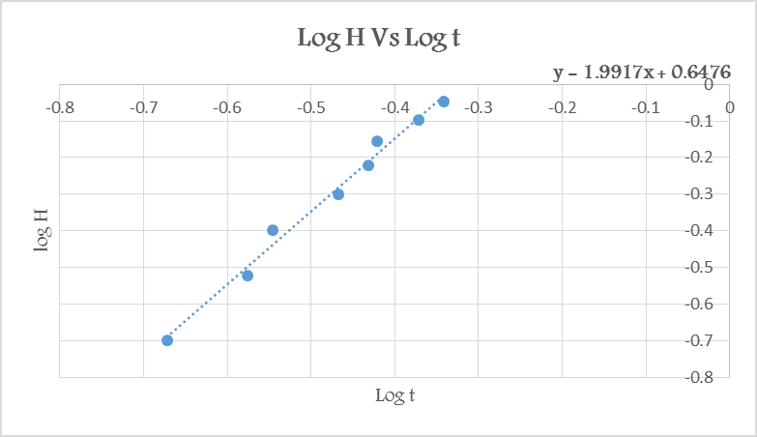
From the graph above , we find the value of α which equals the slope =1.9917.
Since, log H = α log t + log (1/2g)
y-int = log (1/2g) = 0.66.
g = 10 ^{y-int} ×2 = 9.1417m/s²
Δg = 2×10^{y-int}×ln10 ×Δy-int = 0.6314 m/s²
→g = 9.1 ± 0.6 m/s²
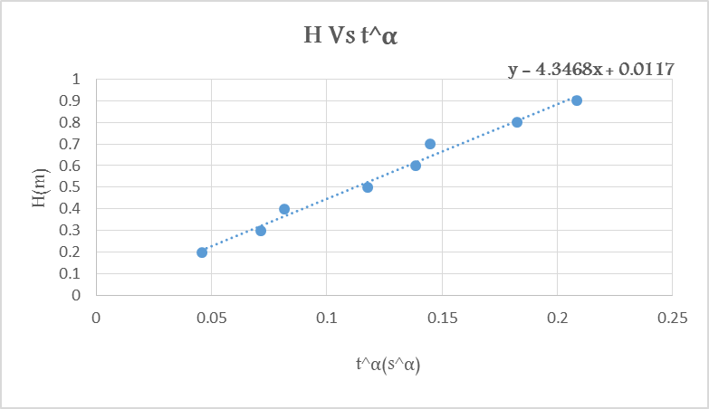
From the above graph :
Since, H= 1/2g× t ^{α}.
the slope = ½ g .
g=2×4.3468=8.6936 m/s²
Δg = 2×Δslope=0.43447 m/s²
H(m) | t ^{α}(s^{α})
0.2 | 0.045812
0.3 | 0.07136
0.4 | 0.081694
0.5 | 0.117553
0.6 | 0.13853
0.7 | 0.144802
0.8 | 0.182481
0.9 | 0.208383
→g = 8.7 ± 0.4 m/s²

Conclusion:
g_{avg}=8.9±0.2 m/s²
g_{theo}=9.8 m/s²
| g_{avg} - g_{theo} | is not ≤ 2× Δg (the result is not accepted).
* The acceleration due to gravity is constant regardless of the mass or the other characteristics of the falling object, in this manner we didn’t measure the mass of the ball.
*Such systematic errors have happened while doing the experiment and so, the results have been influenced:
1) The used digital device for measuring the time of falling was broken so, we measured the time manually depending on our eyes rather than the sensors of the device, so we expect that the recorded t’s were not that much accurate .
2) Further, the recorded T was under the influence of energy dissipation because of the presence of friction in the hanging point.
3) The taken values of height were in approximation, because the marker was not fixed .

